Tutor guide
M2- 2024-2025
Second term

- Contents:
  - Characters of O.6.U. graduates:
  - Teaching strategy in O.6.U.
  - -Guide lines (why P.B.L. “Problem Based Learning”) (what the student & tutor will do this term) , (modules in this term & their general objectives)
  - Schedule for lectures , practicals , Early clinical exposure (ECE) , cases ( small group teaching) , (small group discussion ) , skill lab , & exams
  - Rubrics for grading assignments and presentations
  - Portfolio items
  - Cases with objectives
  - 8- Tutor guide for the cases
  - 9- N.A.R.S.
  - Blue prints

- Characters of O.6.U. graduates:
  - Work to maintain normal health, provide primary health care and deal with common health problems in the society
  - Be aware of the importance of a good doctor patient relationship and work to establish and maintain it.
  - Follow rules of medical ethics.
  - Show appropriate attitudes and professionalism.
  - Demonstrate appropriate communication, clinical and practical skills.
  - Be prepared for lifelong learning.
  - Be able to engage in post- graduate and research studies.
  - Acquire basic administrative capabilities

** ملخص إستارتيجية التعليم والتعلم بالكلية**
1.استراتيجية التعلم الذاتي:
أسلوب من أساليب التعلم المتطورة التى تمكن الطالب من تحصيل المعارف والمها ارت معتمداً على
قدارته الذاتية من مصادر التعلم المختلفة ، فيعلم نفسه بنفسه وفقاً لقدارته ولسرعته فى التعلم.
2ـ استراتيجيه التعلم التفاعلي:
تعتمد استراتيجية التعليم التفاعلي على إسلوب التفاعل بين الطالب والمحاضر والمادة العلمية ويمكن تطبيق هذا المفهوم من خلال عدة وسائل منها التعليم التعاوني والتعليم الإلكتروني.
أ- التعلم التعاوني:
من خلال عمل الطلاب معا فى مجموعات صغيرة العدد للعمل على حل المشكلات أو د ارسة حالة والمشاركة فى حملات التوعية في تفاعل إيجابي متبادل يشعر فيه كل فرد أنه مسئول عن تعلمه وتعلم الاخر .
ب-التعليم الالكتروني:
وسيمة تدعم العملية التعليمية وتحولها من طور التلقين إلى طور الإبداع والتفاعل وتنمية المها ارت، حيث تعتمد عمى تطبيقات الحاسبات الإلكترونية وشبكات الإتصال والوسائط المتعددة في نقل
المهاارت والمعارف وتضم تطبيقات عبر الموقع الالكترونى وغرف التدريس الإفتراضية.
3ـ التدريب
- التدريب الإكلينيكى
- التدريب الميدانى
- القوافل الطبية
- التدريب الصيفى بالمستشفى
- التدريب بمركز التدريب الطبى المستمر ووحدة الابحاث الطبية المتقدمة
- التدريب بالمستشفيات بالخارج

**اساليب وطرق التعليم والتعلم
أساليب أخرى لمتدريس التفاعمى | لاساليب الغير تقميدية | الاساليب التقميدية
البحوث وتقديم العروض العملية  ) انشطة اخرى: المشاركة فى القوافل الطبية وحملات التوعية( | حل المشكلات | المحاضرات باستخدام الداتا شو
 | حل المشكلات | & Tutorial السيمينا ارت
الرسومات التوضيحية وعمل بوسترات للابحاث | نماذج ومحاكاة | الدروس المعملية والإكمينيكية  ) مستشفى الكلية ـ مستشفى طب القصر العينى  الكس  ترابيزة سكترا  التعليم باستخدام الحالات  التعليم التكاملي التفاعلي
الرسومات التوضيحية وعمل بوسترات للابحاث | Skill lab مشاهدة
التعلم الالكتروني | لعب الادوار
الزيا ارت الميدانية )الوحدات الصحية – المصل واللقاح – المحرقة بالمستشفى – وحدة التعقيم( | د راسة الحالة
التدريب الصيفى بمستشفى الجامعة وبالخارج | المناقشة فى مجموعات صغيرة
وللتأكد من تحقيق مخرجات التعلم المستهدفة:ـ
يتم تقييم مستوى الطلاب بطرق متعددة تشمل:
- الامتحانات الدورية
- الامتحانات التحريرية
- حل المشكلات ودراسة الحالة
- الامتحانات العممية والاكلينيكية وتطبيق نظام) OSPE - OSCE

عميد الكلية أ.د/عمرو نديم

- PBL Philosophy:
In a world where available information is growing exponentially, we believe that the most important thing a student needs to know is how to learn. So the main learning goals of the PBL are a framework for looking at concepts, skills, and abilities and help guide the creation of personalized student curriculum. PBL offers unique environments where students can flourish as individuals within a community of learners.
- PBL Process:
The core of the PBL process is the tutorials that will be held once weekly beside the practical sessions and the interactive lectures. In each tutorial there will be a case scenario that is delivered to the students, where they collaborate together through the seven jumps process to point out the possible problems present in the case and to find out the intended learning objectives need to be known through this case. In the second tutorial, they will discuss the objectives of the case after self study, and a new case will be delivered. In PBL process the role for lectures aim at clarification of complicated areas of information or to integrate different areas of information. Practical sessions and clinical skill lab are included as educational activities in BPL. They act as tools for the students to gain the needed psychomotor skills and to attain the professional attitude and behavior.
- Student role:
The student is the center of the learning process in PBL. Students will depend on themselves in finding out the learning objectives by brain storming in the case study session. Then they will go home and study and search in the texts for the information of the objectives they got. Then the following session they should try to present the information they gazered and summarized to their students in an easy palatable way. In PBL the students have to work hard, prepare themselves well for every tutorial group meeting, collaborate with their colleagues and practice team work. They also will have their reflection about the process, their colleagues and the tutor.
- Tutors role:
- The tutor will work as a facilitator more than traditional teacher who delivers all the information to the students. Tutors role is to stimulate and motivate the students to learn and to search for the information and knowledge. During the case they will guide the students and redirect them towards the intended learning objectives. The tutors share in the assessment process. Moreover, the tutor together with the students has the responsibility of setting the roles of the tutorial session.
- The tutor will receive guide information for the objectives in each case from the departments at least one week before the case is to be discussed, he should read them and then in the discussion of the case he should see if the students had fulfilled all the needed items so as to approve their work or they need to search more for certain items and get them so as to complete their work completely or they got more or un needed items they should discard them. By the end of the cases of the module students will have their hand out covering all items needed in the objectives they searched for
- All staff members should have their official mails done by the beginning of the academic year so as good communication may be applicable and to facilitate uploading of their lectures every Wednesday of each week
- In session ( 1 ) ( week 1)
- One case will be red by the students
- They make brain storming with each other and with the tutor to get the objectives the case is talking about. They will go home to search for them and make presentation about them the coming session.
- Weeks for reading of the cases and discussion of the objectives are written above each case.
- The presentation have certain rubrics the tutor try that the students stick more and more to them each presentation then at the last presentation of the module they will have certain mark among their portfolio total mark about:
- The presentation they showed along the module and their share in the discussions and preparation of the work needed (see professional behavior sheet included) (the mark is given by the tutor)
- After they finish the presentation in each session they will read the following case and brain storm to get the objectives that they will go home to prepare them as presentation in the coming case session and so on all the sessions
- If the case is long its presentation by the students may take two weeks not one week to ensure that the students presented the objectives in the case in a good way
- -All students are to make their Emails in the first week so as to be able to have the on line information uploaded weekly concerning the following:
- Lectures
- Videos
- Presentation done by their colleagues
- On line exams formative and summative

ملخص إستارتيجية التعليم والتعلم بالكلية**
1.استراتيجية التعلم الذاتي:
أسلوب من أساليب التعلم المتطورة التى تمكن الطالب من تحصيل المعارف والمها ارت معتمداً على
قدارته الذاتية من مصادر التعلم المختلفة ، فيعلم نفسه بنفسه وفقاً لقدارته ولسرعته فى التعلم.
2ـ استراتيجيه التعلم التفاعلي:
تعتمد استراتيجية التعليم التفاعلي على إسلوب التفاعل بين الطالب والمحاضر والمادة العلمية ويمكن تطبيق هذا المفهوم من خلال عدة وسائل منها التعليم التعاوني والتعليم الإلكتروني.
أ- التعلم التعاوني:
من خلال عمل الطلاب معا فى مجموعات صغيرة العدد للعمل على حل المشكلات أو د ارسة حالة والمشاركة فى حملات التوعية في تفاعل إيجابي متبادل يشعر فيه كل فرد أنه مسئول عن تعلمه وتعلم الاخر .
ب-التعليم الالكتروني:
وسيمة تدعم العملية التعليمية وتحولها من طور التلقين إلى طور الإبداع والتفاعل وتنمية المها ارت، حيث تعتمد عمى تطبيقات الحاسبات الإلكترونية وشبكات الإتصال والوسائط المتعددة في نقل
المهاارت والمعارف وتضم تطبيقات عبر الموقع الالكترونى وغرف التدريس الإفتراضية.
3ـ التدريب
- التدريب الإكلينيكى
- التدريب الميدانى
- القوافل الطبية
- التدريب الصيفى بالمستشفى
- التدريب بمركز التدريب الطبى المستمر ووحدة الابحاث الطبية المتقدمة
- التدريب بالمستشفيات بالخارج

**اساليب وطرق التعليم والتعلم
أساليب أخرى لمتدريس التفاعمى | لاساليب الغير تقميدية | الاساليب التقميدية
البحوث وتقديم العروض العملية  ) انشطة اخرى: المشاركة فى القوافل الطبية وحملات التوعية( | حل المشكلات | المحاضرات باستخدام الداتا شو
 | حل المشكلات | & Tutorial السيمينا ارت
الرسومات التوضيحية وعمل بوسترات للابحاث | نماذج ومحاكاة | الدروس المعملية والإكمينيكية  ) مستشفى الكلية ـ مستشفى طب القصر العينى  الكس  ترابيزة سكترا  التعليم باستخدام الحالات  التعليم التكاملي التفاعلي
الرسومات التوضيحية وعمل بوسترات للابحاث | Skill lab مشاهدة
التعلم الالكتروني | لعب الادوار
الزيا ارت الميدانية )الوحدات الصحية – المصل واللقاح – المحرقة بالمستشفى – وحدة التعقيم( | د راسة الحالة
التدريب الصيفى بمستشفى الجامعة وبالخارج | المناقشة فى مجموعات صغيرة
وللتأكد من تحقيق مخرجات التعلم المستهدفة:ـ
يتم تقييم مستوى الطلاب بطرق متعددة تشمل:
- الامتحانات الدورية
- الامتحانات التحريرية
- حل المشكلات ودراسة الحالة
- الامتحانات العممية والاكلينيكية وتطبيق نظام) OSPE - OSCE

عميد الكلية أ.د/عمرو نديم

- Scoring Rubric for Presentations:
Category | Scoring Criteria | Total Points | Score
Organization  (15 %) | Were the main ideas presented in a clear manner? | 5
Organization  (15 %) | Information is presented in a logical sequence. | 5
Organization  (15 %) | Presentation appropriately cites requisite number of references. | 5
Content  (45 %) | - The Introduction is attention-getting,  - It lays out the problem well,  - It establishes a framework for the rest of the presentation. | 5
Content  (45 %) | Technical terms are well-defined in language that is appropriate for the target audience. | 5
Content  (45 %) | The Presentation contains accurate information. | 10
Content  (45 %) | The material included is relevant to the overall message/purpose. | 10
Content  (45 %) | Appropriate amount of material is prepared, and the points made reflect well their relative importance. | 10
Content  (45 %) | There is an obvious conclusion summarizing the presentation. | 5
Presentation  (40 %) | Speaker maintains good eye contact with the audience and is appropriately animated (e.g., gestures, moving around, etc.). | 5
Presentation  (40 %) | Speaker uses a clear, audible voice. | 5
Presentation  (40 %) | Delivery is poised, controlled, and smooth. | 5
Presentation  (40 %) | Good language skills and pronunciation are used. | 5
Presentation  (40 %) | Visual aids are well prepared, informative, effective, and not distracting. | 5
Presentation  (40 %) | Length of presentation is within the assigned time limits. | 5
Presentation  (40 %) | Information was well communicated. | 10
Score % | Total Points | 100%

Steps to register on the Moodle
e-learning website for Faculty of Medicine
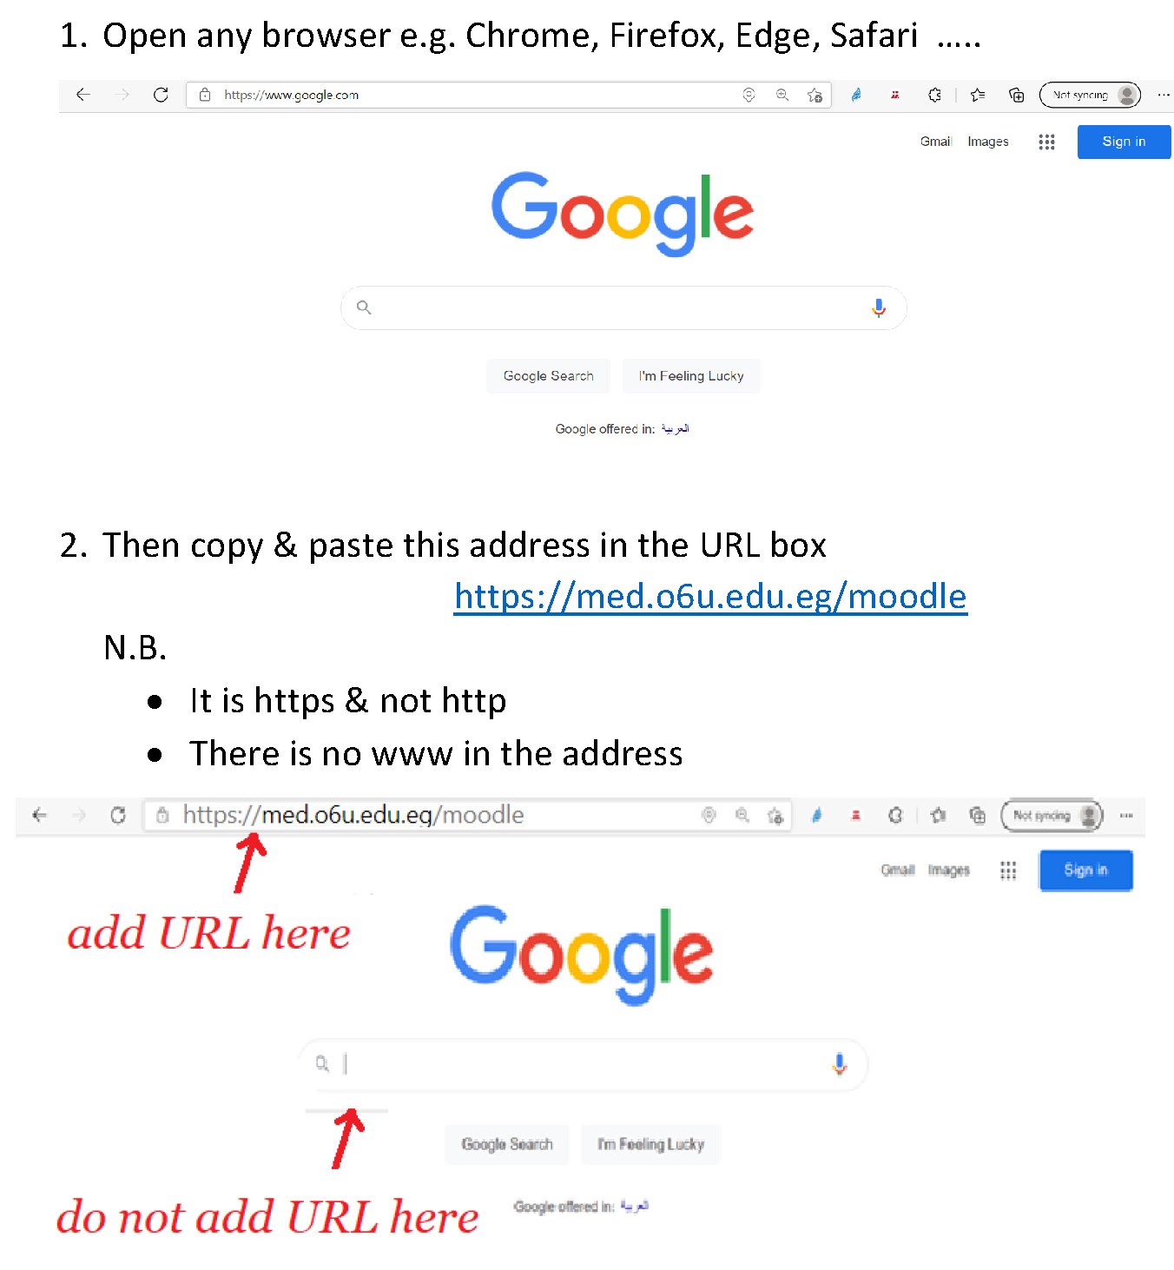
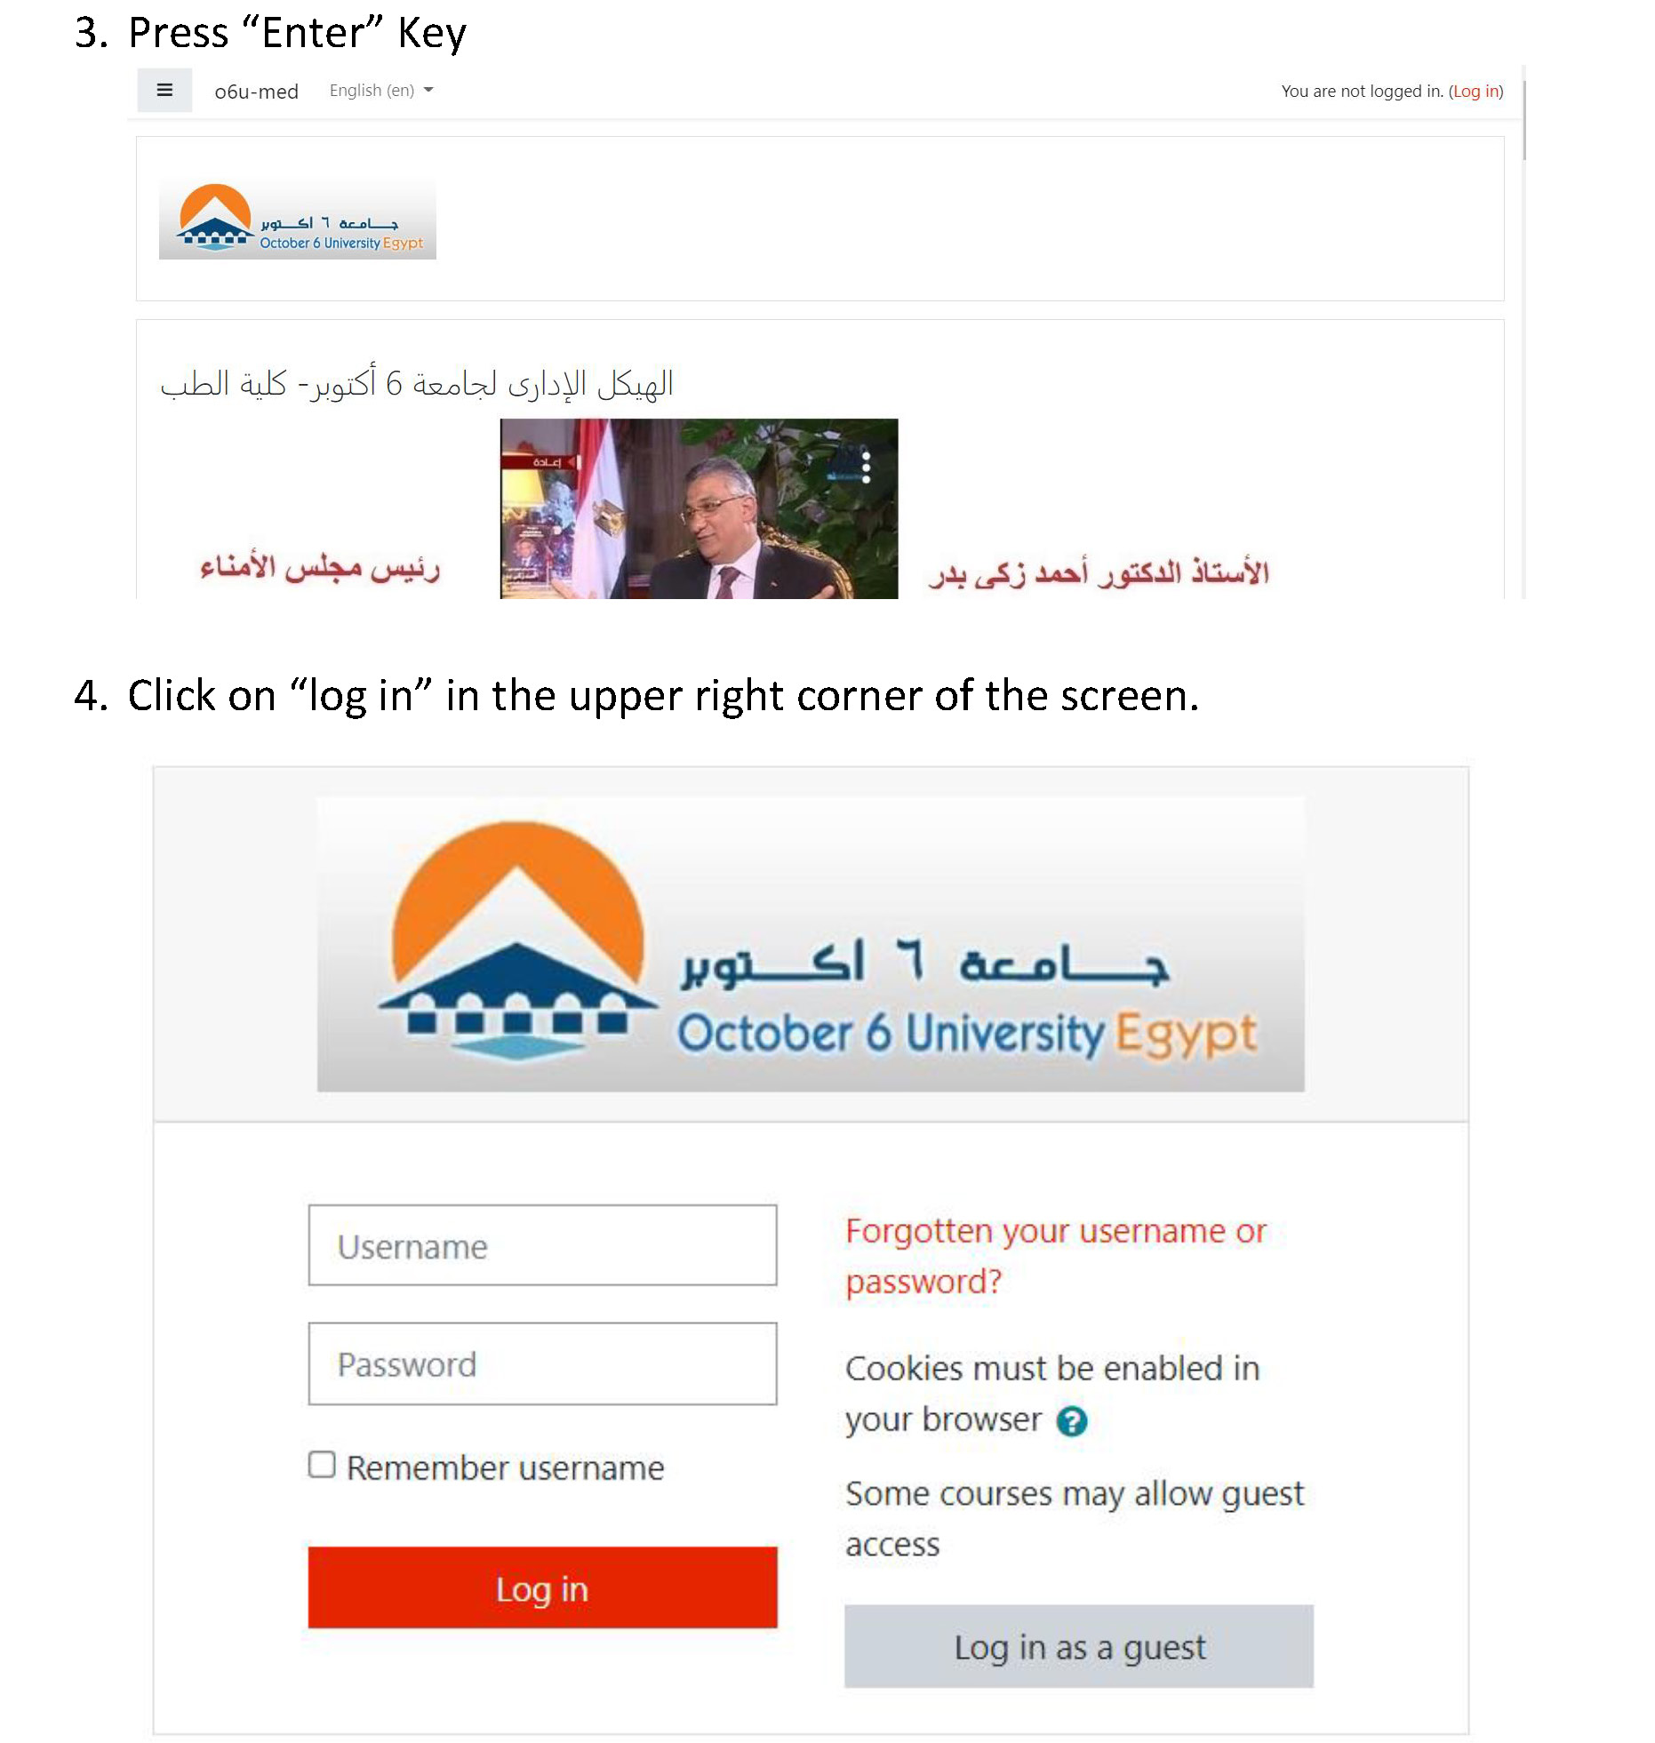
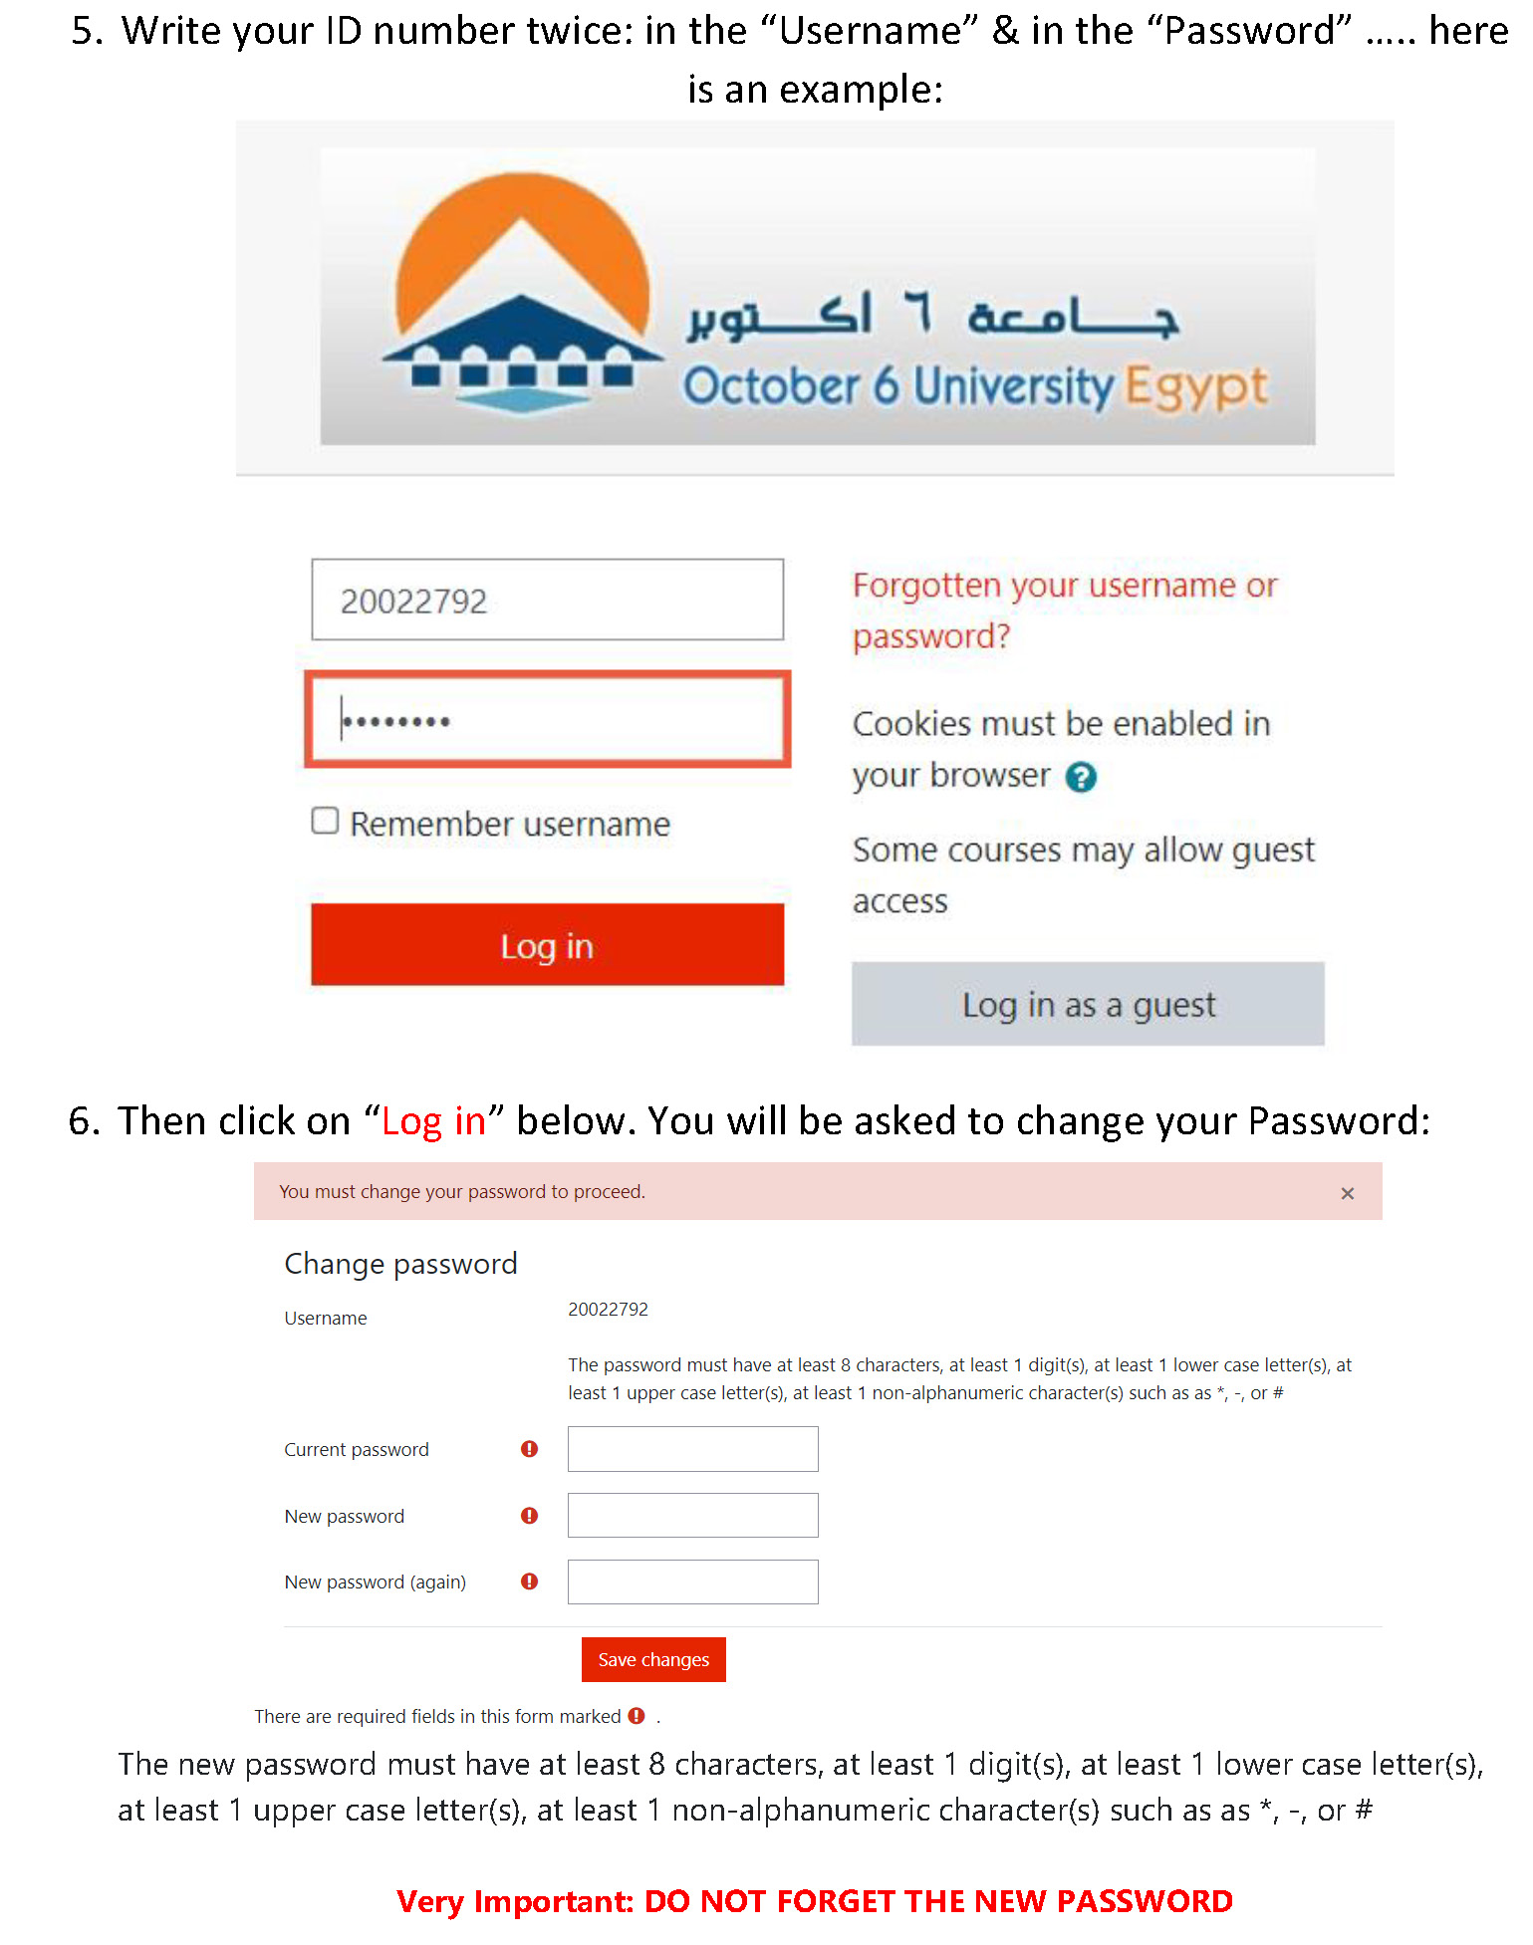
How to enroll yourself in a Module?
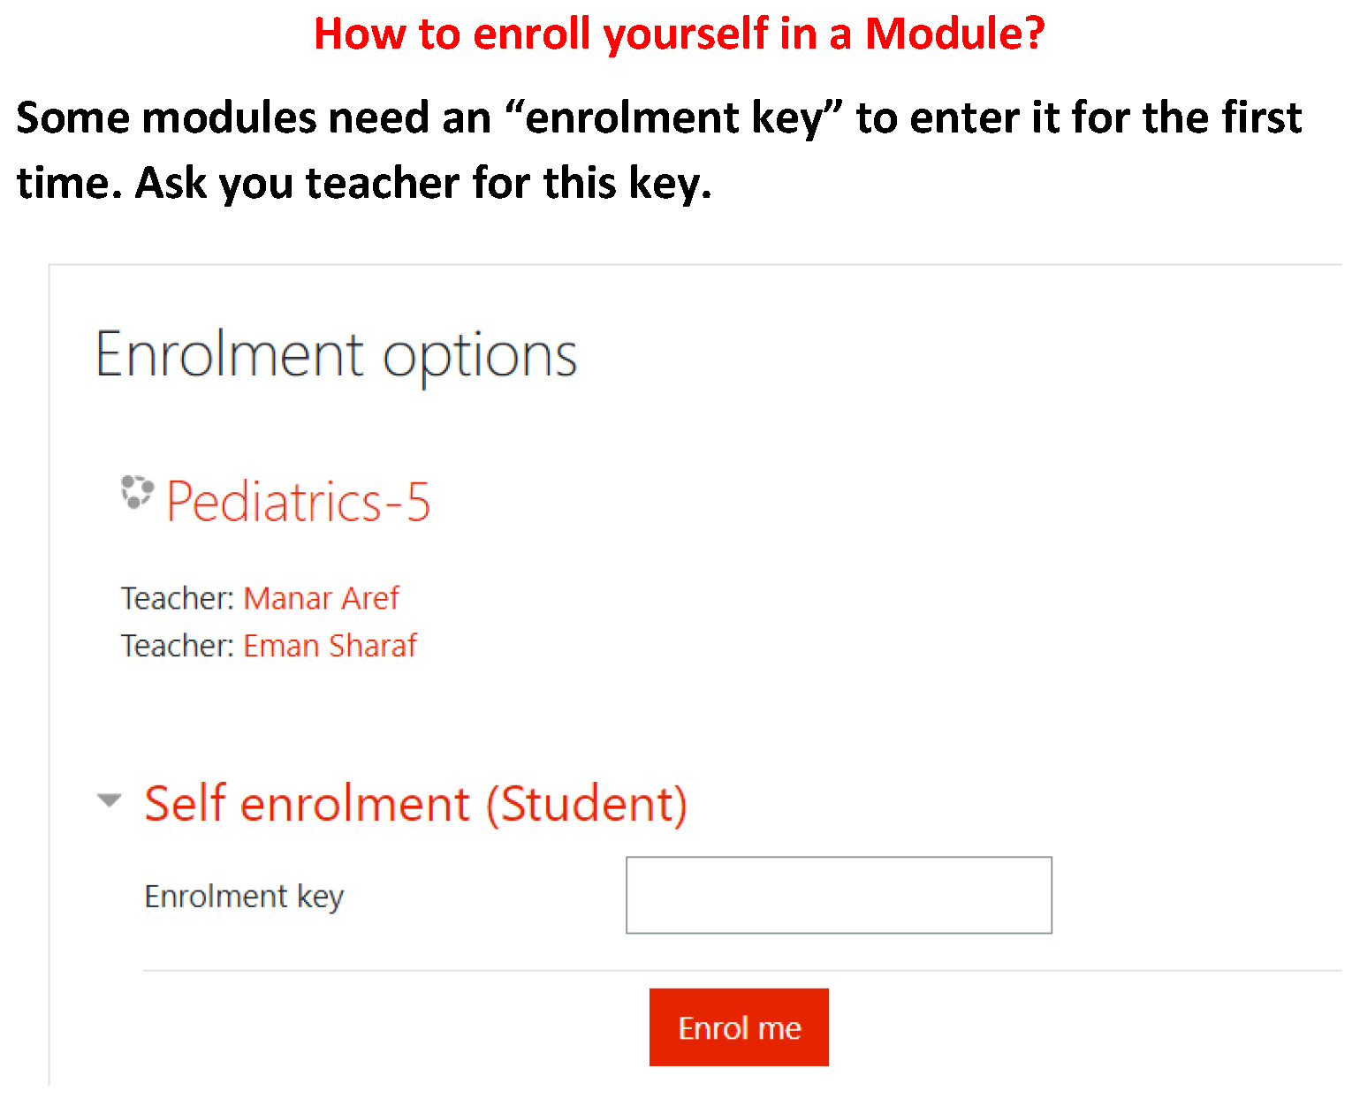
The students portfolio (October 6 university - faculty of medicine - 2024 - 2025):
- Portfolio will be formed and submitted electronically
- The student binder for the portfolio should contain the followings:
- Binder should contain the names of the group of the students, and contact information ( telephone , - emails ) , their leader and names and emails of their tutor (s),
- Students should form the tasks needed and collect the presentations the group will do along the sessions of the cases and put them in the binder of the portfolio, with the cases , CV and the needed assignments , prochures , or links for the channels as will be announced

-Students should attend the clinical discussion case that will be held with the members of the departments sharing in the module

- Any community medical work the student completed under supervision of a staff presenting the followings:
- Name of staff & position
- Date
- Site
- Results
- ObstacleS
- Conferences attended by him if present
- Visits done to clinical departments to see relevant experiments if present.
- PORTFOLIO SHOULD BE SUBMITTED IN FULL BY FIRST WEEK OF MAY.
- Portfolio scoring (Rubrics for evaluating portfolios):
- Each student should be rated as one of the followings :
- Out standing & he will be given 95% to 100% of the portfolio mark
- Acceptable & he will be given 70% to 75% of the portfolio mark
- Marginal & he will be given 60% to 65% of the portfolio mark
- Unacceptable & he will be given less than 60% of the portfolio mark
Professional Behavior of student in the case checklist
Students Name: ....................................
Date: ...................................................... End of module (Summative): ...........................
Module title: .....................................................................
Student’s Signature :............................ Tutor’s Name:.....................................................

Criteria | Scale: | Comments
Criteria | 1 and 2 is unsatisfactory,  3, 4 and 5 is satisfactory performance | Comments
Preparation:  Is well prepared with relevant information, uses a variety of references and summarizes key points | 1 2 3 4 5
Critical thinking:  Identifies problem, analyzes problem, suggests possible reasons for the problem, helps group to formulate learning objectives | 1 2 3 4 5
Participation:  Participates actively, talks on turn and listens attentively to others | 1 2 3 4 5
Communication Skill & Group Skills:  Respects tutor and colleagues, communicates well uses appropriate language, accepts feedback and responds appropriately.  Contributes to group learning, shares information with others, demonstrates sensitivity to views and feeling of others, takes on assigned tasks willingly | 1 2 3 4 5
Presentation skills:  Presents the information relevant to the learning objectivse of the case, explains clearly the reasoning process with regard to solving the problem | 1 2 3 4 5
 | SATISFACTORY | UNSATISFACTORY

-The students portfolio (October 6 university - faculty of medicine - 2024 - 2025):
- Portfolio will be formed and submitted electronically
- The student binder for the portfolio should contain the followings:
- Binder should contain the names of the group of the students, and contact information ( telephone , - emails ) , their leader and names and emails of their tutor (s),
- Students should form the tasks needed and collect the presentations the group will do along the sessions of the cases and put them in the binder of the portfolio, with the cases , CV and the needed assignments , prochures , or links for the channels as will be announced

-Students should attend the clinical discussion case that will be held with the members of the departments sharing in the module

- Any community medical work the student completed under supervision of a staff presenting the followings:
- Name of staff & position
- Date
- Site
- Results
- ObstacleS
- Conferences attended by him if present
- Visits done to clinical departments to see relevant experiments if present.
- PORTFOLIO SHOULD BE SUBMITTED IN FULL BY FIRST WEEK OF MAY.
- Portfolio scoring (Rubrics for evaluating portfolios):
- Each student should be rated as one of the followings :
- Out standing & he will be given 95% to 100% of the portfolio mark
- Acceptable & he will be given 70% to 75% of the portfolio mark
- Marginal & he will be given 60% to 65% of the portfolio mark
- Unacceptable & he will be given less than 60% of the portfolio mark

OSCE | OSPE | End module | Continuous assessment (portfolio ) | Mid module | SECOND YEAR
 | 23 marks total  -slides electronic and practical | 30 marks total  25 MCQ  5 SAQs electronic | 7 marks total | 15 marks electronic | RSS 75
 | 38 marks total  -slides electronic and practical | 50 marks total  40 MCQ  10 SAQs electronic | 12 marks total | 25 marks electronic | CVS 125
 | 45 marks total  -slides electronic and practical | 60 marks total  50 MCQ  10 SAQs electronic | 10 marks total  1.5 attendance sections  1.5 attendance cases  4 presentation  3 portfolio | 35 marks electronic | GIS 150
 | 23 marks total  -slides electronic and practical | 30 marks total  25 MCQ  5 SAQs electronic | 7 marks total | 15 marks electronic | URS 75

Tasks for the portfolio and blue print :
Tasks of portfolio (RSS)
Anatomy department
Students will divided into groups (10-15 students in each) and prepare videos, photos and cross- sectional figures about anatomy of different parts of respiratory system.

Histology department
Draw a labelled diagram for a lung alveolus

Physiology department
Photograph the respirometer apparatus and mention how the vital capacity and the timed vital capacity are formed.

Module RSS Blueprint

MCQ and SAQ
Topic | Type | Hours  (30) | % | Mid MCQ  (15) | Final MCQs  (20) | Final SAC  (10) | Total marks  (45)
1-Anatomy of the respiratory system | L | 6 | 20% | 3 | 3 | 3 | 9
2- Histology of the respiratory system | L | 6 | 20% | 3 | 3 | 3 | 9
3-The Lung functions& Respiratory pressures (Physiology) | L | 2 | 6.7% | 1 | 2 |  | 3
4-Surfactant and dead space (Physiology) | L | 2 | 6.7% | 1 | 2 |  | 3
5-Compliance& work of breathing (Physiology) | L | 2 | 6.7% | 1 | 2 |  | 3
6-Gas transport (O2& CO2) (Physiology) | L | 4 | 13.3% | 2 | 2 | 2 | 6
7-Control of respiration (Physiology) | L | 4 | 13.3% | 2 | 2 | 2 | 6
8-Regulation of respiration (2) (Physiology) | L | 2 | 6.7% | 1 | 2 |  | 3
9- Hypoxia& cyanosis Effect of increased barometric pressure  (Physiology) | L | 2 | 6.7% | 1 | 2 |  | 3
Total |  |  | 100% | 15 | 20 | 10 | 45

Module work & practical

Subject | Module work (7 marks) | Practical (23 marks)
Physiology |  | 10 Electronic | 3 OSPE
Anatomy |  | 3 Electronic | 2 OSPE
Histology |  | 3 Electronic | 2 OSPE

Module CVS

Tasks for portfolio of Physiology:
1-Attend ECG , Echo Doppler &write what you have seen.

Tasks for portfolio of Anatomy:

.Devide the students into 3 groupes:

.Group one:making transverse sections for the body.

.Group two:making anatomical pictures files.

.Group three:making videos.

Tasks for portfolio of Histology:

Draw a labelled diagram for a blood capillary.

Module CVS Blueprint

MCQ and SAQ
Topic | Type | Hours(48) | % | Mid MCQ  (25) | Final MCQs  (40) | Final SAC  (10) | Total marks  (75)
Physiology | L |  | 50% | 13 | 20 | 4
Cardiac properties | L | 2 | 4
Cardiac cycle | L | 4 | 9
Cardiac output&reserve | L | 2 | 4
Physiology of vascular system &blood flow | L | 4 | 9
Arterioles | L | 2 | 4
Blood pressure | L | 2 | 4
Coronary circulation | L | 2 | 4
Venous return | L | 2 | 4
Shock | L | 2 | 4
Capillary microcirculation&Oedema | L | 2 | 4
Anatomy | L |  | 30% | 7 | 12 | 3
Pericardium | L | 2 | 4
Heart | L | 4 | 8
Arteriesin mediastinum | L | 4 | 8
Veins in mediastinum | L | 2 | 4
Embriological preview of the heart | L | 2 | 4
Embriological preview of blood vessels | L | 2 | 4
Histology | L |  | 12% | 3 | 5 | 2
Cardic muscle differences from the heart | L | 2 | 4
Histology of blood vessels | L | 2 | 4
Histology of A-V Junctions | L | 2 | 4
Biochemistry | L |  | 8% | 2 | 3 | 1
Cardiac Enzymes | L | 4 | 8
 | L
TOTAL
Total |  |  | 100% | 25 | 40 | 10 | 75

Module work & practical

Subject | Module work (12 marks) | Practical (38marks)
Physiology |  | 16Electronic | 3 OSPE
Anatomy |  | 10Electronic | 3OSPE
Histology |  | 4Electronic | 2OSPE

Module GIS

Tasks for portfolio of Physiology:
Mention the laboraty tests done to diagnose jaundice and mention its types and causes and treatment

Anatomy
مهام البورتفوليو
URS
تحديد مستوى الحصوة وذلك عن طريق صور الاشعات في سكترا ويتم الامضاء في نفس الجلسة(ارجو من الهيئة المعاونة تجهيز عدد مناسب ومراعاة ان URS اصلا اسبوعان فقط)

CVS - GIS - RSS

يتم تقسيم الطلبة مجموعات من ١٠-١٥ طالب ويتم عمل المشروعات متزامنة ويتم تسليمها في الاسبوع السادس بعد انتهاء أول مقرر ويتم الامضاء على ال ٣ تكليفات معا بامضاء في كل بورتفوليو وتكلف المجموعات كما يلي

مجموعات ١-X
CVS صور
GIS مجسمات قطاعات عرضية
RSS فيديوهات

مجموعات Y-X
GIS صور
RSS مجسمات قطاعات عرضية
CVS فيديوهات

مجموعات Y-النهاية
RSS صور
CVS مجسمات قطاعات عرضية
GIS فيديوهات

بناء على التفاصيل التالية

الصور... تقوم كل مجموعة بعمل فايل باور بوينت به ٥٠ صورة حول موضوع معين من مصادر دقيقة على ان تكون كل صورة نسختان (نسخة عليها علامات تعريف وأخرى مفرغة منها) وتتنوع الصور بين
cadavers, atlas, radiology, transverse sections

نماذج مجسمة لقطاعات عرضية (مع توحيد الماتيريال والمقاس والألوان)

الفيديوهات... تقوم كل مجموعة بعمل ٢ فيديو من ١-٢ دقيقة يحمل معلومة طبية متعلقة بتشريح المنطقة ويتم رفعها على قناة خاص
Histology
Mention the structure of the wall of the gall bladder and causes of gall bladder stones

Physiology task module URS

Attend two hemodialysis sessions and write what you have seen

Module URS Blueprint

MCQ and SAQ
Topic | Type | Hours | % | Mid MCQ | Final MCQs | Final SAC | Total marks
Anatomy of the kidney, ureter and urinary bladder | L | 6 | 20% | 3 | 3 | 3 | 9
Histology of the kidney, ureter and urinary bladder | L | 6 | 20% | 3 | 3 | 3 | 9
Physiologic structure of the nephron of the kidney, types of nephrons, formation of urine and renal blood and plasma flow | L | 2 | 5% | 1 | 1 | - | 2
Glomerular filtration rate and reabsorption of sodium, potassium and glucose and diuretics | L | 4 | 15% | 1 | 4 | 2 | 7
Function of the different tubular segments and reabsorption of water and concentration of urine | L | 2 | 10% | 2 | 3 | - | 5
Renal handling of glucose and sodium | L | 4 | 15% | 1 | 4 | 2 | 7
Mechanism of urine concentration | L | 2 | 5% | 1 | 1 | - | 2
Counter current mechanism | L | 2 | 5% | 1 | 1 | - | 2
Acid base balance | L | 2 | 5% | 1 | 1 | - | 2
Total |  | 30 | 100% | 15 | 20 | 10 | 45

Module work & practical

Subject | Module work (7 marks) | Practical (23 marks)
Physiology |  | 10 Electronic | 3 OSPE
Anatomy |  | 3 Electronic | 2 OSPE
Histology | Drawing juxta glomerular app | 3 Electronic | 2 OSPE

Task URS
Histology:
Draw juxtaglomerular apparatus?

Cases
(Second year first term 2024-2025)
RSS module
Case 1: pneumothorax
A 30-year-old male was involved in a motor vehicle accident and presented with severe chest pain and difficulty breathing. He had visible bruising on the right side of his chest and crepitus on palpation. On making examinations, breath sounds were decreased on the right sounds, also tenderness on palpation the thoracic cage. His Vital signs showed tachycardia and hypotension.
Chest X-ray revealed a linear shadow of visceral pleura with lack of lung markings peripheral to the shadow, indicating collapsed lung and associated rib fractures. The patient was unstable, Immediate needle decompression was performed in the second intercostal space at the midclavicular line. A chest tube was then placed to facilitate continuous drainage of air from the pleural space. He was stabilized and monitored in the ICU for further management of his trauma.
Objectives
- Define pneumothorax and mention its effects (physiology)
- Discuss layers and recesses of the pleura (Anatomy )
- Discuss histology of the pleura (Histology)

Foreign body inhalation
A 2-year-old boy was presented to the emergency department with a sudden-onset of cough and difficult breathing. The child’s mother reported that he was eating peanuts shortly before he suddenly started coughing uncontrollably and gagging. He was unable to speak and became increasingly distressed. On examination, the child was in distress, with stridor and decreased air entry on the right side of the chest. He was noted to have suprasternal and subcostal retractions. He had no nasal congestion, rhinorrhea, or previous history of difficulty breathing. Also, his vital signs were as follows: temperature, 38.4°C; respiratory rate, 45 breaths per minute; pulse, 140 beats per minute; blood pressure, 90/64 mm Hg; and oxygen saturation, 100% on a nonrebreather mask. Chest radiography was made, the results showed hyperinflation of the right lung. Otolaryngology was consulted, and the boy underwent emergent rigid bronchoscopy for possible FBA, during which a piece of peanuts was removed from the right main bronchus. His postoperative course was uncomplicated, and he was discharged home the following day.
Objectives
- Mention examples of foreign bodies can be inhaled and their effects on respiration (Physiology).
- Compare between the two bronchi , where the foreign body is commonly lodged and why? (Anatomy)
- Mention epithelium lining different parts of the bronchial tree (Histology)

Tutor guide

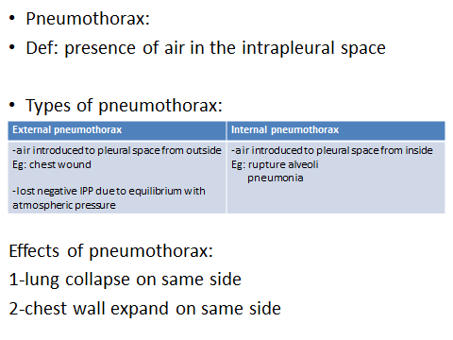
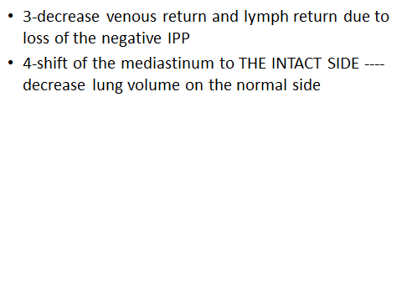

- SURFACTANT
- Surface active agent when spread over fluid lining alveoli it decrease its surface tension ---help lung expansion
- Chemical nature of surfactant:
- Ca++, phospholipid , proteins
- Secreted by type II alveolar epithelial cells

- Function of surfactant:
- 1-facilitate lung expansion ---
- *form surfactant –air interface ---it has less surface tension 10 times than fluid air interface-----facilitates lung distension-----decrease effort to expand lungs
- *the apoprotein and Ca++ help easy spread of lecithin over the surface of fluid lining alveoli to function and decrease surface tension effectively
- 2-prevent alveolar collapse:
- The surfactant reduces the surface tension of fluid lining alveoli---prevent collapse of alveoli during expiration
- Decrease surfactant occurs in:
- 1-RDS (Respiratory distress syndrome).
- -condition occur in premature infants
- -the type II alveolar cells which form the surfactant are still immature and can not form it sufficiently
- -there is deficient surfactant
- -increase surface tension of fluid lining alveoli
- -decrease lung compliance
- -baby suffers from *difficult to start breath
- *rapid breath
- *hypoxia
- -diagnosis ---Ratio between Lecithin and Shingomyelin in amniotic fluid is less than ONE (normally it is 2 at 35 week gestation due to increased cortisol which reach high level in fetus near end of term)
- 2Hypoxia:
- Def: O2 defeciency at the tissue level.
- Anoxia:
- Def: complete absence of O2
- Types of Hypoxia:
- 1-Hypoxic hypoxia
- 2-Anemic hypoxia
- 3-Stagnant hypoxia
4-Histotoxic hypoxia
- Hypoxic hypoxia:
- *most common type
- *Causes
- 1-decrease PO2-----high altitudes
- mines
- 2-depress respiratory centers
- morphine intake
- anaesthesia
- 3-O.L.D.---------- bronchial asthma
- emphysema
- 4-R.L.D.-----tumor, pneumothorax,
paralysed muscles of chest
- 5-increase thickness of respiratory membrane
- (Fibrosis)—this impairs the diffusion of O2
- 6-area in lung has poor ventilation as in emphysema----blood entering it remains venous---go to tissues with low O2
- 7-A.S.D.(atrial septal defect)
- Shunt of the venous blood to the arterial blood

- *Acute hypoxia (PO2 between 25-40mmHg)—person feel –Drowsy
- _Poor mental judge
- _Euphoria
- _Headache, nausea, vomiting
- *Chronic hypoxia(PO2between 40-60mmHg)—as persons living on top of mountains---they will feel
- -Fatigue
- -Dyspnea
- -Drowsy
- -headache, nausea
- 2-anemic hypoxia:
- It may be either
- Quantitative Qualitative
- Decrease Hb (anemia) Abnormal Hb
1-anemic hypoxia:
- Why person with anemia does not have severe hypoxia AT REST but has severe hypoxia AT EXERCISE
- Qualitative:
- 1-Carbon monoxide:
- *CO -----gas formed by incomplete combustion of carbon
- *it is toxic due to
- -the CO combine with Hb in the same sites for O2-to form ----carboxyHb
- -the affinity of Hb to combine with CO is 210 times as its affinity to combine with O2
- Signs:
- *cherry red color
- *increase CO
- *headache, nausea, vomiting
- *NO INCREASE IN VENTILATION
- PO2 is normal
- no stimulation of peripheral chemoreceptors

- Met Hb:
- ferrous of Hb
- oxidation by nitrate drugs
Ferric (can not carry O2)
Signs:
Grey ,blue skin
- 3-stagnant hypoxia:
- It is caused by
- *slow circulation
- *in adequate blood flow
- So tissues take O2 from same amount of blood many times-----decrease O2 in it----hypoxia
Histotoxic hypoxia:
N.B.----for the cells to be able to utilize oxygen in the blood there should exist enzyme-----CYTOCHROME OXIDASE -----if it is decreased OR absent the tissue cells can not utilize the oxygen in the blood
Causes of histotoxic hypoxia:
1-cyanide poisoning:
The cyanide -----inhibit the cytochrome oxidase enzyme--------------cells can not use oxygen.
2-Methyl alcohol ,Narcotics:
The cytochrome oxidase enzyme is released inactive then activated by dehydrogenase enzyme
Methyl , &narcotics inhibit –dehydrogenase enzyme
- Treatement of cyanide poisoning:
- Methylene blue OR Nitrates
- form methaemoglobin
- the methaemoglobin react with cyanide
- form non toxic compund (cyan met haemoglobin

- *Anemic hypoxia
*Stagnant hypoxia
*hypoxic hypoxia due to A-V shunt
- There will be ONLY increase in the O2 in physical solution
- 3
CVS module
A71 years old man present to emergency room with severe midsternal chest pain . He appears anxious and in distress HR=66/min ,BP 92/68 mmHg ,RR= 14 breath per minute,There is marked jagular venous distention , On auscultation an S4 galloop is audible and lung field are clear EVG shows 2 mm ST elevation in leads II,II,AVF

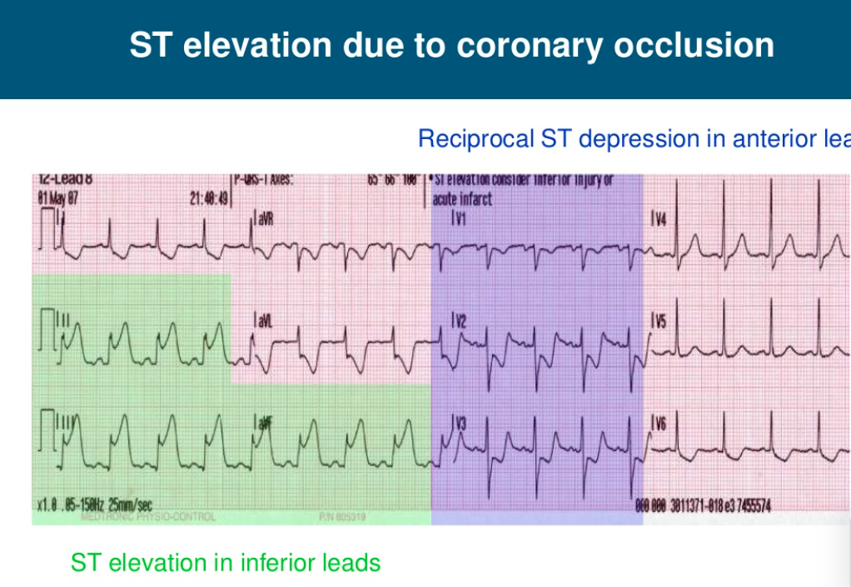

What is your diagnosis ?

Objectives :
- Acute coronary syndrome management
- ECG finding in Acute coronary syndrome
- Histology of the cardiac muscle and its blood supply
- How to prevent coronary artery diseases

Tutor guide

Arterial Blood Supply of the Heart:
- The heart is supplied by the right and left coronary arteries:
(I) The Right Coronary Artery:
Origin and Course:
- It arises from the anterior aortic sinus of the ascending aorta.
- Then, it runs inferiorly in the anterior part of the coronary groove down to the inferior border of the heart.
- It turns to the left in the posterior part of the coronary groove where it ends by anastomosing with the circumflex branch of the Lt. coronary A.
Branches and Distribution:
1. SA nodal A.: Supplies the SA node in 65% of people.
2. Right conus A.: From the beginning of the Rt. coronary A. It supplies the infundibulum of Rt. ventricle.
3. Right marginal A.: Runs along the lower border of the heart towards the apex. It supplies the Rt. ventricle.
4. Direct atrial and ventricular branches to the Rt. atrium, Rt. Ventricle.
5.The posterior interventricular A.: descends in the corresponding groove towards the apex. It supplies:
- A.V node in 80% of people.
- Posterior parts of both ventricles.
- Posterior 1/3 of the interventricular septum.

(II) The Left Coronary Artery:
Origin and Course:
- It arises from the left posterior aortic sinus of the ascending aorta.
- It runs to the left between the pulmonary trunk and the left auricle, on reaching the coronary groove, it divides into two main branches; the circumflex and the anterior interventricular arteries
(1) The circumflex A.:
- It is the continuation of the Lt. coronary A.
- It winds around the left border of the heart and runs in the posterior part of the coronary groove where it ends by anastomosing with the right coronary artery.
Branches
1.S-A nodal artery, from its beginning, supplies S-A node in 35% of people.
2.Left marginal A follows the left border of the heart to supply the left ventricle.
3.A-V nodal artery from its termination, supplies A-V node in 20% of people.
4.Direct arterial and ventricular branches to the left atrium and left ventricle.
(2). The anterior interventricular A.:
- It descends in the anterior interventricular groove down to the apex of the heart and anastomoses with the posterior interventricular branch of the right coronary artery
Branches
1. Left conus artery, supplies the infundibulm and adjacent part of the Rt. ventricle and anastomoses with the right conus artery.
2. Anterior parts of the both ventricles.
3. Anterior 2/3 of the interventricular septum.

➢ Clinical Anatomy:
1. Gradual incomplete occlusion of the coronary A. leads to angina pectoris manifested clinically as pain (of effort).
2. Sudden occlusion of the larger branches of either coronary A. by a thrombosis leads to necrosis of the cardiac muscle (myocardial infarction).
3. In gradual occlusion, there is a time for healthy anastomoses to open up, in sudden occlusion, there is not. The coronaries are considered end arteries.
4. Cardiac pain is carried by afferent nerve fibers which enter the spinal cord via the posterior roots of the upper 4 or 5 thoracic nerves. Cardiac pain is referred to the skin areas supplied by these nerves: over the middle of the sternum and the medial side of the arm and forearm.

Objective :The ECG findings of an acute anterior myocardial infarction wall include:
- ST segment elevation
- Reciprocal ST segment depression in the leads (II, III and aVF).
ST-segment elevation myocardial infarction (STEMI) is the term cardiologists use to describe a classic heart attack. It is one type of myocardial infarction in which a part of the heart muscle (myocardium) has died due to the obstruction of blood supply to the area.
the ST segment refers to the flat section of an electrocardiogram (ECG), in particular, the flat section that connects two distinct complexes on the tracing (the QRS complex and the T wave). When a person has the most severe type of heart attack, this segment will no longer be flat but will appear abnormally elevated.

Types and Severity
STEMI is one of three types of acute coronary syndrome (ACS). ACS occurs when a plaque ruptures from within a coronary artery, causing the partial or complete obstruction of that artery. The obstruction itself is caused when blood clots form around the area of the rupture.
When obstructed, the portion of the heart muscle serviced by that artery will quickly suffer from a lack of oxygen, called ischemia. Chest pains (angina) are often the first signs of this. If the obstruction is extensive enough, some of the heart muscle will begin to die, resulting in myocardial infarction.
ACS is categorized by the level of obstruction and the resulting damage to the heart muscle:
- ST-segment elevation myocardial infarction (STEMI): If the complete obstruction of a coronary artery occurs, resulting in the death of heart muscle tissue, we refer to that as STEMI, the worst form of ACS.¹﻿
- Unstable angina: In some cases, the clots will form, dissolve, and re-form during a period of hours or days without causing a fixed obstruction. When this happens, the person may experience on-again-off-again angina even when resting. This type of ACS is called unstable angina.
- Non-ST-segment elevation myocardial infarction (NSTEMI): This occurs when the obstruction doesn't completely stop the blood flow. While some cell death will occur, other parts of the muscle will survive. It may be called a "partial heart attack."

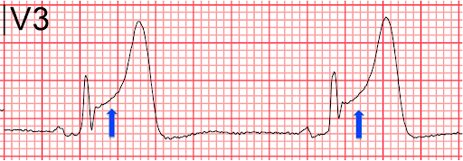

Cardiac histology
Unlike skeletal muscle cells, cardiomyocytes are usually mono-nucleated; although there are some instances where di- or multinucleated cells have been encountered. The nuclei are also centrally located within the cylindrical cell. The cytoplasm of the cardiomyocyte (sarcoplasm) contains a large number of mitochondria to meet the high metabolic demand of the cells.

There are repeating units of contractile fibres known as sarcomeres. Each sarcomere is made up of thin and thick myofilaments known as actin and myosin, respectively. Bundles of myofilaments (myofibrils) extend across the length of the cell. The myofilaments are bordered on either side by dense Z lines that can be observed intersecting light areas of the cell known as I bands. As a result of the regularly repeating contractile units (sarcomeres), cardiac tissue has a distinct striated appearance (due to alternating I bands and dark regions known as A bands) on light microscopy, much like skeletal muscle tissue.
Each cardiomyocyte is attached to its neighbouring cell via intercalated disks. These are densely stained ends of the cell that are heavily populated by desmosomes, gap junctions and fascia adherens. Gap junctions permit rapid transmission of action potentials from one cell to the other. They extend across the membranes of juxtaposed cells, creating direct pathways for ions to flow. This allows all the cells of the heart to contract in synchrony. The desmosomes and fascia adherens are anchoring proteins that hold the myofibrils and the cardiomyocyte’s cytoskeleton in place.

Specialized cardiomyocytes
The rhythmic contraction of the heart is completely independent of conscious effort. The specialized cardiomyocytes that facilitate this feature are the sinuatrial node, atrioventricular node and the Purkinje fibres. Unlike average cardiomyocytes, these cells have inherently leaky ion channels that result in easier depolarization. Furthermore, there are fewer myofibrils in the heart conductive tissue than there is in the contractile tissue. Consequently, there is less resistance in these cells, making it easier for an action potential to flow through them. The reduction in resistance is further compounded by the fact that these cells are somewhat wider than their contractile counterparts, allowing for free flow of the stimulus.

Management of acute coronary syndrome :

Diagnosis
If you have signs or symptoms associated with acute coronary syndrome, an emergency room doctor will likely order several tests. Some tests may be done while your doctor is asking you questions about your symptoms or medical history. Tests include:
- Electrocardiogram (ECG). Electrodes attached to your skin measure the electrical activity in your heart. Abnormal or irregular impulses can mean your heart is not working properly due to a lack of oxygen. Certain patterns in electrical signals may show the general location of a blockage. The test may be repeated several times.
- Blood tests. Certain enzymes may be detected in the blood if cell death has resulted in damage to heart tissue. A positive result indicates a heart attack.
The information from these two tests — as well as your signs and symptoms — is used to make a primary diagnosis of acute coronary syndrome. Your doctor can use the information to determine whether your condition can be classified as a heart attack or unstable angina.
Other tests may be done to learn more about your condition, rule out other causes of symptoms, or to help your doctor personalize your diagnosis and treatment.
- Coronary angiogram. This procedure uses X-ray imaging to see your heart's blood vessels. A long, tiny tube (catheter) is threaded through an artery, usually in your arm or groin, to the arteries in your heart. A dye flows through the tube into your arteries. A series of X-rays show how the dye moves through your arteries, revealing any blockages or narrowing. The catheter may also be used for treatments.
- Echocardiogram. An echocardiogram uses sound waves, directed at your heart from a wand-like device, to produce a live image of your heart. An echocardiogram can help determine whether the heart is pumping correctly.
- Myocardial perfusion imaging. This test shows how well blood flows through your heart muscle. A tiny, safe amount of radioactive substance is injected into your blood. A specialized camera takes images of the substance's path through your heart. They show your doctor whether enough blood is flowing through heart muscles and where blood flow is reduced.
- Computerized tomography (CT) angiogram. A CT angiogram uses a specialized X-ray technology that can produce multiple images — cross-sectional 2-D slices — of your heart. These images can detect narrowed or blocked coronary arteries.
- Stress test. A stress test reveals how well your heart works when you exercise. In some cases, you may receive a medication to increase your heart rate rather than exercising. This test is done only when there are no signs of acute coronary syndrome or another life-threatening heart condition when you are at rest. During the stress test, an ECG, echocardiogram or myocardial perfusion imaging may be used to see how well your heart works.

Treatment
The immediate goals of treatment for acute coronary syndrome are:
- Relieve pain and distress
- Improve blood flow
- Restore heart function as quickly and as best as possible
Long-term treatment goals are to improve overall heart function, manage risk factors and lower the risk of a heart attack. A combination of drugs and surgical procedures may be used to meet these goals.

Medications
Depending on your diagnosis, medications for emergency or ongoing care (or both) may include the following:
- Thrombolytics (clot busters) help dissolve a blood clot that's blocking an artery.
- Nitroglycerin improves blood flow by temporarily widening blood vessels.
- Antiplatelet drugs help prevent blood clots from forming and include aspirin, clopidogrel (Plavix), prasugrel (Effient) and others.
- Beta blockers help relax your heart muscle and slow your heart rate. They decrease the demand on your heart and lower blood pressure. Examples include metoprolol (Lopressor, Toprol-XL) and nadolol (Corgard).
- Angiotensin-converting enzyme (ACE) inhibitors widen blood vessels and improve blood flow, allowing the heart to work better. They include lisinopril (Prinivil, Zestril), benazepril (Lotensin) and others.
- Angiotensin receptor blockers (ARBs) help control blood pressure and include irbesartan (Avapro), losartan (Cozaar) and several others.
- Statins lower the amount of cholesterol moving in the blood and may stabilize plaque deposits, making them less likely to rupture. Statins include atorvastatin (Lipitor), simvastatin (Zocor, Flolipid) and several others.

Surgery and other procedures
Your doctor may recommend one of these procedures to restore blood flow to your heart muscles:
- Angioplasty and stenting. In this procedure, your doctor inserts a long, tiny tube (catheter) into the blocked or narrowed part of your artery. A wire with a deflated balloon is passed through the catheter to the narrowed area. The balloon is then inflated, opening the artery by compressing the plaque deposits against your artery walls. A mesh tube (stent) is usually left in the artery to help keep the artery open.
- Coronary bypass surgery. With this procedure, a surgeon takes a piece of blood vessel (graft) from another part of your body and creates a new route for blood that goes around (bypasses) a blocked coronary artery.

How to prevent coronary diseases
There are several ways you can reduce your risk of developing coronary heart disease (CHD), such as lowering your blood pressure and cholesterol levels.
- Eat a healthy, balanced diet. ...
- Be more physically active. ...
- Keep to a healthy weight. ...
- Give up smoking. ...
- Reduce your alcohol consumption. ...
- Keep your blood pressure under control.

GIS module
Case (1 ):
Dr. Ali begins his morning list in the endoscopy suite with Mrs. Mariam, a 50-year-old lady. Noticing her anxiety, he reassures her before inserting the endoscope. As she swallows, he advances it through the oesophagus into the stomach, aspirates secretions, examines the lining, takes a biopsy, and proceeds to the duodenum. He then informs her that the sample will be sent to pathology for analysis.
Intended learning outcomes (objectives )

Q) How could dr. Ali ensure he enters the stomach?
A) The distance from the incisors to the cardiac sphincter (gastroesophageal junction) is approximately 45 cm. Additionally, anatomical landmarks and gastric rugae confirm entry into the stomach.
Q) Does the endoscope slide in equally easily through both the cardiac and pyloric sphincters? Why?
A) No. The endoscope passes easily through the cardiac sphincter as it is a physiological sphincter with low resistance. However, it is more difficult to pass through the pyloric sphincter, as it is a well-developed muscular sphincter.
Q) If the specimen examination results revealed cancer, which lymph nodes should be examined?
A) The gastric and coeliac lymph nodes, as they are the primary drainage sites for the stomach and are commonly involved in gastric cancer spread.
Q) How could dr Ali ensure the region of the stomach:
A) Describe the histological structure of the fundus and pylorus of the stomach and duodenum
- Outline the mechanism of swallowing and oesophageal motility
- Discuss the gastric movements, stomach emptying and their regulation
- List and define the functions of the various gastric secretions and gastric enzymes

Case (2)
A 45 year old male presents with sudden, severe abdominal pain and tenderness. He has a history of epigastric pain, referred to his left shoulder, worsening at night and relieved by antacids, along with NSAID use for back pain. An X-ray reveals free air under the diaphragm, anterior to the stomach, indicating a perforated peptic ulcer. Emergency surgery confirms and repairs the perforation.

Intended learning outcomes (objectives )
Q) What are the nerves transmitting the sensations in this condition?
A) Visceral sensation from the stomach is carried by the vagus nerve. The pain from a perforated peptic ulcer is transmitted primarily by the phrenic nerve due to peritoneal irritation (hence the referred pain to the left shoulder).

Q) Which anatomical structures are at risk of injury during surgical repair of this case?
A) In an anterior perforated peptic ulcer, the main structures at risk include Liver (left lobe), peritoneum and greater omentum (greater omentum may be adherent to the injury), abdominal wall muscles, vessels and nerves and diaphragm (if near the fundus)
Q) How does the diaphragm play a role in the clinical presentation of this patient?
A) Air under the diaphragm (visible on an upright X-ray) is a key diagnostic sign of perforation. Irritation of the diaphragm's peritoneal surface leads to referred pain to the shoulder via the phrenic nerve (C3-C5). The air tends to collect below the right copula of diaphragm due to its higher level.
Q) Which cell type is responsible of Hcl secretion?
A) Parietal cells

Case (3)
A 45-year-old male with a history of liver cirrhosis presents with bright red blood per rectum for one day. Examination reveals ascites and abdominal tenderness. Rectal exam shows bright red blood without palpable masses. Laboratory tests indicate elevated liver enzymes and hyperbilirubinemia (3 mg/dL). CT scan confirms liver cirrhosis, splenomegaly, and signs of portal hypertension. Colonoscopy identifies bleeding rectal varices, confirming portal hypertension as the underlying cause

Intended learning outcomes (objectives )
Q) Describe anatomical basis of venous drainage of the rectum and anal canal affecting this case?
A) The rectum and anal canal have dual venous drainage:
- Superior rectal vein → Inferior mesenteric vein (Portal)
- Middle & inferior rectal veins → Internal iliac vein (Systemic).
In portal hypertension, blood flow is redirected through the middle & inferior rectal veins, leading to rectal varices and bleeding.
Q) What are the other sites of portosystemic anastomosis to be examined?
A) Other key sites of portosystemic anastomosis include lower esophagus between Left gastric vein & Azygos vein (Esophageal varices) and around the umbilicus between Paraumbilical veins & Epigastric veins (Caput medusa)
Q) What is the normal size of the spleen? How is it affected by portal hypertension?
A) Normal spleen length is 12 cm. The portal hypertension causes Congestive splenomegaly due to increased splenic vein pressure, leading to splenomegaly
Q) What are the layers of the rectum and the site of the venous plexus
A) Describe the histological structure of the rectum and recto anal junction

Case (4)
A 45-year-old female presents with severe right upper quadrant pain radiating to the back, nausea, and vomiting, triggered by a fatty meal. Examination reveals jaundice. Laboratory tests show elevated bilirubin and pancreatic enzymes. Ultrasound confirms a large gallstone in the bile pathway. The patient undergoes ERCP with stone extraction, followed by cholecystectomy

Intended learning outcomes
Q) Does elevated pancreatic enzymes add to the site detection of the stone?
A) Yes. Elevated pancreatic enzymes suggest biliary obstruction near the ampulla of Vater, where the common bile duct and pancreatic duct converge, leading to impaired drainage of both bile and pancreatic secretions.

Q) What are the main anatomical considerations during surgical removal of the gallbladder
A) The liver as the gallbladder is directly related to its inferior surface
The cystic Artery which should be ligated before gall bladder removal
Patency and integrity of hepatic and common bile duct to allow the flow of the bile to the duodenum
Other nearby structures e.g. duodenum and colon must be protected during dissection.
Q) What is the lining epithelium of the different parts of the biliary tree?
A) Mention the histological structure of the biliary tree

Cases for the module URS

Cases for the module URS 203

Case 1: A Neighbor’s concern about his reports
Akmal is a second-year student at October 6 university. One afternoon, one of his neighbors visited him asking his opinion about his urine analysis report and Ultrasonogram. Actually as the appointment of Mr Akmal with his doctor was 3 days later, he was worried about his reports. Thinking that as Hisham is a medical student, he might help him to assure, that the report findings were not serious. The urine analysis showed presence of protein of 3 plus (increased) and albumin was also detected. The
ultrasound showed normal kidneys, ureters and urinary bladder.
Hisham had studied the normal urine analysis in the college and knows that serum proteins as albumin are normally not filtered from the blood to the urine.
- Objectives :
- Describe the macroscopic & microscopic structure of Kidney, Ureter and Urinary bladder. (Anatomy & Histology).

- Explain dynamics of glomerular filtration and clearance
(physiology).

October 6 university team at a Seminar
6 students of M2 and two professors were selected from faculty of medicine –october 6 university to attend an international seminar on acid base balance. There were many lectures said by reputed speakers from many countries all over the world. In the afternoon session of the 2nd day, the facilitator of the session divided the participants into small working groups and gave them some clinical scenarios. October 6 university group
received a case with following history:
“A 72-year-old female was found in her house on the floor with the gas stove switched on with no flame. Her neighbours could not tell the ER doctor for how long she had been there as such. Femoral arterial blood gases were collected about five minutes after her arrival in the hospital, which were as follows:
: 7.27 (Normal range: 7.35 to 7.45*) pH pCO₂ : 28 mmHg (Normal range: 35-45 mmHg*) pO₂
: 79 mmHg (Normal range: 80-100 mmHg*)
HCO₃ : 20 mmol/l (Normal range: 23-28 mmol/l*)

Following is the discussion in the group regarding the above case; - 1st Student: The pH is low, I think it is acidosis.
- 2nd student: But which acidosis, metabolic acidosis or respiratory acidosis?
- Professor: Actually, it is metabolic acidosis because the bicarbonate is low.
- 3rd student: Sorry, I am little bit confused. Why it is not respiratory alkalosis, as the pCO₂ is low too and I remembered from the seminar that low pCO₂ is the feature of respiratory alkalosis?
- Professor: I am glad you remembered this, but please note that ph is low than normal, so it is acidosis not alkalosis and can someone else tell me why the PCO₂ is too low?
- 2nd student: I think there is something going on with her respiration too.
- 3rd student: I guess that since it is metabolic acidosis where the primary acid base change is a decrease in serum HCO₃, there should be a compensatory hyperventilation, expelling CO₂ out of body.
- Professor: Yes, you are right, I am so happy about your progress. Now there is question for all of you. What are the other compensatory mechanisms by which our body corrects different acid base disorders?

LEARNING OBJECTIVES:
1. Explain the renal tubular cell’s structure (Histology).

2-Differentiate between different primary acid base disorders (Metabolic alkalosis, Metabolic acidosis, Respiratory alkalosis, Respiratory acidosis) (physiology).

3- What are the compensatory mechanisms, underlying different acid base disorders? (physiology).

