Cardio Vascular System
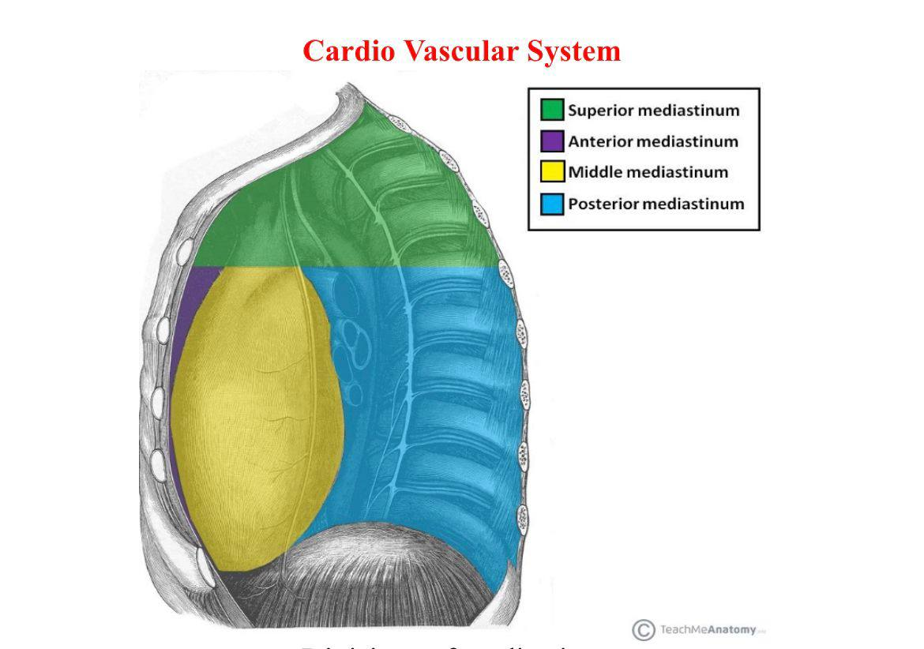
Divisions of mediastinum

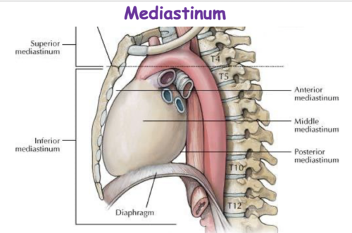
Ant, middle & post mediastinum

The Mediastinum
Definition: it is the space between the 2 lungs & pleurae.
Boundaries:
Sup: thoracic inlet (bounded by 1st thoracic vertebra, 1st ribs and sup border of sternum).
Inf: diaphragm.
Ant: sternum.
Post: thoracic vertebrae.
On each side: lung & pleura.
Subdivisions: it is divided by imaginary line between the sternal angle and T4 vertebra into superior and inferior mediastinum. The inf is further divided into middle (containing the heart and pericardium), anterior (ant to it) and post (post to it)
 | Sup mediastinum | Ant mediastinum | Middle mediastinum | Post mediastinum
Contents | From ant to post:  - 2 brachiocephalic Vs & SVC (upper ½)  - Arch of aorta & its branches  - Trachea  - Esophagus | - Remnants of thymus  - Sternopericardial ligaments | - Heart & pericardium  - Ascending aorta, pulmonary trunk, Terminal parts of SVC, IVC & pulmonary Vs  - Phrenic Ns  - 2 main bronchi | - Descending aorta  - Esophagus  - Azygos Vs
Applied anatomy:
Mediastinitis: inflammation of mediastinum.
Mediastinal syndrome: pressure on mediastinal contents (due to tumor, enlarged lymph node, aortic aneurysm… etc.). It may affect structures as
Bronchus → collapse of lung lobe
Trachea → dyspnea (difficult breathing)
Esophagus → dysphagia (difficult swallowing)
SVC → congestion of upper limbs, head and neck
Phrenic N → paralysis of diaphragm
Lt recurrent laryngeal N (supplying the larynx) → hoarseness of voice

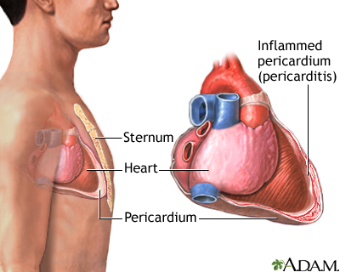
Fibrous pericardium

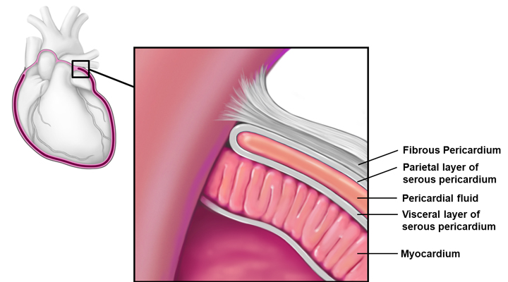
Layers of pericardium

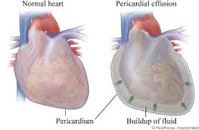
Pericardial effusion

Pericardium
Definition: fibroserous sac which surrounds the heart and proximal part of great vessels
Layers:
- Fibrous: conical; its apex surrounds aorta, pulmonary trunk & SVC, its base is attached to diaphragm and pierced by IVC, and posteriorly it is pierced by 4 pulmonary Vs
- Serous: subdivided into:
- Visceral: adherent to the heart. It is supplied by coronary As and autonomic Ns (insensitive to pain, touch and temperature).
- Parietal: lines the fibrous pericardium. It is supplied by branches from aorta, and by phrenic Ns (sensitive to pain)
Pericardial cavity: a potential space, between the two layers of the serous pericardium and contains few drops of synovial fluid.
Sinuses of pericardium
Transverse sinus:
Boundaries:
Ant: ascending aorta & pulmonary trunk
Post: upper part of atria & SVC
Function: allows the distension of aorta & pulmonary trunk.
Oblique sinus: part of pericardial cavity behind the Lt atrium
Boundaries:
Ant: back of Lt atrium
Post: fibrous pericardium lined by parietal pericardium, descending aorta and esophagus
Rt: IVC & Rt 2 pulmonary Vs
Lt: Lt 2 pulmonary Vs
Function: It allows the distension of Lt atrium.
Applied anatomy: pericardial effusion: the pericardial cavity is filled with excess fluid (hydrothorax), preventing the normal distension of heart leading to venous congestion (congested neck veins and enlarged liver), weak pulse and may lead to death. Drainage may be performed by needle insertion within 1 cm to the left of sternum between 4th & 6th costal cartilages (no lung or pleura).

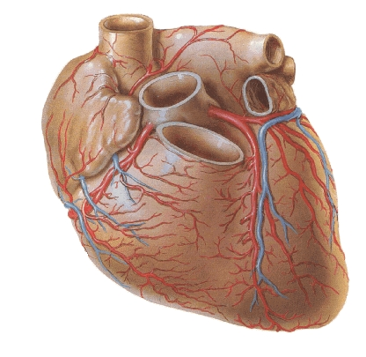 | 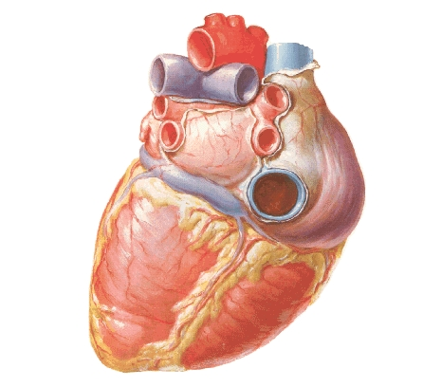
Sternocostal surface | Post & inf surfaces

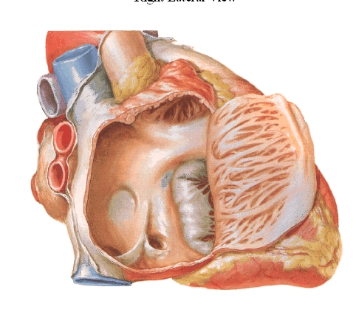 | 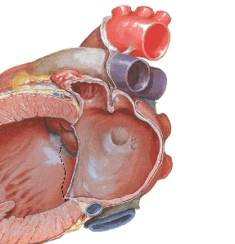
Rt atrium | Lt atrium

Heart
External features:
Borders of the heart:
Sup: 2 atria
Inf: 2 ventricles (mainly by Rt ventricle, the Lt forms the apex)
Rt: Rt atrium
Lt: Lt atrium & Lt ventricle
Surfaces of the heart:
- The heart is rotated so that the Rt chambers constitute ⅔ of its ant aspect while the Lt chambers constitute ⅔ of its post and inf aspects.
Sternocostal (ant) surface:
- Directed forward, upward and to the left
- Divided by coronary groove (A-V groove) into:
Atrial: sup small part formed of Rt atrium & its auricle and Lt auricle
Ventricular: inf larger part. Divides by ant interventricular groove into Rt ⅔ (Rt ventricle) and Lt ⅓ (Lt ventricle)
Base (post surface):
- Directed backward
- Formed of Lt atrium (mainly) and Rt atrium. Both are separated from ventricles (diaphragmatic surface) by interventricular groove
- It is related to oblique sinus, fibrous pericardium, esophagus, descending aorta and T5-8 vertebrae.
Diaphragmatic (inf) surface:
- Directed downward
- Divided by post interventricular groove into Lt ⅔ (Lt ventricle) and Rt ⅓ (Rt atrium).
Apex of the heart: formed of Lt ventricle and directed downward, forward and to the Lt.
Chambers of the heart:
 | Rt atrium | Lt atrium
Exterior | - Related to RT lung & pleura + Rt phrenic (to the Rt) & Lt atrium  - Shows a groove; terminal sulcus (sulcus terminalis) | - Post & to the Lt of Rt atrium
Interior | - Shows a crest; terminal crest (crista terminalis)  - Correspond to sulcus terminalis  - Extends between SVC & IVC  - Divides Rt atrium into:  - Ant (rough) part (including Rt auricle): shows pectinate muscles (musculi pectinate) (parallel muscle fibers from sulcus terminalis to Rt auricle)  - Post (smooth) part (sinus venarum): receives SVC, IVC & coronary sinus | - Rough  - Shows the auricle  - Shows pectinate muscles
Openings | - SVC: sup & post, has no valve  - IVC: inf & post, has a valve  - Coronary sinus: between IVC & tricuspid valve, has a valve  - Rt A-V opening: 3 fingers width, guarded by tricuspid valve  - Ant cardiac Vs  - Vena cordis minimae: forms minor openings (foramina venarum minimarum) | - 4 pulmonary Vs  - Lt A-V opening: 2 fingers width, guarded by mitral valve  - Vena cordis minimae
Interatrial septum: shows
Fossa ovalis: oval depression (derived from septum primum)
Anulus ovalis (limbus fossa ovalis): arched margin (sup, ant & post) to the fossa (derived from septum secondum)
N.B.: Foramen ovale: congenital malformation in the form of a slit between upper border of fossa ovalis & annulus ovalis
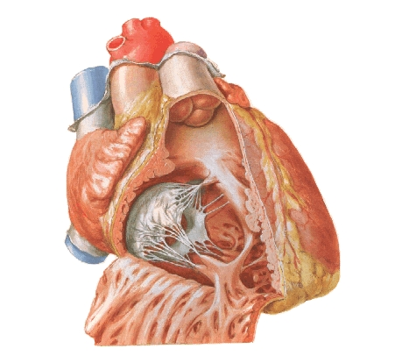
Rt ventricle

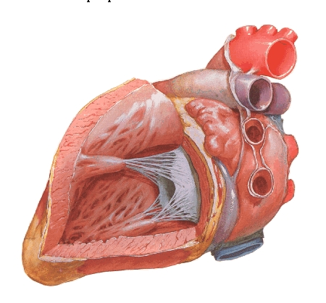
Lt ventricle

 | Rt ventricle | Lt ventricle
Exterior | - Has a thinner wall than Lt ventricle  Walls  - Ant (sternocostal): related to pericardium, Lt lung & pleura & thoracic wall  - Inf (diaphragmatic): related to diaphragm  - Lt (septal): the septum is convex towards its cavity (the Rt ventricle is semilunar in cross section) | - Its wall is thicker (3 times as Rt ventricle)  - Forms the apex  Walls  - Ant (sternocostal): related to pericardium, Lt lung & pleura, Lt phrenic N & thoracic wall  - Inf (diaphragmatic) wall: related to diaphragm  - Rt (septal) wall: the septum is concave towards its cavity (the Lt ventricle is circular in cross section)
Interior | Upper part (infundibulum):smooth, it supports pulmonary cusps in diastole | Upper part (aortic vestibule): smooth, it allows closure of aortic valve in diastole
 | Lower part: rough, due to:  - Trabeculae carnae: muscular ridges  - Papillary muscles:  - 3; ant, post (inf) & septal (according to attachment to ventricular walls)  - Each is attached to 2 adjacent cusps of tricuspid valve by chorda tendinae (on its ventricular surface)  - Septomarginal trabeculae (moderator band): extends from septal wall to ant wall (ant papillary M) | Lower part: rough, due to:  - Trabeculae carnae: more than Rt ventricle  - Papillary muscles:  - 2; ant & post (inf)  - Each is attached to 2 adjacent cusps of mitral valve by chorda tendinae (on its sides)  - No septomarginal septum
Openings | - Rt A-V opening:  - Inf & post  - 3 fingers width  - guarded by tricuspid valve  - Pulmonary opening:  - Sup & post  - guarded by pulmonary valve | - Lt A-V opening:  - Inf & post  - 2 fingers width  - guarded by mitral valve  - Aortic opening:  - Sup & post  - guarded by aortic valve
Interventricular septum
- It is oblique (the Rt ventricle is partly ant to the Lt ventricle).
- It is convex towards Rt ventricle (semilunar cross section) & concave towards Lt ventricle (circular cross section).

Parts:
- Muscular (septum musculare): larger lower part.
- Membranous (septum membronicum): smaller upper part.

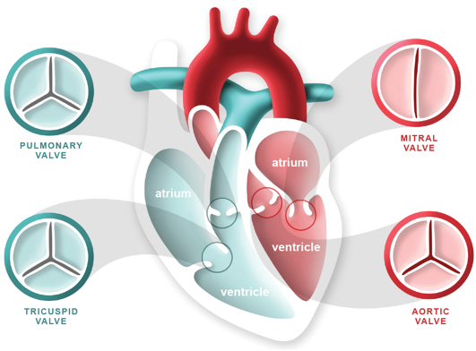
Site of cardiac valves

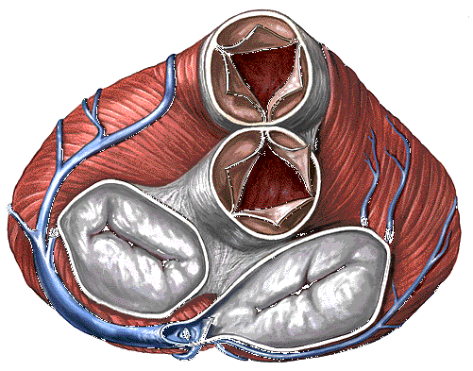 | 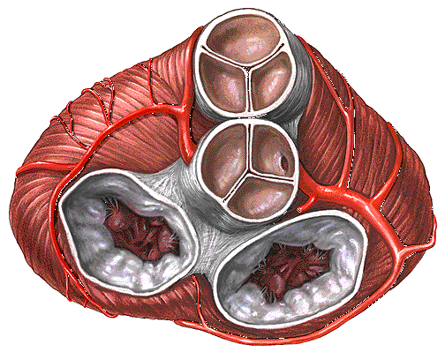
Sup view of cardiac valves

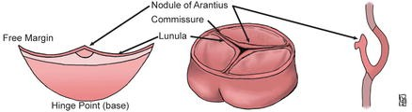
Nodule and lunula

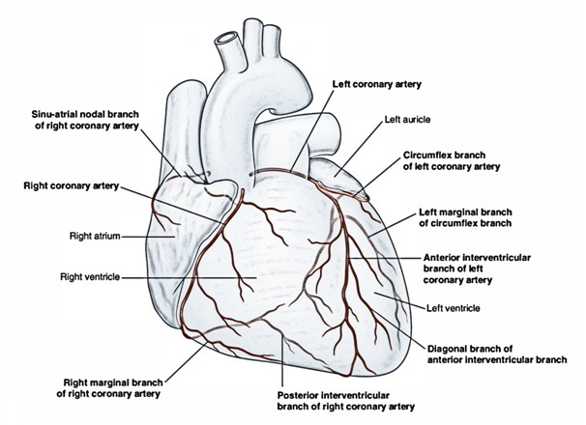
Coronary arteries

Valves of the heart:
 | Tricuspid | Mitral
Site | Between Rt atrium & Rt ventricle | Between Lt atrium & Lt ventricle
Cusps | - 3 cusps; ant (largest), post (inf) & septal  - Bases of the cusps are fixed by a fibrous ring surrounding the orifice (annular membrane)  - Corda tendinae (of papillary muscles) are attached to adjacent sides of 2 cusps (ventricular surface)  - Atrial surface is smooth & ventricular surface is rough | - 2 cusps; ant (larger, ant & to Rt), post (smaller, post & to Lt)  - Bases of the cusps are fixed by a fibrous ring surrounding the orifice (annular membrane)  - Corda tendinae (of papillary muscles) are attached to adjacent sides of 2 cusps (sides of cusps)  - Both surfaces are smooth

 | Pulmonary | Aortic
Site | Between Rt ventricle & pulmonary trunk | Between Lt ventricle & aorta
Cusps | - Formed of 3 cusps; post, Rt ant & Lt ant | - Formed of 3 cusps; ant, Rt post & Lt post
Cusps | - Each cusp is convex towards the ventricle & concave towards the artery  - Each cusp shows a nodule (at the middle of free margin) & a lunula at the sides
Blood supply of the heart:
Arterial
 | Rt coronary | Lt coronary
Beginning | Ascending aorta (ant sinus) | Ascending aorta (Lt post sinus)
C&R | Passes between pulmonary trunk & Rt auricle → passes in coronary groove between Rt atrium & Rt ventricle | Passes between pulmonary trunk & Lt auricle
Branches | - Direct branches to Rt atrium & Rt ventricle  - Rt marginal A: passes along the inf border & supply the Rt ventricle  - S-A node (in 65%)  - Rt conus A: supply the infundibulum  - Post interventricular A: Passes in post interventricular groove & ends by anastomosing with ant interventricular A. It supply:  - The 2 ventricles  - Interventricular septum (post ⅓)  - A-V node (in 80%) | - Circumflex A: passes in coronary groove between Lt atrium & Lt ventricle & supply:  - Direct branches to Lt atrium & Lt ventricle  - Lt marginal A: passes along the Lt border & supply the Lt ventricle  - S-A node (in 35%)  - A-V node (in 20%)  - Ant interventricular A: arises close to pulmonary trunk, passes in ant interventricular groove & ends by anastomosing with post interventricular A. It supply:  - The 2 ventricles  - Interventricular septum (ant ⅔)  - Lt conus: supply the infundibulum
End | By anastomosing with Lt coronary A | By anastomosing with Rt coronary A

Applied anatomy:
- Anastomosis between the coronary artery and its branches is poor, it increases with age but still inadequate. The arteries are anatomically anastomosing but functionally end arteries.
- Narrowing of coronary A will lead to angina while complete obstruction will lead to infarction
- The diseased segment may be treated by balloon dilatation or graft by pass (sometimes using part of saphenous V).
- The heart is supplied by T1-5, so its pain is referred to front of chest, Lt arm and forearm
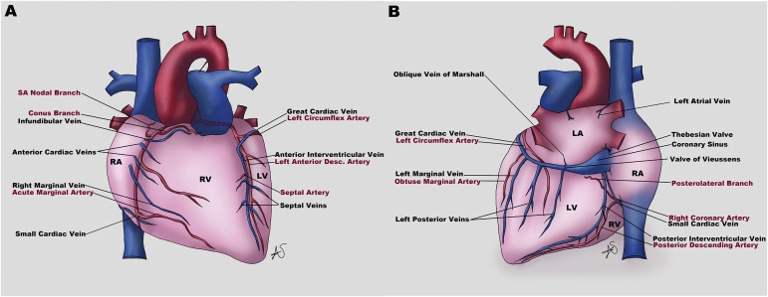
Venous drainage of the heart

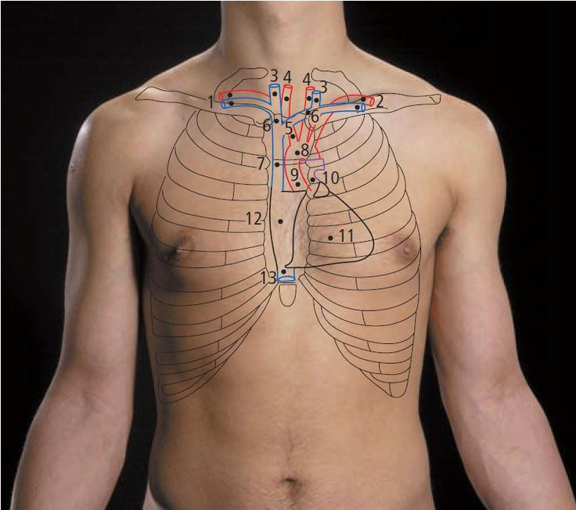
Surface anatomy of the heart and its valves

Venous

Coronary sinus:
- Wide short channel (3 cm) in the post part of coronary groove between Lt atrium & Lt ventricle
- Opens in Rt atrium to the Lt of IVC (guarded by valve)
Tributaries:
- Great cardiac V: ascends in ant interventricular groove → curves to Lt → Lt end of coronary sinus. It receives Lt marginal V
- Middle cardiac V: ascends in post interventricular groove → middle of coronary sinus
- Small cardiac V: ascends along the inf border of heart → curves posteriorly → Rr end of coronary sinus. It receives Rt marginal V
- Post V of Lt ventricle
- Oblique V of Lt atrium
- Ant cardiac Vs: 3-4 Vs which drain the ant surface of Rt ventricle & open in Rt atrium
- Venae cordis minimi: small Vs within the myocardium. They open in all chambers specially atria.
Surface anatomy:
- From Lt 2nd costal cartilage 0.5 inches from side of sternum
- To Rt 3rd costal cartilage 0.5 inches from side of sternum
- To Rt 6th costal cartilage 1 inch from side of sternum
- To Lt 5th intercostal space at midclavicular line (3 inches from midline)
Surface anatomy of the valves:
Pulmonary: Lt 3rd costal cartilage behind Lt margin of sternum
Aortic: Lt 3rd intercostal space behind Lt margin of sternum
Mitral: Lt 4th costal cartilage behind Lt half of sternum
Tricuspid: 4th intercostal space at midline
N.B.: auscultatory areas: it depends on the sound of blood accompanied by valve movements. So it does not match the surface anatomy of the valves
Aortic: Rt 2nd intercostal space close to the sternum
Pulmonary: Lt 2nd intercostal space close to the sternum
Tricuspid: Lt 4th or 5th intercostal space close to the sternum
Mitral: Lt 5th intercostal space at midclavicular line (apex)

Histology of the cardiac muscle

Cardiac Muscle
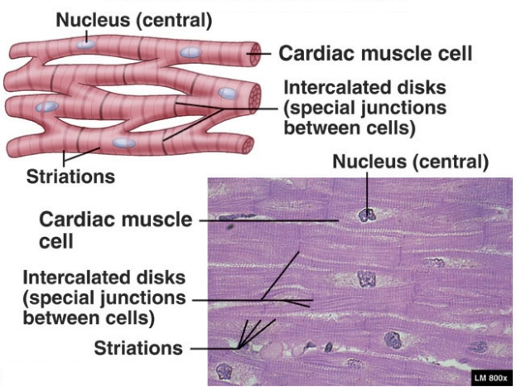
- Site: in wall of heart.
- Size of fiber: approximately 15 um in diameter and from 85 to 100 um in length.
- Shape of fiber: cylindrical branching.
- Sarcolemma: very thin.
- Sarcoplasm: acidophilic granular, rich in mitochondria, glycogen,
lipofuscin pigment (brown) which increases with old age brown atrophy of the heart.
- Nucleus: single, central, oval.
- Organization: the muscle fibres are arranged in different directions. Surrounding the muscle fibers is a delicate sheath of endomysial connective tissue containing a rich capillary network.
- Origin: mesoderm cells of the primitive heart tube align into chainlike arrays. Rather than fusing as in the development of skeletal muscle, cardiac cells form complex junctions between their extended processes. Cells within a chain often bifurcate and bind to cells in adjacent chains.
- Regeneration: NO regeneration but dead cells are replaced by fibrous tissue as a result of fibroblast invasion to damaged area.
- Types: red
EM of myofibrils
It differs from that of skeletal muscle myofibrils in:
- Transverse striations are not regular as in skeletal muscle.
- Presence of intercalated discs.
Intercalated discs:
- LM. It appears as darkly stained line across the muscle fibre
- A complex step like junctions formed by end to end attachment between sarcolemma of 2 adjacent cardiac muscle cells.
- It is formed of transverse and lateral parts.
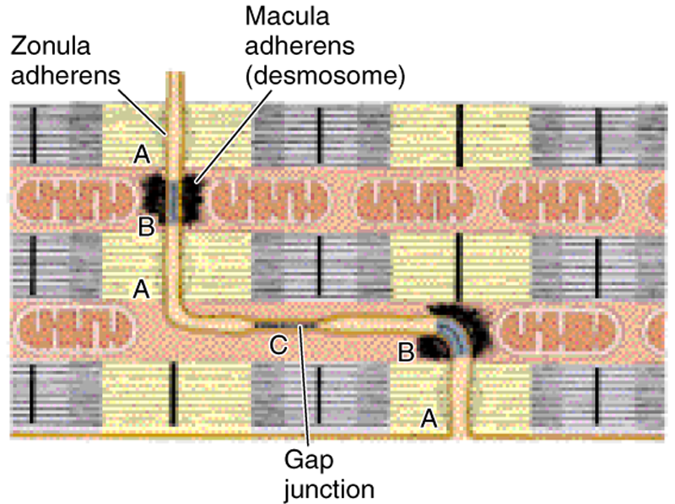

  - Transverse( Vertical) part:
    - Runs across the fibres at right angles.
    - Formed of fascia adherens and desmosomes to bind the cardiac cells together, preventing them from pulling apart under constant contractile activity.
  - Lateral part:
    - Runs parallel to the myofilament
    - Formed of gap junction to provide ionic continuity between allowing the signal to contract to pass in a wave from cell to cell.
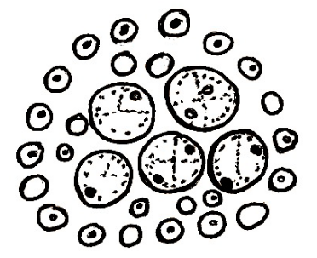
EM of sarcolemma and sarcoplasmic reticulum:
- T tubules are wider than that of skeletal muscle.
- T tubules are present at the level of Z line.
- Sarcoplasmic reticulum is poorly defined.
- T tubules are associated with one poorly defined expanded cisternae of the sarcoplasmic reticulum forming diads.
Conductive System of the heart:
It consists of : SAN, AVN, AVB, bundle branches.
Purkinje fibres:
- In AVB and its branches.
- Modified cardiac muscle fibres that transmit cardiac impulses 5 times faster.
- Larger in diameter than cardiac muscle fibres.
- Paler vacuolated cytoplasm (glycogen).
- Myofibrils are few and peripherally situated [no striations].
- One or 2 nuclei [eccentric].
- No intercalated discs.

Physiology of the heart
Cardiac Properties

Rhythmicity (Automaticity )
Def: It is the ability of heart to beat regular impulses independent of any nervous connection
Rhythmic cell are: |  |  |  |  |  | Rhythmic cell |  |  |  |  | SAN |  |  | AVN |  |  | Purkinje
 |  |  |  |  |  | Rate of Discharge |  |  |  |  | 90 /min |  |  | 60 /min |  |  | 30 /min
Rhythmic cell are characterized by :
 |  | Discharge spontaneously
 |  | Membrane potential is unstable no RMP
 |  | It has no plateau
 |  | Membrane more permeable to Na⁺ & Ca⁺⁺
 |  | Firing level = -40 mV
 |  | Peak of AP = + 10 mV
 | Action Potential of Pacemaker  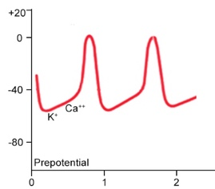 |  |  |  |  |  |  |  |  |  |  | 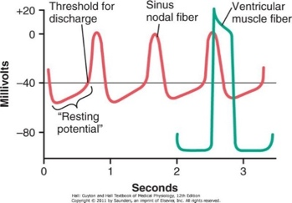  Rhythmical discharge of a sinus nodal fiber.  Also, the sinus nodal action potential is compared with that of a ventricular muscle fiber
 | - Ionic bases:
 |  |  | - Membrane potential: Decrease spontaneously: |  |  |  |  |  |  |  |  |  |  |  |  | - From - 60 mv to -50 mv
 |  |  |  |  |  |  |  |  |  |  |  |  |  |  |  | - Due to: Na⁺ influx.
 |  |  | - At -50 mv: |  |  |  | - Transient Ca⁺⁺ channel open (T - type)
 |  |  |  |  |  |  | - Ca⁺⁺ enter cell to cause depolarization to firing level -40 mv
 |  |  | NB: 1, 2 are called Prepotential
 |  |  | - At -40 mv: |  |  |  | - Opening of long lasting Ca⁺⁺ channel (L-type)
 |  |  |  |  |  |  | - Ca⁺⁺ enters to cause depolarization and there is closure of transient Ca⁺⁺ channels and Na⁺ channels till +10
 |  |  | - Repolarization phase: |  |  |  |  | Due to: |  | Outflow of K⁺ (through K⁺ channel)
 |  |  |  |  |  |  |  |  |  | Closure of L -type Ca⁺⁺ channel
 |  |  | - At -60 mv: Inactivation of K⁺ channels (so K⁺ efflux stops)
 |  |  | NB: The slope of pre potential determine heart rate
 |  |  |  |  | - Increase slope will increase HR (Tachycardia)
 |  |  |  |  | - Decrease slope will decrease HR (Bradycardia)
 |  |  |  | Increase slope causes Tachycardia |  |  |  |  |  |  |  |  | Decrease slope causes Bradycardia
 |  |  |  | - Sympathetic stimulation |  |  |  |  |  |  |  |  | - Parasympathetic stimulation
 |  |  |  | - Catecholamine |  |  |  |  |  |  |  |  | - Acetylcholine
 |  |  |  | - Increase temperature |  |  |  |  |  |  |  |  | - Ca channel blocker (CCB)
 |  |  |  | - Hypokalemia (↓ K) |  |  |  |  |  |  |  |  | - Hyperkalemia (↑ K)
 |  |  |  | - Thyroxin
N.B |  |  |  | Heart rate during rest 70 – 80 due to vagal tone
Conductivity (Spread of cardiac excitation)

 |  |  | Def : |  |  |  | It is ability of cardiac muscle to transmit cardiac excitation wave
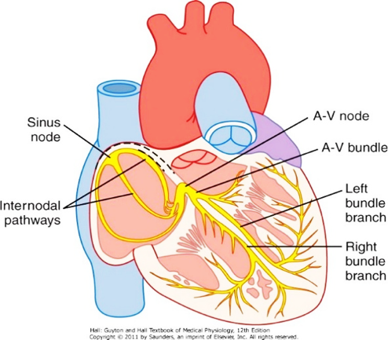
Sinus node & the Purkinje system of the heart, showing also the A-V node, atrial internodal pathways & ventricular bundle branches
 |  |  | - In SAN: Excitation wave is generated
 |  |  | - Then passes through internodal pathway to far part of atria
 |  |  |  | Excitation of atria → atrial contraction → ejection of blood to ventricles
 |  |  | - Then reaches AVN (where there is physiological delay in transmission)
 |  |  | - Then reaches A-V bundle & spread rapidly down to bundle branches and Purkinje fiber then conducted through ventricular muscle itself
 |  |  |  | Ventricular excitation → ventricular contraction → ejects blood to aorta & pulmonary
 |  |  | Rate of conduction in different parts:
 |  |  | - Atrial pathway |  |  |  |  | : 1 m/sec | 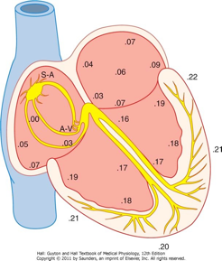  Transmission of the cardiac impulse through the heart, showing the time of appearance (in fractions of a second after initial appearance at the sinoatrial node) in different parts of the heart
 |  |  | - AV node (AVN) |  |  |  |  | : 0.05 m/sec
 |  |  | - Bundle of His |  |  |  |  | : 1 m/sec
 |  |  | - Purkinje fiber |  |  |  |  | : 4-5 m/sec
 |  |  | - Ventricular muscle |  |  |  |  | : 1 m/sec
 | Conduction at AVN:
 | - Is slow (0.05 m/sec)
 | - This delay in conduction due to: Presence of few gap junctions
 | - Significance of slow Conduction at AVN (AVN delay):
 |  |  |  |  |  | - Give a chance for both atria to be excited & to contract to empty their blood into ventricles
 |  |  |  |  |  | - Prevent abnormal rhythm originated in atria to reach ventricles
 | Conduction at Purkinje fibers:
- Is fast (4-5 m/sec)
- This rapid conduction due to: Presence of many gap junctions
- Significance of fast conduction at Purkinje fibers:
 |  | To cover both ventricles in very short time to contract as one unit to eject blood

Excitability (Action potential)

Action Potential:
- Action Potential of ordinary cardiac muscle fibers:
 |  |  | - RMP = -90 mV (ionic bases: Like skeletal muscle)
 |  |  | - AP is composed of the following phases:
 |  |  | 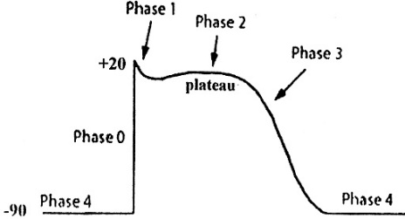
 |  |  | Phase 0: |  |  |  | Depolarization
 |  |  | - Rapid depolarization and reversal of polarity from -90 mV to +20 mV.
 |  |  | - Ionic bases: Na⁺ influx (due to opening of fast Na⁺ channels)
 |  |  | - Repolarization: Is triphasic:
 |  |  | Phase 1: |  |  |  | - Small rapid repolarization to + 10 mV.
 |  |  |  |  |  |  | - Ionic bases: |  |  |  | Inactivation of Na⁺ channels  K⁺ efflux (due to opening of fast K⁺ channels)  Cl⁻ influx
 |  |  | Phase 2: |  |  |  | Plateau:
 |  |  | - Repolarization slow down & membrane potential is around zero mV for about 200 msec
 |  |  | - Ionic bases: |  |  |  |  |  | Balance between: |  |  |  | Ca⁺⁺ influx (through long-lasting Ca⁺⁺ channels) together with Na⁺ influx  K⁺ efflux (through K⁺ channels)
 |  |  | Phase 3:
 |  |  | - Rapid repolarization to RMP due to: |  |  |  |  |  |  |  |  |  |  | Closure of L-lasting Ca++ channels
 |  |  |  |  |  |  |  |  |  |  |  |  |  | Inactivation of Na⁺ channels
 |  |  |  |  |  |  |  |  |  |  |  |  |  | Activation of K⁺ channels leading to K⁺ efflux
 |  |  | Phase 4:
 |  |  | - Resting membrane potential (RMP) (-90) due to: |  |  |  |  |  |  |  |  |  |  |  | Selective permeability  Na-K pump
 |  | - Relation between AP and mechanical response:
 |  |  |  |  | - Contraction (mechanical response) starts just after beginning of depolarization & reaches its maximum by end of plateau (phase 2).
 |  |  |  |  | - Repolarization coincides with first half of relaxation (diastole). (diastolic time double repolarization time).
 | - Relation between AP and mechanical change
 |  |  |  |  |  | - Systole |  | Coincide with period of depolarization till end of plateau
 |  |  |  |  |  | - Diastole |  | Coincide with period of rapid repolarization phase & continue in Rest because mechanical response last one & half as long as action potential
 | - Relation between AP & excitability change
 |  |  |  |  |  | - Absolute Refractory period coincide with period of depolarization till end of plateau (the excitability is lost)
 |  |  |  |  |  | - Relative refractory period coincide with the period of rapid Repolarization phase (the excitability is weak)
 | - Relation between AP & ECG
 |  |  |  | - QRS |  |  |  |  |  | Coincide with depolarization
 |  |  |  | - S-T segment |  |  |  |  |  | Coincide with plateau
 |  |  |  | - T wave |  |  |  |  |  | Coincide with rapid repolarization

Contractility (Excitation-Contraction Coupling)

Definition: |  |  | It is the ability of the cardiac muscle to contract to pump blood. Contraction start after excitation of cardiac wave
Excitation contraction coupling
- Excitation of cardiac muscle (depolarization of AP) leads to Ca⁺⁺ entry inside cardiac muscle.
- Ca⁺⁺ enters sarcoplasm triggers release of large amount of Ca⁺⁺ from sarcoplasm reticulum (through Ca⁺⁺ release channel).
- Ca⁺⁺ binds to troponin-C thus tropomyosin uncover active site. Interaction between actin and myosin followed by sliding of actin over myosin leads to contraction.
- Removal of Ca⁺⁺ from sarcoplasm leads to relaxation.
Factors affecting contractility:
- All or none Rule
 | - Cardiac muscle contract or dose not contract at all
 | - Increase stimulus intensity more than threshold will not change the strength of contraction
 | - Stimulation by stimulus below threshold will produce No response
- Tetanus
 | - Tetanus means sustained contraction (successive contractions fuse & cannot be distinguished from one another)
 | Tetanus cannot occur in cardiac muscle due to: Long ARP which coincide with systole
- Length – Tension relationship:
 | - Force of contraction of heart is directly proportional to initial length of cardiac muscle fiber within limit (starling's low):
 |  | - Increase initial length of cardiac muscle fiber will increase force of contraction to reach maximum at certain length which called L max
 |  | - At L max all cross bridge of myosin bind to active site of actin
 |  | - Increase length above L max will decrease force of contraction

- Force - velocity relationship:
 | - Initial velocity of shortening of cardiac muscle is inversely related to load moved during contraction:
 |  | - Increase load carried by muscle will decrease initial velocity of shortening
 |  | - Decrease load will increase initial velocity of shortening
- Staircase phenomena:
 | - Applying repeated stimuli to cardiac muscle within very short time:
 |  | - The 2nd contraction will be higher than the first
 |  | - And 3rd will be higher than 2nd
 |  | - Until a new level of contraction is reached
 | - Due to: |  | - Increase Ca⁺⁺ ion
 |  |  | - Failure of reuptake (due to weakness of Ca⁺⁺ pump)
- Inotropic state: |  |  |  | (Contractility)
 | - The ability of cardiac muscle to develop force (contract)
 | - Contractile state could: |  |  |  | Increase (+ve inotropic)
 |  |  |  |  | Decrease (-ve inotropic)
 | Factors affecting contractility:
 | [A] Positive Inotropics Factors: |  |  |  |  |  | Sympathetic stimulation (β1-adrenergic).
 |  |  |  |  |  |  | Catecholamines
 |  |  |  |  |  |  | Glucagon hormone
 |  |  |  |  |  |  | Digitalis
 |  |  |  |  |  |  | Xanthines eg caffeine
 | N.B: All these factors act through increasing Ca⁺⁺ in sarcoplasm
 | [B] Negative Inotropic Factors: |  |  |  |  |  |  | Parasympathetic stimulation
 |  |  |  |  |  |  |  | Acetylcholine
 |  |  |  |  |  |  |  | Hypoxia (due to ischemia)
 |  |  |  |  |  |  |  | Calcium channel blockers "CCB"
 |  |  |  |  |  |  |  | Anesthetics
 |  |  |  |  |  |  |  | Anti-arrhythmic drugs

Cardiac Output (CO)
Definition: Cardiac output (CO): Is the volume of blood pumped by each ventricle per minute
 |  |  |  |  | - Normally = 5 L/min
 | NB: Cardiac Index (CI): |  |  |  | - Volume of blood pumped by each ventricle per minute per square meter body surface area
 |  |  |  |  | - Normally = 3.2 L/min/m²
Calculation: |  | Cardiac output (CO): = SV × HR
 |  |  |  |  |  | Normally: CO = 70 × 70 = 5 L/min
Cardiac output depends on: |  |  |  | Heart rate
 |  |  |  | Stroke Volume (SV):
Definition: |  |  |  | Is the volume of blood pumped by each ventricle per beat
Calculation: |  |  |  | SV = EDV - ESV
EDV: End Diastolic Volume
ESV: End Systolic Volume
 |  |  |  | - Normally: SV = 135 - 65 = 70 ml
 |  |  |  | EDV: Is the volume of blood In the ventricle at end of diastole
 |  |  |  | ESV: Is the volume of blood In the ventricle at end of systole
Ejection Fraction (EF):
Definition: EF is the fraction of the EDV that is ejected with each beat
Calculation:
EF= |  |  | Stoke volume |  |  |  |  | X 100
 |  |  | End diastolic volume
Normally: Ejection fraction is 55-75%
Importance : Assessment of Contractility.

Variations of cardiac output (CO):

 | Unchanged in
 | - Sleep
 | - Moderate changes in external temperature
 | Increased in
 | - Excitement | (50- 100%)
 | - Exercise | (300%)
 | - Exposure to high temperature
 | - Eating | (30 %)
 | - Epinephrine secretion
 | - End of pregnancy
 | - Inspiration
 | - Shifting from standing to recumbent position
 | Decreased in
 | - Sitting or standing from lying position
 | - Rapid arrhythmia
 | - Heart failure

Control of the cardiac output
Heart rate (HR)
An increase of HR up to 200/min. (eg during exercise) leads to an increase of CO
Change of Preload
- Preload determines muscle length before start of contraction.
- Ventricular preload is determined by EDV
- EDV depends on venous return
- According to Starling's Law:
- The more the end diastolic volume the more is the force of contractions; within limits.
- An increase of EDV(preload) leads to increase SV with consequent increase of CO
- Preload is affected mainly by venous return
- Factors that increase venous return: Means increase filling of ventricles increased EDV → increased myocardial contractility → increased SV → increased cardiac output
- Factors that affect ventricular preload:
Venous Return (VR): Increased venous return will increase preload
Ventricular compliance: Decreased ventricular compliance will decrease preload eg myocardial infarction
Heart rate: Increased rate more than 200/min leads to a decrease of preload due to shortening of diastole decreased ventricular filling
Effect of afterload on SV
- After load is the load against which the ventricle contracts and eject blood
- The main after load for left ventricle is the aortic pressure
- An increase of after load leads to a decrease of SV → decrease CO
- Decreased after load leads to increase of SV → increase CO
Effect of contractility (inotropic state) on SV
- Positive inotropics increase contractility of the ventricle → ejecting more blood → increase SV → increase CO

Cardiac Reserve "CR"
Definition: |  |  | It is difference between cardiac output pumped by the heart under ordinary circumstances & its maximum capacity for pumping blood
 |  |  | In normal young adult: the CR is 300%
Assessed by: |  |  |  | Low-dose dobutamine stress echocardiography
Mechanisms:
1) +ve chronotropic condition:
(Heart rate reserve) |  |  |  |  |  | During rest: |  |  |  |  | HR = 70
 |  |  |  |  |  | During exercise: |  |  |  |  | HR =200 |  |  | (so COP can increase 3 time)
 |  |  |  |  |  | Limitation: |  |  |  |  | Diastolic period is shorten
2) Factors ↑ preload: |  |  |  |  |  | During rest: |  |  |  |  | = 135 ml
(EDV reserve) |  |  |  |  |  | During exercise: |  |  |  |  | Venous return increase lead to increase ventricular filling → increase EDV → lead to increase force of contraction
3) Factors ↓ afterload |  |  |  |  |  |  | Decrease total peripheral resistance
4) +ve inotropic condition: |  |  |  |  |  |  | During rest: |  |  |  |  | = 65 ml
(ESV reserve) |  |  |  |  |  |  | During exercise: |  |  |  |  | Sympathetic stimulation increase force of contraction lead to decrease ESV → increase SV → COP
 |  |  |  |  |  | Limitation: |  |  |  | Amount of blood
5) Cardiac hypertrophy: |  |  |  |  |  | - increase force of contraction → increase SV → COP
 |  |  |  |  |  | - Cardiac hypertrophy may be: |  |  |  |  |  |  | - Physiological  - Pathological
6) Venous oxygen reserve: During rest:
 |  |  |  |  |  |  |  | - O₂ content in each 100 ml arterial blood: 20 ml O₂
 |  |  |  |  |  |  |  | - O₂ content in each 100 ml venous blood: 15 ml O₂
 |  |  |  |  |  |  |  | - Thus blood supply to tissue = 5 ml O₂
 |  |  |  |  |  | During exercise: |  |  |  |  | Blood supply to tissue increase up to 12 ml

Biochemistry

Enzymes
Enzymes are catalysts of chemical reactions. Most of enzymes are in general globular proteins. Almost all chemical reactions occur in a biological cell need enzymes in order to occur at rates sufficient for life.
apoenzymes or apoproteins are Enzymes that require a cofactor that loosely bound to them An apoenzyme together with its cofactor(s) is called a holoenzyme (it is the active form).
The term "holoenzyme" can also be applied to enzymes that contain multiple protein subunits, such as the DNA polymerases
Cofactors can be either:
- inorganic
(e.g., metal ions and iron-sulfur clusters). An example of an enzyme that contains a metal cofactor is carbonic anhydrase, with a zinc cofactor bound as part of its active site.
- organic cofactors (e.g., flavin and heme).
Organic cofactors can be either:
- prosthetic groups., which are tightly bound to an enzyme.
- coenzymes, which are released from the enzyme's active site during the reaction. Coenzymes include: NADH, NADPH and adenosine triphosphate.

Example of Coenzymes:
- Hydrogen carriers
NAD ,NADP,FAD,FMN,HEAM,Lipoic acid ,Glutathione VITAMIN C and CoQ.
Isoenzymes(isozymes)

They are enzymes catalyze the same reactions at different rates. They have different affinity to the substrate .They consist of many polypeptide chains.
Examples
- Lactate dehydrogenase enzyme
It is formed of 4 polypeptide chains (H,M)there are 5 isozymes of the enzyme.
Isozyme 1 is present in the cardiac muscle and it increases in myocardial infarction
Isozyme 5 is present in the liver and it increases in hepatitis and liver diseases.
- Creatine kinase
It is formed of 2 subunits (M,B).
CK –BB is present in the brain .it increases in brain tumours or infarctions
CK –MM is present in muscles .it increases in muscle diseases
CK –MB is present in the cardiac muscles .it increases in myocardial infarction.
Enzyme activation
There are different ways for activation of enzymes:
- Activation by proteolysis :
- pepsinogen by HCL gives pepsin
- blood clotting factors as prothrombin to thrombin and fibrinogen to fibrin..
- Metal ion activation
The metal may be present in any position through activation process of the enzyme.So,it may be present as the examples:(metal – enz- substrate)or (enz- substrate- metal)or (enz- metal- substrate)
- Allosteric activation;
Many enzymes contain a site other than catalytic site named as the allosteric site.
Binding to this site leads to change in the shape of the enzyme favors the binding of the substrate.
- Covalent modification of the enzyme
Phosphorylation and dephosphorylation of the enzymes leads to change in its activity.
Enzyme Inhibition
Inhibition of the enzyme may be one of two ways:
A)Irreversible
B) Reversible (it may be either competitive or non competitive)

A . Irreversible enzyme inhibition; it includes:
- Factors produce denaturation of the enzyme(as strong acids or bases)
- Inhibitors of sulfhydryl group of the enzyme as oxidizing agents or salts of heavy metals
- Antienzymes (antithrombin or antoporteinases e.g. α 1-antitrypsin deficiency allows elastase to digest the pulmonary tissue in emphysema )
- Inhibition by removal of catalytic ions as EDTA prevent blood clotting and fluoride inhibits enolase enzyme of glycolysis.

B) Reversible Enzyme Inhibition
1.Competitive Enzyme Inhibition
There is structural similarity between the inhibitor and the substrate so both compete for the active (catalytic site of the enzyme) in this condition increasing the inhibitor conc. will affect the rate of the enzyme activity.
Examples :
1)Allopurinol competes with Xanthine on xanthine oxidase prevents formation of uric acid
2) Dicumarol and Warfarin competes with Vitamin K on vit K epoxide reductase
3) Malonate competes with Succinate on succinate dehydrogenase
4) Sulfonamides compete with P- AminoBenzoic Acid on enzymes of folic acid synthesis.
5) Methotrexate competes with DihydroFolate on dihydrofolate reductase for synthesis of tetra hydrofolic acid FH4

Non Competitive Inhibition
In this condition the Substrate and inhibitor bind different sites and increasing concentration of the substrate does not lead to change in the inhibitory process of the enzyme.
It may be:

- Allosteric Inhibition:
Many enzymes contain a site other than catalytic site binding to this site leads to change in the shape of the enzyme doesn’t favor the binding of the substrate.
- Feed Back Inhibition:
The product inhibits the key enzyme or one of the substrates in the pathway.
Enzymes for Clinical and Biomedical Importance
Specific enzymes are present in high concentration in certain organs.
Damage of these organs leads to elevation of specific enzymes.
So, the use of specific enzymes is important for diagnosis of certain diseases.

The myocardium is rich in glutamate oxaloacetate transaminase ,Lactate dehydrogenase and creatine kinase.
Any reduction of blood supply to the myocardium like myocardial infarction and severe angina leads to increase death of myocardiocytes and elevated enzymes present in the myocardium .
Diagnosis of myocardial infarction through the following enzymes:
myocardial infarction ;
1- creatine kinase CK(MB )
2-glutamate oxaloacetate transaminase (GOT)
3-lactate dehydrogenase (LDH)

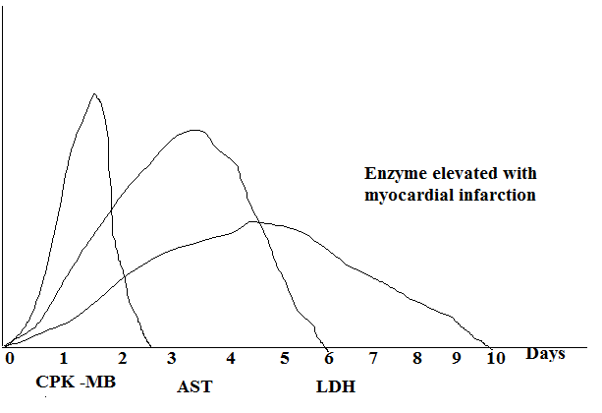

The liver contains many enzymes as it performs many functions but the enzymes present in high concentrations are transaminases for gluconeogenesis and lactate dehdrogenase for the anaerobic glycolysis.
So, hpetitis is diagnosed mainly by :
1- glutamate oxaloacetate transaminase ( GOT)
2-glutamate pyruvate transaminase (GPT),
3-alkaline phosphatase,
4-lactate dehydrogenase (LDH)
The biliary tract is lined by cells and contain many enzymes so in case of obstructive jaundice the following enzymes are elevated;
1-alkaline phosphatase
2-gamma Glutamyl transferase (γ GT)

gamma Glutamyl transferase (γ GT) is elevated in case of alcoholism and drug abuse also.
Pancreatitis is diagnosed by the following enzymes ;
1-pancretic amylase
2- pancreatic lipase (it is also elevated in pancreatic duct obstruction).

Acid phosphatase is an enzyme elevated in case of prostatitis and cancer prostate.

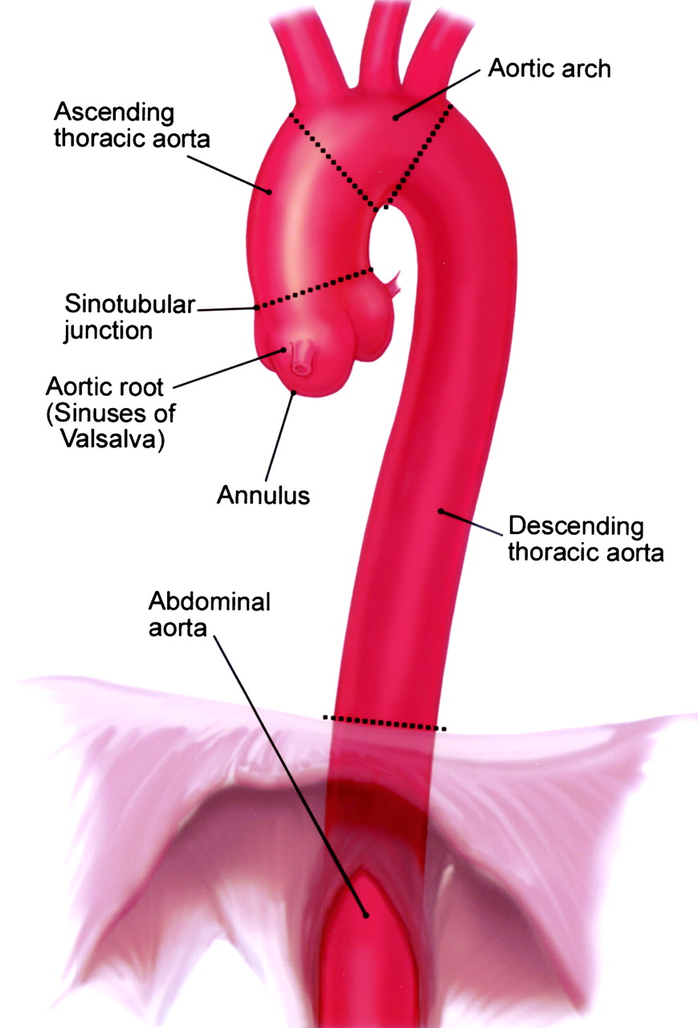Thoracic aorta

Great vessels of the thorax
Ascending Aorta
Beginning: from left ventricle at 3rd left intercostal space behind left margin of sternum. It shows 3 sinuses at its beginning (ant, Rt & Lt post)
Course and relations: lies in middle mediastinum
Ant: pulmonary trunk, right lung & pleura
Post: left atrium
Rt: right atrium & SVC
Lt: pulmonary trunk
- The pulmonary trunk is ant to its lower part and to the left to its upper part. Both lies in one serous pericardial sac.

Branches:
Rt coronary: from ant sinus.
Lt coronary: from left post sinus.
End: 2nd right costal cartilage behind right margin of sternum by becoming arch of aorta.
Arch of aorta
Beginning: at 2nd right costal cartilage behind right margin of sternum as a continuation of ascending aorta.

Course and relations:
Sup:
- Branches of aortic arch (brachiocephalic, Lt common carotid & Lt subclavian As).
- Left brachiocephalic V.
Inf:
- Division of pulmonary trunk & ligamentum arteriosum.
- Left main bronchus.
Ant & to the left: Left lung & pleura.
Posterior & to the right: Trachea, esophagus and vertebral column.

Branches:
- Brachiocephalic A: it enters the neck & divides into Rt subclavian A (to the Rt upper limb) & Rt Common carotid A (to the Rt side of head & neck).
- Left Common Carotid A: it enters the neck to the Lt side of head & neck.
- Left Subclavian A: it enters the neck to the Lt upper limb.
- Thyroidae Ima A: to the thyroid gland.
End: at the left side of T4 vertebra (lower border) by becoming descending aorta.
Descending aorta
Beginning: at the Lt side of T4 vertebra (lower border) as a continuation of arch of aorta.

Course and relations:
Ant:
- Lt bronchus.
- Lt atrium & esophagus (below T7 vertebra).
Post: vertebral column.
Rt: esophagus (above T7 vertebra).
Lt: Lt lung & pleura.

Branches:
- Posterior intercostal As (3-11) & subcostal artery on each side.
- Pericardial, mediastinal, esophageal & phrenic branches.
End: at the lower border of T12 vertebra by becoming abdominal aorta.

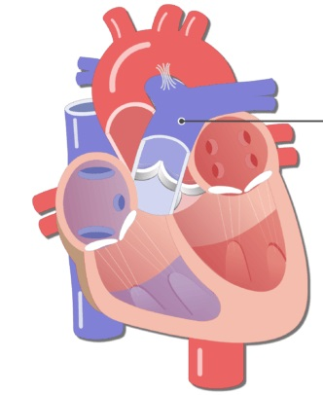
Pulmonary trunk

Large veins of the thorax

Pulmonary Trunk
Beginning: from Rt Ventricle at 3rd Lt costal cartilage behind left margin of sternum. It shows 3 sinuses at its beginning (post, Rt & Lt ant)
End: at 2nd Lt costal cartilage (below aortic arch) by dividing into right and left pulmonary arteries.

Course and relations:
Ant: Lt lung & pleura.
Post: ascending aorta & Lt atrium.
Rt: ascending aorta, Rt coronary A & Rt auricle.
Lt: Lt coronary A & Lt auricle.
- The ascending aorta is post to its lower part and to the Rt to its upper part. Both lies in one serous pericardial sac.
Branches Rt & Lt pulmonary As (caries deoxygenated blood to the lungs).
N.B.: Ligamemtum arteriosum: it is a fibrous band (embryological remnant) connecting arch of aorta & Lt pulmonary A. In case of its abnormal patency, it causes shifting of blood from aorta (high pressure) to pulmonary trunk (low pressure) causing pulmonary hypertension which may lead to Rt side heart failure.
Brachiocephalic Veins
Beginning: behind the medial end of clavicle by union of internal jugular and subclavian Vs.

Course and relations:
 | Rt | Lt
Length | Short (2.5 cm) | Long (6 cm)
Direction | vertical | Obliquely horizontal
Relations | Rt: Rt phrenic & Rt lung & pleura | Ant: sternum (manubrium)  Post: Branches of aortic arch  Inf: arch of aorta

Tributaries:
- Internal jugular & subclavian Vs (beginning).
- Vertebral Vs.
- Internal thoracic V.
- Rt lymphatic duct (to Rt brachiocephalic) or thoracic duct ( to Lt brachiocephalic).
End: behind 1st Rt costal cartilage by union of 2 brachiocephalic Vs forming SVC.
Superior Vena Cava
Beginning: behind 1st Rt costal cartilage by union of 2 brachiocephalic Vs.

Course and relations:
Rt: Rt phrenic & Rt lung & pleura.
- The lower ½: is included within the pericardium to the Rt of ascending aorta.

Tributaries:
- 2 brachiocephalic Vs.
- Azygos V.
End: in the Rt atrium behind 3rd Rt costal cartilage.
Inferior Vena Cava
Beginning (of thoracic part): after passes through diaphragm at the level of T8 vertebra 1 inch to Rt.
End: in Rt atrium behind 6th Rt costal cartilage.
Pulmonary veins
- 4 in number (sup & inf Vs from each lung).
- Carries oxygenated blood from lungs to Lt atrium.

Histology of vascular system

- Vascular system includes:
- Arteries, veins & arteriovenous connections.
- The wall of any blood vessel is formed of three layers.
- Tunica intima; the most inner layer. It consists of:
- Endothelium
b-Sub endothelial CT. [loose areolar CT]
C-Internal elastic lamina [IEL]
-Tunica media; the middle layer. It is formed of circularly arranged smooth muscle fibers, elastic&few collagenous fibers
- Tunica adventitia; the outermost layer. It is formed of areolar CT.

ARTERIES
Arteries are classified into:
1-Large arteries: e.g. aorta carries blood from the heart.
2-Medium sized arteries: carry blood to organs.
3-Small arteries (arterioles): regulate blood flow to capillaries.
4-Meta-arteriols.

POC | Large artery  [Elastic] | Medium sized artery [Muscular] | Small artery [Arteriole]
Sites | Aorta & large arteries | muscular arteries | - Ends of muscular arteries
Wall  Lumen | - thick wall  - wide lumen | - thick wall  - Narrow lumen | -Thin wall  - narrowlumen.
Tunica intima  Int.elasticlamina(IEL) | - S. Sq. Endoth.  - Subendothelial CT.: rich in elasticfs.  - ill-defined [similar to elastic laminae of media.] | - Endothelium  - Thick subendothelial CT  -Thick IEL | - Endothelium  -Thin  Absence of sub-endothelial CT  - IEL gradually disappears.
Tunica media  Ext. elasticlamina EEL | -Thick=:Fenestrated elastic membranes  (40- 70 layer).with  - Smooth muscles in between.  - EEL: ill defined | -Mainly smooth muscles with many elastic fibers  inbetween  -- EEL: may be present | - One or 2 layers of smooth muscles replaced by pericytes in small arterioles.  No EEL
Tunica adventitia  Vasavasorum | elastic fibers rich in  Present | - elastic fibers ewf  may be present | absent

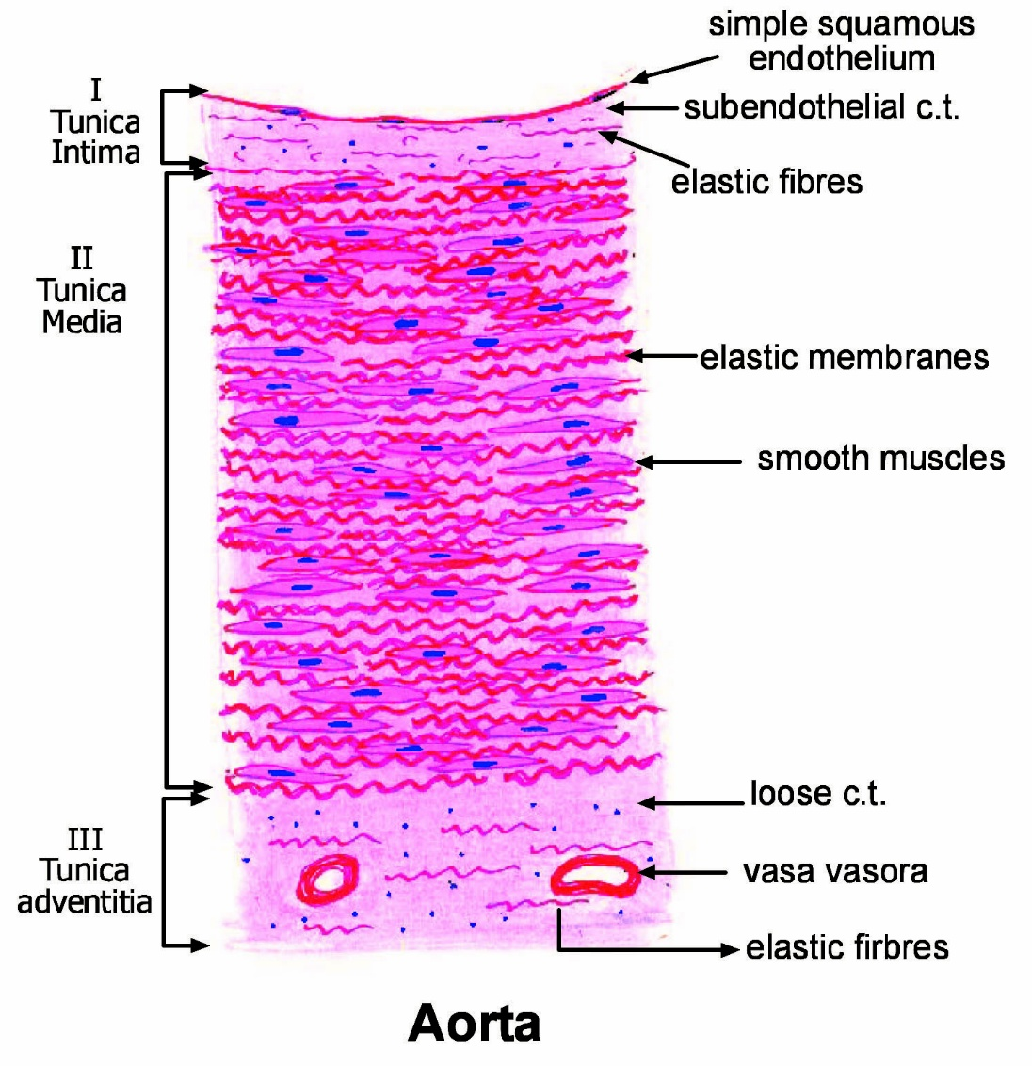

Specialized mediumsized arteries

POC | Basilar a. | Coronary a. | Umbilical a.
Tunica intima | Well-developed IEL | -Well developed IEL  - Thick sub endothelial CT.  -Contains fat droplets & longitudinal smooth muscles. | -No IEL
Tunica media | Thin | -Thick  -EEL. | Smooth muscles  2 layers; inner longitudinal& outer circular.
Tunica adventitia | thin | Thin | Mucoid CT.

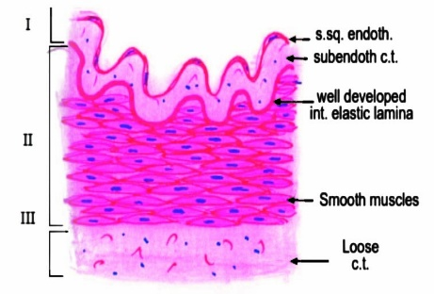
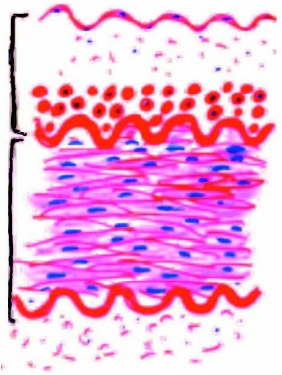
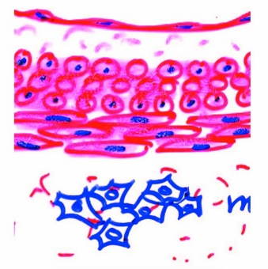
Coronary a.
Basilar a.
Umbilical a.

Metarterioles:
- Arterioles that supply blood to capillaries
- They connect terminal arterioles with capillaries.
- They are surrounded by smooth muscles to act as sphincters to control blood flow to the capillaries.

- They carry blood from tissues to the heart.
- They started by post capillary venules, medium sized & then large veins.
- Structure of medium sized vein is like that of medium sized artery with some differences:

POC | Medium sized artery | Medium sized vein
- Wall thickness | Thick | Thin
- Lumen | - Narrow  - Does not contain blood after death. | - Wide  - Contains blood after death
- Valves | Absent | Present
- Tunica Intima | - thick  - folded  - clear internal elastic lamina | - Thin  - not folded  - No internal elastic lamina
- Tunica Media | - Thick.(main layer)  - Smooth muscles with many elastic fibers.  - External elastic lamina may be present | - Thin.  - Smooth muscles with few elastic fibers.  - Absent
- Tunica Adventitia | - Thin  - Rich in elastic fibers | - Thick.(main layer)  - Absent
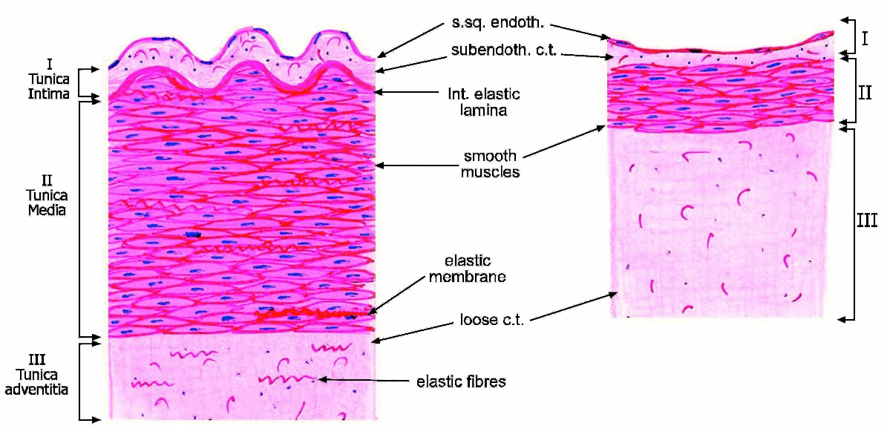
Medium sized vein

Medium sized artery

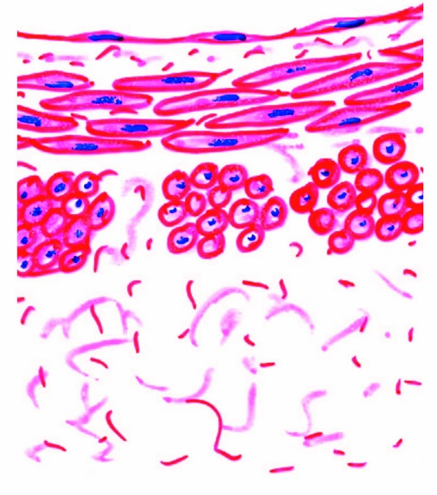
Large veins e.g. Inferior Vena cava:
- Has thick wall &wide lumen
- Tunica intima has No int. EL.
- Tunica media is thin.
- Tunica adventitia: is very thick & contains longitudinal smooth muscle bundles

Connections between Arteries & veins
I- Blood capillaries.
II- Arterio venous anastomoses.

I-Blood Capillaries
Diameter: about 8 μm.
Lumen: narrow.
Structure:
- It is formed of one layer of endothelial cells
- resting on a basement membrane
- which splits to enclose pericytes
Types:
1- Continuous (somatic capillaries)
2- Fenestrated (visceral)
3- Sinusoidal capillaries

POC | Continuous  (somatic) caps. | Fenestrated (visceral) capillaries | Sinusoidal capillaries
Diameter | 8 µm | 8 µm | 5-40 µm
Lumen | Narrow & regular | Narrow & regular | wide& irregular
Endothelium | Continuous | Fenestrated endoth., pores covered by diaphragm Except in kidney | Have pores without diaphragm
Basement membrane | Continuous | continuous | Non continuous  or absent
Pericytes | Present  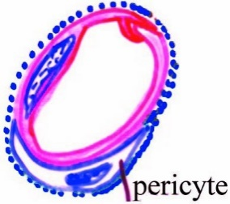 | Present  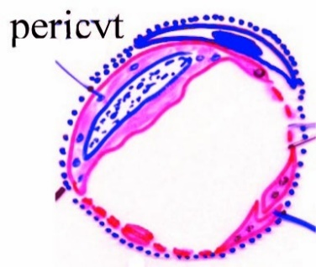 | Macrophage between endoth. cells  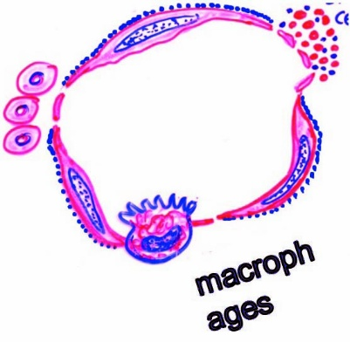
Sites | All over the body  CT  bone, brain,  skin,  Exocrine gland | Intestine  Endocrine glands.  Glomerular capillaries of kidney. | -Liver (carry plasmaprotein)  - Spleen (stored blood)  -Endocrine glands (carry hormones)  -Bone marrow (carry blood cells)

II- Arteriovenous Anastomoses
- Definition:These are direct connections between arterioles and veinules without passing into the capillaries.
- Types:
- Direct: side branch that arise from an arteriole and directly joins the venule
- Indirect: [Glomus]: complicated side branch, branching or convoluted& surrounded by a connective tissue capsule.
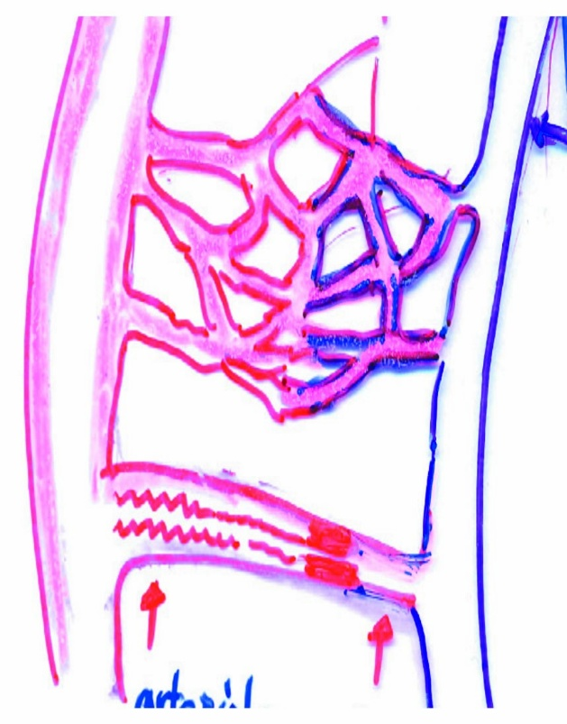
- Structure:
At the arterial side, it is similar to an arteriole. At the venous side, it is similar to a venule. The intermediate segment shows the following:
- The internal elasticlamina gradually disappears.
- The tunica media is replaced by myoepithelial cells to act as a sphincter.
- The adventitia becomes thicker near the venous side.
- Sites:
- Exposed parts of the body:
e.g. external ears, tip of nose, lips, eye lids tips of fingers and toes.
- Internal organs: e.g.
Genital organs (penis, uterus, placenta), G.I.T & endocrine glands.
Functions:
- Regulate body temperature: they dilate on exposure to cold.
- Regulate blood flow to organs to regulate their functions during digestion, absorption and secretion.
- Regulate blood flow to genital organs.
- Regulate the venous return.

Physiology of vascular system

- The four major components of vascular system are:
 |  | - The large arteries |  |  |  | : Rich in elastic fibers & show phenomenon of compliance & elastic recoil.
 |  | - The arterioles |  |  |  | : Have strong muscular coat & are the resistance vessels
 |  | - The capillaries |  |  |  | : Have thin wall & are the exchange vessels.
 |  | - The veins |  |  |  | : Have thin wall & are the major reservoir of the blood
- Basic Principles: Physical factors controlling fluid Flow (F) in a tube:
 |  |  |  | - Pressure gradient (Δ P):
 |  |  |  |  | F ∝ ΔP
 |  |  |  |  |  |  |  |  |  |  |  |  |  |  |  |  |  |  |  |  |  |  |  |  |  |  |  |  |  |  |  | F  Δ P  R  n  L  r |  |  |  | : Flow  : Pressure gradient  : Resistance  : Viscosity of fluid  : Length  : Radius
 |  |  |  |  |  |  |  |  |  |  |  |  |  |  |  |  |  | So
 |  |  |  |  |  |  |  |  |  |  |  |  |  |  |  |  |  |  |  | F ∝ |  |  |  |  |  | Δ P
 |  |  |  | - Resistance (R): |  |  |  |  |  |  |  |  |  |  |  |  |  |  |  |  |  |  |  |  |  | R
 |  |  |  |  | F ∝ |  |  |  |  | 1
 |  |  |  |  |  |  |  |  |  | R
 |  |  |  |  |  |  |  |  |  |  |  |  |  |  |  |  |  |  |  | ΔP ∝F × R
 |  |  |  |  |  |  |  |  |  |  |  |  |  |  |  |  |  |  |  | R ∝ |  |  |  | Δ P
 |  |  |  |  |  |  |  |  |  |  |  |  |  |  |  |  |  |  |  |  |  |  |  | F
 | Factors determining resistance (R):
 | - Radius (r): |  |  |  |  |  | R ∝ |  |  |  | 1
 |  |  |  |  |  |  |  |  |  |  | r⁴
 | - Length (L): |  |  |  |  |  | R ∝ L
 | - Viscosity of fluid (n): |  |  |  |  |  | R ∝ n
 |  |  |  |  |  |  |  | ∴ R ∝ |  |  |  |  | Ln
 |  |  |  |  |  |  |  |  |  |  |  |  | r⁴
 |  |  |  |  |  |  |  | ∴ R = |  |  |  |  | 8 Ln |  |  |  |  |  |  |  |  |  |  |  |  |  | 8 |  |  |  |  |  |  | = constant
 |  |  |  |  |  |  |  |  |  |  |  |  | π r⁴ |  |  |  |  |  |  |  |  |  |  |  |  |  | π
 |  |  |  |  |  |  |  |  | ∴ F = |  |  |  |  | π ΔP r⁴ |  |  |  |  |  |  |  |  | ←This is known as Possielle's Law
 |  |  |  |  |  |  |  |  |  |  |  |  |  | 8 Ln

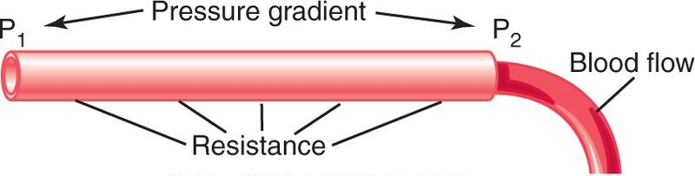
Inter relationships among pressure, resistance, & blood flow
Resistance (R)
- Applying the previous principles on cardiovascular system:
 |  |  |  |  |  |  |  |  |  | Arteries |  |  |  |  | Arterioles |  |  |  |  |  |  | Capillaries | Veins
 | - Pressure difference |  |  |  |  |  |  |  |  | 120-85 |  |  |  |  | 85-35 |  |  |  |  |  |  | 30-10 | 10-0
 | - % of total resistance |  |  |  |  |  |  |  |  | 15% |  |  |  |  | 50% |  |  |  |  |  |  | 25% | 10%
 | - The arteriolar resistance:
 |  |  |  | - Greatest resistance (as they have the narrowest total cross sectional area)
 |  |  |  | - Represents 50 % of resistance as they are: |  |  |  |  |  |  |  |  |  |  |  |  |  |  |  | - Rich in smooth muscle fibers
 |  |  |  |  |  |  |  |  |  |  |  |  |  |  |  |  |  |  |  | - Poor in elastic fibers
 |  |  |  | - Vasoconstriction of arterioles |  |  |  |  |  |  |  |  | → Increase R
 |  |  |  | - Vasodilatation of arterioles |  |  |  |  |  |  |  |  | → Decrease R
 |  | Δ P |  |  |  |  |  | Δ P: The resistance of any part is observed by: Recording the drop of blood pressure before & after crossing this part  F: The overall blood flow in the circulation: Is the cardiac output
 |  | F
 |  |  | In Systemic Circulation
 |  |  | The total peripheral resistance (TPR) is calculated as follows:
 |  |  | R= |  |  |  | Mean aortic pressure - Right atrial pressure
 |  |  |  |  |  |  | Cardiac output
 |  |  | Normally:
 |  |  | R= |  |  |  |  |  | 90-0 |  | = |  |  | 90 |  |  |  |  |  |  | = 18 mmHg/L/min
 |  |  |  |  |  |  |  |  | 5 |  |  |  |  | 5
 |  |  | R= |  |  |  |  |  | ΔP
 |  |  |  |  |  |  |  |  | F
 |  |  | - In Exercise: CO increases and ΔP is constant, so R is decreased
 |  |  | - In systemic Hypertension: CO is constant and ΔP increases, so R is increased

 | In Pulmonary Circulation |  |  |  |  | The Resistance (R)
 | R= |  | Mean pulmonary artery pressure - Left atrial pressure
 |  |  | Cardiac output
 | Normally:
 | R= | 20-5 |  | = | 15 |  | = 3 mmHg/L/min
 | R= | 5 |  | = | 5

Blood Flow

Definition | - The volume of blood that passes a certain point in the circulation (L/min or ml/min)
 | - The overall blood flow in the circulation: Is the cardiac output
 | Two fluids (one dyed red and the other is clear)
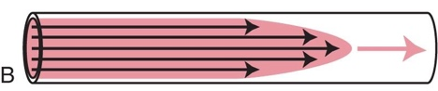
b. Laminar flow The same fluid 1 second after flow begins
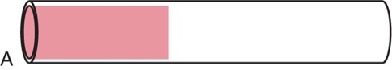
a. Before flow begins
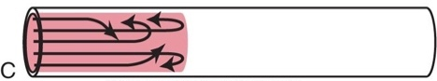
c. Turbulent flow
Types
Laminar flow |  |  | Blood flows in parallel layers (laminae)
 |  |  | - The blood in contact with the vascular wall does not move
 |  |  | - The next layers slide over the stationary layer
 |  |  | - The velocity is maximal at the center
 |  |  | - It is silent (ie not heard by stethoscope)
Turbulent flow: |  |  |  | - Occurs when blood flow velocity exceeds a critical velocity as in:
 |  |  |  |  | - Narrowing of arterioles eg Atherosclerosis or constriction
 |  |  |  |  | - Decrease viscosity as in anemia
 |  |  |  | - Turbulent flow produces a sound

Velocity |  |  | Velocity of blood flow:
 |  |  | - In Aorta: |  | = 0.5 meter/sec [It is a high velocity to ensure rapid delivery of blood to tissues]
 |  |  | - In Capillaries: |  |  | = 0.5 mm/sec [It is a slow velocity to gives enough time for exchange]
NB: Kidney has the highest blood flow /100 gram tissues
 |  | Organ |  | % of CO at rest |  |  | Change at activity
 |  | Skeletal ms |  | 20% |  |  | 10 times
 |  | Skin |  | 5% |  |  | 4times
 |  | Heart |  | 5% |  |  | 4times
 |  | Kidney |  | 20% |  |  | decrease
 |  | Liver |  | 25% |  |  | decrease
 |  | Brain |  | 15% |  |  | No change

Physiology
Arterioles:
 | - Responsible for 50% of circulatory resistance
 | - Arterioles possess the narrowest total cross sectional area being:
 |  |  |  |  |  |  |  |  | - Rich in muscular wall
 |  |  |  |  |  |  |  |  | - Poor in elastic fibers
Regulating of Diameter of Arteriole
Consist of 2 major mechanisms (methods):
Central Mechanisms
-Aim: Of central regulation is to regulate the total peripheral resistance (TPR) to maintain a constant ABP to ensure adequate blood supply to vital organs (heart & brain)
- Central mechanisms includes (consists of) 2 mechanisms:
Neural mechanism
Consists of 2 types of fibers:
- Vasoconstrictor fibers (CV): One type
 |  | - All VC fibers to arterioles are sympathetic
 |  | - Through α-adrenergic receptors
 |  | - To all arterioles except heart+ brain
- Vasodilator fibers (VD): 3 types
 |  | Sympathetic VD fibers:
 |  |  | - To blood Vessels of skeletal muscles
 |  |  |  | - Originate in cerebral cortex, descend to LHCs directly
 |  |  |  | - Through cholinergic receptors
 |  |  |  | - Produce VD even before the start of exercise
 |  |  | - To coronary vessels: Through B1 adrenergic receptors
 |  | Parasympathetic VD fibers:
 |  |  | - To genital tract: Only parasympathetic which is truly VD. It causes erection
 |  |  | - Other VD which occurs as a result of parasympathetic is secondary to increase metabolic activity
 |  | Antidromic VD impulses: |  |  |  |  |  | Stimulation of skin pain receptors

 |  | Vasoactive substances |  |  |  |  |  |  |  |  |  | Consists of 2 types:
 |  | - Circulating VD substances:
 |  |  | Kinins:
 |  |  |  |  |  | - Types: | - Bradykinin (Nano peptide)
 |  |  |  |  |  |  | - Lysyl Bradykinin
 |  |  |  |  |  | - Chemical nature: Both are peptides
 |  |  |  |  |  | - Formation: From precursor proteins: |  |  |  |  |  |  |  |  |  |  |  | - High MW kininogen (HMW)
 |  |  |  |  |  |  |  |  |  |  |  |  |  |  |  |  |  | - Low MW kininogen (LMW)
 |  |  |  |  |  | - Functions: |  |  |  | - Relaxes smooth ms of Bl. Vessels→ VD & decrease ABP.
 |  |  |  |  |  |  |  |  |  | - Contracts smooth ms of hollow viscera.
 |  |  |  |  |  |  |  |  |  | - Increase capillary permeability.
 |  |  |  |  |  |  |  |  |  | - +Ve chemotaxic effect.
 |  |  |  |  |  |  |  |  |  | - Stimulates pain receptors.
 | ANP "Atrial Naturetic Peptide":
 |  |  |  |  | - Chemical nature: Peptides
 |  |  |  |  | - Secreted by: Atrial muscle cells
 |  |  |  |  | - Stimuli for its release: |  |  |  |  |  |  |  |  | - Increase NaCl in plasma
 |  |  |  |  |  |  |  |  |  |  |  |  |  | - Increase ECF volume
 |  |  |  |  | - Actions: |  |  | - Naturesis ie increase Na⁺ excretion, which is accompanied by Cl loss & H₂O loss (Diuresis)
 |  |  |  |  |  |  |  | - Anti-aldosterone effect: It inhibit Na-K ATPase
 |  |  |  |  |  |  |  | - Decrease the response of smooth muscle of BV to circulating VC substances
 |  |  |  |  |  |  |  | - Decrease conversion of prorenin into renin
 |  |  |  |  |  |  |  | - Decrease secretion of: |  |  |  |  |  |  |  |  | - Vasopressin
 |  |  |  |  |  |  |  |  |  |  |  |  |  |  |  |  | - Aldosterone
 |  |  |  |  |  |  |  |  |  |  |  |  |  |  |  |  | - Opposes action of Angiotensin II
 |  |  |  |  |  |  |  | - Decrease ABP
 | Histamine |  |  |  |  |  |  |  | VD specially in allergic and inflammatory conditions
- Circulating VC substances: Includes
 | Catecholamines |  |  |  |  |  |  |  |  |  | Adrenaline
 |  |  |  |  |  |  |  |  |  |  | Noradrenalin
 |  |  |  |  |  |  |  |  |  |  | NB: Noradrenaline has a stronger VC effect than adrenaline
 |  |  |  |  |  |  |  |  |  |  | - Adrenaline causes VD in liver & skeletal muscle
 | Angiotensin II
 |  |  |  | - Chemical nature: Octapeptide (8 a.a.)
 |  |  |  | - Stimulus of secretion: Decrease renal blood flow as in hemorrhage
 |  |  |  | - Formation: Renal ischemia→ renin (released by Juxta Glomerular Cells)
Lung
- Functions: | Increase ABP by 2 mechanisms:
- Powerful VC: In seconds (rapid)
- VC of arterioles → increase TPR “Total Peripheral Resistance”→↑ CO →↑ABP
- VC of veins → increase venous returns (VR) →↑ CO → ↑ABP
- Salt & water retention:
- increase ECF volume→ increase VR→ ↑ CO increase ABP
Vasopressin = ADH “Antidiuretic Hormone”
- Water reabsorption
- Vasoconstriction
Local Mechanisms
- It regulates blood flow according to the local metabolic needs of tissues
- Local mechanisms includes (consists of) 2 mechanisms:
Auto regulation
Definition: | It is the ability of a tissue to regulate its own blood flow
Site: | Autoregulation is well developed in: |  |  |  |  |  | Heart |  |  | Skeletal muscle
 |  |  |  |  |  |  | Kidney |  |  | Liver
 |  |  |  |  |  |  | Brain |  |  | Mesentery
Theories:
- Myogenic theory: |  |  | - It is Bayliss response (intrinsic response)
 |  |  | - Stretch of smooth muscle → contraction
- Metabolic theory: |  | - On increase tissue activity or decrease blood flow, vasodilator metabolites accumulate → VD → Increase blood flow
 |  | - VD metabolites are: |  |  |  | - Low O₂ & Low pH in most tissues
 |  |  |  |  |  | - Increase CO₂ in brain, skin
 |  |  |  |  |  | - K+ in skeletal muscle
 |  |  |  |  |  | - Adenosine in cardiac muscle
 |  |  |  |  |  | - Lactate + Increase temperature of tissue activity
 |  |  |  |  |  | - Histamine in inflammation

Substances secreted by Endothelium:
Include: |  |  | - Prostacyclin
 |  |  | - EDRF
 |  |  | - Endothelins
- Act as a paracrine hormones.
- Regulate cardiovascular functions:
 | - Prostacyclin:
 |  | - Chemical nature: Is derived from arachidonic acid via cyclooxygenase enzyme (COX)
 |  | - Formed by: Endothelial cells
 |  | - Functions: |  | - Decrease platelets aggregation
 |  |  |  | - VD
 | - Endothelium derived relaxing factor: EDRF (Nitric Oxide "NO"):
 | - Chemical nature: |  |  |  | - It Is Nitric Oxide (NO)
 |  |  |  |  | - Synthesized from Arginine by calmodulin dependent NO synthetase.
 | - Mechanism of action: |  |  |  |  | It activates Guanylate cyclase enzyme producing cGMP which relaxes the smooth muscles

 | - Functions: |  |  | Role in CVS: |  |  | - It is inactivated by Hb.
 |  |  |  |  |  |  | - Its tonic release is necessary for normal ABP
 |  |  |  |  |  |  | - Its deficiency causes hypertension
 |  |  |  |  |  |  | - It is released by:
 |  |  |  |  |  |  |  | - Acetylcholine: Which is vasodilator, but if applied to a vessel with removed endothelium → VC
 |  |  |  |  |  |  |  | - Bradykinin, VIP, substance P
 |  |  |  |  |  |  |  | - Product of platelet aggregation if endothelium is intact
 |  |  |  | It causes penile erection
 |  |  |  | Involved in pathogenesis of atherosclerosis
 |  |  |  | It is produced by macrophages & is necessary for its cytotoxic action & kills cancer cells.
 |  |  |  | It plays a role in brain (via cGMP)
 |  |  |  | Nitroglycerine [in treatment of angina] acts by increase cGMP
 | - Endothelins: Most potent VC produced by endothelium
 | - Chemical nature: 21 amino acids polypeptides 4 types:
 |  |  |  |  |  |  |  |  | - ET1 (Enodothelin 1)
 |  |  |  |  |  |  |  |  | - ET2
 |  |  |  |  |  |  |  |  | - ET3
 |  |  |  |  |  |  |  |  | - VIC (vasoactive intestinal contractor)
 | - Receptors: 2 types |  |  |  | - ETA receptor: Responds to ETl
 |  |  |  |  | - ETB receptor: To all.
 | - Cardiovascular effects: |  |  |  |  | - Contracts vascular smooth muscle, veins > arteries.
 |  |  |  |  |  | - VC of coronaries (intense VC).
 |  |  |  |  |  | - VC of renal vessels → Increase resistance.
 |  |  |  |  |  | - Decrease renal blood flow → decrease GFR (glomerular filtrate rate).
 |  |  |  |  |  | - +Ve inotropic and+ Ve chronotropic effects.
- Increase catecholamine, renin, aldosterone & ANP.

Circulation
Cardiovascular system is composed of: |  |  |  |  |  |  |  |  |  |  |  |  |  |  | - Heart
 |  |  |  |  |  |  |  |  |  |  |  |  |  |  | - A closed system of blood vessels
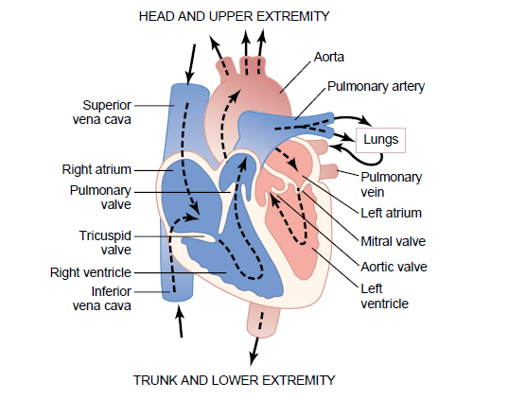
Structure of the heart, and course of blood flow through the heart chamers and heart valves
Heart: | It beats automatically & regularly before birth till death
 | - In systole |  |  |  |  |  |  | : Cardiac contraction to eject blood
 | - In diastole |  |  |  |  |  |  | : Cardiac relaxation to be filled with blood
 | - Formed of: |  |  |  |  |  |  |  | - 2 Separate pumps:
 |  | - Right side pump |  |  |  |  |  |  |  |  |  |  | : Pumps blood to lungs against low resistance & under low pressure (volume pump)
 |  | - Left side pump |  |  |  |  |  |  |  |  |  |  | : Pumps blood to the whole body against high resistance & under high pressure (pressure pump)
 |  | - Each pump Formed of:
 |  |  |  | - Atrium: |  |  |  |  |  | - Thin wall
 |  |  |  |  |  |  |  |  |  | - Acting mainly as reservoir of blood
- Blood passes from atria to ventricles:
70% of blood passes passively by pressure gradient
 |  |  |  |  |  |  |  |  |  | While 30 % of blood passes by atrial systole (contraction)
 |  |  |  | - Ventricle: |  |  |  |  |  |  |  | - Thick wall
 |  |  |  |  |  |  |  |  |  |  |  | - Acting as a pump:
 |  |  |  |  |  |  |  |  |  |  |  | Right Ventricle (RV):
 |  |  |  |  |  |  |  |  |  |  |  |  | - Acts as a volume pump
 |  |  |  |  |  |  |  |  |  |  |  |  | - It propels blood through pulmonary circulation (pulmonary artery)
 |  |  |  |  |  |  |  |  |  |  |  | Left Ventricle (LV):
 |  |  |  |  |  |  |  |  |  |  |  |  | - Acts as a pressure pump
 |  |  |  |  |  |  |  |  |  |  |  |  | - It propels blood through peripheral circulation (Aorta)
Valves:
Function: To allow the passage of blood in one direction only and not the reverse.
 | - Atrioventricular valves (AVV):
 |  |  |  |  |  |  | - Tricuspid valve: Is the right AVV (formed of 3 cusps)
 |  |  |  |  |  |  | - Mitral valve: Is the left AVV (formed of 2 cusps)
 | - Semilunar Valves (their opening looks like a crescent):
 |  |  |  |  | - Aortic valve |  |  |  |  |  |  |  |  | : Between left ventricle & aorta
 |  |  |  |  | - Pulmonary valve |  |  |  |  |  |  |  |  | : Between right ventricle & the main pulmonary artery
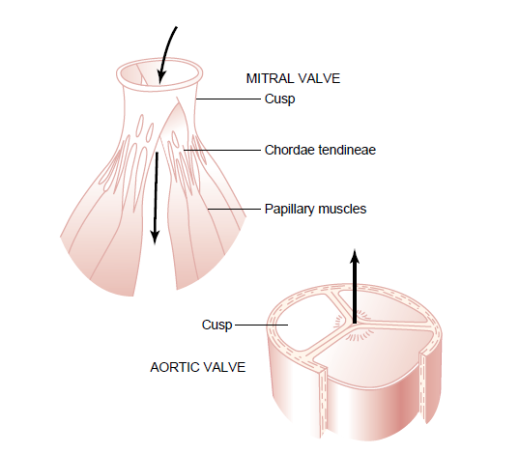
Mitral and aortic valves (the left sided valves)

Circulation: |  | Is divided into 2 circulations:
 | Pulmonary circulation: |  | (Lesser circulation)
 |  | From right ventricle, deoxygenated blood is pumped to pulmonary artery → pulmonary capillaries (where gas exchange occurs) → pulmonary veins → to left atrium
 | Systemic Circulation: |  |  | (=General or Greater circulation)
 |  | From left ventricle, oxygenated blood is pumped to aorta→ to all parts of body (via arteries, arterioles & capillaries)→ venules→ veins → SVC & IVC → to right atrium

 | Special Cardiac Muscle Tissue |  |  |  |  |  |  |  | = Functional Tissue = Conductive tissue
 | - Responsible for initiation & propagation of cardiac impulse
 | - Types of special cardiac muscle Tissue:
- Nodal tissue: |  |  |  | (Automatic -pacemaker fibers)
 |  | - Smaller muscle fibers
 |  | - Initiate the cardiac impulses
 |  | - Located in 2 areas:
 |  |  |  |  | SAN  (Sinoatrial Node) |  |  |  |  |  | AVN  (Atrio-ventricular Node)
 |  |  | Site |  | Right atrium, superior lateral wall near opening of SVC |  |  |  |  |  | Right posterior portion of interatrial septum
 |  |  | Rhythm |  | 90 /min |  |  |  |  |  | 60 /min
 |  |  | Nerve supply |  | 1-Sympathetic |  |  |  |  |  | 1-Sympathetic
 |  |  |  |  | 2- Right vagus |  |  |  |  |  | 2- Left vagus
 |  |  | Function |  | It is the normal Pacemaker of the heart |  |  |  |  |  | It becomes the pacemaker if SAN is damaged
 |  | - The internodal atrial pathway: |  |  |  |  |  | - Begins from: SAN
 |  |  |  |  |  |  |  | - Ends in: AVN
 |  |  |  |  |  |  |  | - They are anterior, middle & posterior
- Conducting tissue
 |  | It carries the cardiac impulse from atria to ventricles, and through ventricular muscle bulk:
 |  | - AV Bundle (His bundle) = atrio-ventricular bundle:
 |  |  | - Arises from AVN, pass through AV ring to the upper part of interventricular
 |  |  | septum where it divides into 2 branches: |  |  |  |  |  |  | Right bundle branches  Left bundle branches
 |  |  | - It is the only electrical connection between atria and ventricles
 |  | - Right & Left bundle branches:
 |  |  | Pass down on either sides of interventricular septum, beneath endocardium, to reach the apex of heart, then reflected upwards to reach the base of heart
 |  | - Purkinje fibers: |  |  |  | - Very small branches
 |  |  |  |  |  | - Arises from: Bundle branches
- Passing from endocardium to pericardium
Anatomical considerations: 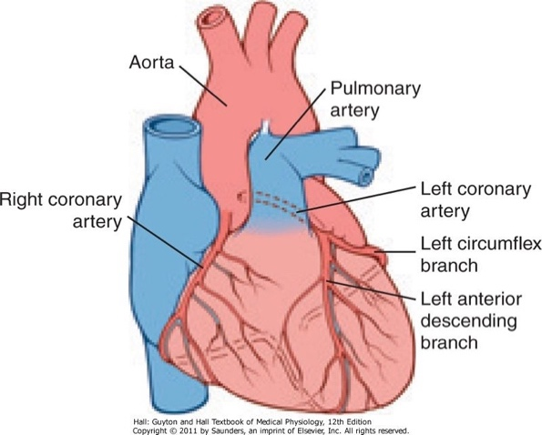
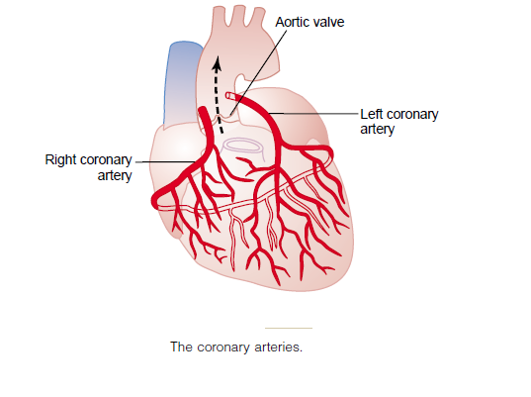
The coronary arteries
Coronay arteries: |  |  |  |  | - (Rt & Lt) arise from coronary sinuses above aortic valve
 |  |  |  |  | - Lt Coronary artery: Supplies anterior + lateral parts of left ventricle
 |  |  |  |  | - Rt Coronary Artery "RCA": Supplies right ventricle and posterior part of left ventricle
Venous Drainae: |  |  |  |  | - Of left ventricle: Drains into Rt atrium [through coronary sinus] (75% of coronary blood)
 |  |  |  |  | - Of right ventricle: Drains directly into Rt atrium [through small anterior cardiac veins]
Coronay capillars: |  |  |  |  | - One capillary for each cardiac muscle fiber
- On ventricular hypertrophy capillary number does not increase → myocardial ischemia →
ischemic cardiomyopathy → heart failure later on

Functial consideration: |  |  |  |  | - At rest: heart extracts 70 - 80 % of O2 in coronary blood, so,  to satisfy increased cardiac demands the only way is to increase coronary blood flow
- Many anastomoses exist among small arteries, of great value in obstruction of one coronary artery

Coronary Artery Diseases (CAD) “IHD”:
 | Decrease coronary blood flow → |  |  |  |  |  |  |  | Hypoxia → Angina pectoris
 |  | Complete Cessation or Severe decrease coronary blood flow →
 |  |  | Myocardial infarction (MI)
 |  |  | - Causes of death in myocardial infarction: |  |  | - Decrease cardiac output → shock
 |  |  |  |  |  | - Acute Pulmonary edema
 |  |  |  |  |  | - Arrhythmia: Ventricular fibrillation
 |  |  |  |  |  | - Rupture of infarcted area

Assessment of coronary blood flow:
 |  | 1- Fick 's principle: |  |  |  |  | - Using N₂O (Kety method) 15%
 |  |  |  |  |  |  | - For 10 minutes
 |  |  |  |  |  |  | - Arterial sample is taken from any artery
 |  |  |  |  |  |  | - Venous sample is taken from coronary sinus
 |  |  |  |  |  |  | - Serial samples are taken
 |  |  |  |  |  | Coronary blood flow = |  |  |  |  |  |  |  | N₂O taken by the heart/min
 |  |  |  |  |  |  |  |  |  |  |  |  |  | (A-V) coronary N₂O difference
 |  |  |  |  |  | = 80 ml/100 gram heart tissue/min at rest
 |  |  |  |  |  | = 600 ml/100 gram heart tissue/min at exercise.
 |  | 2- MPI |  | “Myocardial Perfusion Imaging”
 |  |  |  | Thallium: Detects areas of ischemia which will have low uptake
 |  |  |  | Technetium: Detects areas of ischemia which will have much more uptake
 |  | 3- Coronary Angiography: |  |  |  |  |  |  | Convention by: Cardiac catheter angiography
 |  |  |  |  |  |  |  |  | By MSCT “ Multi slice computerized tomography ”
 |  |  |  |  |  |  |  |  | Shows the distribution of coronary artery
Regulation of Coronary blood flow:
 |  | - Auto regulation: |  |  | Intrinsic mechanism
 |  |  | - Increase Cardiac work |  |  |  |  | as in |  |  |  | → coronary VD
 |  |  |  | Hypoxia, increase CO₂, Increase H⁺, K⁺, lactate, prostaglandin and adenosine
 |  |  | - Hypoxia is the most important VD by 2 ways:
 |  |  |  |  |  |  |  |  |  |  | - Direct effect on coronary vessels
 |  |  |  |  |  |  |  |  |  |  | - Release of VD substances, mostly Adenosine

 |  | - Mechanical Regulation:
 |  |  | - Variation in coronary blood flow during cardiac cycle
 |  |  | - Left coronary artery is much more affected than Rt one by systole and diastole due to stronger Lt ventricular contraction
 |  |  |  | - During Systole: Decrease coronary blood flow
 |  |  |  |  | - Isometric contraction phase: Minimal coronary flow
 |  |  |  |  | - Maximal ejection phase: Relative increase due to Increase aortic pressure.
 |  |  |  |  | - Reduced ejection phase: Relative decrease due to decrease aortic pressure
 |  |  |  | - During Diastole: Increase coronary blood flow
 |  |  |  |  | - Isometric Relaxation phase: Maximal increase
 |  |  |  |  | - Rest of diastole: Coronary flow decrease gradually due to decrease aortic pressure
 |  |  |  |  |  | NB: | Coronary flow decrease in:
 |  |  |  |  |  |  | - Paroxysmal tachycardia: Shortened diastole
 |  |  |  |  |  |  | - Aortic Regurgitation: Due to decreased DBP
 |  |  |  |  |  |  | - Aortic Stenosis: Due to decreased mean ABP

 | - Neural factors: |  | Sympathetic:
 |  |  | Coronary artery contains 2 types of receptors:
 |  |  | - α adrenergic receptors: Mediate VC
 |  |  | - β adrenergic receptors: Mediate VD
 |  |  | - However sympathetic stimulation →VD due to increase work
 |  |  | Vagus (parasympathetic): Cause VC

Arterial Blood Pressure "ABP"

Definitions:
- Arterial Blood Pressure |  |  |  | (ABP): |  | It is the pressure of blood on arterial wall
- Systolic Blood Pressure |  |  |  | (SBP): |  | - It is the maximum pressure reached during systole  - Normally it equals: 120 mmHg (90 -150)
- Diastolic Blood Pressure |  |  |  | (DBP): |  | - It Is the minimum pressure reached during diastole  - Normally it equals: 70 mmHg (60 - 90)
- Pulse pressure: |  | - = Systolic pressure - diastolic pressure  - Normally it equals = 50 mmHg
- Mean systemic arterial pressure (MAP) |  |  |  |  |  |  | : It is the average pressure in arteries throughout the cardiac cycle  MAP = DBP + ⅓ Pulse pressure  = 70 + ½× 50= 90 mmHg.
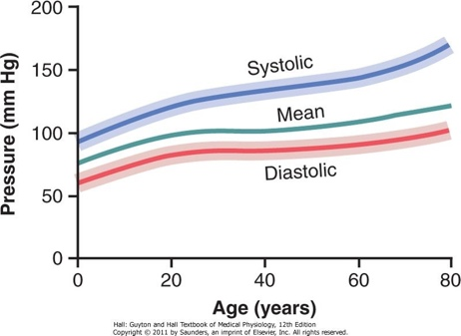
- Changes in ABP with age: |  | SBP systolic
 |  | DBP diastolic
 |  | MAP and mean arterial pressures

Measurement: |  | 2 methods:
 |  |  | Direct |  | : By cardiac catheter (invasive method)
 |  |  | Indirect |  | : By sphygmomanometer (noninvasive method)
Physiological Variations in ABP:
- Age: | ABP increases with age due to loss of elasticity |  |  |  |  |  |  |  | - New born | = 80/40
 |  |  |  |  |  |  |  |  | - 4 years | = 100/65
 |  |  |  |  |  |  |  |  | - 20 years | = 120/70
 |  |  |  |  |  |  |  |  | - 60 years | = 150/90
- Sex: | - Below 45 y female have less ABP than male
 | - Above 45 y the pressure increases in female due to hormonal changes
- Race: | Europeans+ Americans > Orientals due to: stress & high cholesterol in diet
- Emotions: | Sympathetic →Increase ABP especially SP
- Exercise: | → Increase SP +decrease DP
- Gravity: | - each 1 cm below heart increases ABP by 0.77 mmHg
 | - Each 1 cm above the heart decreases ABP by 0.77 mmHg
- Respiration: | Traube-Herring waves are fluctuations of ABP during respiration:
 | - At start of resp.: Decrease ABP, as inspiration → VD (via vagus)
 | - The highest increase in ABP at late inspiration + early expiration

FFactors which determine normal ABP | (ABP = Co × TPR)

Cardiac output |  | COP= SV × HR
 |  | - Stroke volume: |  |  |  |  |  | If HR is kept constant
 |  |  |  |  |  |  |  | - Increase SV will increase systolic pressure
 |  |  |  |  |  |  |  | - Decrease SV will decrease systolic pressure
 |  | - Heart rate: |  |  |  |  | If SV is kept constant
 |  |  |  |  |  |  | - Increase HR will increase diastolic pressure
 |  |  |  |  |  |  | - Decrease HR will decrease diastolic pressure
Elasticity |  | - Elastic fiber of aorta act as buffer to prevent excessive rise in systolic pressure and excessive drop in diastolic pressure
Volume of blood in relation to capacity of circulation
 | - If capacity is kept constant: |  |  |  |  | - Increase volume of blood lead to increase ABP
 |  |  |  |  |  | - Decrease volume of blood lead to decrease ABP
 | - If volume is kept constant: |  |  |  |  | - Increase capacity (V.D) lead to decrease ABP
 |  |  |  |  |  | - Decrease capacity (V.C) lead to increase ABP
Total peripheral resistance
 | - TPR depend on diameter of arterioles and viscosity of blood
 | - Diameter of arterioles |  |  | - VC lead to increase TPR & ABP
 |  |  |  | - VD lead to decrease TPR & ABP
 | - Viscosity of blood |  | - Increase viscosity lead to increase TPR & ABP
 |  |  | - Decrease viscosity lead to decrease TPR & ABP
Regulation of Arterial Blood Pressure:
 | Regulated by 3 mechanisms: |  |  |  | - Rapid |  |  |  |  | : Nervous mechanism
 |  |  |  |  | - Intermediate |  |  |  |  | : Capillary fluid shift mechanism
 |  |  |  |  | - Slow |  |  |  |  | : Hormonal & renal mechanisms
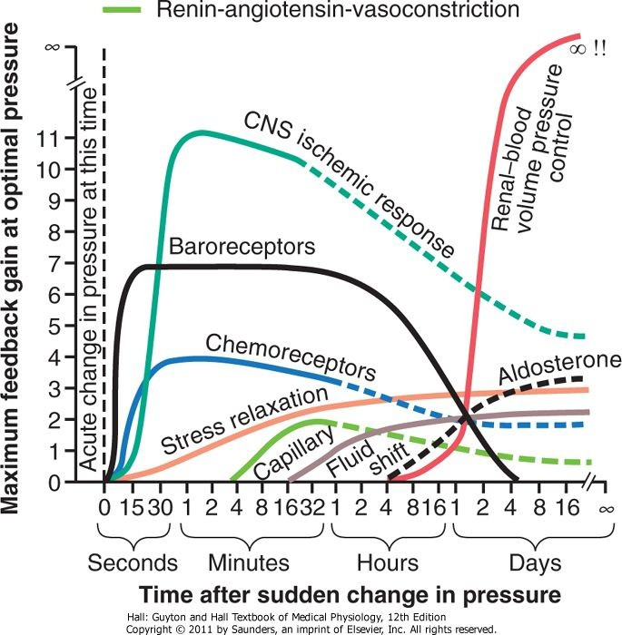  Approximate potency of various arterial pressure control mechanisms at different time intervals after onset of a disturbance to the arterial pressure. Note especially the infinite gain (∞) of the renal body fluid pressure control mechanism that occurs after a few weeks |  |  |  |  |  |  |  |  | 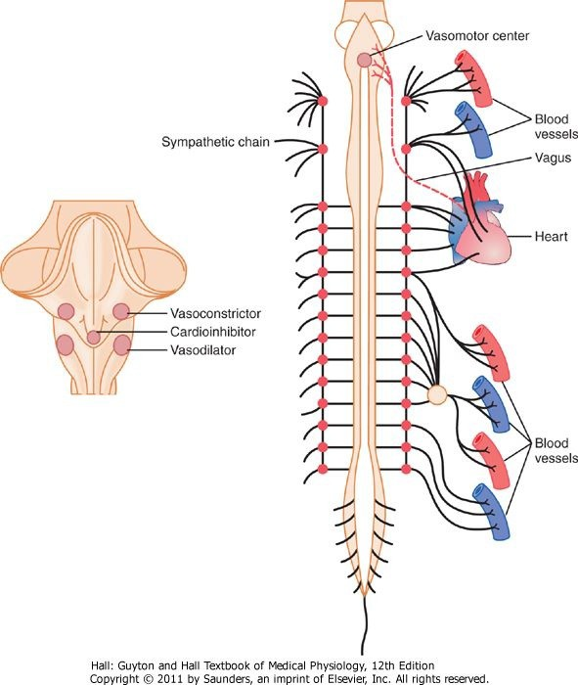  Anatomy of sympathetic nervous control of the circulation.  Also shown by the dashed red line, a vagus nerve that carries parasympathetic signals to the heart

DD

Regulation of Arterial Blood Pressure
 | Nervous Mechanism: | Rapid Mechanism
 | Cardiovascular centers are present in medulla: 2 areas:

 |  | Pressor Area (PA) |  |  |  |  |  |  |  |  |  |  |  |  |  |  |  |  |  |  | Depressor Area (DA)
Site |  | - Lateral reticular formation |  |  |  |  |  |  |  |  |  |  |  |  |  |  |  |  |  |  | - Central + dorsal to PA
Formed of |  | 2 Centers: |  |  |  |  | - Cardiac Stimulatory Center (CSC) |  |  |  |  |  |  |  |  |  |  |  |  |  | 2 Centers: |  |  |  |  | - Cardiac Inhibitory Center(CIC)
 |  |  |  |  |  |  | - Vasoconstrictor Center (VCC) |  |  |  |  |  |  |  |  |  |  |  |  |  |  |  |  |  |  | - Vasodilator Center (VDC)
 |  | CSC |  |  |  |  |  |  |  |  |  |  | VCC |  |  |  |  |  |  |  | CIC |  |  |  |  |  |  |  |  | VDC
 |  | - Its discharge reaches heart via sympathetic: |  |  |  |  |  |  |  |  |  |  | - It has a continuous tone under resting conditions known as Vasoconstrictor tone. |  |  |  |  |  |  |  | - Its discharge reaches heart via vagus |  |  |  |  |  |  |  |  | - It inhibits the VCC
 |  | - Increase atrial properties → increase heart rate → ↑ CO  ↑ ABP |  |  |  |  |  | - Increase ventricular properties → Increase SV → increase CO → increase ABP |  |  |  |  | - VC of arterioles → increase TPR → increase ABP |  |  |  | - VC of veins → increase VR → increase CO → increase ABP |  |  |  | - Decrease atrial properties →decrease heart rate →decrease CO → decrease ABP |  |  |  | - No effect on ventricles
 |  | NB: There is reciprocal innervations between PA & DA (ie a stimulus which stimulate PA will inhibit DA)
 |  | NB: | ABP =CO × R |  |  |  |  |  |  | So increase CO or increase R lead to increase ABP
 | The activity of these centers is modified by afferents from:

Receptors inside CVS
 | Arterial Baroreceptors
 |  | Type: | - Mechanoreceptors: |  |  |  | - Present in adventitia
 |  |  |  |  |  |  | - Respond to stretch of the wall.
 |  | Site: | - Aortic Arch
 |  |  | - Carotid sinus
 |  | Nervous connection: | - Both aortic arch nerve and carotid sinus nerve are buffer
 |  |  | nerves: |  | - Aortic Arch: → 10th cranial nerve
 |  |  |  |  | - Carotid sinus: → 9th cranial nerve
 |  | Stimuli: | ABP between 60-180 mmHg.
 |  |  |  | - Between 60- 180, the more the pressure, the more the impulses coming out.
 |  |  |  | - Maximal rate of discharge occurs at 180 mmHg.
 |  |  |  | - Above 180, no more increase in discharge
 |  | Adaptation: | - Non adapting receptors as they receive very important data.
 |  | Function: | - They send inhibitory impulses to (PA)
 |  |  | - If ABP decreases as in hemorrhage → decrease in inhibitory Impulses to presser area (PA) → PA is released from inhibition → PA raises ABP (discuss).
NB: |  | Carotid Sinus Syndrome:  Very sensitive carotid sinus reflex, in some people, carotid sinus baroreceptors respond to mild pressure (eg shaving, collar, turning head) & causing marked decrease in ABP, cerebral ischemic & subsequently fainting

 | Atrial volume receptors
 |  | Type: | Stretch receptors
 |  | Site: | Wall of both atria (near opening of big veins)
 |  | Nervous connection: | 10th nerve
 |  | Stimuli: | Increase CVP (central venous pressure) as a result of:
 |  |  |  | - Increased blood volume
 |  |  |  | - Increased venous return (VR)
Function: (Response)
 |  | - If CVP increased:→VD → decrease ABP
 |  | - If CVP decreased: →
 |  | - Increase sympathetic activity → ++ PA→ ++ ABP
 |  | - Increase renin → increase aldosterone [Salt & water retention (increase blood volume ↑ VR ↑ CO ↑ ABP )]
- Increase Vasopressin → water retention (increase blood volume ↑ VR
↑ CO ↑ ABP)

 | Peripheral Chemoreceptors
 |  | Type: |  |  | Beside their main role in respiration, it also regulates ABP
 |  | Site: |  |  | - Aortic bodies: At aortic arch
 |  |  |  |  | - Carotid bodies: At carotid bifurcation
 |  | Nervous connection: |  |  | Buffer nerves: | - Aortic bodies: → Branch of 10th nerve
 |  |  |  |  |  | - Carotid bodies: → Branch of 9th nerve
 |  | Stimuli: |  | - Low O₂ tension
 |  |  |  | - Increased CO₂ tension
 |  |  |  | - Increased H⁺
- Hypotension (40 - 60 mmHg) due to hemorrhage:
This drop in ABP causes stagnant hypoxia of chemoreceptors which leads to their stimulation

- Hypotension (40 - 60 mmHg) due to hemorrhage:
This drop in ABP causes stagnant hypoxia of chemoreceptors which leads to their stimulation
 | Response: |  | - Stimulate PA → VC & Increase CO & ↑ ABP

 |  |  |  |  |  |  |  | Left Ventricular Receptors
 |  |  |  |  |  |  |  |  | - Considerable ventricular distension: Stimulates mechanoreceptors in the wall → decrease HR →decrease ABP
 |  |  |  |  |  |  |  |  | - In myocardial infarction (MI): The infracted muscle fibers release chemical substances which stimulate mechanoreceptors decrease HR & ABP
 |  |  |  |  |  |  |  | Pulmonary Receptors
 |  |  |  |  |  |  |  |  | - Distension of pulmonary vessels - decrease HR & ABP
 |  |  | Receptors outside CVS
 |  |  |  |  |  | - Cutaneous pain: Increase HR → increase ABP due to adrenaline secretion
 |  |  |  |  |  | - Visceral pain: Decrease HR decrease ABP & may be shock
 |  |  |  |  |  | - Alam-Smirk Reflex: |  |  |  |  |  | Muscle exercise → stimulation of proprioceptors → increase HR → increase ABP
 |  | Effect of Higher Centers
 |  |  |  |  |  |  | - Cerebral Cortex: |  |  |  | Before the beginning of exercise, it send impulses to reach medullary CVS centers through hypothalamus → increase HR & ABP.
 |  |  |  |  |  |  | - Hypothalamus: |  |  |  | Emotions+ exercise → stimulate PA & inhibit DA → increase HR & ABP
 | Effect of Changes in Blood Gases
 |  |  |  |  | - Indirect mechanism: Role of chemoreceptors on CVS (as before).
 |  |  |  |  | - Direct mechanism: ie direct action on PA & DA.
 |  |  |  |  | Mild decrease O₂ & increase CO₂→ increase ABP.
 |  |  |  |  | Severe decrease O₂ & increase CO₂ → decrease ABP & death.
 |  |  | Capillary Fluid Shift Mechanism |  |  |  |  |  |  |  |  |  | Intermediate Mechanism
 |  |  | - If blood volume is increase →increase ABP → increase capillary hydrostatic pressure → increase filtration of fluid from plasma to the tissue fluid → decrease plasma volume → decrease VR → decrease ABP
Role of Kidney = Hormonal Regulation of ABP |  |  |  |  | Slow Mechanism
 | - Kidney regulates ABP by regulating plasma volume (and ECF "Extra Cellular Fluid" volume)
 | - It is the most important mechanism for ABP regulation
 | - If ABP decreases → It is increased by 2 mechanisms:
 |  | Atrial Mechanoreceptor
 |  |  | Decrease ABP → decrease blood volume → decrease CVP → decrease discharge from atrial receptors → increase secretion of aldosterone & ADH → increase salt & H₂O Retention → increase ECF volume → increase VR → increase ventricular filling → increase CO → increase ABP.
 |  | Renin-Angiotensin system
 |  |  | - Decrease ABP → renal ischemia → renin release. …………. discuss
 |  |  | - NB: Increase ABP will cause increase excretion of salt & H₂O
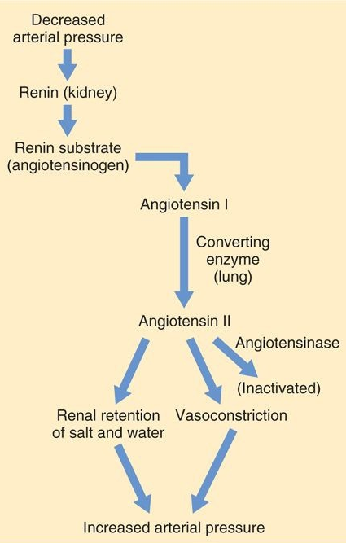
Renin-angiotensin vasoconstrictor mechanism for arterial pressure control
- If blood volume is Decrease → decrease ABP → decrease capillary hydrostatic pressure → decrease filtration of fluid at arteriolar end of capillaries → increase reabsorption at venular end → increase plasma volume → increase VR → increase ABP.
ie Tissue fluid acts as a reservoir for plasma

Venous return
- Definition: |  | - It is blood flow that return to the heart in minute
 |  | - It is normally = cardiac output = 5L/min
- Venous return is: |  |  |  | Directly proportional to pressure gradient between MSFP & RAP
 |  |  |  | NB: |  | - MSFP: |  |  |  |  | “Mean Systemic Filling Pressure”
 |  |  |  |  |  |  |  | - Def.: |  | It is pressure in circulation if pumping action of heart stop
 |  |  |  |  |  |  |  | - It equal 6-8 mmHg.
 |  |  |  |  |  | - RAP: |  |  | “Right Atrial Pressure”
 |  |  |  |  |  |  |  | - Def.: |  | It is pressure in right atrium
 |  |  |  |  |  |  |  | - It equal 0-2 mmHg
 |  |  |  |  | Inversely proportional to resistance in venous system
 |  |  |  |  | NB: |  | Resistance: |  |  |  |  | In venous system can be calculated by:
 |  |  |  |  |  |  |  |  |  |  |  | R= Δ P/F = MSFP-RAP/CO = 7-0/5 = 1.4 mmHg /liter/ min

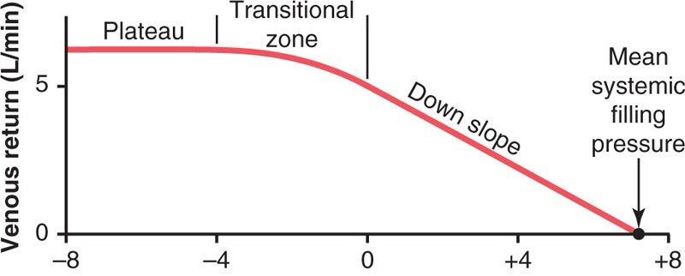
RAP (Right Atrial Pressure)
Normal venous return curve. The plateau is caused by collapse of the large veins entering the chest when the RAP (Right Atrial Pressure) falls below atmospheric pressure. Note also that venous return becomes zero when the RAP rises to equal the MSFP (Mean Systemic Filling Pressure)
- Factors help venous return against gravity:
 | - Contraction of voluntary muscle:
 |  | As calf muscle (the peripheral heart) when muscle contract they will press on near vein pushing the blood toward the heart & the valve in veins prevent blood from return
 |  |  |  |  | Clinical Application
 |  |  |  |  | Prolonged recumbence causing sluggish circulation in LL which predispose to DVT
 | - Pressure gradient between MSFP & RAP:
 |  | - The higher the pressure gradient the higher the VR
 |  | - The lower the pressure gradient the lower the VR
 | - Arterial pulsation: Press on nearby vein, helping VR
 | - Diameter of arterioles: Vasoconstriction increase VR
 | - Tone of veins: |  |  | - VD of veins decrease VR
 |  |  |  | - VC of veins increase VR
 | - Tone of capillaries: |  |  |  |  | - VD of capillaries wills ↓ VR
 |  |  |  |  |  | - VC of capillaries will ↑ VR
 | - Thoracic pump:
 |  | - During inspiration: IPP became more negative lead to increase VR
 |  | - During expiration: IPP become less negative lead to decrease VR
 | - Cardiac suction:
 |  | - Systolic suction: |  |  |  |  |  | Occur during: Maximum ejection in which blood ejected from ventricle to aorta
 |  | - Diastolic suction: |  |  |  |  |  | Occur during: Rapid filling phase in which blood pass passively from atria to ventricle
 | - Contraction of spleen: Lead to increase blood volume & VR
 | - Gravity: |  | - Above the level of heart: Gravity helps VR
 |  |  | - Below the level of heart: Gravity interferes with VR

-Effect of Gravity on Venous system:
 | - Orthostatic Hypotension:
 |  | - During orthostatic (ie changing the position from lying down to erect)
 |  | - If significant amount of blood shifts from thoracic veins to lower limb veins → decrease CVP ,decrease cardiac filling → decrease CO → decrease ABP (ie orthostatic hypotension)
 |  | - Person feels dizzy
 |  | - In normal person: Compensatory mechanisms occur rapidly to correct this hypotension
 | - Hydrostatic Indifferent Point [HIP]:
 |  | - During orthostatic: The pressure in veins: Increase in lower limb, decrease in thorax
 |  | - There must be a transitional zone in which the venous pressure remains constant independent on body posture
 |  | - This zone is called HIP
 |  | - It lies 5 - 7 cm below diaphragm
 |  | - The pressure at HIP = 10 - 11mmHg
 |  | - HIP position is related to capacity of thoracic & lower limb veins.
 |  | - If the body is immersed in H₂O (swimming), the LL (Lower Limbs) veins capacity is decreased → shift of HIP upwards, lying almost at the level of the heart → So the CVP does not vary on changing position → Orthostatic hypotension not occur on swimming.
 | - The pressure in different veins:
- During orthostatic: prolonged standing |  |  | The pressure in leg veins increases from 20 to 80 mmHg, thus on this high venous pressure results in:
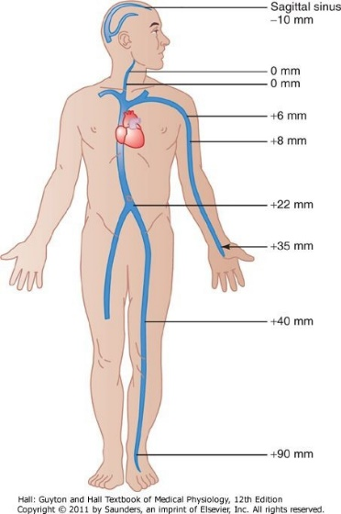 |  |  | Varicose veins (ie dilatation & elongation on LL veins)
 |  |  | Edema: Due to increase filtration
 |  |  | Effect of gravitational pressure on the venous pressures through­out the body in the standing person

Capillary Microcirculation

IIntroduction: |  |  |  | - Capillaries contain 5% of blood
 |  |  |  | - They are exchange vessels
 |  |  |  | - They are 10 billion capillaries
 |  |  |  | - Diameter 10 um
 |  |  |  | - Length 700 um
 |  |  |  | - Surface area 100 m²
 |  |  |  | - Capillary wall is formed of: |  |  |  |  | Single layer of endothelium resting on a thin basement membrane with pores (fenestrations 80-90 A) in diameter.
Capillary blood flow is intermittent:
Due to vasomotor intermittent contraction of arterioles and precapillary sphincter 6 -12 times/min
NB: |  | If all capillaries are opened at one time (as in burns), CVS capacity will exceed blood volume causing marked decrease in ABP ie circulatory shock
VVelocity of Blood flow in capillaries: |  |  |  |  |  |  |  | Velocity = 0.5 mm/sec [as the total cross sectional area of capillaries= 5000 cm² (enough time for exchange)]
Capillary Fragility:
Laplace law: |  |  |  |  | T | : Tension
T = P × r |  |  |  |  | P | : Pressure
 |  |  |  |  | r | : Radius
- According to Laplace law: |  |  |  |  |  | - Capillaries can withstand a pressure of 100 mmHg (although their walls are very thin)  - As they have very small diameter  - So tension is not markedly increased
Causes of capillary fragility
 | - Capillary wall defect: |  |  |  |  | - Vitamin C deficiency
 |  |  |  |  |  |  | Clinical Application
 |  |  |  |  |  |  | Scurvy (↓ vit. C) bleeding as results in bleeding gums
 |  |  |  |  |  | - Senility
 |  |  |  |  |  | - Allergy
 |  |  |  |  |  | - Toxins
 | - Blood diseases: Thrombocytopenic purpura
Capillary reactions to mechanical influences:
- White line: |  |  |  | Gentle stroking of skin by a blunt object → white line for few minutes,
 |  |  |  | caused by VC of capillaries
- Triple Response: Firm stroking of skin →
 | - Red line: At site of injury due to capillary VD by histamine
 | - Spreading flare: Around red line due to arteriolar VD by Antidromic response
 | - Local edema (wheal): Due to increase capillary permeability due to the dilatation. It occurs due to inflammation + insect bites
Equilibrium with interstitial fluid:
Exchange of materials across capillary wall occurs through: 2 Mechanisms:
- Diffusion: | - Quantitatively, it is more important than Filtration
 | - It is passive
 | - Occurs in both directions
 | - It is concerned with H₂O & dissolved substances
 | - Factors affecting diffusion: Diffusion Rate (DR)
 |  | Factors in substance: |  |  |  |  |  | Factors in capillary permeability:
 |  | - Concentration Gradient: DR α Conc. gradient. |  |  |  |  |  | - Liver capillaries, large fenestration, faint interrupted basement membrane → high permeability.  Tissue fluid contains > 4% protein
 |  | - Solubility:
 |  |  | - H₂O sol + lipid insoluble → diffuse through the pores
 |  |  |  |  |  |  |  | - Muscle, skin & heart, lung capillary: No fenestration + well developed basement membrane → low permeability. Tissue fluid <1%
 |  |  | - Lipid sol, diffuse through pores & cell membrane
 |  | - Molecular Weight:
 |  |  | - MW < 5000 → Easy diffusion eg H₂O, NaCl, glucose |  |  |  |  | - Kidney intestine capillaries are thin fenestrated wall + continuous faint basement membrane → moderate permeability
 |  |  | - MW > 5000 → progressive difficult. However, albumin (70,000) diffuse easy (cigar shape)
 | NB: Capillary permeability increases by histamine
- Filtration | - Bulk flow across capillary wall
 | - It is a passive process
 | - It is the Bulk transport of H₂O, electrolytes & crystalloid
- Factors affecting filtration:
Mean forces tending to move fluid outwards:
- Hydrostatic capillary Pressure = 35 mmHg at arteriolar end, 15 mmHg at venular end.
- Interstitial fluid Colloidal OP = 3 mmHg (caused by 1% albumin)
Mean forces tending to move fluid Inwards:
- Colloidal OP of plasma protein = 25 mmHg (mainly albumin)
- Hydrostatic pressure of interstitial fluid = 3 mmHg
Summation of mean forces:
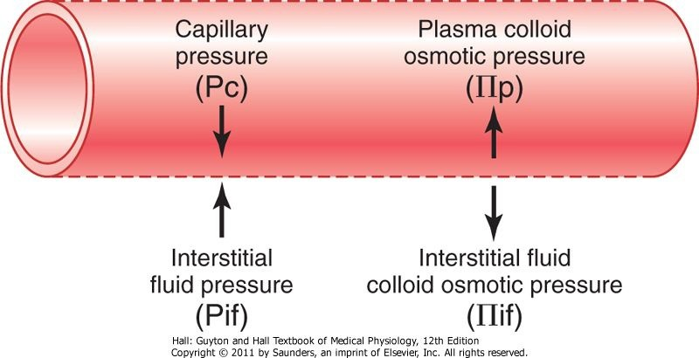Fluid pressure and colloid osmotic pressure forces operate at the capillary membrane. tending to move fluid either outward or inward through the membrane pores

At arteriolar end = 10 mmHg outwards → filtration of fluid from blood to tissues as a bulk
At venular end = 10 mmHg inwards → Reabsorption of a nearly equal amount of fluid into blood (yet, it is smaller, the remaining is taken by lymphatics)
Variation in bulk flow:
- Decreases Colloidal OP of plasma protein: as in liver & kidney diseases → increases filtration
- Increase capillary hydrostatic pressure as in venous obstruction → Increase filtration

Anatomy(Embryology of the heart & blood vessels)

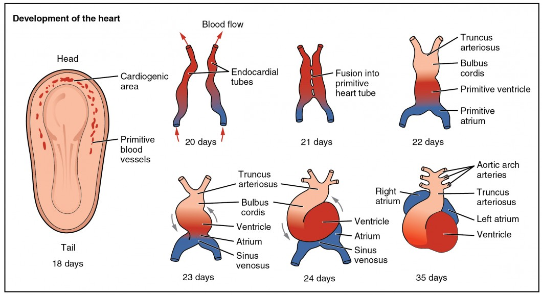
Development of heart tube

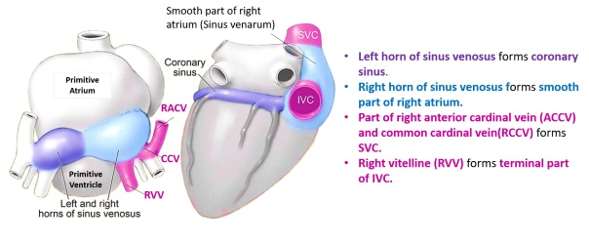
Development of sinus venosus

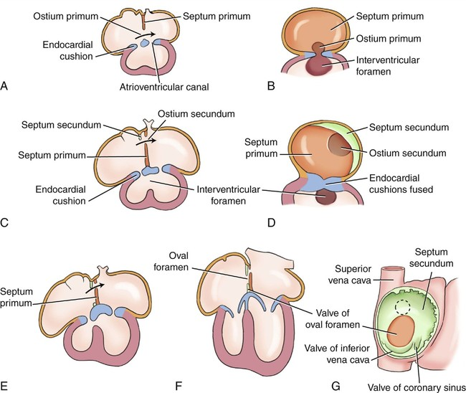
Interatrial septum

Development of heart
- Development of the heart occurs caudal to septum transversum and cranial to stomodeum.
- It begins by the appearance of two heart tubes (endothelial mesodermal cells), both unite forming a single heart tube which develops into the endocardium, the surrounding mesoderm develops into myocardium and epicardium.
- The heart tube shows 5 dilatations, from cranial to caudal; truncus arteriosus, bulbus cordis, primitive ventricle, primitive atrium and sinus venosus.
- Two bends occur; the bulbus cordis becomes to the right of the ventricle, and the truncus arteriosus is still cranial to it. The atrium becomes dorsal to the ventricle, and the sinus venosus is still caudal to it.

Sinus venosus
- It is the most caudal chamber of the heart tube. It is formed of a body and right and left horns. Each horn receives 3 veins:
- Common cardinal (draining the embryo tissues).
- Vitelline (connecting it to yolk sac).
- Umbilical (connecting it to placenta).
- The body and the right horn form the smooth part of the right atrium (sinus venarum). This part will receive the right common cardinal vein (which develops into Lower part of SVC), the right vitelline vein (which develops into the upper part of IVC), the whole right umbilical vein disappears.
- The left horn which develops into the coronary sinus. The left common cardinal develops into oblique vein of left atrium. The cranial parts of left umbilical and left vitelline veins disappear.
Primitive atrium: develops into the rough areas and auricles of right and left atria
A-V canal: is the part of heart tube between the primitive atrium and primitive ventricle. A ventrocaudal septum intermedium appears dividing the A-V canal.

Development of atria:
 | Right atrium | Left atrium
Rough part | Right part of primitive atrium | Left part of primitive atrium
Smooth part | - Body and right horn of sinus venosus  - Right part of A-V canal | - Absorbed pulmonary veins  - Left part of A-V canal
N.B.: early, a single pulmonary vein opens into the left side of the primitive atrium. It is formed of 2 tributaries and each is formed of 2 tributaries. The single pulmonary vein and its 2 tributaries develop into the smooth part of the left atrium. Accordingly, the 4 pulmonary veins open in the left atrium.

Development of interatrial septum
- A septum appears in the A-V canal called septum intermedium.
- A crescentic septum primum descends from the roof of primitive atrium cranio-caudally.
- The 2 ends of the crescent unite with the septum intermedium, while a foramen persists between them in the middle part (foramen primum).
- The cells migrate caudally to close foramen primum. But it causes another foramen in the upper part of septum primum (foramen secundum).
- Another crescentic septum secundum appears to the right of septum primum and descends to unite with septum intermedium.
- The two septa (primum and secundum) are not in contact, and a gap (foramen ovale) persists between cranial edge of septum primum and caudal edge of septum secundum. The part of septum primum enclosed by the edges of septum secundum will form fossa ovalis, while the edges of septum secundum will form limbus foss ovalis (annulus ovalis).

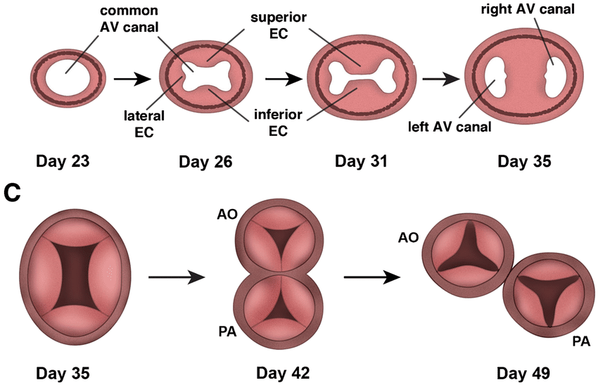
Pulmonary & Aortic valves

Primitive ventricles: develops into the rough areas of right and left ventricles.
Bulbus cordis: develops into the smooth areas of the ventricles (infundibulum and aortic vestibule). A bulbar septum appears separating the 2 parts.

Development of ventricles
 | Right ventricle | Left ventricle
Rough part | Right part of primitive ventricle | Left part of primitive ventricle
Smooth part | Right part of bulbus cordis | Left part of bulbus cordis

Development of interventricular septum:
Muscular part: it is formed passively by the growth and cavitation of the ventricles. It is crescentic in shape. The edges of the crescent unite with septum intermedium leaving a middle gap (interventricular foramen).
Membranous part: fills the interventricular foramen. It is formed of cells migrating from septum secundum (A-V canal) and bulbar septum (bulbus cordis).
Truncus arteriosus: divides by aorticopulmonary septum into ascending aorta and pulmonary trunk. The septum is spiral so that:
- Caudally: the pulmonary is ventral to the aorta.
- In the middle: the pulmonary is left to the aorta.
- Cranially: the pulmonary is dorsal to the aorta.

Development of cardiac valves
Pulmonary and aortic valves
- Derived at the junction between bulbus cordis and truncus arteriosus. Each valve is formed by 3 projections (cushions) forming the cusps of the valve.
- The heart rotates to the left and the cusps become:
- posterior, anterior left and anterior right for the pulmonary
- anterior, posterior right and posterior left for the aorta
Mitral & tricuspid
- Derived from cushions in the A-V canal (3 right and 2 left).
- The cushions are invaded by muscles from the myocardium. The caudal part of the muscles forms papillary muscles while its cranial part fibrose forming chorda tendineae.

Developmental defects:
Dextrocardia: the apex of the heart is inversed to right. Sometimes it is accompanied by inversed internal organs (situs inversus totalis).
Malposition of the interatrial septum to the left may cause pulmonary veins to open in right atrium.
Premature closure of foramen ovale: usually fatal.
Patent foramen ovale: if large it causes blood shunting from left to right atrium.
Patent foramen primum.
Complete absence of interatrial septum (single atrium).
Patent interventricular foramen (membranous or muscular).
Stenosed or wide valve.
Fallot’s tetralogy: consists of pulmonary stenosis, overriding of aorta, right ventricular hypertrophy and interventricular defect.

DEVELOPMENT OF THE Blood vessels
- The blood vessels develop in:
- Extra-embryonic mesoderm of the chorion forming the umbilical vessels.
- Mesoderm of the wall of the yolk sac forming the vitelline vessels.
- Intra-embryonic mesoderm of the embryo, forming the fetal vessels.

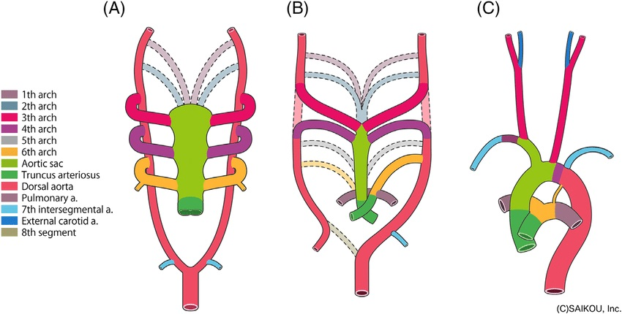

Development of aortic arches

Development of arteries
- Two primitive aortae develop, one on each side of the notochord. They connect truncus arteriosus cranially with umbilical arteries caudally. Due to the head folding its cranial part bent ventrally and becomes divided into:
Ventral aortae: continuous with truncus arteriosus . Both sides fuse together and forms aortic sac, which has a stem and two horns; The stem and left horn share in the formation of arch of the aorta while the right horn forms the brachiocephalic artery.
Dorsal aortae: remain in their positions dorsolateral to the gut. Caudally, they fuse forming the descending thoracic and abdominal aorta which ends by connecting to the 2 umbilical arteries.
Connecting segment (1st aortic arch): Links the dorsal aortae with the aortic sac.
Further five segments (2nd-6th aortic arches): appear at the side wall of pharynx connecting the dorsal aortae and aortic sac and surrounded with mesodermal thickenings called pharyngeal arches.

Fate of the aortic arches:
 | Right | Left
1 | Maxillary A.
2 | Stapedial A
3 | Common carotid & internal carotid As (the External carotid A appears as a branch from the arch)
4 | Part of Rt subclavian A | Part of arch of aorta
5 | Disappear
6 | Rt Pulmonary A (The part connecting it to dorsal aorta disappears) | Lt pulmonary A (The part connecting it to dorsal aorta persists forming truncus arteriosus which obliterates after birth)
N.B.: The recurrent laryngeal nerve hooks around the distal part of the 6th aortic arch. Accordingly, the right one hooks around the right subclavian A and the left hooks around the ductus arteriosus.

Development of aorta:
Ascending aorta: from truncus arteriosus.
Arch of aorta from:
- Stem of aortic sac.
- Lt horn of aortic sac.
- 4th left aortic arch.
- Part of dorsal aorta.
- Aortic isthmus: part of dorsal aorta between origin of Lt subclavian A and truncus arteriosus. It is narrow in fetal life and dilates after birth.
Descending thoracic and abdominal aorta: by union of 2 dorsal aortae.
Congenital anomalies of aorta:
Patent ductus arteriosus: the connection persists between left pulmonary artery and aorta.
Coarctation of arch of aorta: failure of dilatation of aortic isthmus.
Right aortic arch: the Rt 4th aortic arch forms the arch of aorta.
Double aortic arches: both 4th aortic arches persist.
Arteries of the upper limb: Develop from an axial artery (subclavian, axillary, brachial and ant interosseous As) and end forming the deep palmar arch. Radial, ulnar & median arteries develop as branches from the axial A.

Arteries of the lower limb:
Iliac arteries develop from lumbar intersegmental arteries. Femoral artery develops as an extension of external iliac artery.
An axial artery develops and passes in the gluteal region, back of thigh, popliteal fossa (where it is joined by femoral artery), leg and sole of foot. Anterior & posterior tibial arteries develop as branches from the axial artery
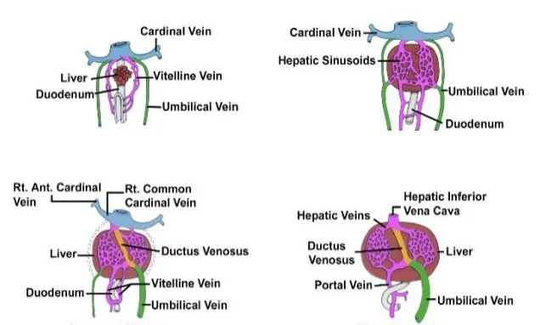
Development of umbilical and vitelline veins

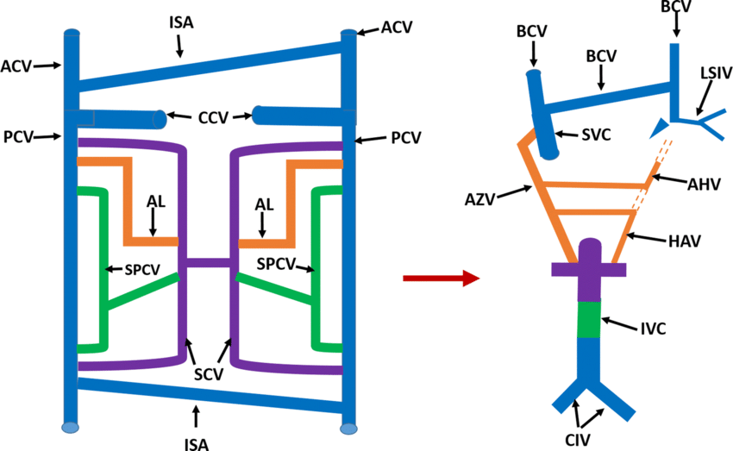
Development of cardinal veins

Development of veins
Vitelline veins
- Two veins connecting the yolk sac to the sinus venosus. Through its way they traverse the septum transversum.
- Caudal to septum transversum, the two veins anastomose and form the portal vein.
- Inside the septum transversum, they break into liver sinusoids. some of liver sinusoids enlarge forming sinus venosus connecting the portal vein to the IVC. After delivery, sinus venosus obliterates forming ligamentum venosum.
- Cranial to septum transversum, the left vein disappears, and the right vein forms the upper part of IVC (between the liver and the heart).
Umbilical veins
- Two veins connecting the placenta to the sinus venosus. Through its way they traverse the septum transversum.
- The right umbilical vein disappears completely.
- The left umbilical vein
- Caudal to septum transversum, it is connected to the placenta. After delivery, it obliterates forming ligamentum teres.
- Inside the septum transversum, it breaks into liver sinusoids.
- Cranial to septum transversum, it disappears.
Cardinal veins
- Six pairs of veins in the body of the embryo. Each vein anastomoses with the veins of the same side and with its corresponding vein of the opposite side.
Vein | Description | Fate of Rt | Fate of Lt | Fate of connection
Common cardinal | Union of ant and post cardinal Vs, opens in the corresponding horn of sinus venosus | Lower part of SVC | Oblique vein of left atrium
Anterior cardinal | Cranial to the heart | - Rt IJV  - Rt brachiocephalic V  - Upper part of SVC | Lt IJV | Lt brachiocephalic V
Posterior cardinal | Caudal to the heart and dorsolateral to the mesonephric ridge | Degenerates except caudally → most caudal part of IVC | degenerates | Lt common iliac V
Subcardinal | caudal to the heart and ventromedial to the mesonephric ridge | - Rt gonadal  - Rt suprarenal  - IVC between them | - Lt gonadal  - Lt suprarenal | Lt renal V
Supracardinal | caudal to the heart and dorsolateral to the aorta | Degenerates except caudally → part of IVC | degenerates
Azygos | caudal to the heart and dorsolateral to the aorta | Azygos V | Sup & inf hemiazygos Vs

Formation of IVC (from caudal to cranial):
- Rt posterior cardinal V. (beginning).
- Rt supracardinal V.
- Anastomosis between Rt supracardinal and Rt subcardinal Vs. (infrarenal part).
- Rt subcardinal V. (renal part).
- Anastomotic between Rt subcardinal and Rt vitelline Vs. (suprarenal part).
- Rt vitelline V. (hepatocardiac part).

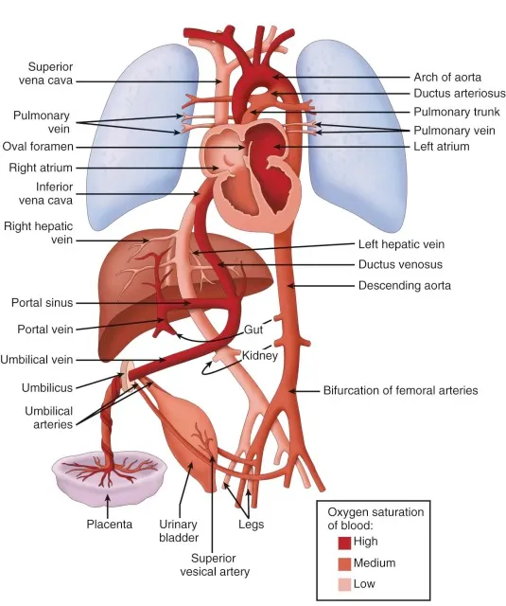
Fetal circulation

Fetal circulation
- The only source of the oxygenated blood to the fetus is the left umbilical vein (the right disappears)
- The blood passes through left umbilical vein to the liver. Most of the blood passes through ductus venosus (connecting portal vein to IVC), while little amount passes through liver sinusoids. Both drain to IVC.
- N.B.: IVC also receives little amount of non oxygenated blood from the venous drainage of the caudal part of the body
- The blood passes from IVC to right atrium → foramen ovale → left atrium → left ventricle → aorta. Most of the blood passes to the branches of the arch of aorta to the cranial part of the body, and little amount to the caudal part of the body
- The non oxygenated blood from the cranial part of the body returns through SVC to the right atrium → right ventricle → pulmonary trunk. Most of the blood passes through ductus arteriosus to the descending aorta, and little amount passes to the lungs
- The descending aorta contains mainly non oxygenated blood and a little amount of oxygenated blood to supply the caudal part of the body and passes through umbilical arteries to the placenta to be reoxygenated.
Changes of fetal circulation at birth: cutting the umbilical cord will stop the oxygenated blood of the left umbilical vein, which stimulates the lung to expand (the famous baby scream). This will lead to:
- As no blood passes through left umbilical vein (it will obliterate forming ligamentum teres). Accordingly, no blood will pass through ductus venosus (which will obliterate forming ligamentum venosum).
- Expansion of lungs will lead to suction of blood from the right ventricle to the lungs → oxygenation → pulmonary veins → left atrium → left ventricle → aorta. At the same time no blood will pass through the ductus arteriosus (which will obliterate forming ligamentum arteriosum)
- Decreased blood flow from IVC to right atrium decreases its pressure, while increased blood return from lungs to left atrium increases its pressure, This leads to closure of foramen ovale (which will obliterate forming fossa ovalis).
- No blood will pass through umbilical arteries (their distal part will obliterate forming medial umbilical ligaments).
N.B.: direct closure occurs at birth while complete obliteration takes few months to complete.

