Block -1
Code 106

General microbiology
and
infection control

Preface

Part I :Microbiology is a broad science includes different specialities. Students need an introduction to the whole subject before concentrating on those parts of greatest interest to them.This is a brief review of general microbiology.

Organization : The book begins first with a series of chapters presenting the general concepts of bacterial microbiology then general concepts of viral and fungal microbiology. The last chapter

is concerned with infection control in health care unit.

.
Professor Mona Gharib
Head of the department of clinical microbiology
and immunology
Faculty of medicine, October university.

Part I
Competence : The student should be able to use general microbiology in identification of organismsObjectives :
- Understand the basic features of bacteriology,virology and mycology
- Understand mode of actions of antibiotics and antiviral drugs
- Understand the principles of sterilization and infection control
Outcome :
- Identify microorganisms as regard their structure , morphology, types of stain
- Differentiate between the stage of growth and environmental factors that might affect their cies
- Determine nutritional , growth of bacteria
- Compare between bacteria according to their oxygen requirements and energy
- Describe the structure of bacteriophage , compare between different life cycles of bacteriophage and determine the role of bacteriophage in nature and in vitro
- Bacterial genetics:define types of mutation,describe the types of DNA in a bacterial cells and compare between types of gene transfer
- Antibiotics and Antiviral elective toxicity
- Describe mechanisms of action of antimicrobial agents ,antibiotic susceptibility testing and importance of combination therapy ,determine the factors that influence the choice of antibiotic and complications of chemotherapy,describe the mechanisms of bacterial resistance to some antimicrobial agents
- Sterilization and disinfection:describe.& classify the proper methods of sterilization and disinfection and their use them
and determine the types of disinfectants
- General aspects of bacterial pathogenesis: define aspects of bacterial pathogenesis,define sources of some infections mode of transmission. and the principles of disease surveillance and screening of bacterial, viral ,fungal ,explain phenomena , pathogenesis and other statements in microbiology,compare between microorganisms and their products
- Describe the normal flora of the body and compare between the types of carriers
- Introduction to virology : Identify Properties of viruses ,state the principal events involved in replication,list viral pathogenesis.Compare between pattern of viral infections,interpret laboratory diagnostic methods in virology and explain the action of antiviral drugs
- Mycology; define the general features of fungi ,iIdentify pathogenic fungi,compare between classes of mycoses ,interpret laboratory diagnostic tests ,list the treatment of fungi
- Infection control:Define :Commonest hospital-acquired infection,factors that increase hospital-acquired infection ,determine the high risk groups in the hospital ,list the sources of infection in a hospital ,the mode of transmission in a hospital and -Compare between various types of precautions taken. Determine the role of microbiology in infection control

Part II Parasitology
- Expected competencies at the end of the course :
- Planning and developing courses of parasitology at different levels of academic settings
- Establishment of practical technique in identifying pathogenic human parasites and laboratory diagnosis of parasitic infections
- Selection of basic and applied research projects focusing on parasitic diseases

Part :II Parasitology 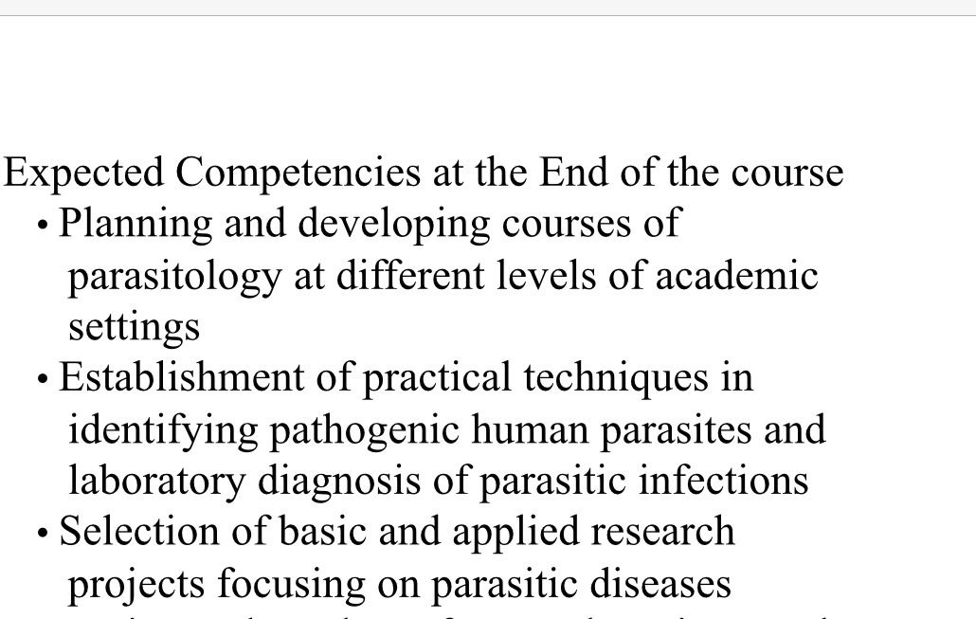
Outcome :
- Identify the sources of infection, mode of transmission & causative organisms of various infectious diseases.
- Point out the principles of disease surveillance and screening, , communicable disease control, health promotion and health needs assessment
- Illustrate the management plan , prophylaxis,& simple prevention methods of clinical case subjected to certain bacterial viral , parasite & helmenthesis
- Describe common arthropods & explain their medical importance the diseases transmitted by them &methods of control
- Determine the epidemiology of infectious diseases.

Part I :General microbiology
Chapter 1
Introduction
Microorganisms are unicellular organisms that can be only seen by light microscope. Microbial colonies can readily be seen in culture by the naked eye.
Prokaryotic and Eukaryotic Cells are two different types of cells in the microbial world
Eukaryotic cells have a "true" nucleus because it is enclosed in a nuclear membrane whereas procaryotic cells are said to have a "primitive" nucleus because their DNA is not enclosed within a nuclear membrane , so it is called nucleoid
- Bacteria are unicellular prokaryotic organisms. They are measured by micrometer so they can be visualized by light microscope .
- Fungi are eukaryotes, generally non-motile, that absorb their nutrients directly from the environment they include mushrooms, molds and yeast.
- Viruses are made up of nucleic acid ( either DNA or RNA) and protein.They lack ribosomes (essential for protein synthesis) so they cannot generate energy.Viruses are considered obligate intracellular parasites because they can only replicate in association with a host cell which they infect. They are measured by nanometer so they can be visualized by electron microscopy.
- Prions are infectious agent made of protein with no nucleic acid .They are responsible for a degenerative nervous system disease in animal and man.They are the causative agents of bovine spongiform encephalopathy in cattle and Creutzfeldt disease in man .
Chapter 2
An Overview of Bacteriology
Microorganisms (prokaryotes) differ from eukaryotes in having:
- No membrane bound nucleus.
- No mitochondria.
- No other membrane bound organelle, endoplasmic reticulum, Golgi body, phagosomes and lysosomes
Microorganisms include bacteria, mycoplasma, rickettsia and chlamydia .
This chapter concern with important criteria used to identify bacteria and describe the general cytology of bacterial cells.

IDENTIFICATION OF BACTERIA:
For microscopic identification of bacteria one must comment on morphology; arrangement, stain reaction, and motility.
Morphology: Bacterial cells take one of three forms: bacillus, coccus,or spiral (spirilla and spirochetes). ( figure 1)
Arrangement of bacteria is formed according to plane of cleavage it could be diplo or chain when cleavage of bacterial cell occur in one plane, or grape like clusters when the cleavage occur in all planes.
Size of bacteria: range from 0.2-1.2um in diameter and 0.4-14um in length.

Fig 1-Different shapes of bacterial cells

Types of stains: Two important stains are used : simple and differential stains.
Simple stain: used to stain all cells, bacteria and tissue cells by the same colour e.g. methylene blue
Differential stain: Distinguish between different types of bacteria. Two important differential stains are used in microbiology: Gram's stain and Ziehl-Neelsen stain.
Gram's stain:divide bacteria into gram positive or violet and gram negative or red due to difference in cell wall structures of both.
Examples of some pathogenic bacteria and important diseases:
Gram positive cocci:
      - Staphylococcus aureus the causative agent of localized lesions like abcess.
Gram positive bacilli :
- Corynebacterium diphtheria the causative agent of diphtheria

Gram negative cocci:
- Neisseria meningitidis the causative agent of meningitis .
Gram negative bacilli :
- E.coli one of the causative agents of urinary tract infections.
Ziehl-Nelsen Stain: This stain is used to identify Mycobcteria (acid and alcohol fast) e.g. M. tuberculosis . having a waxy cell wall which is stained red with a strong carbol fuchsin stain by steaming and resist decolorization with acid and/or alcohol (acid fast) after cooling , other cells are stained blue colour.
Motility: determined by observing living organisms.
General cytology of prokaryotic cells: The ultrastructures of bacterial cells are seen by the electron microscope it include:
- Cytoplasmic region which contains the nucleoid (DNA) ribosomes and other inclusions (Fig 2).
- Cell envelope consists of cell wall and plasma membrane ± capsule/ glycocalyx/slime layers.
- Appendages (proteins attached to the cell surface) e.g flagella and pili (or fimbria).
Cytoplasmic region: contains the following components:
- Nucleoid.
- Ribosome.
- Inclusion granules.
- Mesosomes.
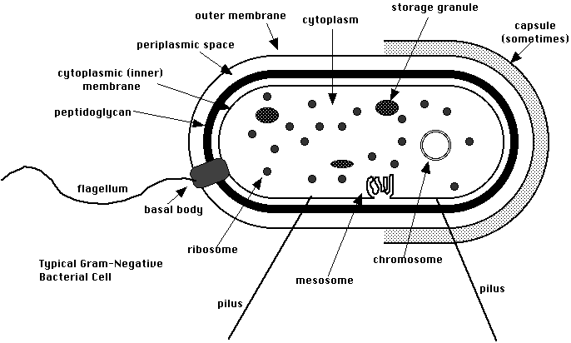
Fig 2-Ultrastructures of bacterial cell

Fig 3-Ultrastructures of bacterial cell

Bacterial nucleoid: double-stranded DNA ,1 mm long, During cell growth and division,the chromosome is replicated in coordination with the mesosomes.
Bacterial ribosome: It is the site of protein synthesis.
Inclusions: energy reserves e.g. carbon stored as glycogen or as fat granules. Phosphate is stored in the form of volutin granules used in ATP synthesis i.e. energy.
Mesosome: They are folded invaginations in the cell membrane of bacteria .It support respiratory enzymes,involved in cell division and spore-formation.
Cell envelope: All bacteria have a cell membrane where respiration occurs. Outside the cell membrane is the cell wall which is rigid and protects the cell from osmotic lysis.
Gram negative bacteria have an additional outer membrane .The space between the inner and outer membranes is known as the periplasmic space. Gram negative bacteria store degradative enzymes in the periplasmic space.
Gram positive bacteria lack a periplasmic space; instead they secrete exo-enzymes and perform extra-cellular digestion.
Digestion is needed since large molecules can not readily pass across cell membrane.
Cytoplasmic membrane: Thin elastic membrane surround the cytoplasm made of two phospholipid layers differ from that of Eukaryotes in lacking sterols.
Functions of cytoplasmic membrane include:
1-Selective transportation of nutrient elements either by simple diffusion in response of concentration gradient or active transport against concentration gradient and this requires energy.
2-Respiration
3-Excretion of extracellular enzymes: To digest large molecules e.g. hydrolytic enzymes and to destroy harmful substance like antibiotics e.g. penicillin-degrading enzymes.
4-Bacterial multiplication: A septum is formed from the cytoplasmic membrane separate the two new bacterial cells.
5-Chemotactic system: Cell membrane respond to surface message by attractants or repellants which bind to specific receptors: e.g.motile bacteria direct their movement to glucose (nutrient element).
Cell wall: It surrounds cytoplasmic membrane. Its thickness varied from 10-25 um, has some elasticity, and it is strong.(Fig 3)
Peptidoglycan (PG) is a basic structure of cell wall ,it resists lysozyme action. Peptidoglycan forms 50%of cell wall of Gram positive bacteria and 10% of cell wall of Gram negative bacteria .

Cell wall has different functions which include:
- It maintains the shape of bacteria.
- Supports the cytoplasmic membrane .
- Involved in bacterial multiplication .
- Responsible for the differences in staining behavior.

The outer membrane of Gram negative bacteria is a phospholipid-protein bilayer external to PG layer. This is the endotoxins of gram negative bacilli.
The differences between Gram positive and Gram negative is shown in table (1 ) and fig 3.
Table 1-Comparison between Gram-positive and Gram-negative bacteria

Feature | Gram-positive Bacteria | Gram-negative Bacteria
- Gram stain | Stain violet | Stain red
- Cell wall :  - Peptidoglycan layer | Thick | Thin
- Teichoic acids | Present | absent
- Periplasmic space | Absent | present
- Outer membrane | Absent | Present
- Lipopolysaccharide (LPS) - Lipid A | none | High
- Toxins produced | Exotoxins by living cell | Endotoxins by lysed cell (lipopoly-saccharides)
- Antibiotic | More susceptible | More resistant
- Resistance to drying | High | Low

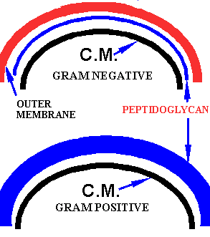
Fig 3-Section in cell wall of gram negative and positive bacteria.NB: C.M. means cytoplasmic membrane

Peptidoglycan (PG) is a basic structure of cell wall it is formed from repeating units of
- N-acetyl-D- glucosamine (NAG) and
- N- acetyl-D-muramic acid (NAM) with
- Peptide side chains which resists lysozyme action.
- Peptido-glycan (PG) is a much thicker layer in gram +ve bacteria than in gram -ve bacteria

Cell wall of Gram positive bacteria is composed of :
- Peptido-glycan:50%of cell wall.
- Teichoic acid: polymer of ribitol and glycerol phosphate, found also in cytoplasmic membrane.
- Both are the major surfaces of G+ve bacteria.

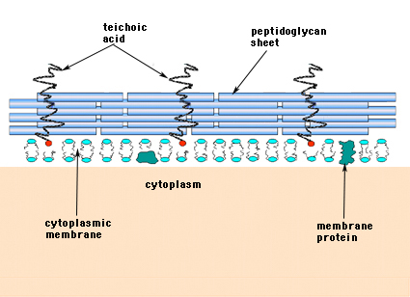

Ig 3 a -Cell wall of Gram positive bacteria

Cell wall of Gram negative bacteria-
- Peptidoglycan: 5-10%of cell wall.
- Outer membrane: phospholipid-protein bilayer external to PG layer.
- The outer surface of the lipid bilayer is a lipo-polysaccharides (LPS)
Importance of LPS
- Can be used to serotype and classify bacteria
- Binds to specific receptors (TLR-4) to activate macrophage
- Can non specically activate B cells without thr help of GT cells
Cell wall-deficient (CWD) bacteria :
- L-form bacteria: This form of bacteria are produced when bacteria are treated with antibiotics that interfere with synthesis of peptidoglycan e.g. penicillin.L-forms bacteria survive antibiotic therapy and their reversion to the walled state can produce relapse of infection. L-forms could be also produced by enzymes that are lytic for the cell wall e.g. lysozyme.
- Mycoplasma: Natural absence of cell wall, thus it has no define shape and is resistant to antibiotics acting on cell wall: e.g. penicillin-cephalosporins
Capsule and other surface layers: They surround the outside of the cell envelope. In most bacteria the capsule is composed of polysaccharide. They are not essential to cell viability. They are formed only in vivo.(fig4)
Capsules of pathogenic bacteria have several functions:
  - Inhibit ingestion by phagocytes so it is considered as virulence factor.
  - Protect the cell wall from antibacterial agents as lyzozymes, bacteriophage and complement.
  - Help attachement of the bacteria to target surface e.g.;Glycocalyx adhere Streptococcus mutans to tooth enamel.
  - Resistance to drying as it inhibit water from escaping into the environment.
  - Reservoir for certain nutrients.
  - Depot for waste products.
Appendages: They are structures that project through cell wall most important are flagella and pili (or fimbria).
A- Flagella: Are responsible for the motility of some bacteria and respond to specific chemical foodstuffs or toxic materials and move towards or away from them a process called chemotaxis.It cannot be seen by light microscope.
Structure: Consist of a number of proteins called flagellin which is antigenic

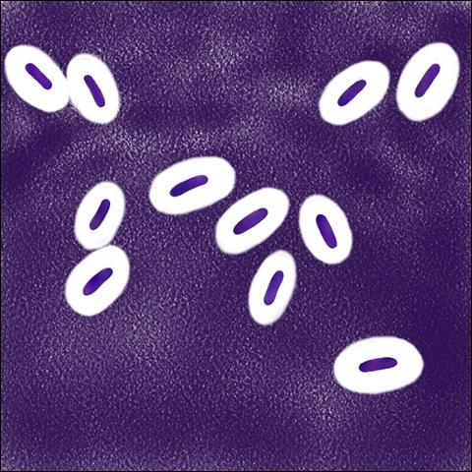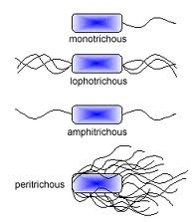
Fig 4-Capsule Fig 5-Flagella
Axial filaments: Present in spirochetes and responsible for its motility. They are two groups of fibers originate in opposite ends of the cell, winding about the bacterium within the periplasmic space, and overlap at the midpoint. The spirochetes rotate along a longitidunal axis, flex and bend along its length.
B- Pili (or fimbriae) are hair-like projections of the cell: (Fig 6)
- Allow adhesion to host epithelial surfaces in infection.
- Some are involved in sexual conjugation e.g. long pilus called F factor responsible for transfer of DNA between bacterial cells.
Bacterial spores (endospores) :The spore is formed by some bacteria and is resistant to adverse conditions, including lack of nutrition, change of growth requirements e.g.pH, temperature, oxygen tension. The cytoplasm is dehydrated and contains calcium dipicolinate (dipicolinic acid) which is involved in the heat resistance of the spore. Spores are commonly found in the genera Bacillus and Clostridium. There is no growth or multiplication of bacteria. There is low metabolic activity. (Fig 7)
The process of sporulation involves: Cytoplasmic membrane enclose part of the cytoplasm that contain the chromosome together with other materials needed for germination and the ribosomes.All are enclosed in thick cortex which resist evaporation of water and spore coat.
Viability and resistance: Spores are resistant to disinfectant, heat up to100°C. They are only killed by moist heat at 120°C for 20 min or 134°C for 10 min.
With Gram stain the spore appear colorless as it cannot be stained due to the presence of cortex and coat.They are stained by modified Ziehl-Neelsen stain called spore stain and appear red.According to position of spores identification of bacteria is done e.g.terminal in Cl. Tetani. When returned to good nutritional conditions the spores germinates to produce a single vegetative cells.

Fig 6-Pili or Fimbria Fig 7-Endospore

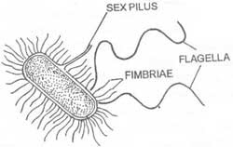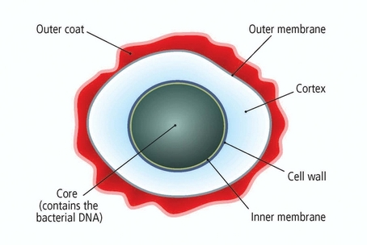

Chapter 3
Nutrition, Growth and Energy Metabolism
Bacterial requirements for growth include sources of energy and metal ions ,optimal temperature, pH and the need or lack of oxygen.
Nutritional growth requirements: It include sources of organic carbon, nitrogen, phosphorus, sulfur and metal ions including iron.
Energy could be obtained from light (phototrophs) or chemical reaction (chemotrophs).
The carbon requirements of organisms must be met by organic carbon or by CO₂.
  - Heterotrophs: Organisms that use organic carbon,they include most pathogenic bacteria.
  - Autotrophs:Organisms that use CO₂ as a sole source of carbon.
Oxygen requirements of bacteria classify them into:
  - Strict aerobes must grow in the presence of oxygen; they cannot carry out fermentation e.g. Pseudomonas.
  - Strict anaerobes :They are killed by oxygen as they lack catalase, peroxidase and superoxide dismutase e.g. Bacteroids.
  - Facultative anaerobe: can switch between aerobic and anaerobic types of metabolism e.g. Staphylococci.
  - Microaerophilic bacteria grow well in low concentrations of oxygen, but are killed by higher concentrations e.g..Vibrio, Helicobacter, Campylobacter.
  - Aerotolerant anaerobes are bacteria which cannot use oxygen for growth, but tolerate its presence as they possess superoxide dismutase. They live by fermentation alone whether or not O₂ is present in their environment e.g.Clostridium perfringes.
Tolerance to oxygen is related to the ability of the bacterium to detoxify superoxide and hydrogen peroxide, produced as by-products of aerobic respiration:
  - Superoxide dismutase: Converts superoxide to hydrogen peroxide , is present in aerobic and aerotolerant bacteria.
  - Catalase: Converts hydrogen peroxide into water and oxygen, is also present in aerobic but lacking in aerotolerant.
- Strict anaerobes lack both enzymes.
- Metabolism of sugars : is achieved by glycolysis, Krebs cycle or Oxidative phosphorylation.
Glycolysis: This is the most common pathway for sugar catabolism. Chemical energy needed for biosynthetic purposes is stored in the form of ATP and NADH.
- Respiration could be:
- Aerobic respiration: The final recepient of hydrogen (electron) in the oxidation process is O2 molecule.A higher energy is produced 38 molecules of ATP
- Anaerobic respiration ;Final recipient of hydrogen (electron) is an inorganic molecule.Small number of ATP molecules are produced i.e. little energy.
- Fermentation: This process occurs in the abscence of oxygen. This is the least method for energy production.
- CO2 requirements: The amount in the air is sufficient for growth of bacteria.If higher amount is needed they are called capnophylic: e.g.Neisseria, brucella.
- Temperature:Bacteria may grow at a variety of temperatures
Mesophiles: They grow between 20-40º C. Optimum temperature for growth is the body temperature 37ºC for pathogenic or opportunistic bacteria.
Thermophiles: They grow at high temperature >60ºC e.g.stearo-thermophylus.
Psychrophiles: They grow at low temperature: 0-8ºC e.g. Flavo-bacterium.
- pH or hydrogen ion concentration:Many bacteria grow best at neutral pH.Certain bacteria can survive and even grow in acidic pH (4 or less) e.g.Lactobacilli in vagina or alkaline conditions pH (8-9) e.g. Vibrios.
Bacterial growth curve :There are four phases in the growth of bacteria(fig8)
- Lag phase: Immediately after inoculation of the cells into fresh medium, the the initial number of bacteria is constant. There is no cell division, the cells synthesize enzymes to adapt to external environment.
- Exponential or Logarithmic phase: All cells are dividing regularly by binary fission and divide at a constant rate .The rate of growth is expressed as generation time or doubling time .In this stage antibiotics and disinfectants are most effectives as they typically target active growing bacteria cell
- Stationary phase: The growth rate slows as a result of nutrient depletion and accumulation of toxic products. This phase is reached as the bacteria begin to exhaust both nutrition and space ("biological space"). Sporulation process and antibiotics production by some bacteria take place in this phase. New cells produced are balanced with dead cells so there is a constant value as the rate of bacterial growth is equal to the rate of bacterial death.
- Decline or Death Phase: The viable cell population declines. Increase death rate is due to exhaution of nutrition and accumulation of toxic waste products.


Fig 8-Bacterial growth curve
Bacteria reproduce by binary fission which is an asexual repro-duction.There is longation of the cell ,the DNA double strand separate and each strand acts as template for synthesis of a daughter strand .A transverse septum from the membrane and cell wall divide the cytoplasm into two equal parts each have copy of chromosome and cytoplasm. The cell splits into two daughter cells or it remain attached in the form of pairs,clusters or chains (Fig 9)
Fig 9-Bacterial reproduction
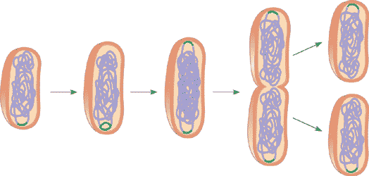

Chapter 4
Bacteriophages
Bacteriophage (phage) are viruses that infect bacteria (Fig 10).
This chapter describe its basic structure,steps taken in the infection process and their role in toxin production,typing and gene transfer.
  - Size: Range from 24-200 nm in length.
  - Head or Capsid: Inside the head is found the nucleic acid DNA (rare RNA).The head protect the nucleic acid.
  - Tail: Attached to the head, it is a hollow tube through which the nucleic acid passes during infection. The tail is surrounded by a contractile sheath which contracts during infection of the bacterium. At the end of the tail there is a base plate and one or more tail fibers attached to it.The base plate and tail fibers are involved in the binding of the phage to the bacterial cell (Fig 10)

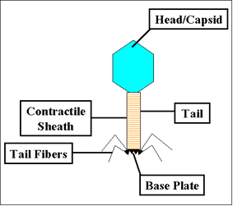

Fig 10- Bacteriophage
Infections of host cells:
      - Adsorption - This step is mediated by the tail fibers which attach to specific receptors on the bacterial cell and the host specificity of the phage is usually determined by the type of tail fibers.
      - Irreversible attachment of phage to a bacterium is mediated by the base plate.
      - Sheath contraction or penetration: contraction of the sheath and injection of phage nucleic acid inside the bacterial cell. The head and tail are left empty outside.
Phage multiplication cycles:
- Lytic cycle: virulent phages multiply inside the bacteria and kill the cell by lysis at the end of the life cycle.
- Temperate (Lysogenic) cycle: After penetration, the virus DNA integrates into the bacterial chromosome and it becomes replicated every time with bacterial chromosome (DNA) during normal cell division. Temperate viruses usually do not kill the host bacterial cells they infect.Infected bacteria are called lysogenic bacteria. The virus in this state is called prophage.
Properties of lysogenic bacteria:
  - Immune to infection by another virus.
  - Acquired new properties: extra genes carried by the phage change the properties of the bacterial cell. This process is called lysogenic or phage conversion. This can be of significance clinically e.g. Exotoxin produced by Corynebacterium diphtheriae is mediated by a gene carried by a phage.
Fate of Temperate (Lysogenic) cycle:
- The phage propagate indefinitely in daughter cells.
- The lysogenic state can be terminated and the phage detach from chromosome.This could be spontaneous or induced by several conditions such as exposure to UV or ionizing radiation, exposure to mutagenic chemicals etc.. Sometimes phage carry genes of bacterial chromosome to another bacteria while detaching, this is called specialized transduction.
Importance of Bacteriophage
- Typing of bacteria with identical biochemical reactions and with common antigens. This is usually done during outbreak to identify the source of infection e.g. wound infections by Staphylococcus aureus
- Cloning vector in recombinant techniques.

Chapter 5
Bacterial Genetics
This chapter discuss the different types of DNA that may be found in bacterial cell: Bacterial chromosome,plasmid DNA or bacteriophage.
    - Bacterial chromosome: Double-stranded DNA with no nuclear membrane and is called nucleoid.

Functions: The chromosome possess all genes essential for bacterial survival and replication
    - Plasmid: These are extra-chromosomal double stranded DNA capable of self replication in cytoplasm. Plasmid is not essential for bacterial growth since the bacteria will not be afftected by its loss (Fig 12).

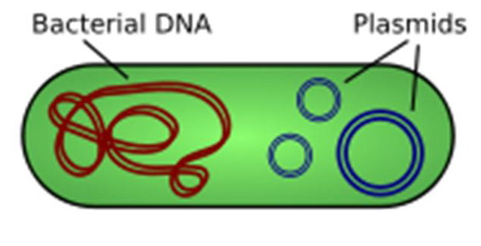

Fig 11-Plasmid: Circular DNA.

According to their transfer properties there are two types of plasmids
  - Conjugative plasmids: are those that mediate conjugation. They are large and have all the genes for both self replication and for transfer of DNA to a recipient as they possess genes for sex pilus.They are present in few copies (1-5 copies) per cell .They are commonly found in gram negative bacteria
  - Non-conjugative plasmids: are those that cannot mediate conjugation as they lack genes for sex pilus.. They are usually smaller than conjugative plasmids They are commonly found in gram positive bacteria. (Table 1)
Another classification of plasmids according to their phenotypic effects , the most important of which : fertility plasmid (F factor) that code for sex pili and resistance plasmids (R factors) that carry antibiotic resistance genes. Antibiotic kills sensitive bacteria and help in dissemination of R-factors.They are conjugative plasmids in which the genes for replication and transfer are located on one part of the R factor and the resistance genes are located on another part:
          - RTF (Resistance Transfer Factor) - carries the transfer genes.
          - R determinant - carries the resistance genes.The resistance genes are often parts of transposon.
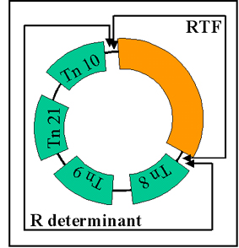

Table 2-Difference between conjugative and non-conjugative plasmid
Feature | Conjugative | Non-conjugative
Size | Large | Small
Copy number | 1-5 (stringent) | >30 (relaxed)
F-factors- Sex pilus | Present | Absent
Transfer of plasmid | By conjugation | By another conjugative plasmid
Type of bacteria | Gram-ve bacilli | Gram+ve cocci
III- Bacteriophage: see Chapter 4
IV-Transposable genetic elements: These are segments of DNA that have the capacity to move from one location to another in DNA (i.e. jumping genes). e.g. Insertion sequences and transposons (Tn), integrons and pathogenicity islands (PAIs). They are not capable of self replication.
Functions:Play a role in gene mutation, antibiotic resistance and can contribute to the virulence of pathogenic organisms .

Chapter 6
Bacterial Mutation and Gene Transfer

This chapter describes types of bacteria mutations and methods of gene transfer from one bacterial cell to another one.
Definitions :
Mutation: Is a change in the base sequence of DNA either spontaneously or from exposure to mutagens e.g. radiation, chemicals.
Genotypic changes: are changes in the base sequence of DNA that result in persistent changes in character and cannot return to its original status, and it pass to daughter cells.
Phenotypic changes: Changes in bacterial character that could be temporary as a response to environmental condition without change in genetic constitution.This change is reversible once the external condition is removed and doesn't pass to daughter cells. e.g. L-forms of bacteria.
Gene transfer mechanisms in bacteria: This could be achieved by: transformation, transduction or conjugation.
- Transformation: is gene transfer resulting from the uptake by a recipient cell of naked DNA i.e. DNA without associated cells or proteins, from a donor cell. Naked DNA of lysed bacteria could be chromosomal or plasmid.
Significance: Transformation occurs in nature and it can lead to increased virulence.
- Transduction: Is the transfer of genetic information from a donor to a recipient by a bacteriophage.
Types of transduction:

- Generalized transduction: in which any bacterial gene from the donor (plasmid or chromosome) is transferred to the recipient. This occur during the lytic cycle of bacteriophage.
- Specialized transduction: in which only certain donor genes can be transferred to the recipient and this occur in temperate cycle when prophage take adjacent genes then replicate
- Conjugation:is the transfer of DNA from a donor (male) to a recipient (female) in one way direction by direct physical contact between the cells through sex pili.
Chapter 7
Antibiotics
This chapter include characteristics of antibiotics. Moreover, it discuss various mechanisms of action of antimicrobial agents,combination therapy,antimicrobial resistance and chemoprophylaxis.
Introduction:
Antimicrobial agents are agent that kills microorganisms. It could be for therapy or for prophylaxis it include:
- Antibiotics :Are produced naturally by certain micro-organisms, it may have a cidal (killing) effect or static (inhibitory) effect on microorganisms. Semisynthetic antibiotic are natural antibiotics modified by the chemist .Synthetic antibiotics synthesized entirely by chemical means.
- Disinfectants kill microbes on non-living surfaces as table or floor e.g chlore
- Antiseptics kill microbes on living tissue as skin e.g alcohol
Selective toxicity: Antibiotics act by finding targets in the microbe that do not exist in human cell. For example, the beta lactam antibiotics (penicillin) inhibit peptidoglycan synthesis in the cell wall not present in human cell wall and so human are not affected by the action of the drug.

Antibiotics are effective against bacteria but not against viruses as influenza virus.
- As bacteria has their own enzymes and cell structure that can be specifically targeted with antibiotics.
- Most viruses often use human enzymes to replicate .
- For the viruses that do have specific viral enzymes, antiviral drugs are available example zidovudine (anti HIV drug).
Spectrum of action: is the range of micro-organisms that is affected by a certain antibiotic:
- Broad spectrum antibiotics are effective against a wide range of bacteria.
- Narrow spectrum antibiotics are effective mainly against only Gram-positive or Gram-negative bacteria, they have.
Mechanisms of action of antimicrobial agents:
  - Cell wall synthesis inhibitors: Generally inhibit some step in the synthesis of bacterial peptidoglycan . They are bactericidal and require actively growing bacterial cells in order to exert their toxicity. They have a high activity against Gram positive organisms,they include:
- Beta-lactam antibiotics: e.g penicillins and cephalosporins:
The initial step in drug action of this group consists of binding of the drug to cell receptors (penicillin -binding proteins (PBPs) then they inhibit the last step in peptidoglycan biosynthesis.
- Glycopeptide e.g. vancomycin: They inhibit early steps during peptidoglycan assembly.
- Bacitracin :It has a high toxicity which excludes its systemic use. It is present in many topical antibiotic preparations.
  - Cell membrane inhibitors : Inhibit the function of bacterial membranes.They have narrow margin of selective toxicity as there are similarities in phospholipids in bacterial and eukaryotic membranes. They are all microbicidal. Antibiotics of clinical importance include: Polymyxin and Colistin,they are effective mainly against gram-negative bacteria.
  - Protein synthesis inhibitors: Their action is always at one of the events of protein synthesis occurring on the ribosomes. Most have an affinity or specificity for bacterial 70S ribosomes as opposed to mammalian 80S ribosomes that have different chemical composition, and functions. In this manner selective toxicity is achieved. The most important antibiotics with this mode of action are:Tetracyclines and aminoglycosides. chloramphenicol, macrolides (erythromycin) ,fusidic acid and clindamycin.They are highly active against Gram negative baclli.

D- Nucleic acid synthesis inhibitors: Drugs that have selective activity to inhibit nucleic acid synthesis of bacteria act by either:
- Inhibition of DNA synthesis e.g.Quinolones.
- Inhibition of RNA synthesis e.g. rifampicin.
E-Competitive antagonism: Inhibitors of folic acid synthesis: Examples: Sulfonamides xTrimethoprim.They are all bacteriostatic.
Mode of action: They are analogues of para-amino benzoic acid (PABA) and compete with PABA for the active site of the enzyme used in the production of folic acid. This combination blocks two distinct steps in folic acid metabolism and prevents the emergence of resistant strains.
Antibiotic susceptibility testing: The basic quantitative measures of the in vitro activity of antibiotics are the minimum inhibitory concentration (MIC) and the minimum bactericidal concentration (MBC).
The MIC is the lowest concentration of the antibiotic that results in inhibition of visible growth under standard conditions.
Breakpoint of any antimicrobial is the concentration of the drug in the serum with optimal dose. Organism with MIC below breakpoint are sensitive. Organims with MIC above breakpoint are resistant.
The MBC is the lowest concentration of the antibiotic that kills 99.9% of the original inoculum in a given time.
Host factors can influence the concentration level of anti-microbials at site of infection. Thus in vitro activity of a drug is not always the same as in vivo activity.
Disk diffusion test:is also known as Kirby-Bauer test is used to measure the effectiveness of antibiotics on pathogenic microorganisms. (see practical book)
Combination therapy: with two or more antibiotics is used in special cases:
- To prevent the emergence of resistant strains.
- To treat emergency cases during the period when an etiological diagnosis is not known.
- To take advantage of antibiotic synergism e.g. endocarditis and septicemia.
- To treat mixed infections.
Effects of combination therapy:
- Antibiotic synergism occurs when the effects of a combination of antibiotics is greater than the sum of the effects of the individual antibiotics e.g.Vancomycin and gentamycin used in treatment of multi-resistant S.aureus (MRSA).
- Antibiotic antagonism occurs when one antibiotic interferes with the effects of another antibiotic e.g. The use of imipenem and pipracillin: e.g The imipenem is beta lactamase inducer which destroy piperacillin. e.g.The use of bacteriostatic drug as chloramphenicol with bactericidal drug as penicillin in treatment of meningitis.
- Indifference action occur when the two drugs gave the same action obtained by either of them as they have the same target e.g.vancomycin and cephalosprin, both inhibit cell wall synthesis.
Factors that influence the choice of antibiotics:
- Site of infection
- Nature of infection should determined wether bacterial, viral or fungal.
- Culture and sensitivity result is the guide for proper antibiotic therapy.
- Potential of drug toxicity should be known .
- Duration of antibiotics is usually between 5-7 days, full uninterrupted course is given to avoid emergence of resistant bacteria.
Complications of chemotherapy:
- Toxicity: Chloramphenicol cause bone marrow depression, streptomycin cause deafness (affect 8th cranial nerves) and aminoglycosides e.g gentamycin and amikacin cause renal failure.
- Allergy: as in penicillins cause local or systemic allergy, sulphonamides cause contact dermatitis.
- Emergence of resistance occur in case low dose, interrupted dose, improper choice of antibiotics.
- Superinfection or overgrowth of resistant bacteria after a prolong antibiotic treatment e.g. oral thrush caused by Candida and pseudo-membrane colitis caused by Clostridium difficile.
Antimicrobial resistance: Appear due to misuse of antibiotics in human, veterinary medicine and in agriculture. Antibiotic resistance in bacteria may be inherent i.e. natural, or acquired .
A- Inherent (intrinsic or natural) resistance:This could be present when the organism:
- Lacks a transport system for an antibiotic.
- Lacks the target of the antibiotic molecule e.g.L-form.
- Has a permeability barrier against the antibiotic e.g in the case of Gram-negative bacteria, where cell membrane pores do not allow some antibiotic to pass.
- Acquired resistance: It results from changes in the bacterial genome. Acquired resistance is driven by two genetic processes in bacteria:
- Mutation and selection (vertical evolution): Resistance that appears after introduction of this drug results from a selective process as the antibiotic selects the strains possessing a resistance gene. This is called selective pressure.
- Exchange of genes between strains and species or horizontal evolution. Acquisition of resistant genes from another organism is either by plasmids, phages, transposons and integrons.These genes codes for production of enzymes that destroy antibacterial drugs.
- Cross Resistance: microorganisms resistant to one drug could be resistant to another drug either because they have the same action e.g. macrolides and clindamycin or because they both have similarity in chemical structure e.g different types of aminoglycosides.

Mechanisms of resistance:
- Inactivation of the antimicrobial agent :by production of an enzyme that is capable of inactivating the antimicrobial agent.
e.g.Beta lactamases: destroy penicillins, cephalosporins.
e.g.Acetyl transferases: destroy chloramphenicol.

- Altered permeability of the antimicrobial agent :is the inability of the antimicrobial agent to enter the bacterial cell e.g. reduce permeability in case pseudomonas resistance to imipenem .

- Altered target site: due to alteration of the target site for the antimicrobial agent.

e.g.penicillin binding protein (PBP) receptors modifications: MRSA and resistant S. pneumonia.
e.g.Alteration of ribosomal subunits affect amino-glycosides.
and erythromycin.

- Replacement of a sensitive pathway : done by the acquisition of a new enzyme to replace the sensitive one. e.g. New metabolic pathways for folic acid synthesis result in resistance to trimethoprim.
Cross Resistance: microorganisms resistant to one drug could be resistant to another drug either because they have the same action or because they both have similarity in chemical structure e.g different types of aminoglycosides.
Chemoprophylaxis: When antimicrobials are used to prevent diseases to occur e.g
- At time of surgery e.g. pre-operative at time of anaesthesia.
- In immuno-compromised patient: e.g. Prevention of endocarditis in patients undergoing dental surgery in cases with damaged heart valve or prosthetic valve
- In people with normal immunity who have been exposed to certain pathogens.e.g.Rifampicin is given to contacts of cases suffering from meiningo-coccal meningitis
Probiotics: Are lived non-pathogenic bacteria that may be effective in the treatment or prevention of certain diseases (chapter 10).

Chapter 8
Sterilization and Disinfection
Control of microbial growth is effected by either killing microorganisms or inhibiting the growth of microorganisms.
This chapter will discuss some important physical and chemical methods used to control microbial growth.
Sterilization is the complete destruction or elimination of all viable organisms including spores in or on an object being sterilized. Sterilization procedures involve the use of physical, irradiation or chemical methods
Disinfection is the elimination only of pathogenic organisms but not their spores.
Cleaning is the removal of organic materials, dust which interfere with disinfection and sterilization, it is done using soap (detergent) and water.

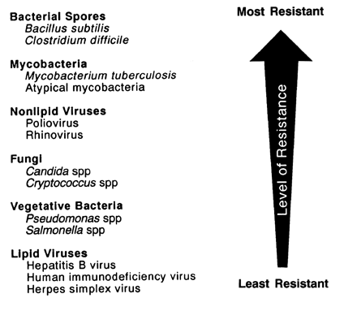

Fig 12 -The descending order of in vitro resistance of microorganisms to sterilization and disinfection
The descending order of resistance of microorganisms to sterilization and disinfection is as follows: Prions are the most resistant forms of living organisms followed by spores → Mycobacteria → small non-enveloped virus (polio) →fungi, large non-enveloped virus (Adenovirus) → vegetative bacteria → Lipid enveloped virus (HBV, HIV).
Methods of Sterilization and disinfection:
I- Physical:
- Heat: Most important and widely used being the safest, efficient and inexpensive method.Spores of bacteria are considered the most viable forms that resist heat so their destruction denote sterility.
A- Moist heat: they act by coagulation and denaturation of microorganism.
- Moist heat below 100ºC- Pasteurization: This method used for removal of pathogenic organisms from milk by either:
- Holder type process: Raising the temperature to 63ºC for 30 min then sudden cooling
- Flash method: Raising the temperature to 72ºC for 20 seconds then sudden cooling.
- Moist heat at 100ºC: Boiling at atmospheric pressure for 10 minutes will kill non-spore forming pathogenic microbes.
- Moist heat above 100ºC: Autoclaving (steam under pressure or pressure cooker): 121º C for 15 minutes under double atmospheric pressure or 134ºC at 3-6 min at 3 atmospheric pressure. This will kill spore forming organisms
Principle: At double atmospheric pressure boiling of water occur at 121°C, at 3 atmospheric pressure occur at 134°C. This apparatus is used frequently for sterilization of surgical instruments and almost anything except heat-labile substances which will be denatured or destroyed by heat. To obtain efficient sterilization by the autoclave the followings must be fulfilled:
    - Air must be removed as it interfere with penetrability of steam and reduce the temperature inside the chamber.
    - Steam must be under pressure and saturated.
    - Sterile hot air at the end of the cycle is essential to dry items.
    - Surgical instruments must be put apart before sterilization.
Advantage of steam sterilization (autoclave):
- Act by coagulation i.e penetrable.
- Liberation of latent heat.
- Non-toxic.
- Inexpensive.
Disadvantage of steam sterilization
- Not used for heat sensitive item.
- Not used for powder, mineral oil, lubricants and waxes.
Monitoring of sterilization process
- Physical monitoring: observation of sterilizer function such as temperature, pressure, time.
- Chemical monitoring: describes color change of indicators.
- Biological monitoring: at least done weekly using spores of Bacillus stearothermophilus which are exposed to sterilization process and no growth is obtained when cultured in broth.
B-Dry heat:
- Dry heat (hot air oven): They act by oxidation e.g.160ºC for 2 hours or 180º C for 1 hour.They are used for glassware, metals.
- Incineration: burns organisms and physically destroys them. This method is used for needles, glassware, direct flame for loops, forceps, for hospital waste disposal etc.
Advantage of dry heat sterilization:
- Low corrosiveness.
- Low cost.
- Used for waterless oil, lubricants, waxes and powders.
Disadvantage of dry heat sterilization:
- Long sterilization time.
- Causes damage to rubbers.
- Low penetrability.
2-Irradiation: usually destroys or distorts nucleic acids e.g.Gamma irradiation and beta-rays and it is used to sterilize heat sensitive items e.g. bone, gloves ,surgical sutures and IV fluid.
- Filtration: It involves the physical removal of all microorganisms in a liquid or gas form, and is especially important to sterilize solutions which would be denatured by heat e.g.
  - Millipore filters are used for sterilization of fluid, antibiotics, injectable drugs, amino acids, vitamins, etc.Millipore filters are made of cellulose acetate being rapid, don’t adsorb substance, don’t affect filtrate.
  - High efficiency particulate air (HEPA) filter is used for filtration of air of operating theatre, laminar flow,drug factories.
Monitoring of millipore filters is done by using bacteria called Serratia marcescence which produce red endopigment on nutrient agar

II-Chemicals and gas:
- Ethylene oxide, is a toxic chemical that kill all forms of life, it is used to sterilize heat sensitive device. Being toxic and of high cost its use is limited .
- Gas plasma :This system use a highly ionized gas ; in one type is hydrogen peroxide vapor and its by-products are water and oxygen which is considered as advantage. In a second type peracitic vapor phase is used which is less damaging than the first one.
Gas plasma is used to sterilize heat sensitive medical devices.
Advantage: Safe for environment and health care workers.
Control of microbial growth: could be done by chemical or physical agents
    - Chemicals by Antimicrobial agents:

      - Antiseptics: Microbicidal agents that can be applied on living tissues like skin and mucous membrane but cannot not be ingested. example: alcohols.
      - Disinfectants: Agents that kill microorganisms, but not their spores and are not safe for application to living tissues. They are used on inanimate objects such as tables, floors, utensils, etc.like chlorine compounds.
Types of disinfectants:
- High level disinfectants.
- Moderate level disinfectants.
- Low level disinfectants.
  - High level disinfectant (HLD): destroy vegetative bacteria including Mycobacteria, all fungi, all non-lipid and lipid enveloped viruses. They can be used for disinfection of heat sensitive semi-critical item such as endoscopes e.g. 2% glutaraldhyde,hydrogen peroxides (H2O2),peracetic acid.
  - Moderate or intermediate level disinfectants (ILD): They are not effective against non-lipid viruses. They are often used for disinfection of heat sensitive non-critical items such as stethoscope e.g. alcohol (70%).
  - Low level disinfectants (LLD): They are not effective against spores, Mycobacteria, non-lipid viruses. They are often used for non-critical item as environmental purpose such as surface and floor e.g. phenol
Based on the risk of infection in patients, three categories of medical devices can be distinguishes:
Critical items: Instruments that enter sterile area (tissue, cavity) and should be sterilized by autoclave, ethylene oxide.
Semi-critical items: These are items that come in contact with mucous or non-intact skin (endoscope, thermometer).They often decontaminated by HLD.
Non-critical items: These are items that come in contact of intact skin. They are often disinfected by ILD, LLD e.g.blood pressure cuffs, stethoscope, bedpans.
B- Physical agents
a- Applications of Heat : Whenever heat is used to control microbial growth both time and temperature are considered.
  - Pasteurization: used to reduce the number of pathogenic micro-organisms that are transmitted by milk e.g. Salmonella and Mycobacterium tuberculosis.
  - Boiling: 100°C for 30 minutes kills everything except spores. Used to decontaminate babie's milk bottles, bedpan and urinals.
  - Sterilization (autoclaving, hot air oven) kills all micro-organisms with heat; commonly employed in canning, bottling, and other sterile packaging procedures (see above).
b- Low temperature (refrigeration and freezing)
c- Drying (removal of H₂O): Methods used to dry is by heat, evaporation, freeze-drying, addition of salt or sugar.
d- Ultraviolet irradiations(UV light): They are non-ionizing rays that have low energy, low penetrability,and are affected by dust used to reduce bacterial air count in operation rooms,laboratory laminar flow and for hospital rooms after the discharge of a case with open tuberculosis .
Chapter 9
General Aspects of Bacterial Pathogenesis
Bacterial pathogenesis depends on the immune status of the host, the nature or virulence of the species or strain and the number of organisms in the initial exposure.
This chapter describe classification of bacteria according to its pathogenesis,stages and determinants of pathogenesis.
Bacteria are classified into:
  - Saprophytic bacteria: Present in nature as air, water and soil
  - Non-pathogenic bacteria (normal flora, commensals): They are living in human; present on skin and gut. Most of these bacteria are harmless. Staphylococcus aureus, S. epidermidis are found normally on the skin, Bacteroides and Enterobacteriaceae found in gastrointestinal tract (GIT).
  - Opportunistic bacteria: In immuno-compromised patients, whose defenses are weakened, normal flora often cause opportunistic infectious diseases when entering the bloodstream e.g. after surgery.
  - Pathogenic bacteria: These are capable of causing disease in man.
The outcome of an infection depends on the virulence of the pathogen and the effectiveness of the host defense mechanisms.
Superinfections: a new infection occurring in a patient having a pre-existing infection; for example, bacterial infection may occur in patients with viral respiratory disease. Superinfection can complicate the course of antimicrobial therapy when the organisms causing the new infection are resistant to the drugs being used to treat the first infection.
Stages of bacterial pathogenesis: Most bacterial infections are acquired from an external source. Sequence of the stages of infection is as follows:
- Transmission from an external source to the portal of entry. This could be by inhalation, contact, ingestion, injection,trans-placental and sexual contact.
- Escape the host defenses
- Colonization: Growth of the bacteria at the site of entry.
- Disease symptoms caused by toxins production or invasion and inflammation.
- Host responses (immunity), both non-specific and specific, during steps 4,5.
- Progression or resolution of disease.
Determinants of bacterial pathogenesis are by :
- Pathogenicity is the ability to produce disease in a host organism.
- Virulence is the degree of pathogenicity of the microbe.
Virulent bacteria can produce disease in man by :
      - Adherence of the microbe to cell surfaces: This requires the participation of two factors: a receptor on tissue cell and an adhesion on bacteria that interact in a complementary and in a specific fashion this explain tissue tropism of micro-organisms. e,g fimbriae ( pili).
      - Invasion and intracellular survival: by which the microbe overcome host defense mechanisms and production of extracellular substances which facilitate invasion such as:
- Enzymes:
  - Hyaluronidase: Breaks down hyaluronic acid present in connective tissue. It is the original spreading factor produced by Streptococci.
  - Collagenase: Breaks down collagen of muscles and facilitates infection.It is produced by bacteria causing gas gangrene (Clostridium species).
  - Neuraminidase: Degrades neuraminic acid (or sialic acid) the intercellular cement of the epithelial cells of the intestinal mucosa. It is produced by Haemophilus influenzae.
  - Streptokinase: They are produced by Streptococci. They convert inactive plasminogen to plasmin which digests fibrin and prevents clotting of the blood.
  - Enzymes that cause hemolysis and/or leucolysis: Usually act on cell membrane and cause cell lysis e.g.
  - Lecithinases break down lecithin of cell membrane.
  - Hemolysins lyse red blood cells.
  - Leukocidins lyse,leucocytes and phagocytes
  - Protease: e.g. Immunoglobulin protease degrades Ig A.
  - Deoxyribonuclease: Breaks down DNA.
  - Coagulase enzyme: This enzyme convert fibrinogen into fibrin deposit around the bacteria thus protect them from phagocytosis e.g.Staphylococcus aureus.
- Inhibition of phagocytic engulfment: Many important pathogenic bacteria carry on their surfaces substances that inhibit phagocytic adsorption or engulfment:
- Cell wall proteins of gram positive cocci as M protein of group A Streptococci (S.pyogenes) and protein A of Staphylococcus aureus.
- Capsule: Prevent attachment of phagocytes to bacterial cells e.g. Polysaccharide capsules of S. pneumoniae, Haemophilus influenzae.
- Coagulase: see under enzymes.
- Ig A proteases
- Ability to survive intracellularly:
- Inhibition of phagolysome fusion as in Mycobacteria
- Escape phagosome as in listeria

C-Antigenic variation : is changing surface antigens to avoid immune destruction ,Example: N. gonnorhea change antigen of pili and outer membrane proteins,Influenza virus make antigenic shift and antigenic drift
D-Toxin production or Toxigenesis:.Bacteria produce two types of toxins called exotoxins and endotoxins.
Exotoxins are released from living bacterial cells and may act at tissue sites away from the site of bacterial growth. If treated with formalin it is converted to toxoid, loosing its toxicity but retain its antigenicity . Toxoid are used in active immunization
Endotoxins are structural components of the cell walls of Gram-negative bacteria. Endotoxins may be released from growing bacterial cells or from lysed cells as a result of effective host defense (e.g. lysozyme) or the activities of certain antibiotics (e.g.penicillins and cephalosporins.
Table 3-Main features of exotoxins and endotoxins
Comparison properties | Exotoxin | Endotoxin
Source | Living bacteria mainly Gram positive bacteria, certain species of Gram negative bacteria | Disintegraded bacteria ,present in cell wall of Gram negative bacteria
Secreted from cell | Yes | No
Nature | Protein | Lipopolysaccharides
Location of coding genes | Plasmid,bacteriophages | Bacterial chromosomes
Toxicity | High | low
Antigenicity | Highly antigenic | Poorly antigenic
Vaccines | Toxoid are used as vaccine | No toxoid,there is no vaccine
Heat stability | Heat labile at 60ºC | Heat stable at 100ºC for 1 hour
Clinical action | Specific in action. | Non-specific action cause fever and shock
Examples | C.diphtheria (phage)  Clostridium tetani (plasmid) | Meningococci, sepsis by gram negative bacilli

Chapter 10

NORMAL FLORA OF HUMANS

Introduction: A diverse microbial flora is associated with the skin and mucous membranes of every human being form shortly after birth until death.

This chapter give definitions of various flora,their distribution in human body,their role as opportunistic pathogens, types of carriers,the difference between prebiotics and probiotics

Resident flora bacteria:They are stable, regularly found at any anatomical site.They colonize certain tissues and not others due to:

- Tissue tropism: the host provides essential nutrients and growth factors for the bacterium, in addition to suitable oxygen, pH,and temperature for growth.
- Presence of specific adherence receptors.
- Biofilm formation : Some are able to construct biofilms on a tissue surface, or they are able to colonize a biofilm built by another bacterial species.

The balance between microbes vary with age, when antibiotics are given and when there is disruption of normal anatomic or physiologic function.

Transient flora :They are normal flora that are not always present or are present for only a few days, weeks, or months before disappearing.

Viruses and parasites are not considered members of the normal microbial flora because they are not commensals and do not aid the host.
Role of normal flora:
  - Infection resistance:
- Prevent colonization by pathogens by competing for attachment sites and receptors or for essential nutrients.This is known as bacterial interference.
- Mucin secretion to prevent attachment of pathogens.
- Antagonize other bacteria through the production of substances which inhibit or kill them e.g bacteriocins.

  - Stimulation of the immune system: Because of cross reactivity between related bacteria ,the antibodies produced in response to normal flora protect the host from pathogenic bacteria.
  - Synthesize and excrete vitamin: e.g Vitamin K produced by intestinal flora.

Normal flora could be a pathogens as :

- Opportunistic infection: occur in immune-compromised status e.g. candidiasis in HIV patients or after trauma e.g post-operative abdominal abcess. Also antibacterial therapy result in superinfection with antibiotic resistant pathogens.
- Change of normal habitat: e.g Urinary tract infection caused by intestinal E.coli and subacute bacterial endocarditis in predisposed patient is caused by Viridans streptococci present as a normal flora in the upper respiratory tract.

Bacteremia : bacteria in blood stream without clinical signs. In a healthy person bacteremia is typically transient and is quickly removed from the blood by the immune system.
Septicemia : When immune response mechanisms fail, bacteria in blood stream (multiplying) occur with clinical signs. It is life-threatening that can lead to tissue damage, organ failure and death.

Normal flora present in skin,mouth, throat, pharynx,vagina are:
- Gram positive cocci: S.epidermidis, Viridans Streptococci, enterococci.
- Gram negative cocci: Neisseria.
- Gram positive bacilli: Diphtheroids.
- Yeast(candida).

Definitions:

Probiotics: Are lived non pathogenic bacteria that may be effective in the treatment or prevention of certain diseases. This could be achieved by colonization resistance by which the non-pathogenic bacteria excludes the pathogen from binding sites on mucosa e.g. oral administration of lactobacillus species reduces hospital acquired diarrhea in young children bacteria.
Prebiotics are non-digestible food ingredients that beneficially affect, stimulate, the normal flora in the colon.

Carriers: A person that shows no symptoms of a disease but carry the infectious agent of that disease and is capable of transmitting it to others. Carriers may present more risk for disease transmission because their contacts are unaware of their infection and their activities are not restricted by illness. Depending on the disease, any of the following types of carriers may be important (table 6):

Table 4-Types of carriers
Type of carrier | Features
1-Incubatory carriers: | People transmitting their infection before their symptoms start. e.g mumps.
2-Carriers with inapparent infections, subclinical infection | show no illness,and are able to transmit their infection to others e.g poliomyelitis virus, meningo-coccal meningitis.The number of subclinical cases are high before a single clinical case appears.
3-Convalescent carriers | are people who continue to be infectious during and even after their recovery from illness. This happens with many diseases. Example: Salmonella.
4-Chronic carriers | are people who continue to harbor infections for a year or longer after their recovery.e.gHepatitis B

Other types of carriers :
- Temporary carriers: The carrier state lasts for less than 6 months.
- Contact carrier: A person can become a contact carrier when he acquires the microorganism due to his contact with the patient.
- Paradoxical carrier : when a carrier the person acquires microorganisms from another carrier

Chapter 11

Introduction to Virology

Virology: is the study of viruses.

A virus is unable to grow outside a host cell. Each viral particle, or virion, consists of genetic material, DNA or RNA, within a protective protein coat called a capsid.

This chapter include morphology,classification of viruses, principal events involved in its replication,various tissue cultures used for its isolation,its pathogenesis, laboratory tests used for diagnosis and antiviral treatment.

Definitive Properties of Viruses:

- Small size: are measured in nanometers 20 – 300 nm so they are only visualized by electron microscope .
- Only one type of nucleic acid either: DNA or RNA (never both).
- Obligate intracellular they require a living cell in order to survive and replicate. They are propagated on tissue culture and not oridinary artificial culture media.
- A virus can be completely eliminated by the immune system.
- Antibiotics have no effect on viruses .They are treated by antiviral drugs
- Vaccines that produce lifelong immunity can prevent viral infections.

Morphology: Viruses have characteristic shapes - spherical ,helical, polyhedron ,sometimes with tails or envelopes. The most common polyhedron is the icosahedron which as 20 triangular faces ( fig 1).

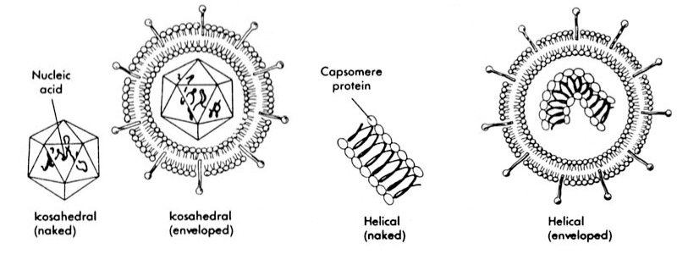

Fig 13 -The most common viral morphologies: Left to right:A naked icosahedral virus (e.g. Poliovirus), an enveloped icosahedral virus (e.g. Herpes virus), a naked helical virus (e.g. Tobacco mosaic virus) and an enveloped helical virus (e.g. Influenza virus).

The genome (DNA or RNA):

It is the infectious part of the virus and codes for proteins (enzymes) necessary for replication:
- Non-structural, e.g. nucleic acid polymerases.
- Structural form parts of the virion.

Capsid:

It is the protein shell of a virus. The capsid encloses the genetic material of the virus. Both capsid and nucleic acid are called nucleocapsid. It has several functions:

- Protect the genome (DNA or RNA).
- Virus-attachment protein to the host cell receptor.
- It gives the virus morphology.
- They could be enveloped: Some viruses by "budding" through the host cell membranes acquire an outer lipoprotein coat from the host (nuclear or cytoplasmic membrane) and always contains unique viral glycoproteins. Enveloped viruses are sensitive to lipid solvent.
- Antigenic: Cellular and humoral mediated responses are directed against capsid proteins.

Principal events involved in replication:
- Adsorption: The first step in infection of a cell is attachment to the cell surface.The viral attachment protein recognizes specific receptors outside of the cell.
- Penetration: The virus enters the cell in a variety of ways
- Fusion: Enveloped viruses fuse directly with the plasma membrane.
- Endocytosis:Non-enveloped viruses enter the cell by invagination of the cell membrane to form vesicles in the cell cytoplasm.
- Uncoating: Release of the viral genome from its protective capsid to enable the nucleic acid to begin replication.
- Eclipse phase: When the nucleic acid is uncoated, infectious virus particles cannot be recovered from the cell which lasts until new infectious virions are made.
- Synthesis of viral nucleic acids and proteins: Messenger RNA (m-RNA) is transcribed from viral DNA and codes for viral proteins that are translated by the host cell:
- Early proteins are usually non-structural (enzymes)
- Late proteins are structural or building blocks of the virion eg.capsid
- Nucleic acid replication produces new viral genomes.
  - Assembly/maturation:New virus particles are assembled.
  - Release of new infectious virions is the final stage by either:
- Budding from the cell surface, occurs with many enveloped viruses.Budding viruses do not kill the cell.
- Lysis of the infected cell as occurs in non-enveloped virus.

Viral pathogenesis:

Transmission of virus: Virus can be transmitted from person-person or animal-person(zoonosis).

      - Person-person transmission can be spread by:

  - Horizontal transmission: due to exposure to respiratory secretion (air-born or "droplets),blood (transfusion, sharing of needles),ingestion such as contaminated water or food and sexual transmission.
  - Vertical transmission: from maternal to fetal/child across the placenta or during breast-feeding.

B- Animal-human transmission (zoonosis) occurs.
- Directly when human is exposed to infected animal .
- Indirectly: Arthropod-borne e.g. by mosquito (most common), ticks (less common), the virus is called Arbovirus.

Pattern of viral infections: There are several possible consequences:

- Subclinical viral infections: This is the commonest type of infection where no clinical signs and symptoms are present
- Acute infections or lytic infections result in the destruction and death of the host cells. Acute viral diseases could be local or systemic, comparison is shown in Table 1.
- Persistent infections (chronic infection): The host cell may not be lysed, such infections may occur over a long period of time by a replicating virus e.g Hepatitis B
- Latent infections: no replication of the virus occur .There is a delay between the infection by the virus and the appearance of symptoms. example in Herpes virus. Dormant virus are usually triggered by stress factors in the host.
- Transformation: Some animal viruses have the ability to change a cell from a normal cell into a tumor e.g oncogenic viruses.

Table 5-Important features of acute viral diseases

Feature | Local infections | Systemic infections
Specific disease | Rhinovirus | Measles
Transmission | respiratory | respiratory
Site of lesions | Portal of entry | Distant site
Incubation period | Short | Long
Viremia | absent | present
Immunity | Short duration | Life long duration
Role of Ig A | important | Not important

Diagnostic methods in virology : can be grouped into 3 categories:
- Direct detection for the presence of virus particles, virus antigen or viral nucleic acids.
- Virus isolation of clinical specimen in: cell culture, eggs or animals
- Serological diagnosis.

In general, the majority of common viral infections can be diagnosed by serology.

A- Direct examination of specimen

  - Electron Microscopy (EM): Required for visualization to identify the morphology and size of the virus. It is also used for detection of viruses that cannot be cultured.
  - Immune electron microscopy: The sensitivity and specificity of EM may be enhanced when virus specific antibody is used to agglutinate virus particles together and thus making them easier to recognize.
  - Light microscopy used to detect viral inclusion bodies which are accumulation of virions at sites of assembly that can be stained and seen by light microscope. e.g Negri bodies in rabies infections.
  - Antigen detection: Viral antigens can be detected by serological techniques such as precipitation, agglutination, immunofluorescence, ELISA. It is used for detection of viruses that cannot be cultured.
  - Molecular techniques for the direct detection of viral genomes include nucleic acid hybridization and Polymerase chain reaction (PCR) .It is used for detection of viruses that cannot be cultured.

      - Viral isolation: Viruses require living cells in order to replicate. Cultured cells, fertilized eggs and laboratory animals may be used for virus isolation.
- Tissue cell cultures are the commonly method used for virus isolation in most laboratories .They are separated into 3 types:

  - Primary cells: These are normal adult cells and can only be passaged once or twice. e.g. Monkey Kidney.
  - Semi-continuous diploid cells: These are cells taken from embryonic tissue, and may be passaged up to 50 times e.g. Human embryonic kidney
  - Continuous cells -These are immortalized cells i.e. tumour cell lines derived from human or animal tissue and may be passaged indefinitely e.g. Hela cells obtained from carcinoma of cervix.

Cell monolayers are inoculated with a suitable clinical specimen, and then observed for cytological changes that indicate virus growth.

There are various ways for detection of virus-infected cells:

- Plaque formation: Localized areas of destructed cell in monolayer cell culture. Using vital stains, plaques, appear as unstained areas on a colored background. Each plaque is the result of infection of one cell by one virus.
- Cytopathic effects (CPE): Viral growth cause microscopic degenerative effects .
- Inclusion body formation: or site of viral replication.It could be made visible by haemotoxylin (basic dye) and eosin (acidic dye) using light microscope .
- Direct fluorescent antibody stain.
- Appearance of a soluble virus-specific protein (antigens) are generally detected by specific antibodies to the protein of interest e.g. Complement fixation test.
- Haemadsorption: Adsorption of erythrocytes to virally-infected cells. This reaction is positive before any visible cytopathic changes . Haemadsorption is mainly used for the detection of Influenza and Parainfluenza viruses.
- Interference: here a known non-cytopathic virus is used to interfere with the replication of a cytopathic virus in the infected cell.
- Morphologic transformation: This is associated with infection of cells by oncogenic viruses; there is lack of contact inhibition
- Neutralization test: using specific antisera to neutralize the CPE.

C-Serological diagnosis: Is done by detection of:

- Rising titres of antibody
- Detection of IgM : in recent infection.
- Sero-conversion:means changing from a previously antibody negative state to a positive state

Serological tests commonly used are enzyme linked immunosorbent assay (EIA), western blot (WB) ,immunofluorescence techniques (IF),complement fixation tests, haemag-glutination inhibition tests and neutralization tests.

Antiviral drugs: Are designed to target one of the steps in the viral life cycle:

Before cell entry: The drug interfere with the ability of a virus to enter a target cell in two ways: it could be similar to host cell receptor or it inhibits uncoating of the virus e.g Amantadine and rimantadine: used in prophylaxis and treatment of influenza.

During viral replication:
  - Nucleoside analogues: that look like RNA or DNA so it deactivate the enzymes e.g :
  - Acyclovir a Guanine analogue .It is effective against all herpes virus infections
  - Zidovudine (AZT): Thymidine analogue inhibit viral reverse transcriptase enzyme of HIV.
  - Ribavirin: inhibits mRNA. Aerosols are used to treat Influenza

B- Protease inhibitors: as Indinavir, Sanquinavir inhibit protease activity in late stage of HIV replication

Both reverse transcriptase inhibitors and protease inhibitors are used in treatment of HIV infection.

- Interferons: inhibit viral replication as it inhibit mRNA.
- Release phase: Prevent the release of viral particles e,g oseltamivir (Tamiflu) used to treat influenza .

Chapter 12

Mycology

Mycology is the study of fungi which include molds,yeast,and mushroom.

General Features of fungi:

- Eukaryotic organisms
- They do not contain chlorophyll.
- They possess complex carbohydrate cell walls.
- They have ergosterol in their cell wall.
- They have filamentous structures.
- They produce spores.
- Heterotrophic: either as free living saprophytes,saprobic (fungus living on dead organic material) or as parasites.

Pathogenic fungi can exist as yeasts or as hyphae or both.

1- Yeasts are unicellular organisms. The yeasts reproduce by budding.
e.g. Candida

2- Hyphae are multi-cellular filamentous structures, constituted by tubular cells with cell walls. When present in a mass it is called mycelia.
- The mycelial forms branch and the pattern of branching help in identification of fungi .
- The mycelia could be septated or non septated.
- Reproduction is by spore formation (conidia). The asexual spores may be large (macroconidia) or small (microconidia)
- e.g.Penicillum, Aspergillus and dermatophytes.

- Dimorphic fungi : they have two forms :
  - Yeast (pathogenic form) usually seen in tissue, in exudates,or culture at 37 ºC.
  - Mycelium (saprophytic form): Present in nature or when cultured at 25ºC.

Conversion to the yeast is essential for pathogenicity. On culture they form filamentous colonies. Dimorphic fungi are identified by several morphological or biochemical characteristics. e.g Histoplasma

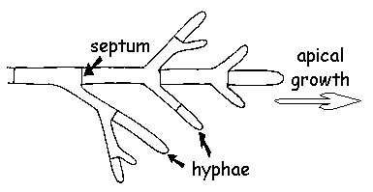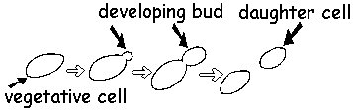
yeast

Fig 15- Morphology of pathogenic fungi

Mycoses:is a condition in which fungi establish infections.

Classification: Mycoses are classified according to the tissue levels initially colonized

- Superficial mycoses : Limited to the outermost layers of the skin and hair e.g Tinea versicolor,

- Cutaneous mycoses: Restricted to the keratinized layers of the skin, hair, and nails as the fungus secrete keratinase.Unlike the superficial mycoses, host immune responses may be evoked, resulting in pathologic changes expressed in the deeper layers of the skin.The causative organisms are called dermatophytes.
  - Causative organisms are: Microsporum, Trichophyton, and Epidermophyton

- Subcutaneous mycoses :Involve the dermis, subcutaneous tissues, muscle, and fascia.These infections are chronic and can be initiated by piercing trauma to the skin, which allows the fungi to enter.These infections are difficult to treat and require surgical debridement.

- Systemic mycoses due to primary pathogens :Originate primarily in the lungs and may spread to many organ systems.Organisms that cause systemic mycoses are virulent.Primary pathogens that cause systemic mycoses are dimorphic.

- Systemic mycoses due to opportunistic pathogens:Infections occur in patients with immune deficiencies as in AIDS, alteration of normal flora by antibiotics, immuno-suppressive therapy, and metastatic cancer. Examples:Candidiasis, and Cryptococcosis.

Laboratory diagnosis

Specimen: According to the site of infection: Skin, nail, hairs, CSF, sputum, blood etc. Skin scrapings suspected to contain dermatophytes or pus from a lesion can be mounted in 10% KOH on a slide to degrades human tissues releasing yeast and hyphae ,and then examined directly under the microscope.

A- Direct examination:
  - Direct unstained film:to detect hyphae, yeast forms,spores.
  - Direct film stained with Gram, India ink amd other stains.
  - Antigen detection by latex agglutination (CSF,serum) e.g Cryptococcal capsular polysaccharide.

B- Culture: A definitive diagnosis requires a culture and identification. Pathogenic fungi are usually grown on Sabouraud dextrose agar.It has a slightly acidic pH (~5.6); cyclohexamide, penicillin, streptomycin or other inhibitory antibiotics are often added to prevent bacterial contamination and overgrowth.Two cultures are inoculated and incubated separately at 25 ºC and 37ºC to reveal dimorphism.

The cultures are examined:
- Macroscopically: including the reverse view of growth.
- Microscopically : they are not considered negative for growth until after 4 weeks of incubation.
- by DNA probes or immuno-fluorescent technique.
- Biochemical reactions.

C- Serology: fungi are poor antigens.Tests for fungi are based on latex agglutination, double immunodiffusion, complement fixation and ELISA .

D- Skin test: insignificant. It is a delayed type hypersensitivity and indicates previous exposure to the agent.

Treatment : Antifungal drugs are used to treat mycoses. Depending on the nature of the infection, a topical or systemic agent may be used.

Chapter 13

Infection control

This chapter gives important definitions about infection control .Moreover it covers the mode of spread of infections in a hospital and various methods of precautions taken.

Definitions:

Infection control means doing everything to prevent health care acquired infection or nosocomial infection.

Nosocomial infection is any infection acquired during hospitalization and was neither present nor incubated upon admission.It occurs after 72 hours and could be extended to 1 year after prothesis insertion.Nosocomial infections :Affect 3 in 100 patients in developed countries.

Iatrogenic infection is defined as an infection after medical or surgical management, whether or not the patient was hospitalized.

Infection control is important for several reasons :
  - Reduce health care cost.
  - Infection could be fatal.
  - Health care personnel if infected could be out of work.

Commonest Hospital-acquired infection
- Urinary tract infection
- Respiratory tract infection
- Surgical site infection
- Food born infection
- Hepatitis.

Hospital-acquired infection is attributed to several factors:

- Patients are treated in close quarters and are subjected to frequent contacts.
- Patients are subjected to many invasive procedures .
- Use of antibiotics: help the appearance of drug-resistant bacteria.

In the hospital the high risk groups mostly exposed to infections are:

  - Patient: Newborns (premature), elderly,seriously ill patients in burn unit, surgical intensive care units(SICU),critical care units(CCU) and long term patients.

Health-care acquired organisms :70% are characterized by being multi-resistant to antibiotics they include:
Gram positive are : Staphylococcus aureus MRSA, Enterococci.
Gram negative bacilli are :Pseudomonas aeruginosa, Klebsiella specially among neonates.

  - Health care workers (HCW): Health care workers are at risk of the following infections: Hepatitis B virus,Hepatitis C virus and Human immunodefiency virus.

The aim of infection control procedures is to break spread of infection in the hospital this could be achieved by:
- Cleanliness: The vital procedure is hand-washing before and after contact with patient or after handling contaminated items.
- The use of protective measures: e.g. gloves, mask, cap,boots etc..

Modes of spread of infection in hospital:

- Infection by contact which could be by:

  - Direct contact: This is the most common way of transmission, it involves skin-to-skin contact like handshaking.The most important organisms transmitted are:
Bacterial: S.aureus, gram-negative bacilli as Klebsiella
Viral: as Respiratory syncetial virus, Hepatitis A, and Rhinoviruses.
Fungus: Yeast as Candida.
  - Indirect contact: It occurs when contaminated inanimate surfaces come in contact with susceptible person (patient) e.g.rectal thermometers can transmit Salmonella spp.

- Infection transmitted by air: They are produced by coughing, sneezing, talking or during suctioning, bronchoscopy.

There are two mechanisms of air transmission:

  - Droplet: Is produced by droplets larger than 5 microns and it rapidly settle out on the surfaces.They are not transmitted beyond few centimeters from the source.Examples of droplet infections:
Bacterial: most bacteria .
Viral: e,g Influenza and german measles (Rubella)
  - Air-born: Is produced by droplet less than 5 microns.The droplets remain suspended in the air for long periods and once inhaled they reach alveoli readily, examples of air-born infections are:
Bacterial: Mycobacterium tuberculosis.
Viral: Measles, Varicella.
Fungal infection: Aspergillus.
- Infection associated with water: Pseudomonas may multiply in any moist area and have simple growth requirement and resistant to antibiotics and disinfectants. It has been found in mouth-wash, dental water units, oxygen humidifiers , hot baths, plants and flowers.
- Infection acquired from food :Hospital food can be the source of antibiotic resistant bacteria which colonize gut and cause infection in susceptible patients e.g Salmonella spps
- Infection by inoculation and body fluid : Now the main risk of injuries are infection with viruses such as Hepatitis B, C and HIV . Single use disposable needles reduce the transmission of infection by this route.Exposure of health care workers to body fluid also carry the risk of infection by these organisms.
- Infection from contaminated infusion: could be due to failure of sterilization during manufacture. Endotoxic shock have been caused by heavily contaminated infusion fluid.
- Vector born transmission: Although rare transmission of Shigella and Salmonella in hospital could be by flies.Malaria is transmitted by mosquito bites.
- From the patient’s environment:The immediate environment if heavily contaminated could be a potential source of air born and direct contact.

From equipment:
- Bed pans and urinal could be important in the spread of enteric bacteria and antibiotic resistant gram negative bacilli.
- Endoscopes are difficult to be disinfected; can transmit S. typhi, and myocbacteria tuberculosis, hepatitis B.

Precaution (Isolation) Guidelines:Modern isolation practices are based on the concept of isolating the disease and not the patient.

Types of precautions:
- Standard precaution
- Transmission- based precautions

Standard precaution (universal precaution):

Purpose: Is to reduce transmission of blood born pathogens and moist body substance pathogen from“ Recognized and Unrecognized”sources of infections. This is achieved by avoidance of needle-stick injury and by wearing gloves.All sharps are discarded in puncture-resistant container. In addition to gloves ,mask, eyewear and gown are worn if blood or other body fluids can splash to the health care worker .

Transmission-based precaution:

Purpose: Is to reduce risk of transmission of infections from patients known to be infected or colonized with highly transmissible pathogens

- Air-born precaution:Patient is isolated in a private negative pressured room and by wearing special nasal mask.
- Droplet precaution: Mask is worn in close contact.
- Contact precaution: Introduction of hand-washing and antiseptics are always accompanied by reduction of infection rate.Alcoholic preparations are used and are effective in elimination of most pathogens.
- Protective precaution: Used for immuno-compromised patients e.g neutropenic,immunodeficient patients,severe burns, transplant recipients, leukaemia , patients receiving radiotherapy.

Handwashing: Is the single most important measure used to reduce the risk of transmission of infection and done in all precautions.Simple soap and water hand-washing for ten seconds is recommended to remove all transient bacteria.It is done wether or not gloves are worn.It may necessary to wash hand between procedures on the same patient to prevent cross-contamination of different body sites.
Antiseptics are used specially for patients under contact precaution.e.g,chlorhexidine in specific situation.

Role of Microbiology in infection control

- Routine monitoring:
  - Testing the sterilization efficacy of autoclave and ethylene oxide or plasma sterilizer by using biological indicator and chemical indicators.
  - Bacterial air count of operation room is done monthly.
  - Renal dialysis unit: Bacterial count is done monthly for water tanks and dialysate.
- Investigations are done in outbreak of infection:It is done to determine the source of infection,.

The high risk- Hospital areas which is included in any infection control program are:
- Adult,pediatric,neoanatal CCU, ICU.
- Operating theatre.
- Renal dialysis unit.
- Central supply and sterilizing department(CSSD).
- Emergency room.
- Pharmacy: Total parentral nutrition.
- Blood bank,out-patients and dental clinic

References

  - Diana Hardie (2001): Medica virology lectures notes-on line,Department of medical microbiology ,University of Cape town.
  - MIM”S medical microbiology and immunology by R. Goering,H Dockrell, M.Zukerman And P.Chiodini 26th edition 2019
  - Jawetz,Melnick and Adelberg's (2013): Medical microbiology , 26th edition ,Lange.
  - Kaplan medical (2006-2007): USMLE step 1 lecture notes Microbiology and immunology.Gabriel Virella (1997):Microbiology and infectious disease,third edition,Williams and Wilkins.
  - Kenneth Todar (2008): The microbial world-on line,university of Wisconsin – Madison,USA
  - Richard Hunt(2008): Microbiology and immunology on-line ,University of south Carolina, school of medicine,Biomedical Science program.

Members of microbiology department faculty of medicine, Cairo university (2007): Essential medical microbiology and immunologysecond edition parts I.II.III.

Geo.F.Brooks,Janet S.Butel and Stephen A .Morse(2004): Jawtz,Melnick and Adelberg's Medical microbiology,Tewnty third edition,Brooks,Butel,Morse.
- Members of microbiology department facultyof medicine Cairo university (2000): Kasr EL-AINI manual of medical microbiology and immunology parts I,II,III,first edition,S.O.P press.
- Shanson(1999): Microbiology in clinical practice,third edition,Butter worth Heinemann.
- Thao Doan ,Roger Melvold ,Susan Viselli,Carl Waltenbaugh (2008): Immunology, editors Richard A.harvey and Pamela C.Champe LippincottWilliams and Wilkins.
- Wenzal, Richard,Edmond,Michael ,Diddier Pittet,Jeanne-Marie Devaster,Timpthy F.Brewer,Alasdair Geddes,Jean Payl butzler(1998):A guide to infection control in the hospital,B.C.Decker.

Block -1
Code 106

Parasitology
Outcome :
- Identify the sources of infection, mode of transmission & causative organisms of various infectious diseases.
- Point out the principles of disease surveillance and screening, , communicable disease control, health promotion and health needs assessment
- Illustrate the management plan , prophylaxis,& simple prevention methods of clinical case subjected to certain bacterial viral , parasite & helmenthesis
- Describe common arthropods & explain their medical importance the diseases transmitted by them &methods of control
- Determine the epidemiology of infectious diseases.

Medical Parasitology

Introduction

Parasitology: is the science dealing with organisms that live on or within other organisms “hosts”.
Parasite: is a living organism that depends on another organism for its survival .

Parasite-host relationship:
- Parasitism: association in which a species depends upon another for its existence and cause harm to it. This association may be temporary or permanent
- Symbiosis: means permanent association of two organisms (both are benefited) that cannot exist independently
- Mutualism: both organisms are benefited
Commensalism: one partner is benefited and the other is unaffected
Types of Parasites:
- Endoparasite: which lives within the body of the host.
- Ectoparasite: which lives on the body surface of the host.
- Facultative parasite: which is capable of living both freely or as a parasite.
- Opportunistic parasite: capable of causing a serious disease in immunodeficient patient
- Obligate parasite: which is completely dependent on the host.
- Commensal : which does not damage the host.

Types of Hosts “which harbors the parasite”: 1-Definitive or final host harbors the final or adult stages of the parasite with sexual reproduction. 2- Intermediate host harbors the immature or larval stages with asexual reproduction.
3-Reservoir host harbors the same species and same stages of a parasite as man and acts as a source for human infection. 4-Vector is the arthropod host which transmits parasites from one host to another

Sources & modes of parasitic infections :
- Water : eg: eggs , larvae & cysts .
- Soil : eg: eggs & larvae of Helminths .
- Animal : eg: Toxoplasmosis .
- Vector : eg: Trypanosoma .
- Air : eg: inhalation of dust containing Entrobius egg .
- Autoinfection : eg: Enterobius & H.nana .
- Blood : eg: Malaria .
- Sexually : eg : Trichomonas vaginalis .
- Contact : eg: Scabies .
Life cycle
A parasite survives by transmission from host to host. The life cycle of a parasite may be simple (involving only one host) or complex (involving 2 or more hosts). In life cycle the stage used in diagnosis (diagnostic stage) and the stage which initiates infection (infective stage).
Clinical findings due to systemic effects:
- Allergy and toxaemia
- Anapylaxis
- Malnutrition
- Anaemia
Clinical findings due to local effects:
- Pressure symptoms
- Mechanical obstruction
- Damage or irritation of epithelium
- Local skin manifestations
Diagnosis of parasitic disease :
- Clinically : symptoms & signs
- Parasitology diagnosis : microscopic detection of eggs, larvae ,…
- Immunological diagnosis : IHAT , ELISA, PCR
Others : Xray , CT, CBC , Endoscope
Classification of parasites:
Parasites are classified mainly according to their morphology and genetic structure:
- Helminths
- Protozoa
- Arthropods

HELMINTHOLOGY

Medically important worms belong to 2 phyla:
I-PHYLUM' PLATYHELMINTHES (Flatworms):.
l-Class TREMATODA (Flukes): non-segmented flatworms
2-Class CESTODA (Tapeworms): segmented flatworms

II-PHYLUM NEMATHELMINTHES (Roundworms):-.

- Class NEMATODA

PLATYHELMINTHES (Flatworms)

CLASS TREMATODA (Flukes)

General characters :
- Flat and leaf-like unsegmented worms.
- Organs of fixation: oral, ventral and genital sucker. . .
- Trematodes are hermaphrodites except schistosomes.
- The eggs of trematodes need snail intermediate host to complete the life cycle.
Trematodes are classified according to the habitat into:
l- Liver flukes: -Fasciola species . .
2-Intestinal flukes: -Heterophyes heterophyes
3-Blood flukes: -Schistosoma species

Fasciola gigantica and Fasciola hepatica

Geographical distribution: Far East and North Africa including Egypt.
Disease:fascioliasis
Habitat: Bile ducts
Definitive host: Cattle,and herbivorous animals which act as reservoir hosts for occasional infection of man.
Intermediate host:
- Fasciola Gigantica : Lymnaea cailliaudi snail.
- Fasciola hepatica : Lymnaea truncatula snail
Infective stage: encysted metacercaria
Mode of infection: is by ingestion of raw vegetable (e.g. green salad) or drinking water containing encysted metacercaria.
Diagnostic stage: “egg”
- Size: 150x70
- Shape: Oval and thin
- Colour: Yellowish – brown
- Content: Immature miradcidium
- Operculum: Present
Morphology: “adult”
- Shape: Leaf-like
- Size: Fasciola gigantica about 6cmx1.5cm with parallel lateral size Fasciola hepatica about 3cmx1cm with prominent shoulders and converging lateral sides.
- Suckers: Fasciola gigantica (the ventral sucker is larger than the oral sucker). Fasciola Hepatica ( oral and ventral suckers are equal in size.

Life cycle :
Egg in feaces »»»» Hatches in water »»»» Ciliated meracidium »»»» Snail “intermediat host “ »»»» Sporocysts »»»» Rediae »»»» Cercariae »»»» Encysted metacercaria on water plants »»»» Food or water »»»» Intestine & Liver.
Pathogenesis:
1- Migration of immature flukes through the liver tissue results in destruction and necrosis of the parenchyma, haemorrhage and inflammatory reactions largely mediated by eosinophils.
2- Hyperplasia of biliary epithelium and fibrous thickening of the ducts occur as a result of mechanical obstruction, inflammatory responses and the activity of proline excreted by the flukes
3- Minute abscesses can form around eggs trapped in the parenchyma
4- Flukes that migrate out of the intestine may lose way and form ectopic lesions.

Clinical Picture of Fascioliasis:
- Fever with urticaria.
- Biliary colic with pain in right hypochondrium
- Digestive disturbances: nausea,vomiting and diarrhoea.
- An enlarged tender liver and jaundice.

Diagnosis:
- Clinically:
Hepatomegly, Jaundice and fever
B- Laboratory:
- Stool Examination for diagnostic stage (eggs).
- 2-Serological tests: (IHAT),(ELISA) are used
- 3- Radiological: X-ray, U.S,C-T

Treatment :
1- Bithionol : 30-50 mg/kg, orally, every other days, for 2 weeks.
2-Triclabendazole (Fasinex): 10mg/kg, single oral dose.

Prevention and control:
1- Health education
2-Proper washing of raw vegetables.
3- Avoid defecation in water.
4-Treatment of patients and reservoir hosts (sheep, cattle).
5- Snail control.
6- Safe water supply

Life cycle

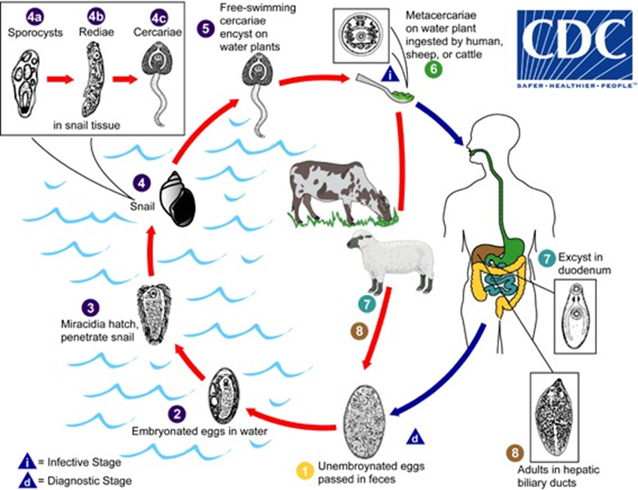

Heterophyes heterophyes (Intestinal fluke)

Geographical distribution: Middle and Far East. In Egypt, it is mainly in Manzala and Borollos
Diseases Heterophyiasis.
Habitat: Small intestine.
Definitive host: Fish-eating animals e.g. dogs, cats (reservoir hosts) and Man.
l.^{sf} intermediate host: Pirenella conica snail.
2nd intermediate host : Mugil (Boury) and Tilapia (Bolti) fish.
Infective stage: encysted metacercaria .
Mode of infection: Man is infected by eating insufficiently cooked, grilled or salted fish containing encysted metacercaria.
Diagnostic stage: egg
- Size: 30×17µ
- Shape: Oval and thick with operculum
- Colour: Yellowish – brown - Content: mature miracidium
Morphology:
- Shape: pear -shaped -
- Size: 1.5× 0.5 mm.
- Two simple intestinal caeca
- Two oval testes lie in the posterior end of the body and one ovary lies anterior of them
Life cycle:
Egg »»»» miracidium »»»» Snail “Pirenella conica”»»»» Sporocysts »»»» Redia »»»»
Cercariae »»»» Metacercaria “infective stage” »»»» Man »»»» Adult worm .
Clinical picture:
1-Asymptomatic.
2-In heavy infection there is diarrhoea, colic and vomiting.
3- Egg embolism (myocarditis), brain haemorrhages and pulmonary hypertension.
Diagnosis:
clinically: History of eating fish
- llaboratory: Stool examination for eggs (diagnostic stage).
Treatment:
Praziquantel (Biltricide): 25mg/kgm orally tds for 1 day.
Prevention and control:
1- Health education
2- Proper cooking and salting of fish.
3- Treatment of cases
4- Snail control.
5- Avoid defecation in water

Life cycle

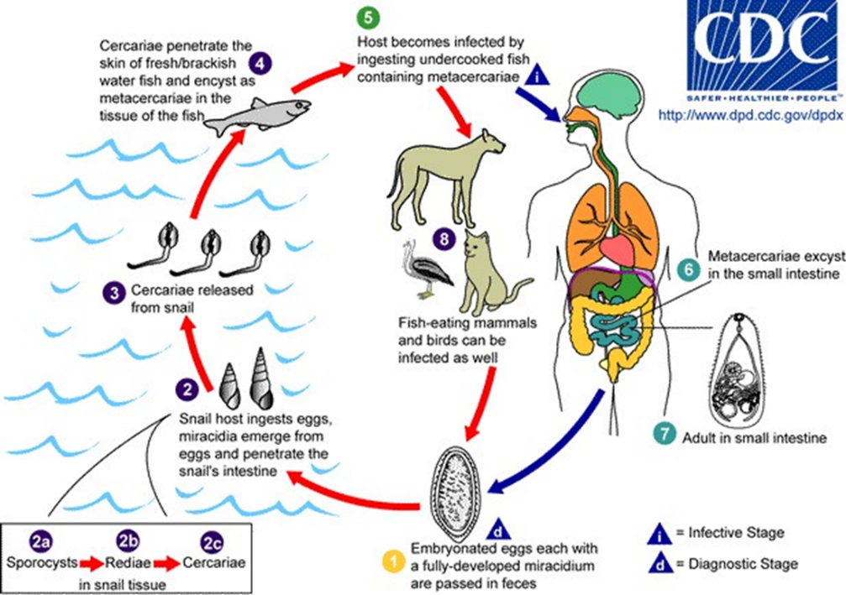

Schistosomes (The blood flukes)
Schistosomes are separate sexes.. The female is longer than the male with a cylindrical body and smooth cuticle
Three species Infect man:
Schistosoma haematobium (Urinary Schistosomiasis )
Schistosoma mansoni (Intestinal schistosomiasis) Schistosoma japonicum (Intestinal schistosomiasis in Far East)

CLASS CESTODEA
SUBCLASS CESTODA
(Tapeworms)

General characters:
- They are flat, and ribbon-like.
- The body segmented and consists of a scolex, a neck and several segments or proglottids:
- The scolex or head has 4 suckers (organs of fixation).
- The neck is the active region.
- The segments or proglottids are differentiated into: immature nearest to the neck, followed by mature and then gravid segments.,
Reproductive system: They are hermaphrodites.

classification of Cestodes.
Cestodes that infect man are:
- Diphyllobothrium latum
- Taenia saginata
- Taenia solium
- Echinococcus granulosus
- Hymenolepis nana

Diphyllobothrium latum
(Fish or broad tape worm)
Geographical distributions: lake regions , not in Egypt, Can be imported in fish.
Disease: Diphyllobothriasis .
Habitat: Small intestine of man and fish eating animals as dogs and cats .
Definitive host: man.
Reservoir host: fish eating animals as dogs and cats .
Infective stage : plerocercoid larva.
Mode of infection : ingestion of raw undercooked (smoked) Salmon fish containing plerocercoid larva.
Diagnostic stage (The immature egg):
- Size: 70x50 microns
- Shape: oval , operculated and thick shelled
- Colour : yellowish brown
- Content: immature
Life cycle :
Egg mature and hatch »»»» coracidium »»»» swallowed by 1st I.H (Cyclop) »»»» Procercoid larva »»»» Cyclop is ingested by 2nd I.H (Salmon) »»»» Procercoid larva develops into Plerocercoid larva
In small intestine »»»» plerocercoid larva »»»» adult »»»» egg in stool after 6 weeks from infection .
Clinical picture:
- Light infection is asymptomatic.
- Intestinal disturbance : hunger pain dyspepsia, colic , nausea, vomiting and diarrhea.
- Neurological manifestations are headache , insomnia and convulsions caused by toxins absorption .
- Intestinal obstruction in large number.
- Macrocytic hyperchromic anaemia (Pernicious) due to :
- Absorption of vit B12 »»»» vit B12 deficiency as the parasite compete for it.
- Toxins secreted by the parasite .
Diagnosis:
- Clinical: by suggestive clinical picture.
- Laboratory: Stool examination for the characteristic egg (diagnostic stage) and mature segment .
Treatment:
- Praziquantel : 10mg/kg single dose.
- Niclosamide : 2gm chewed and swallowed as single dose .
- Vit B12 .
Prevention and control:
1- Health education .
2- sanitary disposal of human excreta.
3- Mass treatment of man and reservoir hosts.
4- proper cooking of fish

Life cycle:

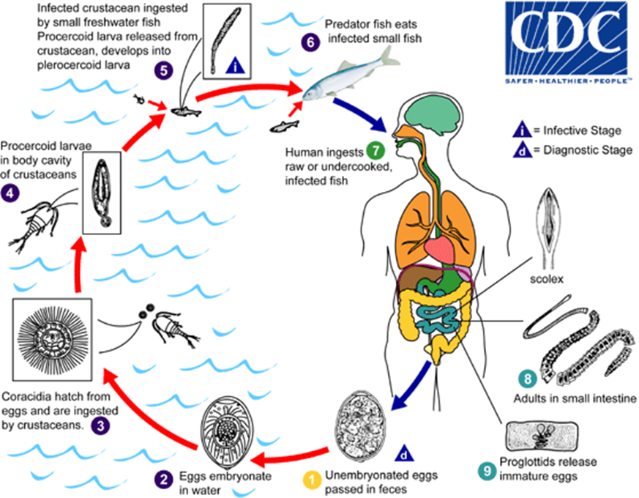

Cysticercosis

Definitions: This is the invasion of human tissues by the larval stage of taenia solium (Cysticercus cellulosae). Man acts as a blind intermediate host.

Hymenolepis nana (Dwarf tape worm)
Geographical distributions: It is cosmopolitan; more common in warm climates. It is the commonest cestode in Egypt.
Disease: Hymenolepiasis nana.
Habitat: Small intestine of man especially the children.
Definitive host: It is the commonest tapeworm in children and man.
Infective stage : Ingestion of eggs in contaminated food or drink or by Autoinfection
Diagnostic stage (The egg):
- Size: 40 microns
- Shape: Spherical with Double-wall, inner shell has 2 polar thickening with 4-8 polar filaments in between the outer and inner shell Colour: transcend
- Content: Hexacanth embryo
- Eggs are immediately infective once formed.
Life cycle :
Egg in stool »»»» Ingestion of egg I.S »»»» Re-enter the intestinal lumen »»»» Adult
Clinical picture:
- Light infection is asymptomatic.
- In heavy infections, there is headache, anorexia, vomiting and diarrhea.
Diagnosis:
- Clinical: by suggestive clinical picture.
- Laboratory: Stool examination for the characteristic egg (diagnostic stage).
Treatment:
- Praziquantel (drug of choice): Adults or children: 25 mg/kg, single dose. 2- Treat all members of the family as the eggs are directly infective
Prevention and control:
1- Health education and personal hygeine.
2- Avoid contaminated food or drink
- Mass treatment.

Life Cycle

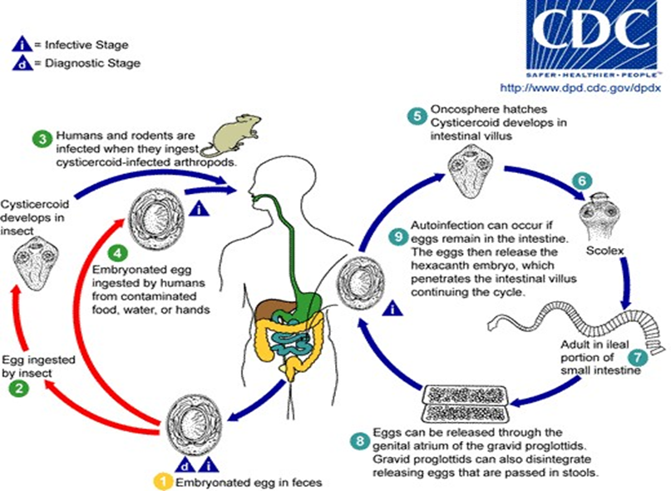

Echinococcus granulosus (The hydatid worm)

Geographical distribution: Worldwide specially in sheep-raising countries.
Disease: Hydatid disease.
Habitat: Small intestine of the definitive host.
Definitive host: Dog and other canines.
Intermediate host: Cattle, sheep and occasionally man.
Infective stage: eggs
Mode of infection: Man becomes accidentally infected by ingestion of the eggs (infective stage) contaminating food or drink, or the hands after petting infected dogs (hair is contaminated with eggs).
Morphology:
- Small cestode, up to 3-6mm long and composed of 3-4 segment.
- Scolex is small with rostellum with 2 rows of hooks. The neck is followed by three segments. The 1st is immature, the 2nd is mature (longer than broad) and the 3rd is the gravid segment (uterus filled with ova) and is about half the length of the worm.
Life cycle :
Egg ingested by intermediate host »»»» Hexacanth embryo»»»» Duodenum »»»» Circulation »»»» Liver or lung»»»»» Cysts »»»» Daughter cyst»»»» Ingested by dog »»»» Adult in intestine .
Clinical picture :
Commonly it is asymptomatic, and will be noted only when it increases in size causing pressure on the surrounding tissue. Rupture of the cyst (due to cough, trauma or surgery) causes fatal anaphylactic shock and seeding of the peritoneal cavity with scolices producing new cysts.
Diagnosis:
- 1-Eosinophilia and serological tests: IHA T, ELISA, PCR .
- 2-X-Ray examination, calcified cysts are easily visualized.
- 3- CT
Treatment:
- Surgical removal of cyst (if possible)
- Medical : Albendazole (400mg twice daily for 30 days).
Prevention and control:
1-Preventing contamination of food and water supplies with faeces of dogs.
2-Elimination of stray dogs.
3-Periodic examination and treatment of infected pet dogs

Life cycle

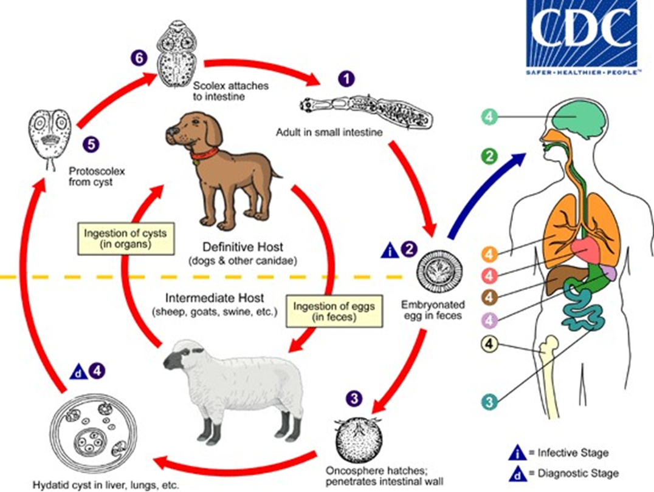

Intestinal nematoda
Ancylostoma duodenale
Geographical distribution: Europe, North Africa (including Egypt), Indi and China
Disease: Ancylostomiasis, hookworm disease
Habitat: Small intestine of man
Definitive host: Man
Infective stage: Filariform larvae
Mode of infection: Man is infected by filariform larvae penetrating the skin usually between the toes or dorsum. of foot during walking in infected soil.
Diagnostic stage (The egg):
- Size: 60 × 40 µ
- Shape: Oval, rounded ends and thin shelled
- Content: 4-cell or morula
- Colour: Translucent
Morphology:
- The adult worm is creamy white and the anterior end is bent dorsally.
- The buccal capsule is wide, well developed and carries 2 pairs of teeth on ventral side.
- The male: It is about 10mm in length and has a copulatory bursa at the posterior end - The female is about 13mm in length and has pointed posterior end.
Life cycle :
Egg in stool »»»» Rhabditiform larva »»»» 2nd Rhabditiform larva »»»» filariform larva »»»» Penetrate skin »»»» Circulation »»»» Lung »»»» Trachea to small intestine »»»» Adult Clinical picture:
- skin: (Ground itch) due to penetration of the skin
- Lung: loeffler’s syndrome
- The adult worms attached to the intestinal mucosa cause minute ulcers d- Hypochromic microcytic anaemia: iron deficiency anaemia e- Nausea, vomiting, abdominal colic, diarrhea and loss of weight
Diagnosis:
- Clinically: iron-deficiency anaemia is suggestive B- Laboratory:
- Stool examination for egg (Diagnostic stage) b- Blood picture for anemia.
Treatment:
Albendazole: 400mg single oral dose 2- Iron supplement and protein rich diet
Prevention and control:
1-Health education.
2-Personal prophylaxis.
3- Mass treatment.
4-Sanitary disposal of human faeces which should not to be used as fertilizer.

life cycle

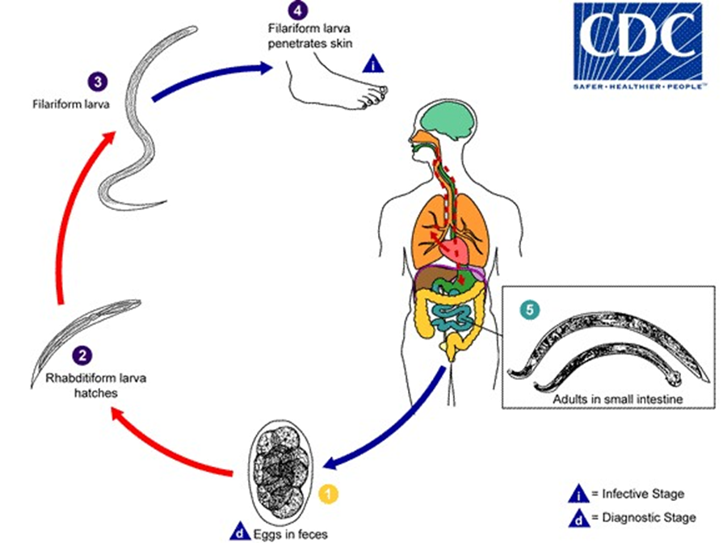

Trichuris trichiura (Whip worm)

Geographical distribution: Cosmopolitan.
Disease: Trichuriasis
Habitat: Large intestine of man mainly caecum .
Definitive host: Man.
Infective stage: egg containing mature larva
Mode of infection: ingestion of egg containing mature larva
Diagnostic stage: Egg
- Size: 50x25 µ
- Shape: Barrel, thick shelled
- Colour: brownish.
- Content: immature ovum.
Morphology:
- Anterior narrow part contains esophagus
- Posterior broad part contains rest of the orans .
- The male is 4-5 cm , Post. end is curved with single spicule. The female is 5 cm , Post. end is straight
Life cycle :
Egg in soil »»»» mature larva in egg »»»» ingestion by man »»»» larva in small intestine »»»» adult in large intestime
Clinical picture:
- Asymptomatic
- Abdominal colic.
- Dysentery and rectal prolapse.
- Appendicitis
- Anemia
Diagnosis:
• Clinically : not specific
• Laboratory :
- Stool examination for Eggs
- CBC
Treatment:
Mebendazole (Vermox): 200 mg/day for 3 days.
Prevention and control:
1- Health education.
2-Purification and chlorination of water
3-Proper washing of raw vegetables and washing hands before meals .
4-Proper disposal of sewage.
5-Mass treatment .

Life cycle

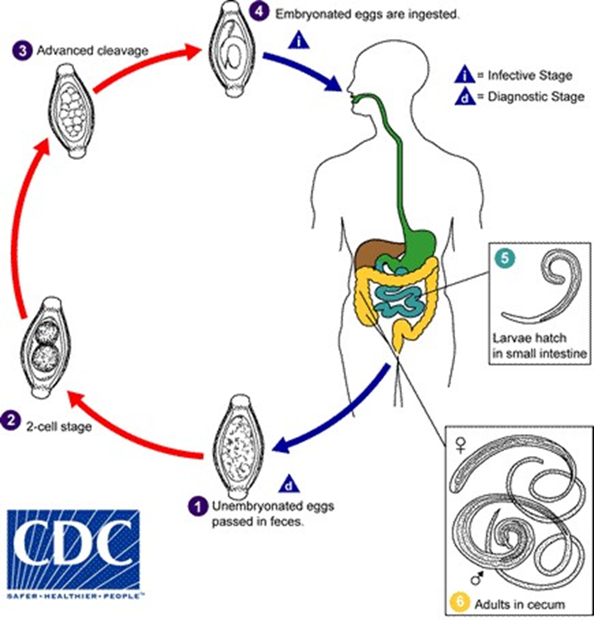

Strongyloides stercoralis

Geographical distribution:
Tropical and Subtropical countries including Egypt.
Disease: Strongyloidiasis.
Habitat: It is a facultative parasite that has 2 forms:
-Free living forms in soil.
-Parasitic forms in small intestine of man.
Definitive host: Man.
Infective stage : Filariform larvae
Mode of infection:
- filariform larvae from soil or water penetrate his skin during walking.
- Auto-infection
Diagnostic stage: The rhabditiform larva
Life cycle :
larva in stool »»»» indirect development in the soil »»»» filariform larva »»»» Penetrate foot »»»» Lung »»»» swallowed »»»» Adult
Clinical picture:
1- Skin:
• Ground itch.
• Larva currens: Larva penetrate perianal skin and extend as linear eruption across buttocks and thigh.
2- Epigastric pain, nausea, vomiting, and diarrhea.
3- Malabsorption, steatorrhea and loss of weight.
4- Hyperinfection: strongyloides stercoralis is an opportunistic parasite. When the immunity of the patient is impaired or due to the use of immunosuppressive drugs, autoinfection increases resulting in intestinal hyperinfection.
Diagnosis:
- Clinically: Bronchitis followed by diarrhoea
- Laboratory:
- Stool examination for Rhabditiform larvae (diagnostic stage).
- Stool culture: for Free living worms and larvae.
- Serological tests: IF AT and ELISA.
Treatment:
l-Ivermectin (drug of choice): 200ug/kg/day for 1-2days.
Prevention and control As Hookworm

Life cycle

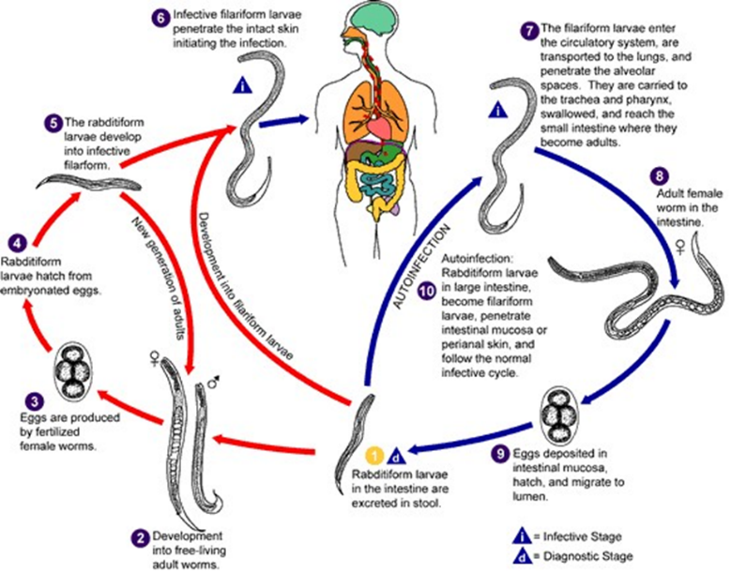

Trichinella spiralis

Geographical distribution: It has a cosmopolitan distribution especially among pork-eating people.
Disease:Trichinelliasis or trichinosis.
Habitat: Small intestine.
Definitive and intermediate hosts:Pigs, rats, and occasionally man.
Reservoir host: Pigs and rats.
Infective stage:is the trichina capsule. It is ellipsoid in shape and its long axis parallel to the long axis of muscles. It contains a coiled larva.
Mode of infection: Through eating insufficiently cooked pork meat or raw pork
Life cycle :
The male dies After fertilization & female penetrate submucosa »»»» Larva »»»» Circulation
»»»» Striated m.s ”diaphragm , tongue, eye” »»»» Encysted larva »»»» Eaten by man »»»» Larva to small intestine »»»» Adult
Clinical picture:
1-Invasion phase: There is gastroenteritis: diarrhea, nausea, vomiting, colic.
2-Larval migration phase: Fascial oedema, myalgia with difficulty in mastication and swallowing, and eosinophilia.
3-Encapsulation phase:
- The symptoms improve and the patient starts to recover, myocarditis may persist.
Diagnosis:
- Clinically: symptoms & signs
- Laboratory:
1- Serological tests: IHAT, IF A T, ELISA: are diagnostic tests. 2- Eosinophilia.
3-Muscle biopsy: detect larvae.
4-X ray : calcified cysts
Treatment:
- Mebendazole:200mg tds for 10 days.
- Thiabendazole: 25 mg/kg x 2 for 3 days.
Prevention and control:
- Proper inspection of pig's meat in slaughter houses.
- Pork meat must be well cooked; Deep freezing meat at -25°C for 10 days.
- Avoid feeding raw garbage to pigs.

Life cycle
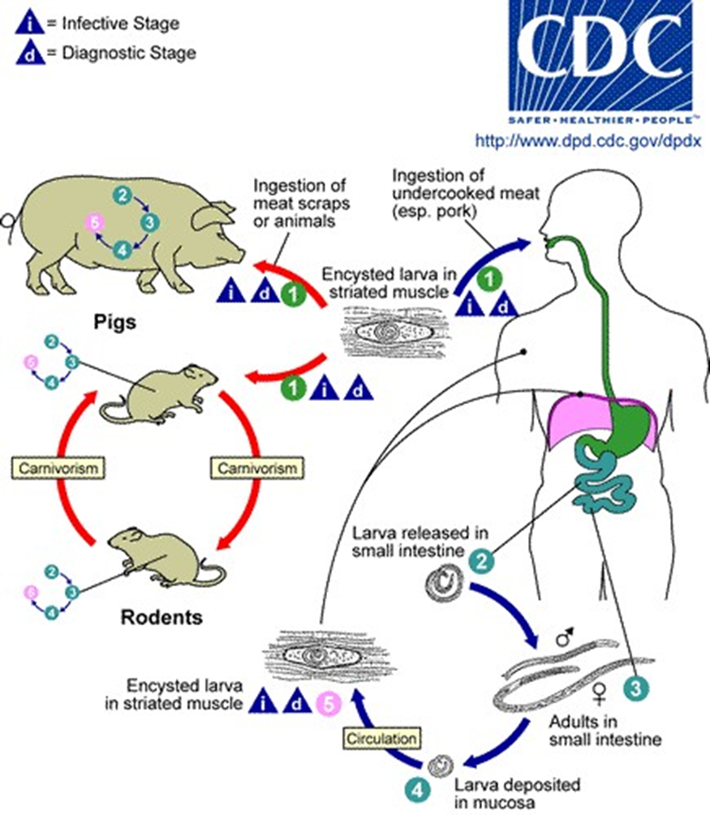

Filariae

Nematoda which give Microfilaria:
1-Wuchereia bancrofti------- elephantiasis
2-Wuchereria malayi-------- elephantiasis
3-Mansonella ozzardi------- Non pathogenic
4- Loa loa---------------------- Calabar swelling
5- Onchocerca volvulus------- (Sudan blindness)

TISSUE NEMATODES Filaria worms

Loa loa
(Eye worm)
Geographical Distribution:
West and central parts of Tropical Africa.
Life Cycle:
- Adults live free in the subcutaneous tissue of man migrating and can be seen under conjunctiva of the eye (eye worm).
- Microfilariae appear in blood in day time (10 AM-2 PM) i.e diurnal periodicity, 250 x 8 u in size, with kinky curves and tight sheath. Tail end is full of nuclei.
- The vector is the day time biting big fly Chrysops
- The development of microfilariae to infective filariform larvae and mechanism of transmission resemble that of. W.bancrofti.
Pathogenesis and clinical picture:
The most common clinical manifestations of loaiasis are calabar swellings and pruritus.
- Calabar swellings are most commonly observed on hands, wrists and forearms, but may appear anywhere on the body. They are painless and non-pitting. They last from a few hours to several days and may recur for years. They are due to hosts immune response to parasite antigen.
- Generalized pruritus, fatigue and arthralgia are common.
- Adult worms may be noticed moving under conjunctiva or skin. They appear and disappear within 10-15 minutes usually leaving no trace behind
Diagnosis:
- Clinical: worms seen under conjunctiva and history of calabar swellings.
- Laboratory:
-Detection of microfilariae in blood in day time.
-Serology
-PCR
-Eosinophilia
Treatment
- Chemotherapy as in bancroftian filariasis
- Surgical removal of adult if seen under the conjunctiva.
Prevention and Control:
- Treatment of patients
- Control of Chrysops is difficult because it breeds in swampy areas of forests

Dracunculus Medinensis

Geographical distribution: East and west Africa Arabia, yemen, India (where weIls are used for water supply)
Disease: dracunculosis
Definitive: Host: Man and animal
Habitat: Subcutaneous tissues of man and reservoir animals
Intermediate host: Cyclops
Infective stage: Infective larve in body cavity of Cyclops
Diagnostic Stage: Larvae in skin blister
Mode of infection: drinking water containing infected Cyclops
Morphology:
Adult: Thread-like and cylindrical (male 3cm, Female 30-100 cm)
Life cycle :
Ingestion of cyclops »»»» small intestine »»»» larva »»»» subcutaneous tissues »»»» water »»»» cyclops swallow larva .
Clinical picture:
- Local erythema, tenderness and pain
- Formation of blister and ulcer, eosinophilia - urticaria, nausea and vomiting
Diagnosis:
- Clinically: the outline of the worm under the skin maybe seen. - Specimen from local lesion examined microscpically - X-ray to detect calcified worm.
- I/D test, serological test.
Treatment :
- General measures (antiseptics, dressing, antibiotics)
- Rolling up the worm on a stick and pulling a few cm every day (rupture of the worm produces a severe inflammatory reaction and shock)
- Surgical removal
- Drug (Thiabendazole).
Prevention and control:
- Health education, boil or filter drinking water in suspected areas.
- Infected people are not allowed with water supplies.

Life cycle

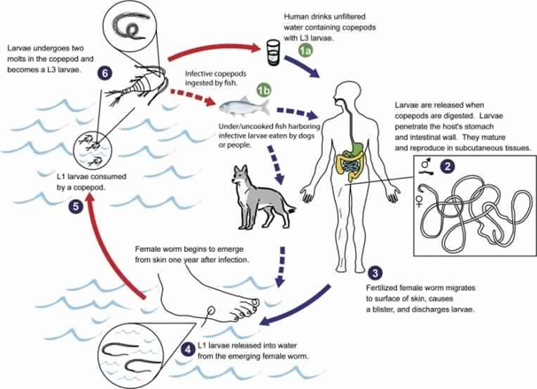

PROTOZOA

Protozoa are unicellular organisms capable of performing all the vital functions of life.

General Characters of Protozoa
1-Morphology:
-The protozoon consists of a mass of protoplasm differentiated into cytoplasm and nucleoplasm. Cytoplasm is differentiated into:
i-Ectoplasm: An outer, layer. ii-Endoplasm: An inner, layer.
-Nucleus:
Locomotion: It is a function of the ectoplasm that is performed by flagella, cilia and pseudopodia
2- Reproduction: may be:
- Asexual and sexual
- Excretion
- Secretions either; “ Digestive enzymes,Toxins “.
- Cyst wall.

CLASSIFICATION OF PROTOZOA

It is classified into 3 phyla:
1-Phylum: Sarcomastigophora:
-Sarcodina (Amoebae)
-Mastigophora (Flagellates)
2- Phylum: Ciliophora (Ciliates)
3-Phylum: Apicomplexa (Plasmodium, Toxoplasma) AMOEBAE

Entamoeba histolytica

Geographical distribution: Cosmopolitan Disease: Amoebiasis, amoebic dysentery.
Habitat: large intestine.
Definitive host: Man.
Infective stage: Mature 4- nucleated cysts.
Mode of infection: is by ingestion of mature 4-nucleated cysts in:
- Improperly washed vegetables (salad) or fruits.
- Contaminated food due to mechanical transmission of cysts by flies.
- Food handlers.
- Auto-infection (Faeco-oral).
Morphology: E.histolytica exists as amoeboid trophozoites and cysts.

1- Trophozoite:
- Shape: amoeboid (irregular shape).
- Ectoplasm: well- developed with pseudopodia.
- Endoplasm: granular, contains a vesicular nucleus (fine central karyosome and fine peripheral chromatin regularly arranged on nuclear membrane).
2-Cyst:
- Shape: rounded with well-developed cyst wall.
- Nuclei: 4 identical nuclei in the mature cyst.
Life cycle :
Ingestion of cyst »»»» trophozoite »»»» colon
Clinical Picture:
1- Asymptomatic infections:
This is the most common presentation, they have no ulcerative lesions but they are cyst passers (healthy carriers). They are active sources of infection.
II- Symptomatic infections:
A- Intestinal amoebiasis may occur as:
1- Acute amoebic dysentery:
- There is abdominal pain and severe dysentry (diarrhea with blood, mucus) with tenesmus.
- The condition may last for a few days, then it disappears spontaneously or it is transformed into chronic amoebiasis.
2- Chronic non-dysenteric amoebiasis:
- Symptoms of intermittent diarrhea, alternate with constipation.
B- Extra-intestinal amoebiasis: The infection spreads directly or by blood.
1- Hepatic amoebiasis: Amoebic liver abscess: The liver is enlarged and tender.
2-Pulmonary amoebiasis: Less common, due to direct extension from to hepatic lesion.
Diagnosis:
1- Intestinal Amoebiasis:
- Stool examination for trophozoites and cysts.
- Sigmoidoscopy and proctoscopy.
2- Extra-intestinal amoebiasis:
- Serologieal tests: IHAT and ELISA.
- Aspiration of hepatic abscess.
- X-ray, scanning and ultrasonography.
Treatment of amoebiasis:
Amoebicidal drugs may act on:
- Luminal forms e.g. (Diloxanide furoate, and iodoquinol) - and/or on Tissue forms e.g. (Metronidazole [Flagyl], Tinidazole).
According to the clinical picture: l- Asymptomatic cases or carriers (cysts only in stools) Diloxanide furoate (furamide) 500mg tds for 10 days.
2- Intestinal amoebiasis:
a- Metronidazole 750mg tds for 10 days followed by Diloxanide furoate (furamide) 500mg tds for 10 days 3- Extra-intestinal amoebiasis:
- Metronidazole or Tinidazole followed by Diloxanide furoate - Aspiration of large liver abscess may be necessary.

Prevention and control:
1- Health education.
2- Safe water supply and sanitary sewage disposal of excreta.
3- Treatment of patients and carriers especially food handlers.
4-Washing of fresh and fruits.
5-Insect control.
Life cycle
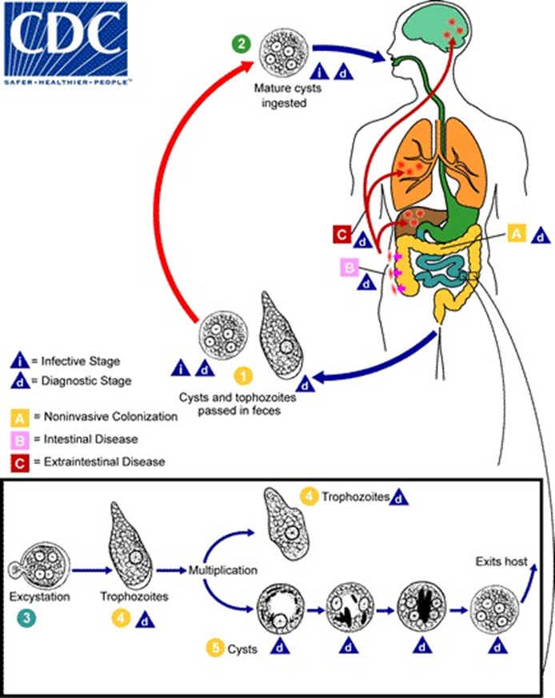

Balantidium coli
This is the only pathogenic ciliate and the largest protozoan affecting man.
Geographical: Worldwide.
Disease: . Balantidiasis or balantidial dysentery.
Habitat: Large intestine
Definitive host: man
Reservoir host: pigs.
Diagnostic stages :
1- Trophozoite: oval in shape and covered by cilia. Two nuclei; a large macronucleus and a micronucleus.
2- Cyst: rounded with thick wall containing 2 nuclie Infective stage: Cyst.
Mode of infection: Ingestion of cysts contaminating food and water.
Life cycle :
Cyst »»»» trophozoite »»»» small intestine »»»» colon
Clinical picture:
- Asymptomatic carrier: passing cysts in stools.
- Acute infection: Diarrhoea, or dysentery, mucus and blood in stools.
- No Extra-intestinal lesions.
Diagnosis:
Stool examination for trophozoites and cysts.
Treatment:
Metronidazole (Flagyl): oral dose of 250mg tds 7 days.
Prevention and control:
- As for E. histolytica.
- Handling of pigs with care.

Life cycle

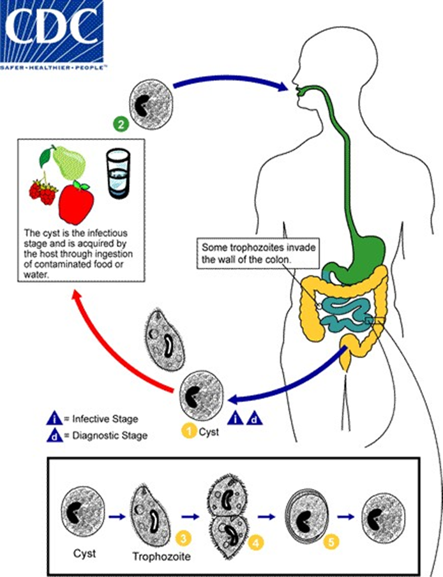

Flagellates
It is classified according to habitat into:
I-Intestinal flagellates: Giardia lamblia
2-Urogenital flagellates: Trichomonas vaginalis
3-Blood and tissue flagellates: Leishmania species and trypanosome species
Giardia lamblia

Geographical distribution: Worldwide.
Disease: Giardiasis.
Habitat: Duodenum and jejunum of small intestine.
Hosts: Man especially children.
Diagnostic stage:
- Trophozoite: pear shaped or oval and bilaterally symmetrical
- Two sucking discs and 4 pairs of flagella
- Cyst:oval with 4 nuclie present at one pole
Infective stage: Mature cyst
Mode of infection: Ingestion of mature cyst contaminating food and water or (Faeco-oral autoinfection).
Morphology:
1-Trophozoite:
- pear shaped or oval and bilaterally symmetrical.
-Two sucking discs, 4 pairs of flagella and a thick rod (axostyle).
2-Cyst:
-Oval .
Four vesicular nuclei present at one pole.
Axostyle and a parabasal body.
Clinical picture:
- Diarrhea, and fatty stool due to inability to absorb fat.
- Loss of weight and vitamin deficiency.
- Cholecystitis
Diagnosis:
- Clinically: symptoms & signs
- Laboratory:
Stool examination for trophozoites and cysts.
Treatment:
Metronidazole (Flagyl): 250-500 mg tds for 10 days.
Prevention and control: As Amoebiasis.

Trichomonas vaginalis
Geographical distribution:worldwide sexually transmitted disease Disease: Trichomoniasis.
Habitat:
- In females : vagina, urethra and urinary bladder.
- In males: urethra, urinary bladder, prostate
Definitive host:man
Infective stage: The trophozoite which is very resistant. There is no cyst stage.
Mode of infection:
1-Sexual intercourse.
2- Contact with contaminated toilet seats, and underclothes.
Clinical picture:
- In females: Vaginitis discharge (leucorrhoea) itching and burning sensation.
- In males, majority of cases are asymptomatic and act as carriers. There may be dysuria, frequency of micturition and prostatitis.
Diagnosis:
- Trophozoites in vaginal discharge or urine of females, and in urine, semen or prostatic secretions in males.
Treatment:
1- For both partners:
Metronidazole( Flagyl) 250mg tds orally for 10 days.
2- For females:
- (flagyl) local vaginal inserts.
- Lacticacid douche.

Blood and Tissue Flagellates
(HEAMOFLAGELLATES)

Morphological forms are:
1) Amastigote:
- It is oval in shape, a nucleus and a rod-shaped kinetoplast.
- There is no free flagellum. It occurs only intracellularly.
2) Promastigote:
- It is fusiform in shape, the kinetoplast lies at the anterior end from which arises a free flagellum.
3)- Epimastigote:
- It is similar to the promastigote, but the kinetoplast is anterior to the nucleus with the flagellum attached to a short undulating membrane, then it becomes free anteriorly.
4)- Trypomastigota:
-It is similar to the promastigote,but the kinetoplast is at the posterior end.
-A long flagellum arised from the kinetoplast, attached to an undulating membrane and becomes free anteriorly. It is found in the blood and CSF:
a- Amastigote and Trypomastigote are Parasitic forms
b- Promastigote and Epimastigote are Transitional forms occur in insects
and ctuture
Blood and Tissue flagellates includes two important genera which can infect man:
l-Genus Leishmania
2-Genus Trypanosoma

Leishmania

Disease: Leishmaniasis.
Habitat: It inhabits the reticule-endothelial system (R.E.C) of man and are transmitted by female sand fly called Phlebotomus
Infective stage: Promastigotes.
Mode of infection: Bite of infected female sand fly.
Life cycle:
On biting infected man, the females sand fly ingests amastigote forms with its blood meal. They change to promastigotes in the gut and multiply then pass to its .buccal cavity. When biting a new host, the promastigotes (infective stage) are inoculated into the wound. In the host they engulfed by the reticilo endothelial cells and charige to amastigote forms , which multiply by binary fission .The infected cells rupture and the parasites are released to reinfect other cells.
The genus Leishmania includes many species , which infect man :
- Leishmania donovani causing Visceral Leishmaniasis
- Leishmania tropica causing Cutaneous Leishmaniasis
- Leishmania braziliensis causing Mucocutaneous Leishmaniasis

Visceral Leishmaniasis (Kala azar)
Leishmania donovani complex
Geogrphical distribution :Far East and Cental Africa
Clinical picture:
- Hepatosplenomegaly, generalized lymphadenopathy and dysentery.
- Anemia, leucopenia and thrombocytopenia.
- The commonest cause of death is secondary bacterial infection as pneumonia.
Diagnosis:
l-Detection of amastigotes from blood and aspirates (from spleen, liver, bone marrow or lymph nodes), microscopically and by culture on special medium.
2-Serological tests: I.F.A.T. and ELISA.
Treatment:
Sodium-antimony gluconate or pentostam: 600 mg IV or 1M/day.

Trypanosoma
Two types:
1-African Trypanosomes causing Sleeping sickness. It includes Trypanosoma gambiense and Trypanosoma rhodesiense.
2-American Trypanosomes causing Chagas disease caused by Trypanosoma cruzi.
Trypanosoma gambiense
Disease: west African trypanosomiasis or sleeping sickness.
Habitat: Blood, lymphatic system and C.N.S Definitive host: man.
Vector: Glossina (Tsetse Fly)
Infective stage: Metacyclic trypmastigotes.
Mode of infection: Bites of Glossina
Diagnosric stage: polymorphic trypomastigotes.

Trypanosoma rhodesiense
As T. gambiense but it has more acute and rapid course.

Trypanosoma cruzi
Disease: American Trypanosomiasis or Chagas' disease.
Habitat: Blood, reticulo-endothelial cells and muscle fibres including the heart of man.
Hosts: Man, dogs, cats and rodent.
Vector: Winged bug (Triatoma).
Infective stage: Metacyclic trypomastigotes.
Mode of infection: Contamination of the bite wound by faeces of the vector.
Diagnostic stage
a)- The amastigote intracellular form in tissues as heart, liver, lung, bone marrow, C.N.S.
b)- The monomorphic trypanosome form in peripheral blood which is c-shaped with short undulating membrane and a big kinetoplast.

Life cycle

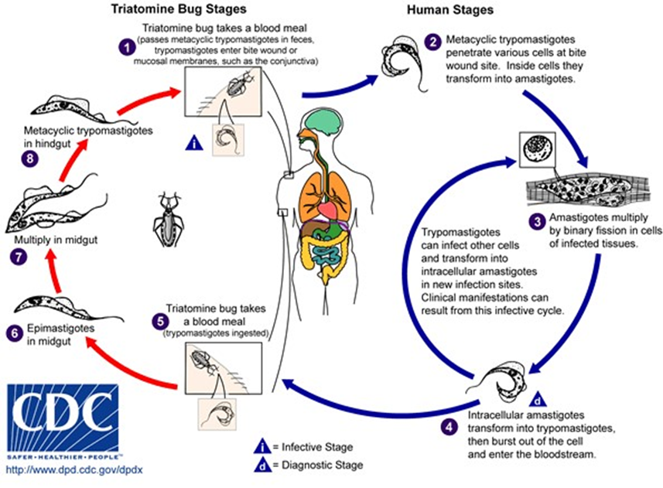

Intestinal Sporozoa
Cryptosporidium parvum
Disease: Cryptosporidiasis
Geographical distribution: Worldwide. It is common as water-borne outbreaks.
Definitive hosts: According to species, Cryptosporidium is a parasite of rodents, birds, reptiles, fish and cattle that act as a reservoir host for infection of man.
In Man: Cryptosporidium is an opportunistic parasite especially in immunosuppressed patients due to HIV infection (AIDS), hypogammaglobulinaemia, chemotherapy or radiotherapy. Infants are specially susceptible.
Site: The mucous membrane of the gastrointestinal tracts is affected. The parasite multiplies in the brush border of the epithelial cells.
Morphology:
- Size: infective sporulated occysts measure 2 x 4-5 u.
- Shape: round or oval oocysts that contain 4 fusiform sporozoites.
Infective stage: mature sporulated oocysts with 4 sporozoites that remain viable for months under moist conditions.
Mode of infection
- Ingestion of food or drink contaminated with mature oocysts
- Auto infection
Pathogenesis and Clinical Picture:
- The infection causes inflammatory changes, atrophy of intestinal villi and crypt hyperplasia.
- Infection of immunocompetent usually results in mild self-limited diarrhea lasting for 2 weeks. In some cases, especially in children , the infection is accompanied by abdominal discomfort, anorexia, fever, nausea and loss of weight.
- The immunocompromised patients:
-The disease is usually severe, especially in AIDS patients and could life-threatening (opportunistic infection)
-There is severe diarrhea and malabsorption that may lead to dehydration of the patient.
-Dissemination of the parasite to other organs, as the oesophagus, gall bladder, urinary bladder and respiratory tract can develop.
Diagnosis:
-Examination of faeces specially using concentration techniques, acid-fasting staining (modified Z.N stain) and immunofluorescene assay to detect the oocysts.
- Intestinal biopsy.
Treatment:
- Drugs as nitazoxanide.
- Spiramycin suppress infection, continuous maintenance is needed.
- Supportive treatment (fluid & electrolytes)
Epidemiology :
1- Cryptosporidiosis is a zoonotic disease and may be acquired from domestic animals. People handling animals are at higher risk of infection
2- Cryptosporidium is highly resistant to chemicals used to treat drinking water thus water-borne outbreaks of infection can occur.

Toxoplasma gondii
Geographical distribution: Worldwide.
Disease: opportunistic parasite that causes Toxoplasmosis:
Habitat: Reticuloendothelial cells.
Definitive host: Only cats harbor asexual and sexual stages.
Accidental or Intermediate: All mammals including man harbor asexual stages.
In definitive host: Asexual and sexual developmental cycles take place in the epithelial cells of the small intestine.
In accidental host: The parasite develops within a vacuole in any nucleatedcell specially the reticulo-endothelial system, the brain and retinal cells.
Infective stage:
- Tachyzoites :They are 3 x 7 µ, crescent with a pointed anterior end and rounded posterior end and a central nucleus.
- Pseudocysts are macrophages cells containing several rapidly multiplying tachyzoites.
- Cysts (acute stage) rounded and have a well-defined cyst wall and contain thousands of slowly multiplying bradyzoites. Bradyzoites are morphologically similar to tachyzoites
- Oocysts (chronic stage). They are ova] and contain two round sporocysts each containing four sporozoites
Mode of infection:
Man is infected by
- Ingestion of food (vegetables) or drink contaminated by mature oocyst
- Ingestion of improperly cooked meat containing cysts and pseudocysts.
- Transplacental route from mother to foetus.
- Organ transplantation and blood transfusion (rare)
Cat by:
- Ingestion of true or pruedocysts in muscles.
- Ingestion of oocyst in soil.
Clinical picture:
- Asymptomatic.
- Congenital toxoplasmosis: Congenital transmission occurs when the mother is exposed to infection for the first time while she is pregnant. Abortion, CNS and eye manifestations or hepatosplenomegaly may occur.
- Acquired toxoplasmosis: Toxoplasmosis is less severe, causing lymphadenopathy.
- Recrudescence: In immunosuppressed patients (due to AIDS or immunosuppressive treatment). It is an opportunistic infection. Reactivation of latent infections causing meningo-encephalitis and pneumonitis.
Diagnosis:
- Clinically: symptoms & signs
- Laboratory:
  - serological.
  - I.D tests.
  - X-ray
  - U.S
Treatment:
Pyrimethamine (Daraprim)+ salphadiazine, Spiramycin (Rovamycin)
Prevention and control:
1-Avoid eating improperly cooked meat.
2-Healtheducation of pregnant women.
3-Proper washing of raw vegetables and fruits that could be contaminated with stools of infected stray cats.
Life cycle

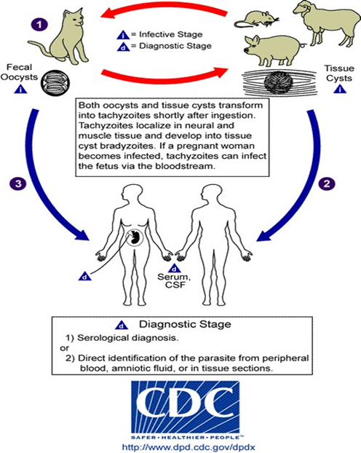

Medical Entomology
Medical entomology is the study of members of the phylum Arthropoda that cause diseases to man.

Medical importance of Arthropods:
- Arthropods as agents of diseases and discomfort:
- Inoculation of poisons derived from certain glands and injected in the human body e.g. ticks, spiders and scorpion.
- Invasion of tissues as in case of scabies and myiasis.
- They cause dermatitis and allergic skin lesions by their bites e.g. fleas, mosquitoes, bugs and lice.

- Arthropods as transmitters of disease:
Arthropods transmit bacterial, rickettsial, spirochaetal, viral and parasitic diseases either mechanically or biologically:
- Mechanical transmission:
- Indirect: They act as passive carriers of organisms on their hairs, mouth parts or legs e.g. Musca domestica.
- Direct: They pick the organisms from a diseased person and inoculate them to healthy one e.g. Stomoxys transmits animal trypanosomes during disturbed feeding.
- Biological transmission:
Arthropods play an active role in disease transmission where multiplication and lor development of organisms occur (called vector). It may be:
- Propagative: multiplication of organisms occurs without developmental changes e.g. yellow fever virus (Aedes aegypti), plague organisms (fleas).
- Cyclopropagative: multiplication and developmental changes of the organisms occur e.g. malaria parasites in Anopheles, and Leishmania parasites in sand fly.
- Cyclodevelopmental: developmental changes occur without multiplication e.g. filaria (mosquitoes).
- Trans ovarian: organisms 'transmitted from infected mother to offspring through the ova e.g. organisms transmitted by hard and soft ticks.
- Trans-stadial: (stage to stage) c.g. organisms of scrub typhus which pass from larvae (as ectoparasite of man) to nymph to adults to next larvae.

Life cycle of Arthropods
Development is by metamorphosis, which may be:
1- Complete metamorphosis: (egg → larva → pupa → adult) e.g. mosquitoes, flies, fleas.
2- Incomplete metamorphosis: (egg → nymph → adult) e.g. bugs and lice.

Classification of arthropods
I- Class INSECTA: (e.g. mosquitoes, flies, lice, fleas, bugs).
II- Class ARACHNIDA: (e.g. ticks, mites)
III-Class CRUSTACEA: (e.g. Cyclops)

Mosquito habits
(Ecology or BIONOMICS)
The study of the habits of mosquitoes is essential for their control.
- Aquatic stages:
Egg: is a quiescent stage. The presence of water is essential. Eggs of different species differ in their tolerance to dryness and temperature.
Larva: the selected water collection by the females differs from one species to another for their egg deposition and the needs of their larvae.
- Fast, slow running or even stagnant water.
- Turbidity, salinity and pollution of water collection.
- Shaded or sunny, big or small collection vi water.
- Deep or shallow water.
- Flora: the plants found in the breeding place may be toxic.
Pupa: this stage is not affected because it does not feed and relatively short.
- Adult stages:
- Adults vary in the emergence, swarming, mating and oviposition.
- They also vary in the resting places after meals e.g. ceiling and dark corners.
- Feeding habits: some prefer animal blood (zoophilic) and others prefer human blood (anthropophilic).
- Hibernation: most mosquitoes hibernate in winter and regain activity when it becomes warm again.
- Flight range varies in different species.
Mosquito control
- Aquatic stages:
  - Mechanical (physical) control:
- Removal of plants where larvae breed in shaded areas and development of shade when they need sunshine.
- Filling or drainage of breeding places.
- Production of turbidity in clear water.
- Changing the current and level of water to prevent permanent growth.
  - Biological control:
- Natural enemies such as frogs (which eat both aquatic and adult stages), ducks and fish (Gambusia affinis).
  - Chemical control:
- Malariol: cheap non-volatile oil which is a mixture of crude oils causing suffocation of aquatic stages (larvae and pupae).
- Paris green: copper arsenical compound, used mixed with dust (1% mixture) and sprayed on the surface of water. It acts as stomach poison to larvae of mosquitoes. The pupa is not affected as it does not feed.
- II- Adult stages:
- Wire screening of doors and windows and mosquito nets (narrow enough to prevent mosquitoes, 27 meshes / square inch).
- Mosquito repellents applied to skin e.g. citronella oil, indalone, dimethylphthalate and diethyltoluamid (OFF).
- Spraying with insecticides
- Animal barriers: placing farm animals between the breeding places and human habitations as most mosquitoes are zoophilic to attack animals and save man.
- Sterilization of males by irradiation produce infertile eggs.
- Using natural enemies e.g. frogs and lizards to feed on adult mosquitoes.

II- FAMILY: PSYCHODIDAE
Phlebotomus
(sand fly)
Geographical distribution: Several species are prevalent in Mediterranean coasts, Middle East, Africa, India, China and America. Phlebotomus papatasii is prevalent in Egypt.
Habits:
- Only females are blood suckers, feed by night and hide at day time.
- Sand flies cannot fly for long distances. They tend to jump for short distances. This is why Phlebotomus borne diseases are of rather limited nature.
Medical importance:
- Transmission of diseases:
- Protozoal: leishmaniasis (cutaneous, muco-cutaneous and visceral).
- Bacterial: Oroya fever or Carrion's disease or bartonellosis caused by Bartonella bacilliformis. The disease is prevalent in South America, characterized by skin nodules and severe anaemia (due to severe haemolysis caused by B.bacilliformis which live inside RBCs).
FLIES
Musca domestica (House fly)
It is cosmopolitan, the adult fly is greyish and measures 7-10 mm. The mouth parts are adapted for sucking fluid only and not piercing.
Medical importance:
- Mechanical transmission of organisms on its hairs, mouth parts, legs, vomitus and faeces.
1- Transmission of parasitic diseases:
- Cysts of protozoa e.g. E. histolytica, G.lamblia.
- Eggs of helminths e.g. A. lumbricoides; T. trichiura, H. nana, E. vermicularis.
2- Bacterial diseases: e.g. typhoid, cholera.
3- Viruses: e.g. Enteroviruses, poliomyelitis, infective hepatitis A-virus.
B)- Accidental myiasis

Subfamily: Sarcophaginae
Medical importance:
They cause semi-specific myiasis.
Mettalic flies
They cause myiasis as the larvae are deposited on living and necrotic tissues :
• Sarcophaga : Grey , 2-3 times the size of Musca , abdomen is Chess-broad pattern.
• Mettalic flies : they are metallic colored flies : Calliphora (metallic blue) , Lucilia (metallic green)

ORDER: SIPHONAPTERA
(Fleas)
Geographical distribution: cosmopolitan.
Habits:
- Fleas are temporary ectoparasites.
- The adults (both sexes) are blood suckers while larvae feed on solid organic matter.
- They are host specific but may infest others.
- Season: they increase in spring and autumn.
- Life span is about 1 year.
Medical importance:
- Fleas as vector of diseases:
- Plague: causative organism is Yersinia pestis.
Mechanism of transmission:
- After ingestion of infected blood, Yersinia pestis multiply in fiea's stomach which becomes blocked by multiplying organisms.
- When such flea tries to feed, the new blood cannot pass the obstruction and is regurgitated with bacilli into the site of bite and transmits infection (anterior station).
- Moreover, the flea is unable to feed satisfactorily. So, it moves from one host to another spreading the disease.
- Endemic or murine typhus: causative organism is Rickettsia mooseri (R.typhi).
Mechanism of transmission:
- Rickettsia multiply in the epithelial lining of the mid-gut of the flea.
- The cells rupture and Rickettsia are released in the lumen and päšš out with the faeces of fleas (posterior station).
- Man is infected through:
- Contamination of skin with flea faeces by scratching.
- Inhalation of dried faeces as Rickettsia remain alive and virulent in the faeces of the flea for 40 days.
- Crushing the fleas.
- Fleas as intermediate host of parasitic diseases:
- Rat fleas act as intermediate host for H.nana and H.diminuta.
- Dog and cat fleas act as intermediate host for D.caninum.
- Fleas attacking their host:
Tunga penetrans causing Chigger's or Jigger's disease.
- Tunga is found in tropi: al and subtropical regions of America, Africa and Far East.
- The fertilized female flea turrows into the skin of the sole of the foot or between the toes to take its blood meal.
- As the eggs develop, the hindermost part of the flea projects out and mature eggs are expelled outside to continue their life cycle in the soil.
Clinical picture: painful nodular swelling which may ulcerate.
Treatment: surgical removal of the flea with antiseptic dressing and antibiotics.
Prevention: wearing shoes.
Control of fleas:
- Human fleas:
- Application of insecticides under carpets.
- Use of vacuum cleaner to clean floors and carpets from eggs and larvae of fleas.
- Dog and cat fleas:
- Dusting animals and their resting places with insecticides.
- Rat fleas:
- Dusting rat holes with insecticides.
- Using rodenticide (warfarin).
- Strict quarantine measures against ships coming from foreign parts by fumigation to kill rats.

Bugs
Cimex lectularis (Bed bug)
Adult bug is reddish brown, wingless, they are temporary parasites and suck blood usually during the night. During the day they hide in dark places such as cracks and holes in furniture, walls and between bed mattresses.
Medical importance:
They cause irritation, insomnia and allergic dermatitis.
Prevention & control :
Residual insecticides.

Triatoma megista (Winged bug, Kissing bug)
Large insect measuring 2-3cm , dark brown and the head is elongated like a cone . The wings cover the abdomen when the bug is at rest .
Medical importance:
the intermediate host of Trypanosoma cruzi , causing Chagas disease .
Prevention & control :
Residual insecticides.
Lice
Types of Lice :
1-Pediculus humanus capitis
2-Pediculus humanus corporis
3-Phthirus pubis

Order: Acarina
(Ticks)
Medically important ticks belong to 2 families:
- Ixodidae or Hard ticks.
- Argasidae or Soft ticks.
General characters:
- Body is made of one piece with 4 pairs of legs.
- They show incomplete metamorphosis: eggs hatch giving larvae with 3 pairs of legs that moult giving nymphs then adults.

Medical importance of ticks:
- Diseases caused by ticks:
- Dermatosis: Any tick that attacks human skin produces trauma by its injurious mouth parts. The feeding activity provokes an inflammatory infiltration of the tissues producing hyperaemia, oedema and haemorrhage. Forcible removal of the tick may be complicated by 2ry infection and ulceration.
- Paralysis: A rapid ascending flaccid paralysis with difficulty in swallowing and respiration that may lead to death in severe cases especially children and aged adults. It is caused by toxins in their saliva. Most of the patients recover and paralysis subsides after removal of the tick.
- Diseases transmitted by hard ticks:
- Rickettsial diseases:
- Rocky-mountain spotted fever caused by R.rickettsii.
- Boutonneuse fever (African tick fever) caused by Rconori.
- Queensland tick typhus by R.australis.
- Q-fever caused by Coxiella burneti.
- Bacterial and spirochaetal diseases:
- Tularaemia caused by Francisella tularensis.
- Lyme disease caused by Borrelia burgdorferi. It is a systemic illness with skin lesions, fever, arthritis, carditis or meningitis.

- Viral diseases:
- Viral encephalitis.
- Haemorrhagic fever.
- Colorado tick fever.
- Protozoal diseases:
- Babesiosis caused by Babesia divergens.
Transmission can occur either by:
- Saliva in the bite wound.
- Contamination of skin abrasions by faeces.
- Transovarian transmission.
- Diseases transmitted by soft ticks:
- Endemic relapsing fever caused by Borrelia duttoni.
- Q-fever caused by Coxiella burnetti.
Mechanism of transmission:
Organisms pass to the body cavity where they pass either to:
- Saliva in the bite wound.
- Contamination of wounds and abrasions by coxal fluid.
- Transovarian transmission.
Control of ticks:
- Careful search for ticks in persons exposed to infested areas and early removal of ticks by gentle traction after applying chloroform or ether or kerosene or a glowing match or cigarette to the tick avoiding breaking off the capitulum.
- Soft ticks are killed by spraying their hiding places with insecticides.
- Hard ticks being permanent ectoparasites, insecticides should be applied directly by spray or dipping the domestic animals in basins containing 0.5% gammaxane. Also the infected ground and houses should be sprayed with insecticides.
- Using repellants, wearing high boots and clothes treated with diethyltoluamid.
- Rodent proofing buildings.
- Anti tick vaccine is proved effective in veterinary practice.

References:
1-Basic Clinical parasitology , Harold W.Brown and Franklin A.Neva , fifth edition
2-Medical Parasitology , Ninth edition , David T.John , William A. Petri, Edward K.Markell, Marietta Voge.
3-Cairo University Clinical Parasitology book for 3rd year medical students , Egypt.
4-http://www.cdc.gov.
5-Medical Parasitology , Third edition, D.R Arora , Brji Bala Arora.
6-AGuide to Human Parasitology , ninth edition. Davey and W. Crewe.

