Practical

CONTENTS

Subject | Page
- Auscultation of heart sounds | 119
- Arterial pulse | 122
- Hess capillary fragility test | 123
- Measurement of arterial blood pressure | 124
- ECG | 130

Auscultation of heart sounds
Materials:
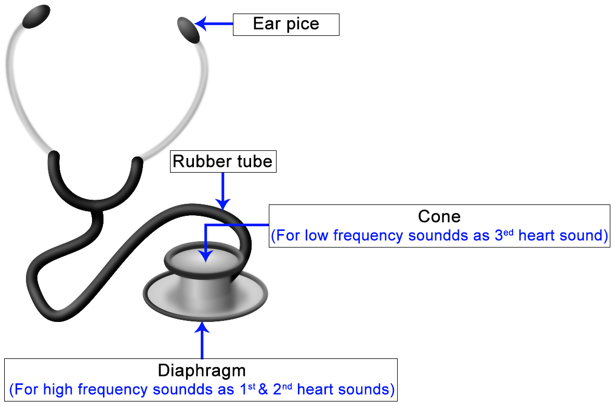
Procedure:
- The subject lies in supine position
- The doctor stands on the right side of the subject
- Locate the apex beat: |  |  | Which is usually located in the left 5th intercostal space in mid -clavicular line (gently press the pulp of your finger to palpate the region of apex) the lowest and the outermost point at which the finger is forced up, is the region of apex beat.
- Then place the stethoscope on the following 4 positions:
 |  |  |  | - Mitral area (apex beat)
 |  |  |  | - Tricuspid area (lower end of sternum)
 |  |  |  | - Pulmonary area (second left intercostal space)
 |  |  |  | - Aortic area (second right intercostal space)
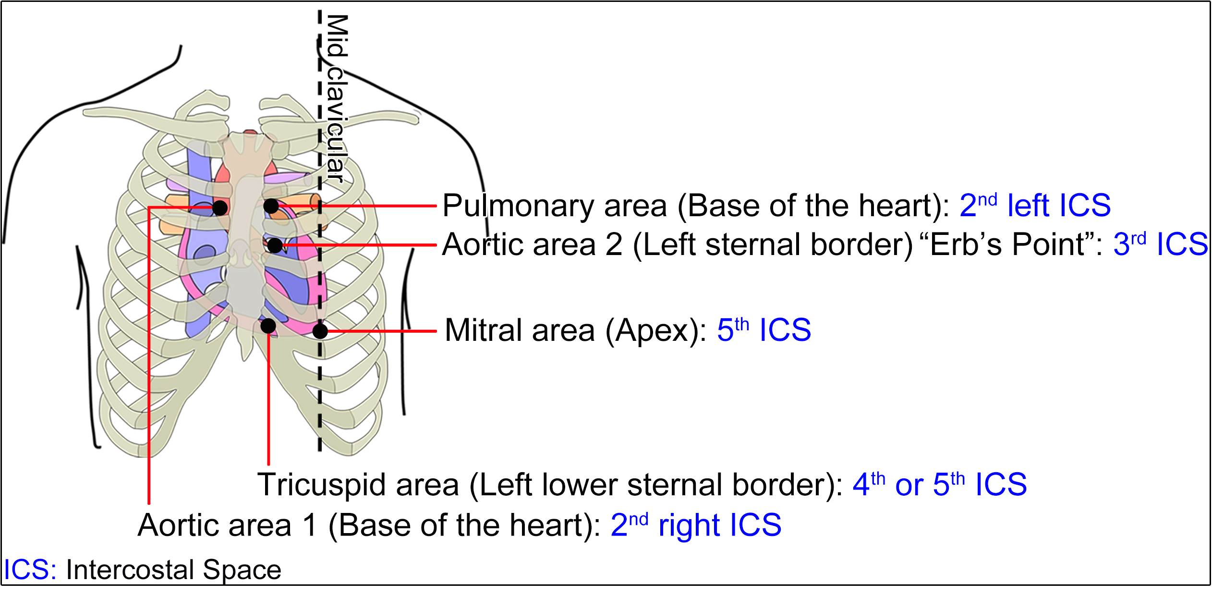
Heart sounds

First Heart Sound: | - Due to Closure of mitral & tricuspid valves
 | - Best heard on mitral & tricuspid area
 | - Occurs during isometric contraction phase & early maximal ejection phase
 | - Length = 0.16 second
Second heart sound: | - Closure of semilunar valves. (pulmonary and aortic valves)
 | - Aortic component best heard on aortic area while pulmonary component best heard on pulmonary area
 | - Occurs during isometric relaxation phase
 | - Length = 0.1second
Third heart sound: | - It is heard due to increased gush of blood from atrium to ventricle or due to flappy ventricular wall (in heart failure)
(Pathological)
 | - May be present normally in children
Fourth heart sound: | - Due to vigorous atrial contraction due to increase the end diastolic pressure of the ventricle on the top of ventricular hypertrophy (as in systemic hypertension or pulmonary hypertension)
(Pathological)

Causes of tachycardia |  |  |  | Causes of bradycardia
- Anxiety |  | Physiological |  | - Sleep
- Exertion |  |  |  | - Athletes
- Fever |  | Pathological |  | Hypothyroidism
- Anemia
- Thyrotoxicosis (Hyperthyroidism)
- Atropine |  | Drugs |  | - Digitalis
- Thyroxin |  |  |  | - β- blockers
Cardiac cycle
Summary of Phases of cardiac cycle:
VP (Ventricular pressure) |  |  |  | VV (Ventricular volume) |  |  |  | Aortic & Pulm. pressure |  |  |  | HS (Heart Sounds) |  |  |  | ECG |  |  |  | Valves
❶ Atrial systole (Atrial contraction) [0.1 sec]
↑→↓ |  |  |  | ↑ |  |  |  | ↓ |  |  |  | S4 |  |  |  | P |  |  |  | AV Valves: Opened
 |  |  |  |  |  |  |  |  |  |  |  |  |  |  |  |  |  |  |  | Semilunar Valves: Closed
❷ Isometric Contraction Phase [0.05 sec]
↑ |  |  |  | Constant |  |  |  | ↓ |  |  |  | S1 |  |  |  | QRS |  |  |  | AV Valves: closed
 |  |  |  |  |  |  |  |  |  |  |  |  |  |  |  |  |  |  |  | Semilunar Valves: Closed
❸ Maximum Ejection Phase [0.15 sec]
↑ |  |  |  | ↓ |  |  |  | ↑ |  |  |  | S1 |  |  |  | T |  |  |  | AV Valves: Closed
 |  |  |  |  |  |  |  |  |  |  |  |  |  |  |  |  |  |  |  | Semilunar Valves: opened
❹ Reduced Ejection Phase [0.1 sec]
↓ |  |  |  | ↓ |  |  |  | ↓ |  |  |  | - |  |  |  | T |  |  |  | AV Valves: Closed
 |  |  |  |  |  |  |  |  |  |  |  |  |  |  |  |  |  |  |  | Semilunar Valves: opened
❺ Protodiastole Phase [0.04 sec]
↓ |  |  |  | Constant |  |  |  | ↓ |  |  |  | S2 |  |  |  | T |  |  |  | AV Valves: Closed
 |  |  |  |  |  |  |  |  |  |  |  |  |  |  |  |  |  |  |  | Semilunar Valves: Closed
❻ Isometric Relaxation Phase [0.06 sec]
↓ |  |  |  | Constant |  |  |  | ↓ |  |  |  | S2 |  |  |  | End of T |  |  |  | AV Valves: Closed
 |  |  |  |  |  |  |  |  |  |  |  |  |  |  |  |  |  |  |  | Semilunar Valves: Closed

Arterial pulse
Technique:
- Place the middle 3 fingers over the wrist, at the base of thumb.
- Points to be observed:
 | ❶ Rate |  |  | : | - Normal heart rate |  |  |  |  | : 60 - 90 beats per minute (bpm)
 |  |  |  |  | - More than 100 |  |  |  |  | = Tachycardia
 |  |  |  |  | - Less than 60 |  |  |  |  | = Bradycardia
 | ❷ Rhythm |  |  | : | - Normal : Regular
 |  |  |  |  | - May be irregular: As in (atrial fibrillation, extra systole)
 | ❸ Volume |  |  | : | - Big pulse volume |  |  |  | : As in fever, severe anemia
 |  |  |  |  | - Small volume |  |  |  | : As in heart failure, shock
 | ❹ Condition of arterial wall |  |  | : | Compress the radial artery by the index then roll the artery under the middle finger:
 |  |  |  |  |  | - In the young person you cannot feel it
 |  |  |  |  |  | - But in old age it is felt as cord like structure due to atherosclerosis
 | ❺ Equality on both sides |  |  | : | Causes of inequality: |  |  |  |  | Embolus in brachial or Radial arteries

Hess capillary fragility test
Steps: | - Tie cuff of sphygmomanometer around the arm
 | - Raise pressure to 80 mmHg (to prevent venous return)
 | - Keep pressure for 15 minutes then release the pressure
 | - Count number of petichae on cubital fossa in 5 cm circle
 | - If petichae: | - Less than | 3 = Normal
 |  | - More than | 3 = Increased capillary fragility
Causes of increased capillary fragility: |  |  |  | - Defect in capillary wall: | - Old age
 |  |  |  |  | - Vitamin C deficiency
 |  |  |  |  | - Allergy
 |  |  |  |  | - Toxins
 |  |  |  | - Thrombocytopenia

Measurement of Arterial Blood Pressure (ABP)
Arterial blood pressure (ABP):
 | Is defined as pressure exerted by the blood on the wall of arteries
 |  |  | Arterial blood pressure = |  |  |  |  |  | Systolic pressure |  |  |  | ABP= |  | SBP
 |  |  |  |  |  |  |  |  | Diastolic pressure |  |  |  |  |  | DBP
Systolic blood pressure (SBP) |  |  |  |  |  | : | - Is the maximum pressure in the arteries during systole  - The normal systolic pressure ranges between 90-150 mmHg
Diastolic blood pressure (DBP) |  |  |  |  |  | : | - Is the minimum pressure in the arteries during diastole  - The normal diastolic pressure ranges between 60-90 mmHg  - Depends on the peripheral resistance (diameter of arterioles)
Pulse pressure: |  |  |  |  |  | : | Is the difference between systolic and diastolic pressures
 |  |  |  |  |  |  | Pulse pressure = Systolic Pressure - Diastolic Pressure
Mean systemic arterial blood pressure:
 |  | - The average pressure in the arteries throughout the cardiac cycle
 |  | - The force moving blood to the tissue throughout the cardiac cycle
 |  | - MSAP = Diastolic Pressure + ⅓ Pulse Pressure

Material: | - Blood pressure is measured indirectly by the use of sphygmomanometer
 | - Sphygmomanometer consists of: |  |  | - Rubber bag
 |  |  |  | - Hand pump
 |  |  |  | - Mercury manometer
 |  |  |  | - Mercury reservoir
 | - Blood pressure is most commonly measured in the brachial artery:
 |  | ❶ Convenient place for measurement
 |  | ❷ At approximately at the same level of the heart
- Types of sphygmomanometer apparatus: |  |  | 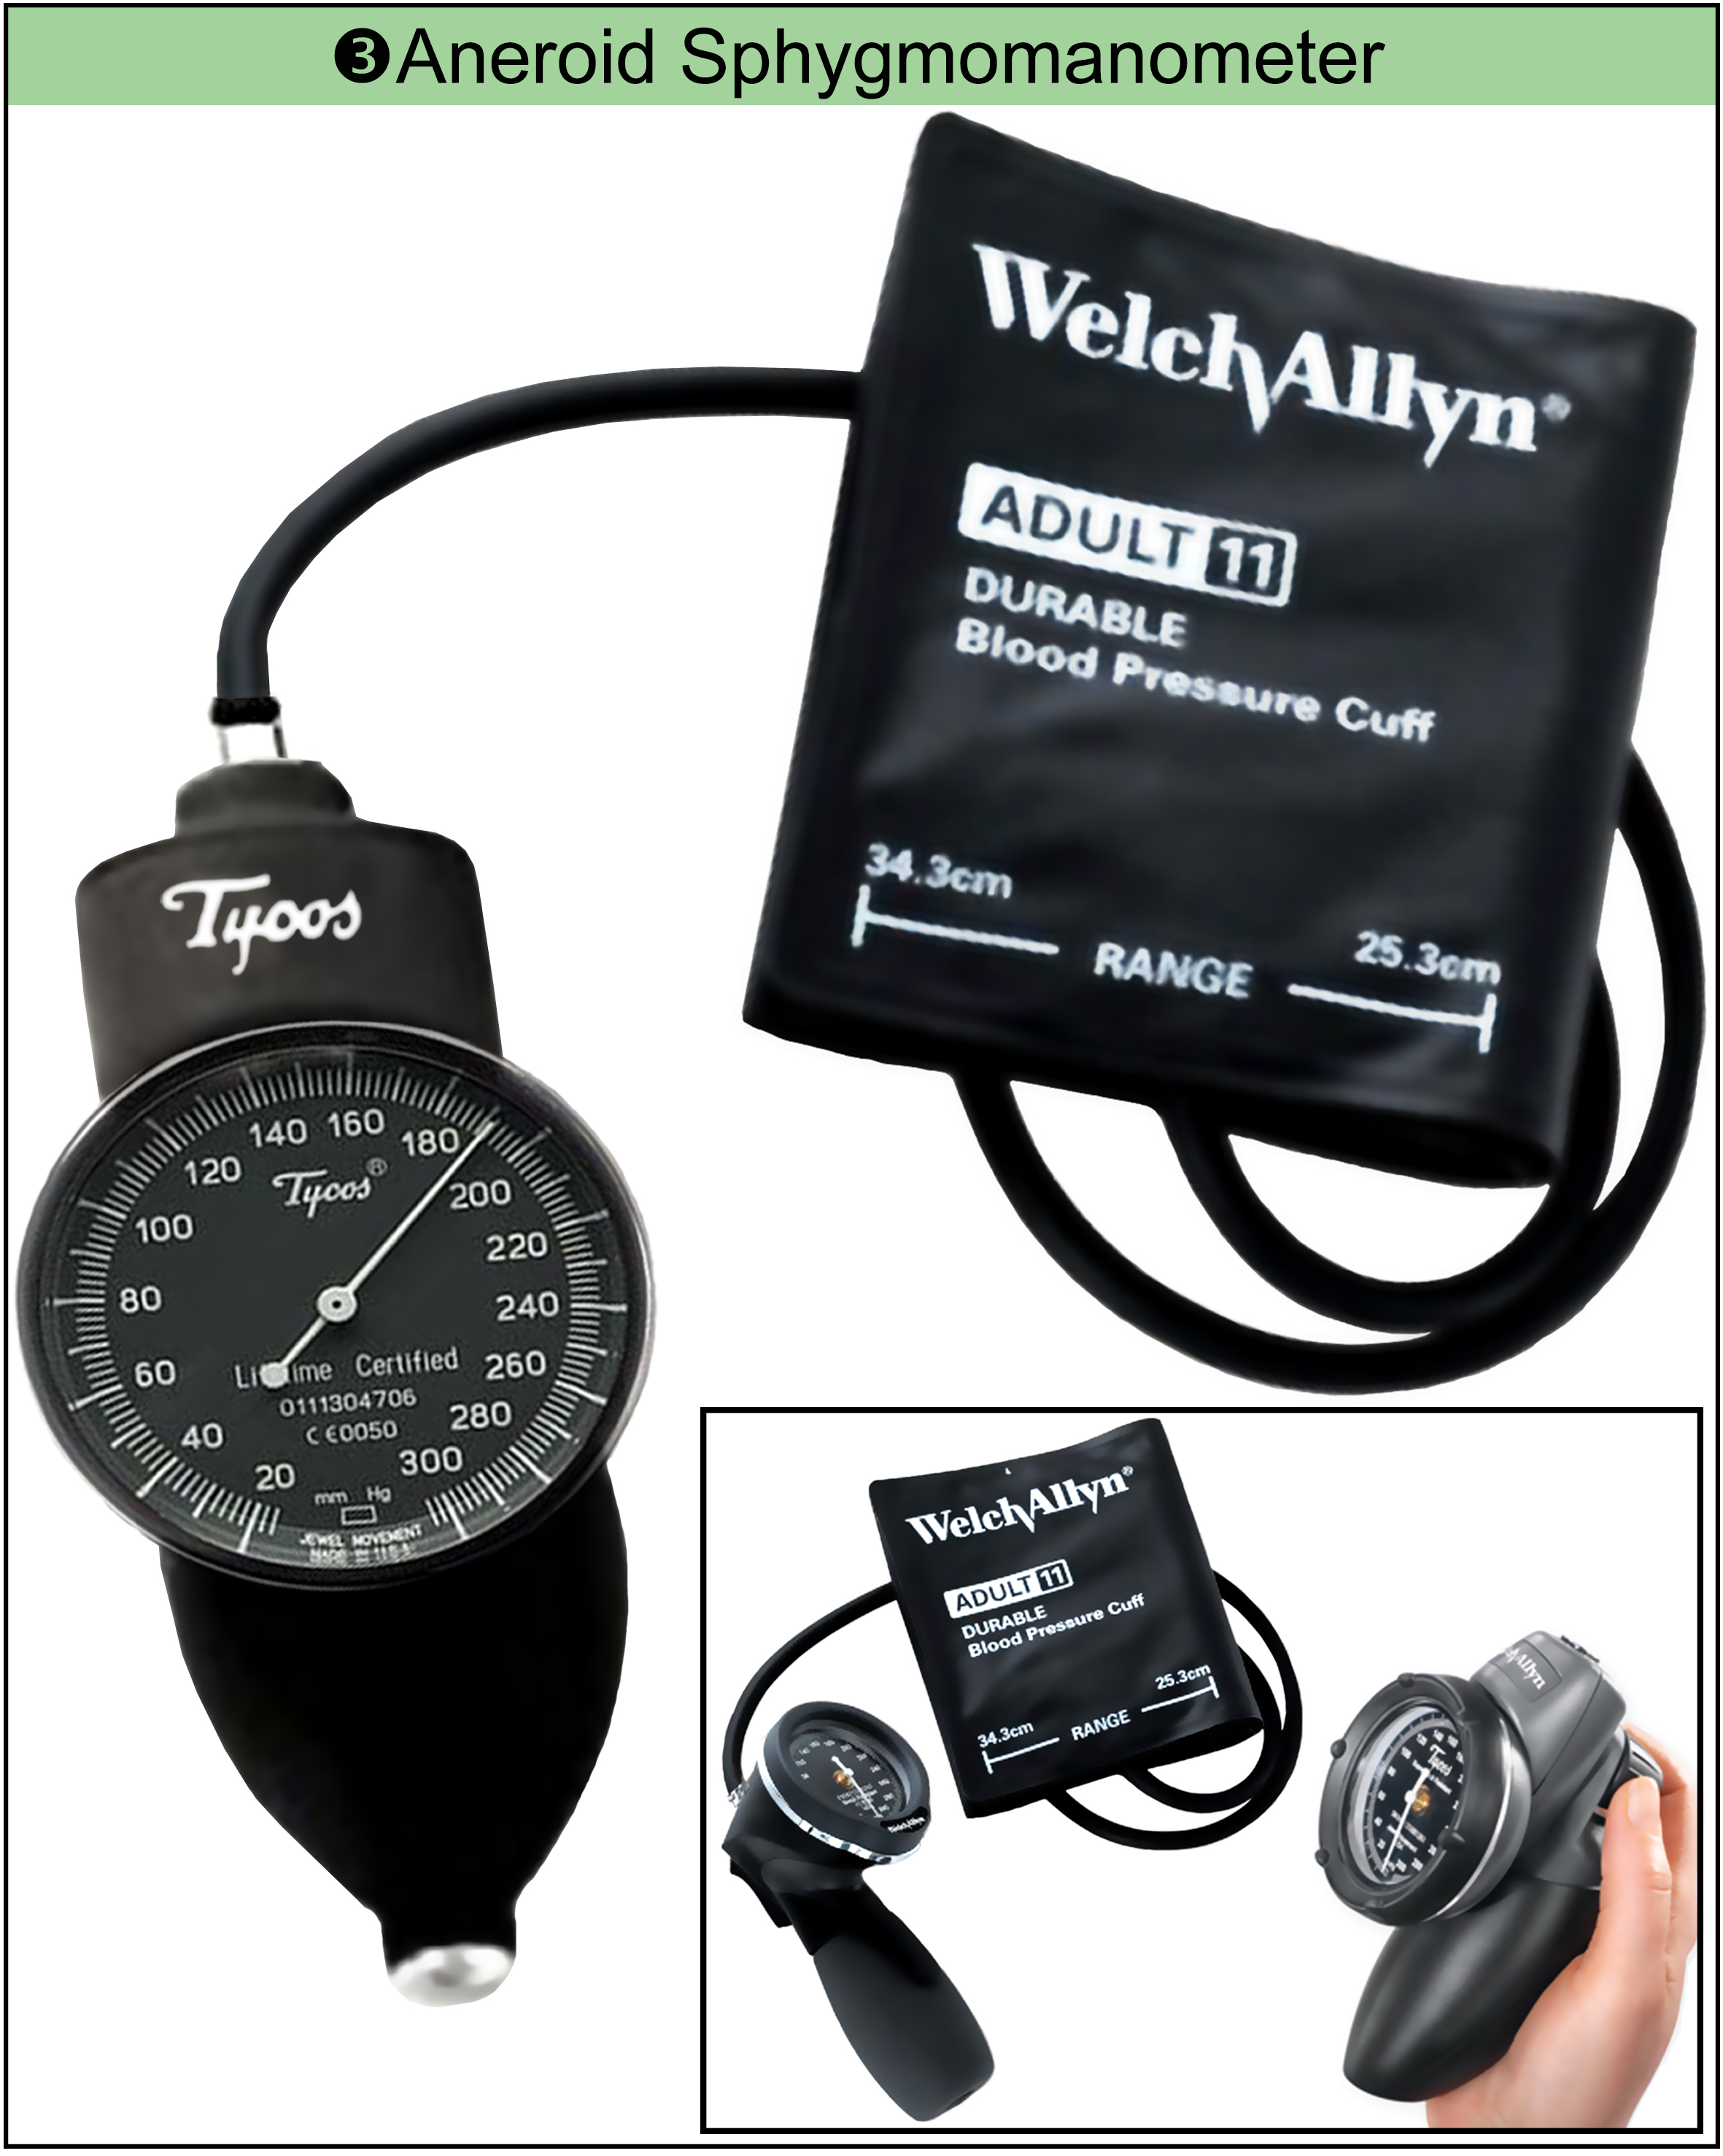
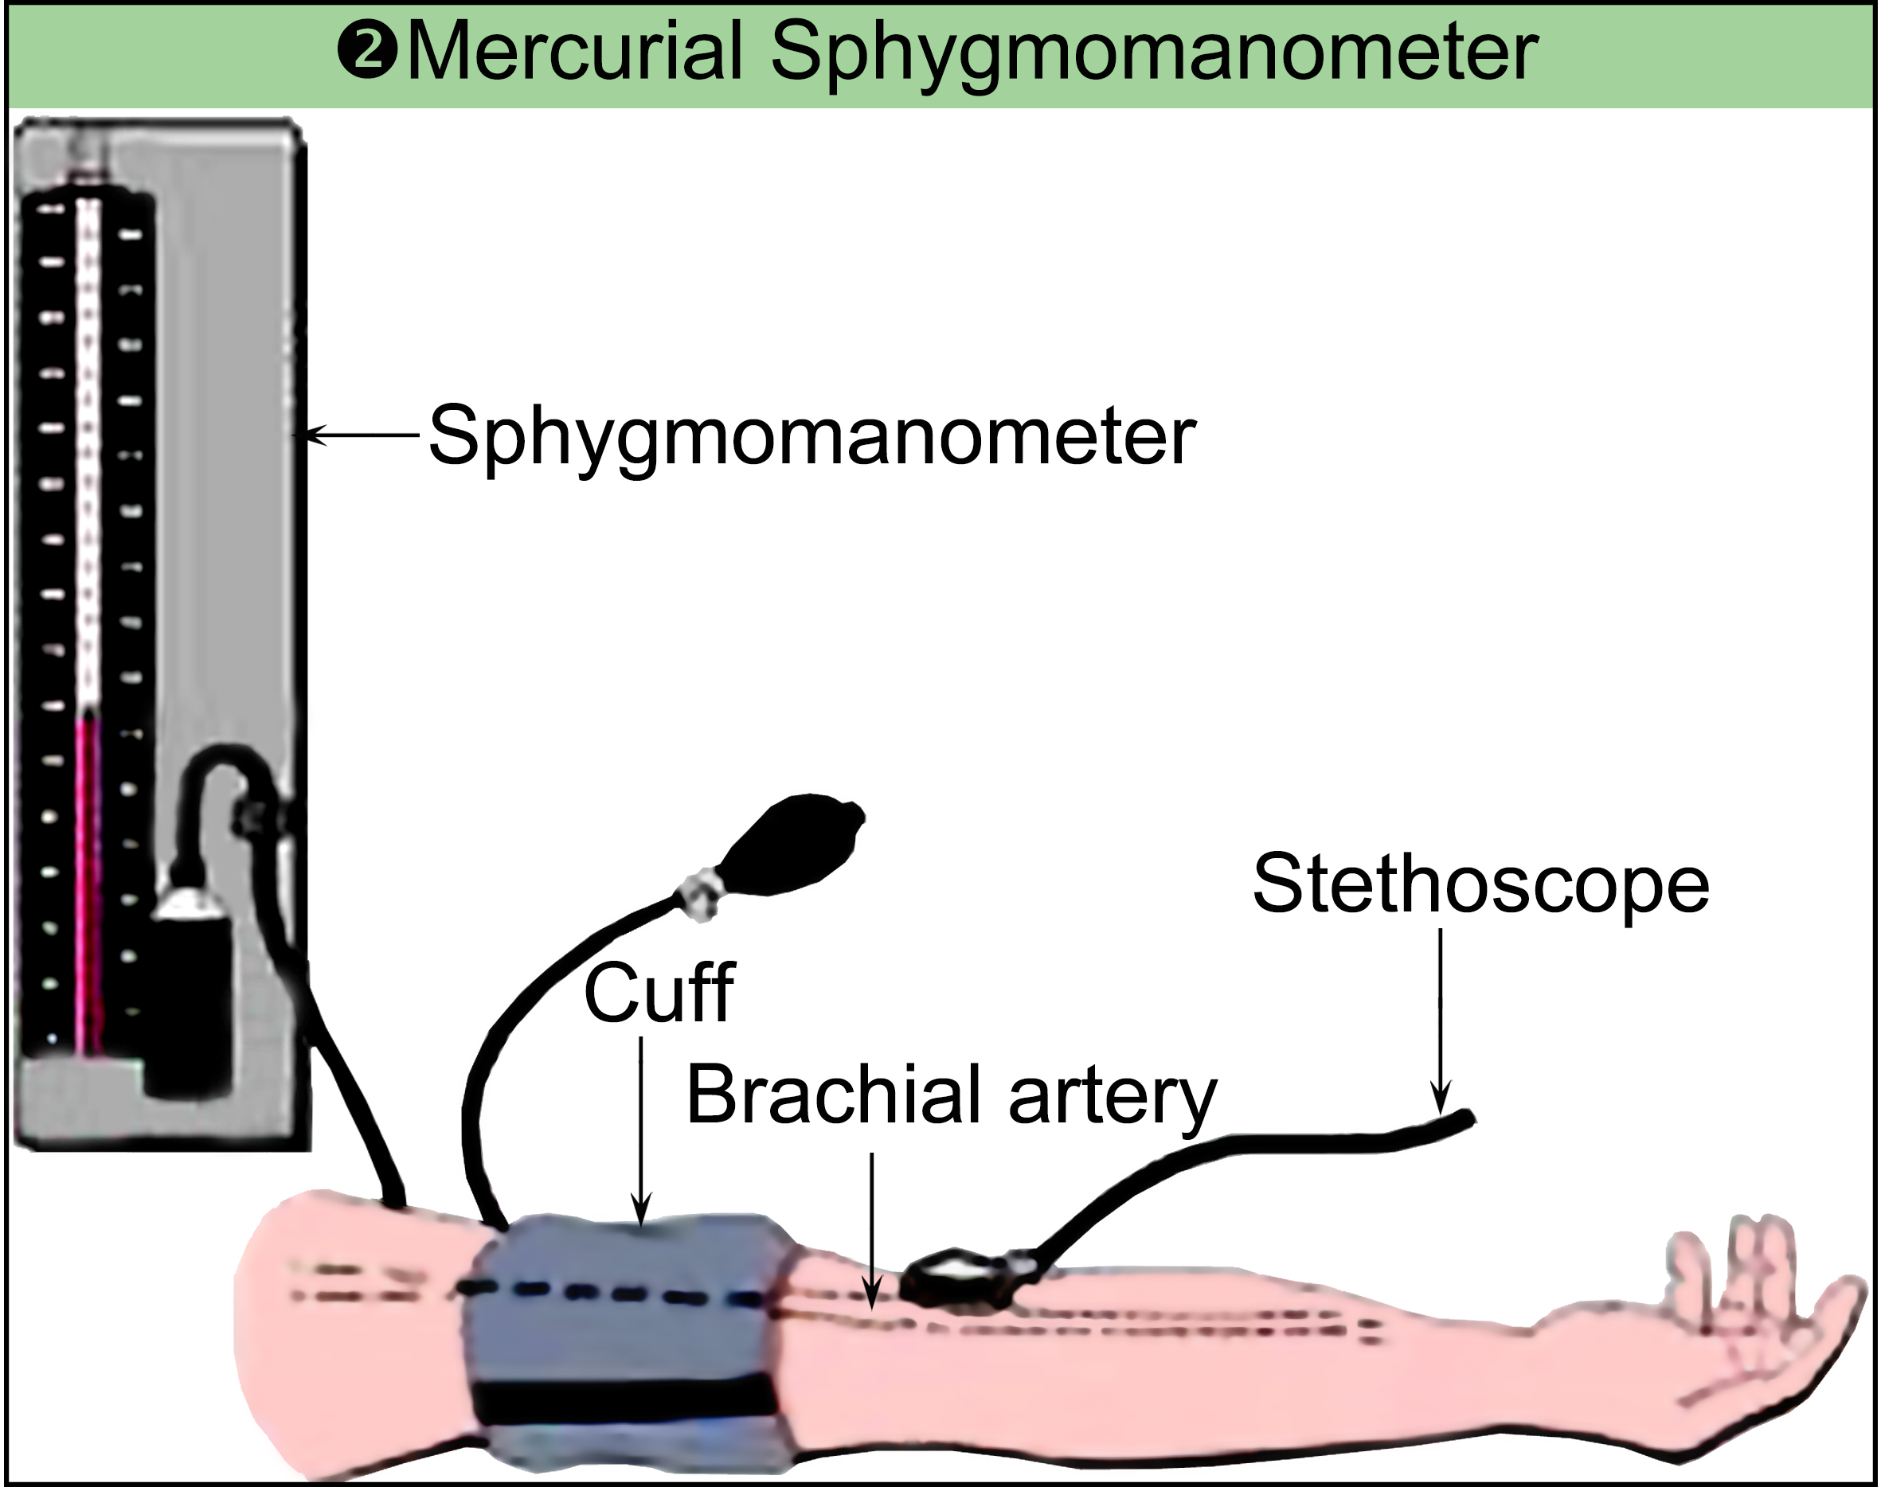
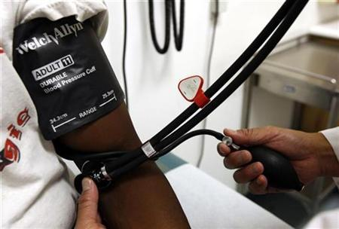

Methods: |  |  |  | - Sitting or recumbent position
 |  |  |  | - The arm is supported horizontally at the level of heart
Palpatory Method
 | - Put the cuff around the upper arm with its lower edge 3 cm above the elbow
 | - Palpate the radial pulse at the wrist
 | - Close the valve
 | - Inflate the cuff slowly
 | - Note the pressure when radial pulse disappears
 | - Deflate the cuff slowly to reduce the pressure in the cuff (by opening the valve to let air out of the beg)
 | - Note the pressure at which the radial pulse reappears. (this the systolic blood pressure)
 |  | NB: |  | - The palpatory method measures only the systolic pressure
 |  |  |  | - Inaccurate
Auscultatory method
 |  | - Put the cuff around the upper arm with its lower edge 3 cm above the elbow.
 |  | - Palpate the brachial pulse at the (cubital fossa medial to the tendon of biceps)
 |  | - Placed the stethoscope over the brachial artery
 |  | - Close the valve
 |  | - Inflate the cuff slowly to raise the pressure in the cuff above the systolic pressure (measured by the palpatory method) by 30 mmHg
 |  | - Deflate the cuff slowly to reduce the pressure in the cuff (by opening the valve to let air out of the beg)
 |  | - Note the pressure at which sound appears. (this the systolic blood pressure)
 |  | - You will be able to hear four phases of sounds changes called korotkoff sounds:
 |  |  | - Phase 1 |  |  |  | : Sharp and clear sound
 |  |  | - Phase 2 |  |  |  | : The sound become softer
 |  |  | - Phase 3 |  |  |  | : The sound become louder & clear
 |  |  | - Phase 4 |  |  |  | : The sound become muffled (decreased)
 |  | - The first sound heard represent the systolic pressure.
 |  | - The point of complete disappearance of the sound represents the diastolic pressure.
 |  | Remarks: |  |  |  | - The cuff should be applied directly on bare arm (not on clothes)
 |  |  |  |  |  | - Do not put the diaphragm of the stethoscope underneath the cuff
 |  |  |  |  |  | - Do not inflate or deflate the cuff very rapidly or very slowly
 |  |  |  |  |  | - The arm should be at the heart level and supported
 |  |  |  |  | - Auscultatory gap: |  |  |  |  | (sound may disappear between the systolic & diastolic and then reappear)
 |  | NB: | - Hypertension: |  |  |  |  | (persistent elevation of diastolic blood pressure > 90 mmHg or systolic >150 mmHg)
 |  |  | - Hypotension: |  |  |  |  | (decline of systolic blood pressure < 90 mmHg or diastolic < 60)
 |  | 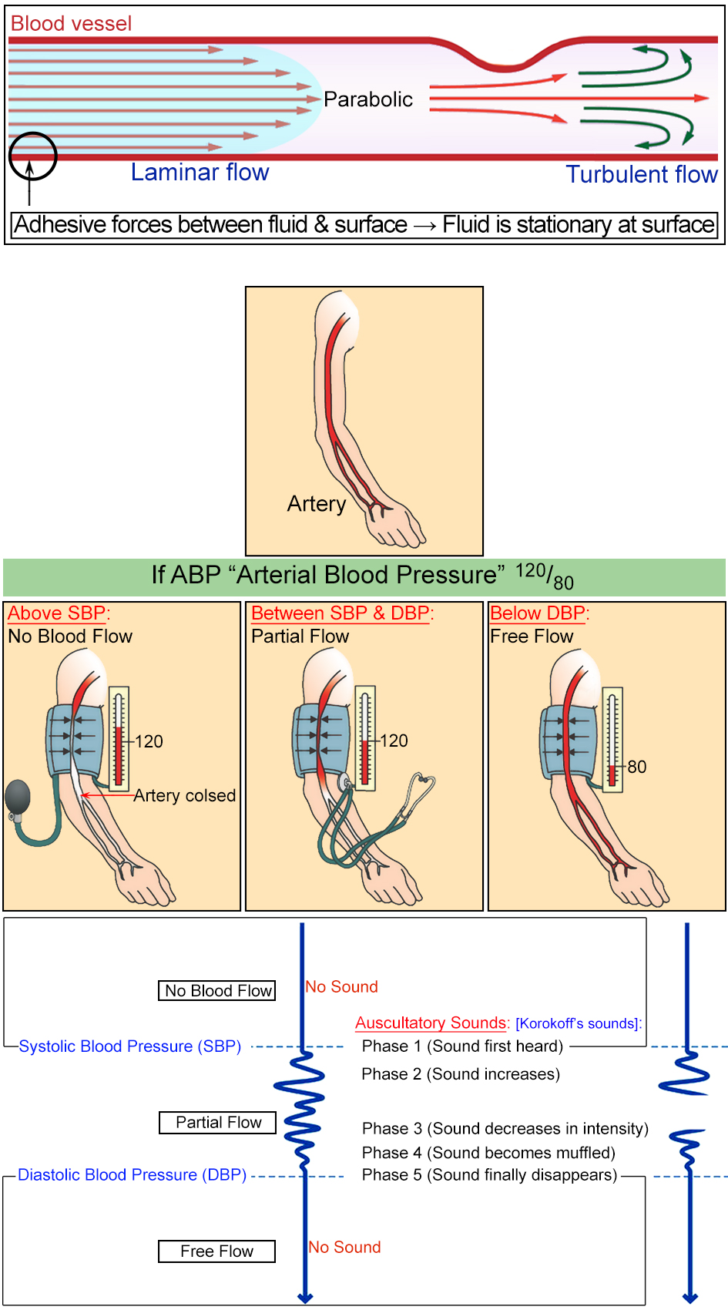
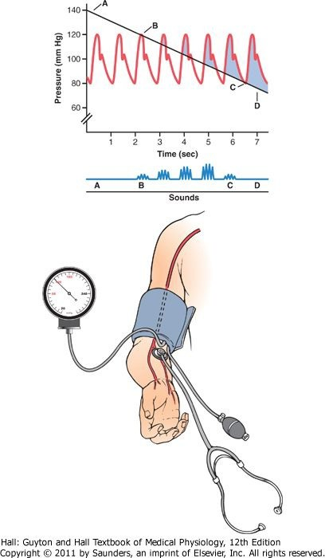
Auscultatory method for measuring systolic and diastolic arterial pressures
Uses of sphygmomanometer: |  |  |  |  |  |  |  |  | ❶ | Measuring of arterial blood pressure (ABP)
 |  |  |  |  |  |  |  |  | ❷ | Diagnosis of latent tetany
 |  |  |  |  |  |  |  |  | ❸ | Hess test in vascular purpura
 |  |  |  |  |  |  |  |  | ❹ | Hemostasis

Uses of Stethoscope: |  |  |  | ❶ | Measurement of arterial blood pressure (ABP)
 |  |  |  | ❷ | Heart sounds
 |  |  |  | ❸ | Chest sounds
 |  |  |  | ❹ | Intestinal sounds

ECG (Electrocardiogram)
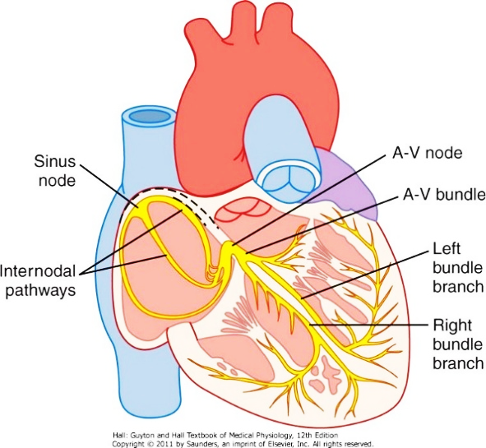
Definition: |  |  | Is the recording of the heart electric activity
Conductive system of heart:
- Action potential generated at SA node
- Conducted through intra nodal fibers to the atria then to AV node
- Slowest in the AV node
- Conducted through bundle of his which divides into left and right bundle branches
- The bundle branches divide into: |  |  |  |  | - Purkinje fibers that conduct excitation wave to all regions of the right
 |  |  |  |  | - Left ventricles |  | (action potential is fastest in the purkinje system)
NB: |  | Significance of slow conduction in AV node:
 |  | ❶ Allowing time for ventricular filling before ventricular contraction
 |  | ❷ Protect the ventricles from abnormal atrial high rhythm

Types of electrode:
- Exploring electrode: Electrode put on area having potential deference & find reading
- Indifferent electrode: |  |  |  |  | - Electrode put on area having zero potential
 |  |  |  |  | - It is formed by uniting potential of 3 electrodes on:
 |  |  |  |  |  |  |  |  |  | - Right arm |  |  |  |  |  |  |  |  |  | To resistance of 5000 ohm
 |  |  |  |  |  |  |  |  |  | - Left arm
 |  |  |  |  |  |  |  |  |  | - Left foot
Lead: |  | When 2 electrodes are connected together they form a lead
 |  | Types of leads: |  |  |  | ❶ Bipolar leads: |  |  |  |  |  |  |  | - Lead formed of 2 exploring electrode
 |  |  |  |  |  |  |  |  |  |  |  |  |  | - EX: Bipolar limb leads
 |  |  |  |  |  | ❷ Unipolar leads: |  |  |  |  |  |  |  |  | - Lead formed of:
 |  |  |  |  |  |  |  |  |  |  |  |  |  |  |  |  | - Exploring electrode
 |  |  |  |  |  |  |  |  |  |  |  |  |  |  |  |  | - The other is indifferent electrode
 |  |  |  |  |  |  |  |  |  |  |  |  |  |  | - EX: |  |  |  | Unipolar limb leads, unipolar chest leads
 |  | Bipolar Limb Leads: |  |  |  |  |  |  | Lead |  |  |  |  | Electrode
 |  | (Standard) |  |  |  |  |  |  |  |  |  |  |  | -ve |  |  |  |  |  |  | +ve
 |  |  |  |  |  |  |  |  | ❶ Lead I |  |  |  |  | Right upper limb |  |  |  |  |  |  | Left upper limb
 |  |  |  |  |  |  |  |  | ❷ Lead II |  |  |  |  | Right upper limb |  |  |  |  |  |  | Left lower limb
 |  |  |  |  |  |  |  |  | ❸ Lead III |  |  |  |  | Left upper limb |  |  |  |  |  |  | Left lower limb
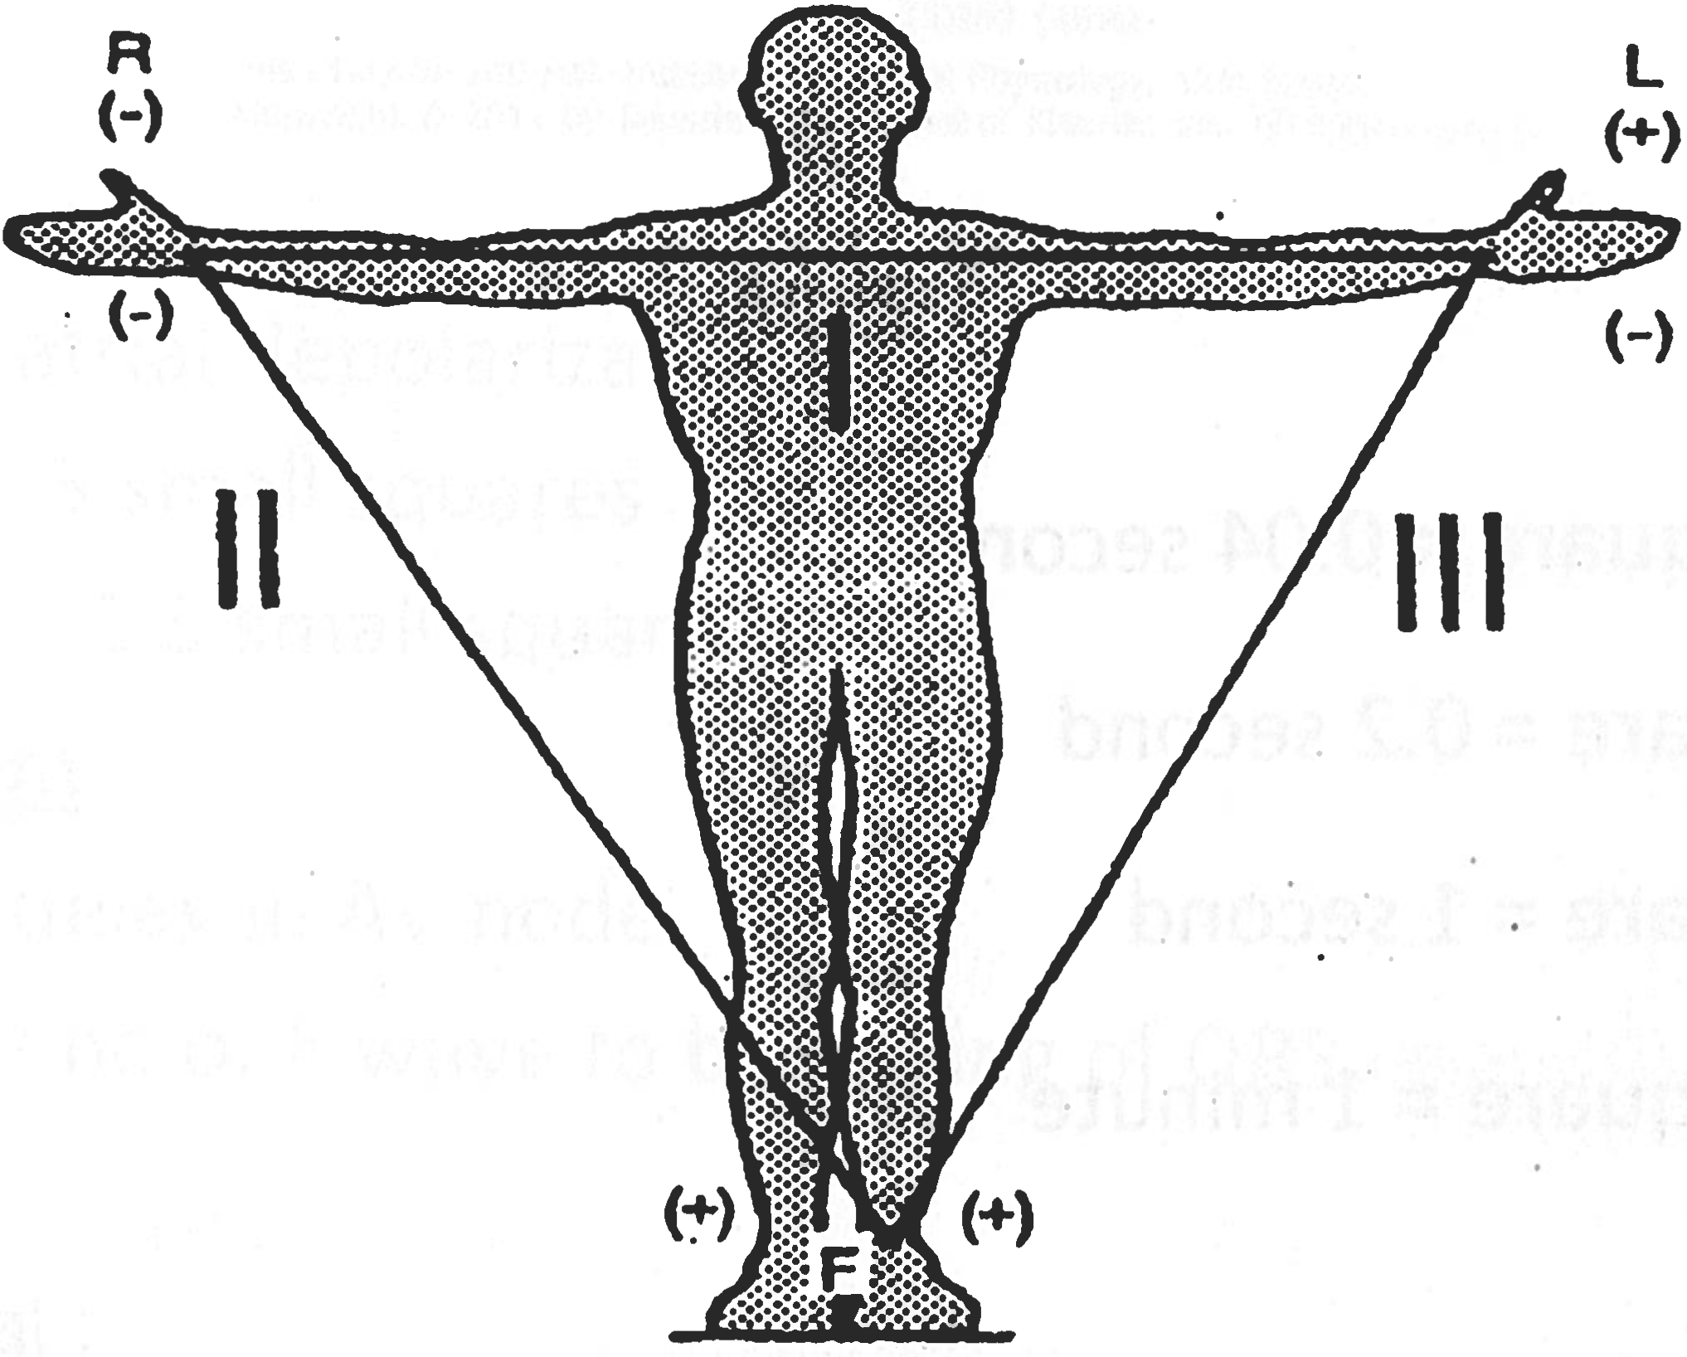
The Einthoven triangle
 | Unipolar Limb Leads |  |  |  |  |  |  |  | Lead |  |  |  |  | Electrode
 |  | (Augmented) |  |  |  |  |  |  |  |  |  |  |  | indifferent |  |  |  |  |  |  | +ve
 |  |  |  |  |  |  |  |  | ❶ aVR |  |  |  |  | - Left upper limb |  |  |  |  |  |  | - Right upper limb
 |  |  |  |  |  |  |  |  |  |  |  |  |  | - Left lower limb
 |  |  |  |  |  |  |  |  | ❷ aVL |  |  |  |  | - Right upper limb |  |  |  |  |  |  | - Left upper limb
 |  |  |  |  |  |  |  |  |  |  |  |  |  | - Left lower limb
 |  |  |  |  |  |  |  |  | ❸ aVF |  |  |  |  | - Right upper limb |  |  |  |  |  |  | - Left lower limb
 |  |  |  |  |  |  |  |  |  |  |  |  |  | - Left upper limb
 |  |  |  |  |  |  |  |  | Unipolar chest leads
 |  |  |  |  |  |  |  |  | - V₁ |  |  | : | Right 4th intercostal space adjacent to sternum
 |  |  |  |  |  |  |  |  | - V₂ |  |  | : | Left 4th intercostal space adjacent to sternum
 |  |  |  |  |  |  |  |  | - V₃ |  |  | : | Between V3 and V4
 |  |  |  |  |  |  |  |  | - V₄ |  |  | : | 5th intercostal space mid clavicular line
 |  |  |  |  |  |  |  |  | - V₅ |  |  | : | Left 5th intercostal space anterior axillary line
 |  |  |  |  |  |  |  |  | - V₆ |  |  | : | Left 5th intercostal space mid axillary line
ECG paper |  |  | Horizontally: |  |  |  | - 1 |  |  |  | Small square |  |  |  |  |  |  | = 0.04 second
 |  |  |  |  |  |  | - 1 |  |  |  | Big square |  |  |  |  |  |  | = 0.2 second
 |  |  |  |  |  |  | - 5 |  |  |  | Big square |  |  |  |  |  |  | = 1second
 |  |  |  |  |  |  | - 300 |  |  |  | Big square |  |  |  |  |  |  | = 1minute
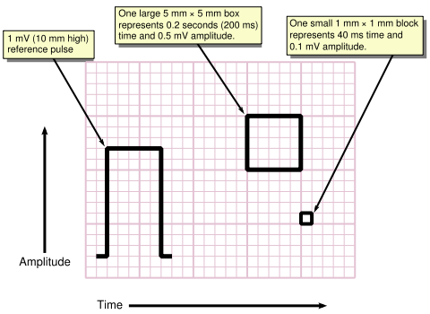
Components of normal ECG
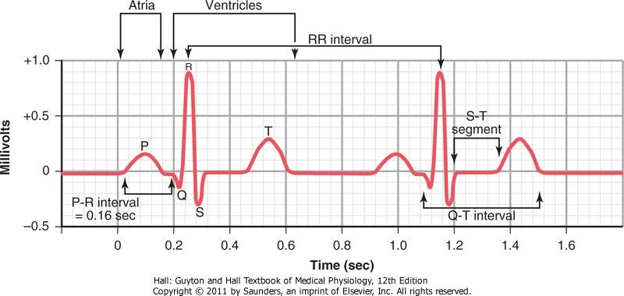
P wave: | - Represents atrial depolarization
 | - Duration |  |  |  | : 3 Small squares
 | - Amplitude |  |  |  | : 2.5 Small squares
P-R segment: | - Represents delay in AV node
 | - Start from end of P wave to beginning of QRS complex
 | - Isoelectric
P-R interval: | - P wave + PR segment
 | - Duration |  |  |  |  | : 3 - 5 small squares
 | - Is decreased |  |  |  |  | (increased conduction velocity though AV node) by stimulation of sympathetic nervous system
 | - Is increased |  |  |  |  | (decreased conduction velocity through AV node) by stimulation of parasympathetic nervous system
 | - Prolonged pathologically in heart block
QRS complex : | - Represents ventricular depolarization
 | - Duration: |  |  | - Less than 2.5 small squares
 |  |  |  | - Components : |  |  |  |  | - Q wave |  | :(1st -ve wave in the complex)
 |  |  |  |  |  |  |  |  | - R wave |  | :(1st +ve wave in the complex)
 |  |  |  |  |  |  |  |  | - S wave |  | :(1st -ve wave after "R")
ST segment: | - Represents plateau of ventricular repolarization
 | - Start by the end of QRS [at a junctional point (J point)]
 | - Ends by merging smoothly to T wave
 | - Normally: Isoelectric
T wave: | Represents the descending limb of ventricular repolarization
ST interval : | ST segment + T wave
QT interval : | - Start by beginning of QRS
 | - Ends by end of T wave
ECG analysis: | ❶ Rhythm: |  |  |  | - Measure successive R-R intervals
 |  |  |  |  | - If fixed = regular rhythm
 |  |  |  |  | - If variable =irregular rhythm
 | ❷ Rate: | - In case of irregular rhythm: |  |  |  |  |  |  |  |  |  | Number of R in 30 big square (6 second) × 10
 |  | - If regular :
 |  |  | - Heart rate = |  |  |  |  | 300
 |  |  |  |  |  |  |  | Number of big squa1·e between 2 successive R
 |  |  | - Heart rate = |  |  |  |  | 1500
 |  |  |  |  |  |  |  | Number of small square between 2 successive R

NB: |  | - Normal heart rate: (60 -100 beats / min)
 |  | 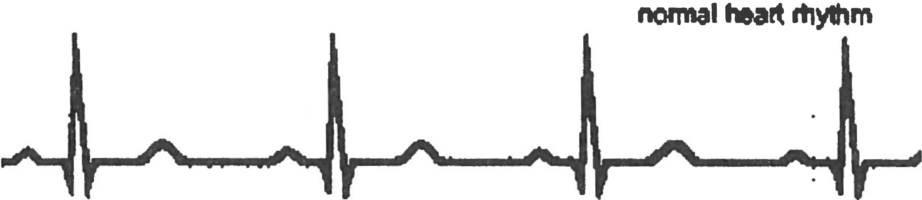
 |  | - Tachycardia: (heart rate > 100 beats / minute)
 |  | 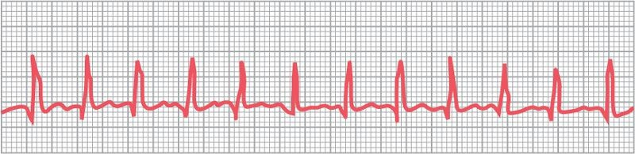
 |  | - Bradycardia: (heart rate < 60 beats / minute)
 |  | 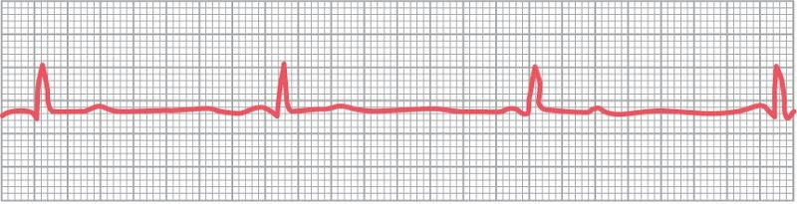
 |  | - Prolonged PR interval: (more than 5 small squares)
 |  | 