INTRODUCTION TO
MOLECULAR BIOLOGY
PRACTICAL BIOCHEMISTRY
Spectrophotometer
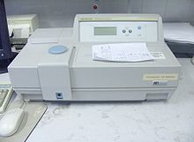
A spectrophotometer is an apparatus used to measure the amount of photons converted into electric current that can measure intensity as a function of the light source wavelength.
Important features of spectrophotometers are spectral bandwidth and linear range of absorption or reflectance measurement.
spectrophotometry is the quantitative measurement of the reflection or transmission properties of a material as a function of wavelength.
spectrophotometry deals with visible light, near-ultraviolet, and near-infrared.
Principle of spectrophotomerty:
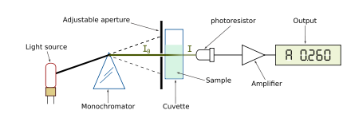

The apparatus is:
The light source is imaged upon the sample.
• A fraction of the light is transmitted or reflected from the sample.
• The light from the sample is imaged upon the entrance slit of the monochromator.
• The monochromator separates the wavelengths of light and focuses each of them onto the photodetector sequentially.
It is used for measurement of mainly in the routine laboratories as estimation of blood glucose kidney functions and renal functions tests.
ELISA enzyme-linked immunosorbent ssay (ELISA)
ELISA principle:
Step 2
principle that specific antibodies bind the target antigen and detect the presence and quantity of antigens binding
The antigen antibody reaction operates in specially designed microtubes named as ELISA well. There are 96 wells in each kit. The number of standards supplied in each kit is 16 standards.
Step 3
As the diagram below

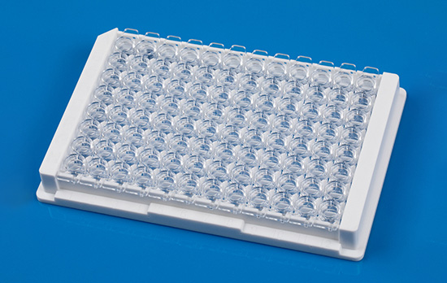

ELISA applications:
- a diagnostic tool in medicine and plant pathology.
- a quality-control check in various industries.
- It is the first screening test widely used for HIV because of its high sensitivity.
- Detection of many diseases:
- detection of Mycobacterium antibodies in tuberculosis
- detection of rotavirus in feces
- detection of hepatitis B markers in serum
- detection of enterotoxin of E. coli in feces
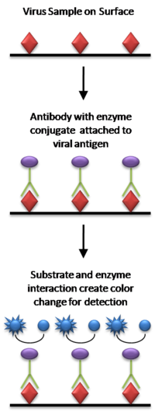

Mention in details 4 main types of ELISA

Polymerase Chain Reaction (PCR)


It is a biochemical technology in molecular biology used to amplify a single or a few copies of a piece of DNA across several orders of magnitude, generating thousands to millions of copies of a particular DNA sequence.
The method relies on thermal cycling, consisting of cycles of repeated heating and cooling of the reaction for DNA melting and enzymatic replication of the DNA.
Primers (short DNA fragments) containing sequences complementary to the target region along with a DNA polymerase (after which the method is named) are key components to enable selective and repeated amplification.
Taq polymerase (an enzyme originally isolated from the bacterium Thermus aquaticus).
DNA polymerase enzymatically assembles a new DNA strand from DNA building-blocks, the nucleotides, by using single-stranded DNA as a template and DNA oligonucleotides (also called DNA primers), which are required for initiation of DNA synthesis.
The components of PCR include:
- DNA template that contains the DNA region (target) to be amplified.
- Two primers that are complementary to the 3' (three prime) ends of each of the sense and anti-sense strand of the DNA target.
- Taq polymerase or another DNA polymerase with a temperature optimum at around 70 °C.
- Deoxynucleoside triphosphates (dNTPs, sometimes called "deoxynucleotide triphosphates"; nucleotides containing triphosphate groups), the building-blocks from which the DNA polymerase synthesizes a new DNA strand.
- Buffer solution, providing a suitable chemical environment for optimum activity and stability of the DNA polymerase.
- Divalent cations, magnesium or manganese ions; generally Mg2+ is used, but Mn2+ can be utilized for PCR-mediated DNAmutagenesis, as higher Mn2+ concentration increases the error rate during DNA synthesis
- Monovalent cation potassium ions.

The vast majority of PCR methods use thermal cycling, i.e., alternately heating and cooling the PCR sample through a defined series of temperature steps.
PCR progresses, the DNA generated is itself used as a template for replication, setting in motion a chain reaction in which the DNA template is exponentially amplified. PCR can be extensively modified to perform a wide array of genetic manipulations.

