Approach To Clinical Practice
CONTENTS

Part I
- Introduction
- Clinical skills
- The comprehensive adult health history
- The physical examination, approach and overview
- Decision making in clinical medicine
Part II
Important Cardinal manifestations and disease presentation
- Pain
- Alteration in body temperature
- Fatigue
- Edema
Part III
Laboratory medicine
Part IV
Clinical radiology

PART I

- The Practice of Medicine
No greater opportunity, responsibility, or obligation can fall to the lot of a human being than to become a physician. In the care of the suffering, [the physician] needs technical skill, scientific knowledge, and human understanding. Tact, sympathy, and understanding are expected of the physician, for the patient is no mere collection of symptoms, signs, disordered functions, damaged organs, and disturbed emotions. [The patient] is human, fearful, and hopeful, seeking relief, help, and reassurance.
Tinsley Randolph Harrison (March 18, 1900 – August 4, 1978)
• Medicine is a profession that incorporates science and the scientific method with the art of being a physician.
• When compared with its long and generally distinguished history of caring and comforting, the scientific basis of medicine is remarkably recent. Other than an understanding of human anatomy and the later description, almost all of modern medicine is based on discoveries made within the past 150 years.
• The essential humanistic qualities of caring and comforting can achieve full benefit only if they are coupled with an understanding of how medical science can and should be applied to patients with known or suspected diseases.
• The term internal medicine, which is often misunderstood by the lay public, was developed in 19th-century Germany.
• (Inneren medizing) was to be distinguished from clinical medicine because it emphasized the physiology and chemistry of disease, not just the patterns or progression of clinical manifestations.
• Modern medicine has moved rapidly past organ physiology to an increasingly detailed understanding of cellular, subcellular, and genetic mechanisms.
• This explosion in medical knowledge has led to increasing specialization and sub specialization, defined initially by organ system and more recently by locus of principal activity (inpatient vs. outpatient), reliance on manual skills (proceduralist vs. no proceduralist), or participation in research.

THE SCIENCE AND ART OF MEDICINE
When a patient poses challenging clinical problems, an effective physician must be able to identify the crucial elements in a complex history and physical examination; order the appropriate laboratory, imaging, and diagnostic tests; and extract the key results.
As the number of tests increases, so does the likelihood that some incidental finding, completely unrelated to the clinical problem at hand, will be uncovered. Deciding whether a clinical clue is worth pursuing or should be dismissed as a “red herring” and weighing whether a proposed test, preventive measure, or treatment entails a greater risk than the disease itself are essential judgments that a skilled clinician must make many times each day.
This combination of medical knowledge, intuition, experience, and judgment defines the art of medicine.

- CLINICAL SKILLS
- If asked why they entered medicine, most doctors would say that they wish to relieve human suffering and disease. In order to achieve this aim for every patient, it is essential to understand what has gone wrong with normal human physiology.
- History taking and clinical examination are crucial initial steps to achieving this understanding, even in an era in which the availability of sophisticated investigations might suggest to a lay person that a blood test or scan will give all the answers.
- In addition, the distinction between cure of disease and relief of symptoms remains as valid today as in the past. No patient should leave a medical consultation feeling that nothing can be done to help them, even when the disease is incurable.

There are two main steps to making a diagnosis:
1 To establish the clinical features by history and examination – this represents the clinical database.
2 To interpret the clinical database in terms of disordered function and potential causative pathologies, whether physical, mental, social or a combination of these.
The final goal of assessing the patient clinically is reaching an accurate diagnosis in order to apply a proper management plan
- Accurate diagnosis of the patient condition is an organized process that proceeds through orderly arranged steps; that is; history taking, physical examination and if necessary diagnostic studies.
- In other words, dealing with the patient clinically proceeds according to the following simple scheme;

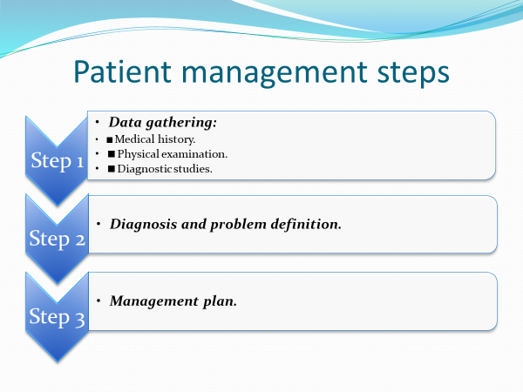
Subjective Versus Objective Data
As you acquire the techniques of history taking and physical examination, remember the important differences between subjective information and objective information.
Symptoms are subjective concerns, or what the patient tells you. Signs are considered one type of objective information, or what you observe. Knowing these differences helps you group together the different types of patient information.
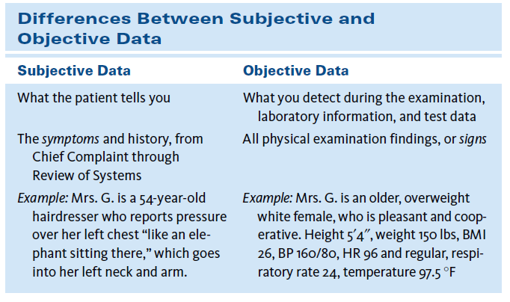

Approach to the patient
- Patients commonly have complaints (symptoms). These symptoms may or may not be accompanied by abnormalities on examination (signs) or on laboratory testing.
- Conversely, asymptomatic patients may have signs or laboratory abnormalities, and laboratory abnormalities can occur in the absence of symptoms or signs.
- The fundamental basis of internal medicine is that diagnosis should elucidate the pathophysiologic explanation for symptoms and signs so that therapy may improve the underlying abnormality, not just attempt to suppress the abnormal symptoms or signs.
- The patient-physician interaction proceeds through many phases of clinical reasoning and decision making.
- The process commonly requires a careful history or physical examination, ordering of diagnostic tests, integration of clinical findings with test results, understanding of the risks and benefits of the possible courses of action, and careful consultation with the patient and family to develop future plans.
- To care for a patient as an individual, the physician must understand the patient as a person.

Orderly steps for diagnosing a disease
• The ultimate goal for all physicians is providing proper management for their patients.
• Proper management necessitates proper diagnosis of any medical illness, the proper diagnosis relies on three pillars:
- Medical history
- Physical examination
- Diagnostic studies

- THE COMPREHENSIVE ADULT HEALTH HISTORY
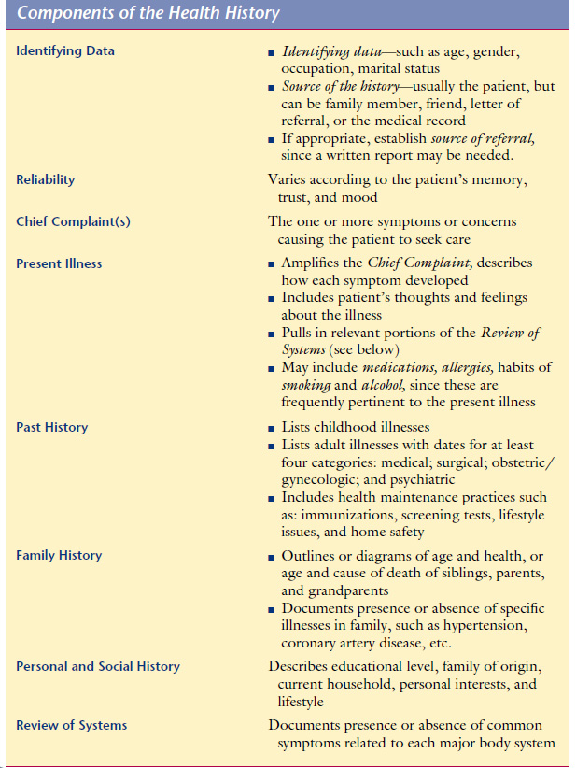

- Personal and Social History

- Includes identifying Data. Includes age, gender, marital status, and occupation.
- The Personal and Social History also conveys lifestyle habits that promote health or create risk such as exercise and diet, including frequency of exercise, usual daily food intake, dietary supplements or restrictions, and use of coffee, tea, and other caffeine-containing beverages.
- There are what is called special habits of medical importance, these include smoking, alcohol intake and drug abuse.
- Smoking should be quantified in terms of smoking index (smoking index = number of cigarettes consumed daily X years of smoking ) , whereas mild is less than 200, moderate 200-400 and heavy is more than 400.
- Regarding alcohol intake, inquiry should be taken regarding which type of alcohol and at what frequency.
- Drug abuse should be inquired upon for males and females.
Complications of illicit drug misuse
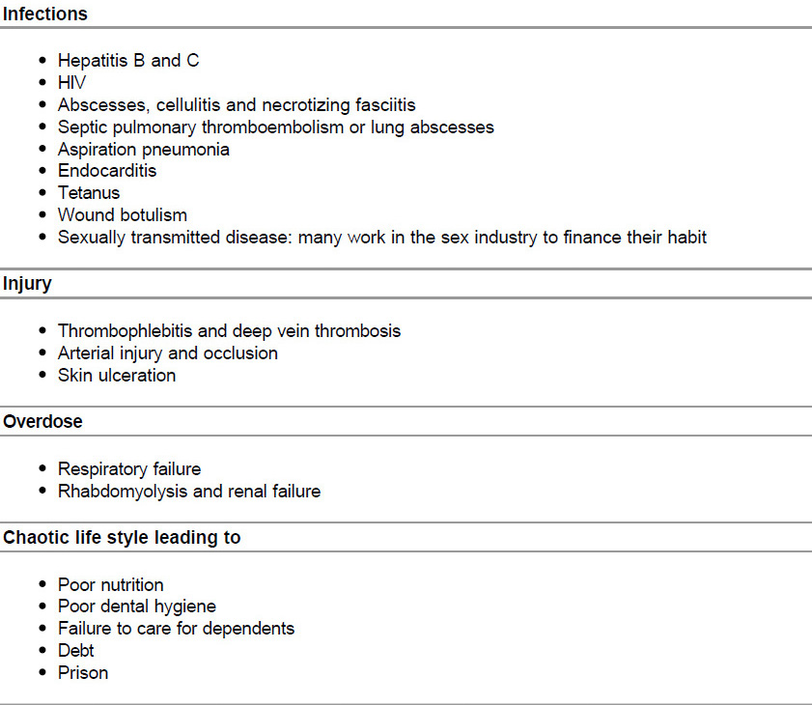

- Chief Complaint(s)
Make every attempt to quote the patient’s own words.
Sometimes patients have no overt complaints, in which case you should report their goals instead. For example, “I have come for my regular checkup”; or “I’ve been admitted for a thorough evaluation of my heart.”
- Present Illness

- This section of the history is a complete, clear, and chronologic account of the problems prompting the patient to seek care. The narrative should include the onset of the problem, the setting in which it has developed, its manifestations, and any treatments.
- The principal symptoms should be well-characterized, with descriptions of (1) location, (2) quality, (3) quantity or severity, (4) timing, including onset, duration, and frequency, (5) the setting in which they occur, (6) factors that have aggravated or relieved the symptoms, and (7) associated manifestations
- It is also important to include “pertinent positives” and “pertinent negatives” from sections of the Review of Systems related to the Chief Complaint(s).
- These designate the presence or absence of symptoms relevant to the differential diagnosis, which refers to the most likely diagnoses explaining the patient’s condition.
- Other information is frequently relevant, such as risk factors for coronary artery disease in patients with chest pain, or current medications in patients with syncope.
- The present illness should reveal the patient’s responses to his or her symptoms and what effect the illness has had on the patient’s life.
- Medications should be noted, including name, dose, route, and frequency of use.
- The list includes nonprescription drugs, vitamins, mineral or herbal supplements, birth control pills, and medicines borrowed from family members or friends.
- Allergies, including specific reactions to each medication, such as rash or nausea, must be recorded, as well as allergies to foods, insects, or environmental factors.

- Past History

- Childhood illnesses, such as measles, rubella, mumps, whooping cough, chicken pox, rheumatic fever, scarlet fever, and polio are included in the Past History.
- Also included are any chronic childhood illnesses.
- You should provide information relative to Adult Illnesses in each of four areas:
Medical (such as diabetes, hypertension, hepatitis, asthma, HIV disease, information about hospitalizations, number and gender of partners, at-risk sexual practices);
Surgical (include dates, indications, and types of operations);
Obstetric/gynecologic (relate obstetric history, menstrual history, birth control, and sexual function);
Psychiatric (include dates, diagnoses, hospitalizations, and treatments).
- You should also cover selected aspects of Health Maintenance, including Immunizations, such as tetanus, pertussis, diphtheria, polio, measles, rubella, mumps, influenza, hepatitis B, Haemophilus influenza type b, and pneumococcal vaccines.
- Screening Tests, such as tuberculin tests, Pap smears, mammograms, stools for occult blood, and cholesterol tests, together with the results and the dates they were last performed.

- Family History

- Under Family History, outline or diagram the age and health, or age and cause of death, of each immediate relative, including parents, grandparents, siblings, children, and grandchildren.
- Review each of the following conditions and record if they are present or absent in the family: hypertension, coronary artery disease, elevated cholesterol levels, stroke, diabetes, thyroid or renal disease, cancer (specify type), arthritis, tuberculosis, asthma or lung disease, headache, seizure disorder, mental illness, suicide, alcohol or drug addiction, and allergies.

- Occupational history

- The work people do may have a profound influence on their health. Some occupations are known to be associated with certain illnesses.
- Symptoms which improve over the weekend or during holidays should always suggest an occupational disorder. Remember that hobbies may also be associated with certain illnesses, e.g. psittacosis pneumonia and extrinsic allergic alveolitis in those who keep birds.
Examples of occupational disorders
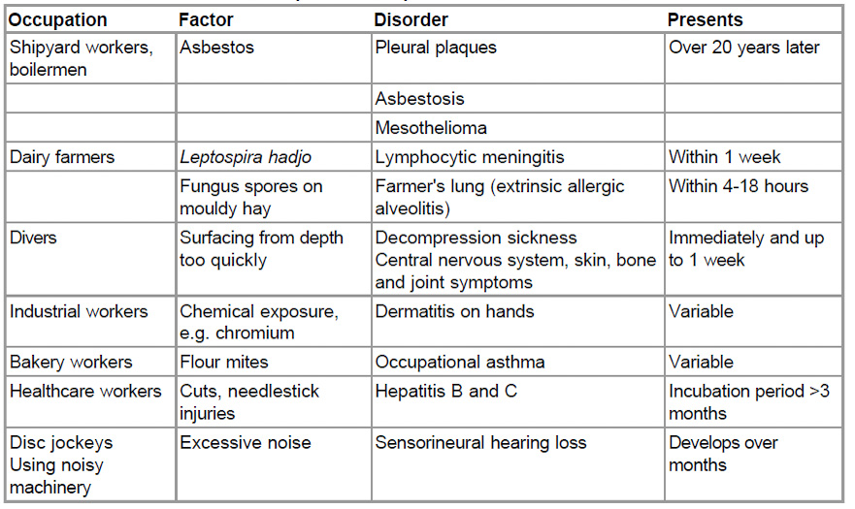
- Travel history
Travelers to hot climates are at risk of contracting tropical infections, and air travel itself may increase the risk of certain conditions e.g. middle ear problems and deep venous thrombosis
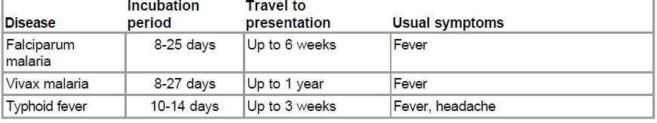
- Review of Systems

- Think about asking series of questions going from “head to toe.”
- In other words ask quickly about relevant questions related to systems other than the system included in the present history.
- Start with a fairly general question as you address each of the different systems.
- This focuses the patient’s attention and allows you to shift to more specific questions about systems that may be of concern. Examples of starting questions are: “How are your ears and hearing?” “How about your lungs and breathing?” “Any trouble with your heart?” “How is your digestion?”
- The Review of Systems questions may uncover problems that the patient has overlooked, particularly in areas unrelated to the present illness.

Systematic inquiry - cardinal symptoms
General health Well-being Energy Appetite Sleep Weight change Mood
Cardiovascular System
- Chest pain on exertion (angina)
- Breathlessness: lying flat (orthopnoea) at night (paroxysmal nocturnal dyspnoea) on minimal exertion - record how much
- Palpitation
- Pain in legs on walking (claudication)
- Ankle swelling
Respiratory system
- Shortness of breath (exercise tolerance)
- Cough
- Wheeze
- Sputum production (colour, amount)
- Blood in sputum (haemoptysis)
- Chest pain (due to inspiration or coughing)
Gastrointestinal system
- Mouth (oral ulcers, dental problems)
- Difficulty swallowing (dysphagia - distinguish from pain on swallowing, odynophagia)
- Nausea and vomiting
- Vomiting blood (haematemesis)
- Indigestion
- Heartburn
- Abdominal pain
- Change in bowel habit
- Change in colour of stools (pale, dark, tarryblack, fresh blood)
Genitourinary system
- Pain passing urine (dysuria)
- Frequency passing urine (at night, nocturia)
- Blood in the urine (haematuria)
- Sexual partners - unprotected intercourse
- Men If appropriate: prostatic symptoms including difficulty starting - hesitancy
- poor stream or flow
- terminal dribbling
- incontinence
- urethral discharge
- libido
- erectile difficulties
- Women Last menstrual period (consider pregnancy)
- Timing and regularity of periods
- Length of periods
- Abnormal bleeding
- Vaginal discharge
- Contraception
- If appropriate: libido pain during intercourse (dyspareunia) incontinence (stress and urge)
Nervous system
- Headaches
- Dizziness (vertigo or light-headed)
- Faints
- Fits
- Altered sensation (numbness or tingling (paraesthesiae))
- Weakness
- Visual disturbance
- Hearing problems (deafness, tinnitus)
- Memory and concentration changes
Musculoskeletal
- Joint pain, stiffness or swelling
- Mobility
- Falls
Endocrine
- Heat or cold intolerance Change in sweating Excessive thirst (polydipsia)
Other
- Bleeding or bruising Skin rash

- THE PHYSICAL EXAMINATION: APPROACH AND OVERVIEW
- Equipment required for a full examination
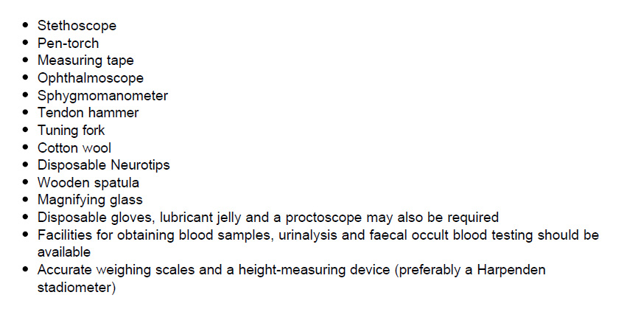
- The usual sequence of examination is
- Inspection.
- Palpation.
- Percussion.
- Auscultation.

The Comprehensive Physical Examination
General Survey | Observe the patient’s general state of health, height,  build, and sexual development
Vital Signs | Pulse, blood pressure, temperature and respiratory rate
Skin | Observe the skin of the face and its characteristics, Inspect and palpate the hair and nails, Continue your assessment of the skin as you examine the other body regions
Upper limbs | Inspection: fasciculations, wasting, trophic changes.  Test for tone, power, reflexes, coordination and cutaneous sensation.  Test joints for swelling, pain and movement, if relevant
Hands | Clubbing, tremor, wasting, arthropathy, metabolic flap, Dupuytren’s contracture, splinter haemorrhages, nail-fold infarcts, koilonychia, leuconychia, nicotine stains.
Head, Eyes, Ears, Nose, Throat | Head: Examine the hair, scalp, skull, and face. Eyes: Check visual acuity and screen the visual fields Observe the eyelids and inspect the sclera and conjunctiva of each eye. With oblique lighting, inspect each cornea, iris, and lens. Ears: Inspect the auricles, canals, and drums Throat (or mouth and pharynx): Inspect the lips, oral mucosa, gums, teeth, tongue, palate, tonsils, and pharynx.
Neck | Inspect and palpate the cervical lymph nodes. Note any masses or unusual pulsations in the neck. Feel for any deviation of the trachea. Observe sound and effort of the patient’s breathing. Inspect and palpate the thyroid gland.
Back | Inspect and palpate the spine and muscles of the back.
Thorax and Lungs | Inspect, palpate, and percuss the chest.  Listen to the breath sounds, any adventitious sounds, and, if indicated, transmitted voice sounds.
Breasts, Axillae | In a woman, inspect the breasts with her arms relaxed, then elevated, and then with her hands pressed on her hips. In either sex, inspect the axillae and feel for the axillary nodes. Feel for the epitrochlear nodes
Cardiovascular System | Observe the jugular venous pulsations and measure the jugular venous pressure in relation to the sternal angle. Inspect and palpate the carotid pulsations. Listen for carotid bruits. Inspect and palpate the precordium. Note the location, diameter, amplitude,  and duration of the apical impulse Listen at the apex and the lower sternal border with the bell of a stethoscope. Listen at each auscultatory area with the diaphragm.
Abdomen | Inspect, auscultate, and percuss the abdomen. Palpate lightly,  then deeply. Assess the liver and spleen by percussion and then palpation. Try to feel the kidneys, and palpate the aorta and its pulsations
Lower extremities | Examine the legs, assessing three systems while the  patient is still supine.  Peripheral Vascular System. Palpate the femoral pulses, and if indicated, the popliteal pulses. Palpate the inguinal lymph nodes. Inspect for lower extremity edema, discoloration, or ulcers. Palpate for pitting edema.  Musculoskeletal System. Note any deformities or enlarged joints. If indicated, palpate the joints, check their range of motion Nervous System. Assess lower extremity muscle bulk, tone, and strength; also sensation and reflexes. Observe any abnormal movements.
Nervous system | The complete examination of the nervous system can  also be done at the end of the examination. It consists of the five segments  described below: mental status, cranial nerves (including funduscopic examination),  motor system, sensory system, and reflexes.

- Decision Making in Clinical Medicine
Practicing medicine at its core requires making decisions. What makes medical practice so difficult is not only the specialized technical knowledge required but also the intrinsic uncertainty that surrounds each decision.
With the exponential growth in medical literature and other technical information and an ever-increasing number of testing and treatment options, twenty-first century physicians who seek excellence in their craft must master a more diverse and complex set of skills than any of the generations that preceded them.
The practice of medicine and clinical decision making relies on three pillars:
(1) expertise in clinical reasoning (what it is and how it can be developed); (2) rational diagnostic test use and interpretation; and (3) integration of the best available research evidence with clinical judgment in the care of individual patients (evidence-based medicine [EBM]).
- CLINICAL EXPERTISE;
Defining “clinical expertise” remains surprisingly difficult. Chess has an objective ranking system based on skill and performance criteria. Athletics, similarly, have ranking systems to distinguish novices from Olympians. But in medicine, after physicians complete training and pass the boards (or get recertified), no tests or benchmarks are used to identify those who have attained the highest levels of clinical performance. At each institution, there are often a few elite” clinicians who are known for their “special problem solving prowess” when particularly difficult or obscure cases have baffled everyone else.
Broadly construed, clinical expertise encompasses not only cognitive dimensions involving the integration of disease knowledge with verbal and visual cues and test interpretation but also potentially the complex fine-motor skills necessary for invasive procedures and tests. In addition, “the complete package” of expertise in medicine requires effective communication and care coordination with patients and members of the medical team.

- INTERPRETATION OF DIAGNOSTIC TESTS
DIAGNOSTIC TESTING: MEASURES OF TEST ACCURACY
The purpose of performing a test on a patient is to reduce uncertainty about the patient’s diagnosis or prognosis in order to facilitate appropriate management. Although diagnostic tests commonly refer to laboratory (e.g., blood count) or imaging tests or procedures (e.g., colonoscopy or bronchoscopy), any information that changes a provider’s understanding of the patient’s problem qualifies as a diagnostic test.
The accuracy of any diagnostic test is assessed relative to a “gold standard,” where a positive gold standard test defines the patients who have disease and a negative test securely rules out disease.
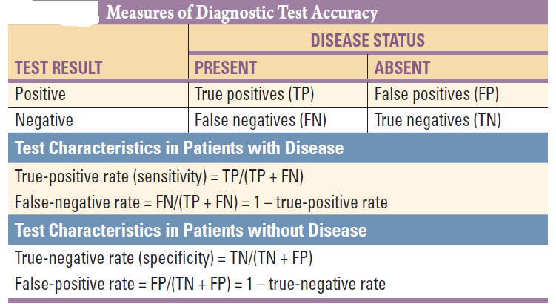

- The sensitivity or true-positive rate reflects how well the new test identifies patients with disease. It is the proportion of patients with disease (defined by the gold standard) who have a positive test. The proportion of patients with disease who have a negative test is the false-negative rate, calculated as 1 – sensitivity.
- The specificity, or true-negative rate, reflects how well the new test correctly identifies patients without disease. It is the proportion of patients without disease (defined by the gold standard) who have a negative test. The proportion of patients without disease who have positive test is the false-positive rate, calculated as 1 – specificity.
- In theory, a perfect test would be one with a sensitivity of 100% and a specificity of 100% and would completely distinguish patients with disease from those without it.
- A useful mnemonic to help remember the somewhat paradoxical relationship between what the test is best at technically versus what it is most useful for clinically is: a test with a very high sensitivity (Sn) when negative (N) helps rule out (out) disease (SnNout), and a test with a very high specificity (Sp) when positive (P) helps rule in (in) disease (SpPin).
- Calculating sensitivity and specificity requires selection of a threshold value or cut point above which the test is considered “positive.” Making the cut point “stricter” (e.g., raising it) lowers sensitivity but improves specificity, while making it “laxer” (e.g., lowering it) raises sensitivity but lowers specificity. This dynamic trade-off between more accurate identification of subjects with disease versus those without disease is often displayed graphically as a receiver operating characteristic (ROC) curve by plotting sensitivity (y axis) versus 1 – specificity (x axis).
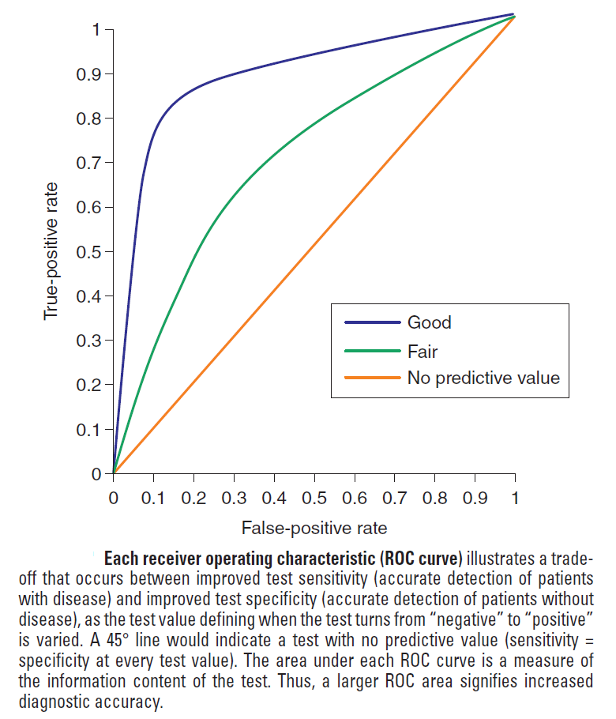

- EVIDENCE-BASED MEDICINE
Clinical medicine is defined traditionally as a practice combining medical knowledge (including scientific evidence), intuition, and judgment in the care of patients . Evidence-based medicine (EBM) updates this construct by placing much greater emphasis on the processes by which clinicians gain knowledge of the most up-to-date and relevant clinical research to determine for themselves whether medical interventions alter the disease course and improve the length or quality of life.

PART II

Cardinal Manifestations And Presentation Of Diseases
- PAIN
The province of medicine is to preserve and restore health and to relieve suffering. Understanding pain is essential to both of these goals. Because pain is universally understood as a signal of disease, it is the most common symptom that brings a patient to a physician’s attention.
The function of the pain sensory system is to protect the body and maintain homeostasis. It does this by detecting, localizing, and identifying potential or actual tissue-damaging processes.
THE PAIN SENSORY SYSTEM
When it is acute, pain is characteristically associated with behavioral arousal and a stress response consisting of increased blood pressure, heart rate, pupil diameter, and plasma cortisol levels. In addition, local muscle contraction (e.g., limb flexion, abdominal wall rigidity) is often present.
PERIPHERAL MECHANISMS
The Primary Afferent Nociceptor A peripheral nerve consists of the axons of three different types of neurons: primary sensory afferents, motor neurons, and sympathetic postganglionic neurons.
Individual primary afferent nociceptors can respond to several different types of noxious stimuli. For example, most nociceptors respond to heat; intense cold; intense mechanical distortion, such as a pinch; changes in pH, particularly an acidic environment; and application of chemical irritants including adenosine triphosphate (ATP), serotonin, bradykinin (BK), and histamine.

CENTRAL MECHANISMS
- The Spinal Cord and Referred Pain
The axons of primary afferent nociceptors enter the spinal cord via the dorsal root. They terminate in the dorsal horn of the spinal gray matter
- Ascending Pathways for Pain
A majority of spinal neurons contacted by primary afferent nociceptors send their axons to the contralateral thalamus. These axons form the contralateral spinothalamic tract, which lies in the anterolateral white matter of the spinal cord the lateral edge of the medulla, and the lateral pons and midbrain. The spinothalamic pathway is crucial for pain sensation in humans.
Interruption of this pathway produces permanent deficits in pain and temperature discrimination.
Spinothalamic tract axons ascend to several regions of the thalamus. There is tremendous divergence of the pain signal from these thalamic sites to several distinct areas of the cerebral cortex that subserve different aspects of the pain experience.
One of the thalamic projections is to the somatosensory cortex. This projection mediates the sensory discriminative aspects of pain, i.e., its location, intensity, and quality.
TREATMENT
Acute pain
The ideal treatment for any pain is to remove the cause; thus, while treatment can be initiated immediately, efforts to establish the underlying etiology should always proceed as treatment begins.
Drugs used for pain relief
- Nonnarcotic Analgesics, ASPIRIN, ACETAMINOPHEN, AND NONSTEROIDAL
ANTI-INFLAMMATORY AGENTS (NSAIDS)
These drugs are considered together because they are used for similar problems and may have a similar mechanism of action (Table 13-1). All these compounds inhibit cyclooxygenase (COX), and except for acetaminophen, all have anti-inflammatory actions, especially at higher dosages. They are particularly effective for mild to moderate headache and for pain of musculoskeletal origin.
Examples include: Acetylsalicylic acid, Acetaminophen, Ibuprofen, Indomethacin, Celecoxib
- OPIOID ANALGESICS
Opioids are the most potent pain-relieving drugs currently available. Of all analgesics, they have the broadest range of efficacy and provide the most reliable and effective treatment for rapid pain relief. Although side effects are common, most are reversible: nausea, vomiting, pruritus, sedation, and constipation are the most frequent and bothersome side effects.
Examples include; codeine, morphine, methadone, meperidine, fentanyl and tramadol.
Chronic pain
Managing patients with chronic pain is intellectually and emotionally challenging. Sensitization of the nervous system can occur without an obvious precipitating cause, e.g., fibromyalgia, or chronic headache. In many patients, chronic pain becomes a distinct disease unto itself. The pain-generating mechanism is often difficult or impossible to determine with certainty.

- ALTERATION IN BODY TEMPERATURE
FEVER
Body temperature is controlled by the hypothalamus. Neurons in both the preoptic anterior hypothalamus and the posterior hypothalamus receive two kinds of signals: one from peripheral nerves that transmit information from warmth/cold receptors in the skin and the other from the temperature of the blood bathing the region.

- The average oral temperature, usually quoted at 37°C (98.6°F), fluctuates considerably. In the early morning hours it may fall as low as 35.8°C (96.4°F), and in the late afternoon or evening it may rise as high as 37.3°C (99.1°F). Rectal temperatures are higher than oral temperatures by an average of 0.4 to 0.5°C (0.7 to 0.9°F), but this difference is also quite variable. (In contrast, axillary temperatures are lower than oral temperatures by approximately 1 degree, but take 5 to 10 minutes to register and are generally considered less accurate than other measurements.)
- Oral temperatures is not recommended when patients are unconscious, restless, or unable to close their mouths. It is also not recommended for pediatric patients.
- Mercury or digital thermometer can be used but the standard is using the mercury one.

Normal body temperature: 36.6-37.2 C
Subnormal temperature: < 36.6 C
Febrile: > 37.2 C
Hyperpyrexia: > 41.6 C
Hypothermia: < 35 C

Fever of unknown origin
Clinicians commonly refer to any febrile illness without an initially obvious etiology as fever of unknown origin (FUO). Most febrile illnesses either resolve before a diagnosis can be made or develop distinguishing characteristics that lead to a diagnosis. The term FUO should be reserved for prolonged febrile illnesses without an established etiology despite intensive evaluation and diagnostic testing.
FUO is now defined as follows:
1. Fever ≥38.3°C (≥101°F) on at least two occasions
2. Illness duration of ≥3 weeks
3. No known immunocompromised state
4. Diagnosis that remains uncertain after a thorough history-taking, physical examination, and the following obligatory investigations: determination of erythrocyte sedimentation rate (ESR) and C-reactive protein (CRP) level; platelet count; leukocyte count and differential; measurement of levels of hemoglobin, electrolytes, creatinine, total protein, alkaline phosphatase, alanine aminotransferase, aspartate aminotransferase, lactate dehydrogenase, creatine kinase, ferritin, antinuclear antibodies, and rheumatoid factor; protein electrophoresis; urinalysis; blood cultures (n = 3); urine culture; chest x-ray; abdominal ultrasonography; and tuberculin skin test (TST).

Some causes of fever of unknown origin
Infections
Bacterial, nonspecific: Abdominal abscess, adnexitis, apical granuloma, appendicitis, cholangitis, cholecystitis, diverticulitis, endocarditis, endometritis
Bacterial, specific: Actinomycosis, atypical mycobacterial infection, bartonellosis, brucellosis
Fungal: Aspergillosis, blastomycosis, candidiasis
Parasitic: Amebiasis, babesiosis, echinococcosis, fascioliasis
Viral: cytomegalovirus infection, dengue, Epstein-Barr virus infection, hantavirus infection, hepatitis
Noninfectious Inflammatory Diseases
Systemic rheumatic and autoimmune diseases: Ankylosing spondylitis, antiphospholipid syndrome, autoimmune hemolytic anemia, autoimmune hepatitis, Behcet’s disease
Vasculitis : Allergic vasculitis, eosinophilic granulomatosis with polyangiitis, giant cell vasculitis/polymyalgia rheumatica
Granulomatous diseases: Idiopathic granulomatous hepatitis, sarcoidosis
Neoplasms
Lymphoma, leukemia, hepatocellular carcinoma, colon cancer and renal tumors

- FATIGUE
- Fatigue is one of the most common symptoms in clinical medicine. It is a prominent manifestation of a number of systemic, neurologic, and psychiatric syndromes.
- Fatigue refers to the subjective experience of physical and mental weariness, sluggishness, low energy, and exhaustion.
- In the context of clinical medicine, fatigue is most practically defined as difficulty initiating or maintaining voluntary mental or physical activity.
- Fatigue should be distinguished from muscle weakness, a reduction of neuromuscular power most patients complaining of fatigue are not truly weak when direct muscle power is tested. Fatigue is also distinct from somnolence, which refers to sleepiness in the context of disturbed sleep-wake physiology, and from dyspnea on exertion, although patients may use the word fatigue to describe any of these symptoms.

DIFFERENTIAL DIAGNOSIS
Psychiatric Disease: Fatigue is a common somatic manifestation of many major psychiatric syndromes, including depression, anxiety, and somatoform disorders.
Neurologic Disease: examples include multiple sclerosis, Parkinson disease,
Sleep Disorders : Obstructive sleep apnea is an important cause of excessive daytime sleepiness in association with fatigue and should be investigated using overnight polysomnography, particularly in those with prominent snoring, obesity, or other predictors of obstructive sleep apnea.
Endocrine Disorders: examples include hypothyroidism, Addison disease
Liver and Kidney Disease
Malnutrition.
Infections: Both acute and chronic infections commonly lead to fatigue as part of the broader infectious syndrome. Examples include TB, infective endocarditis, infectious mononucleosis, HIV and chronic hepatitis.
Drugs: examples include antidepressants, antipsychotics, anxiolytics, opiates, antispasticity agents, antiseizure agents, and beta blockers.
Cardiovascular and Pulmonary Disorders: Fatigue is one of the most taxing symptoms reported by patients with congestive heart failure and chronic obstructive pulmonary disease.

Malignancy: Fatigue, particularly in association with unexplained weight loss, can be a sign of occult malignancy.
Hematologic Disorders: Chronic or progressive anemia may present with fatigue, sometimes in association with exertional tachycardia and breathlessness.
Immune-Mediated Disorders: Fatigue is a prominent complaint in many chronic inflammatory disorders, including systemic lupus erythematosus, polymyalgia rheumatica, rheumatoid arthritis.
DIAGNOSTIC APPROACH
- Detailed history and detailed physical examination can reveal the cause of fatigue in most cases.
- When it comes to laboratory evaluation A reasonable approach to screening includes a complete blood count with differential (to screen for anemia, infection, and malignancy), electrolytes (including sodium, potassium, and calcium), glucose, renal function, liver function, and thyroid function. Testing for HIV and adrenal function can also be considered. Published guidelines for chronic fatigue syndrome also recommend an erythrocyte sedimentation rate (ESR) as part of the evaluation.

- EDEMA
- Approximately two-thirds of total body water is intracellular and one third is extracellular. One-fourth of the latter is in the plasma, and the remainder comprises the interstitial fluid. Edema represents an excess of interstitial fluid that has become evident clinically.
- There is constant interchange of fluid between the two compartments of the extracellular fluid. The hydrostatic pressure within the capillaries and the colloid oncotic pressure in the interstitial fluid promote the movement of water and diffusible solutes from plasma to the interstitium. This movement is most prominent at the arterial origin of the capillary and falls progressively with the decline in intracapillary pressure and the rise in oncotic pressure toward the venular end.
- Fluid is returned from the interstitial space into the vascular system largely through the lymphatic system. These interchanges of fluids are normally balanced so that the volumes of the intravascular and interstitial compartments remain constant. However, a net movement of fluid from the intravascular to the interstitial spaces takes place and may be responsible for the development of edema under the following conditions: (1) an increase in intracapillary hydrostatic pressure; (2) inadequate lymphatic drainage; (3) reductions in the oncotic pressure in the plasma; (4) damage to the capillary endothelial barrier; and (5) increases in the oncotic pressure in the interstitial space.

CLINICAL CAUSES OF EDEMA
A weight gain of several kilograms usually precedes overt manifestations of generalized edema. Anasarca refers to gross, generalized edema. Ascites (Chap. 50) and hydrothorax refer to accumulation of excess fluid in the peritoneal and pleural cavities, respectively.
Edema is recognized by the persistence of an indentation of the skin after pressure known as “pitting” edema. In its more subtle form, edema may be detected by noting that after the stethoscope is removed from the chest wall, the rim of the bell leaves an indentation on the skin of the chest for a few minutes.
GENERALIZED EDEMA
Causes of generalized edema
- Cardiac causes: examples include cardiac failure of different causes.
- Renal disease: examples include chronic renal failure, nephrotic syndrome.
- Hepatic disease: examples include liver cirrhosis
- Nutritional causes: malnutrition that eventually leads to hypoalbuminemia.
- Drug induced: examples include, non-steroidal anti-inflammatory drugs, calcium channel blockers, vasodilators, steroids.

LOCALIZED EDEMA
In thrombophlebitis, varicose veins, and primary venous valve failure, the hydrostatic pressure in the capillary bed upstream (proximal) of the obstruction increases so that an abnormal quantity of fluid is transferred from the vascular to the interstitial space, which may give rise to localized edema.

Part III. Laboratory Medicine

Effects of Pre analytical , analytical and post analytical Variables on clinical laboratory tests
Quality assurance: includes all measures which are done in the laboratory in order to minimize and overcome any error. Quality assurance is divided into 3 main parts:
1- Control of pre analytical variables.
2- Control of analytical variables.
3- Post analytical variables.
1- Preanalytical factors: are those factors that affect the laboratory results due to handling of the specimen sample prior to analysis and patient preparation.
2-The analytical factors :The analytical phase is the set of procedures and processes performed within the laboratory to carry out the measurement of an analyte in a patient sample. It is concerned with the technical accuracy of the test itself, from the moment the sample is introduced to the instrument to the generation of the results. It includes verification of instrument linearity, precision, accuracy, the use of standard materials, proper maintenance of instruments and quality control (QC) samples.
3-Postanalytical factors :Include proper reviewing of the results to ensure their accuracy and clinical validity and other aspects that occur after the analysis phase. A common example of post analytical error is a transcription error.
Preanalytical phase of quality assurance
1-Fasting: Verification of fasting before sampling is mandatory for: ( fasting glucose: 8 h & triglycerides: (12-16 h) ,Total cholesterol: either fasting or non fasting sample can be used
2-Exercise: Plasma pyruvate and lactate. Cellular permeability which lead to slight increase in serum activities of enzymes originating from skeletal muscles as AST, CK, LDH, Aldolase.
3- IMI or muscle trauma: increase CK ,aldolase and the skeletal muscle component of LDH.
4- Effect of smoking: Nicotine stimulate the adrenal medulla and the concentration of epinephrine in the plasma is increased.Glucose concentration may increase by 10 mg/dl within 10 minutes of smoking a cigarette. Plasma cholesterol triglyceride, and LDL-cholesterol concentrations are higher in smokers than in non smokers. In contrast serum HDL- cholesterol concentration are lower in smokers than in nonsmokers.
5-Alcohol : Alcohol ingestion causes marked hypertriglyceridemia. Chronic alcohol ingestion affect the activity of many enzymes including GGT.AST and ALT activities may be also increased.
6-Stress:Stress associated with blood collection may ↑ cortisol , catecholamines and GH.
7-Drugs: Antibiotics:
Culture and sensitivity : if antimicrobial drugs are given before specimens are taken for microbiologic study, culture should be obtained at least 48 hours from cessation of antibiotics
Patient & specimen identification: The identification on the specimen label should match the identification on test requisition form and bar code technology is preferred to avoid manual errors
1-Posture: change from supine to standing position decrease Plasma volume of the blood :because only protein free fluids passes through capillaries to the tissue, Increase Plasma protein concentration by about 8-10% including: albumin and protein bound substances as thyroxin and Calcium . Increase secretions of catecholamines, aldosterone, renin.
2-Collection site:
The median cubital vein is the preferred site . Veins on the back of the hand may be used.
- It is better to do blood analysis before starting infusion.
If a blood sample is highly indicated during infusion , it should be collected from the other arm to obtain best results . If not possible, samples are drawn after turning off IV line for 5 minutes prior to venipuncture. Select a vein other than the one with the IV line.
Example :Saline infusion :- All results diluted ( become low) + high Na&Cl ,
Preparation of the collection site:
3-Venous occlusion (tourniquet):Tourniquet should be applied about 10 cm above the Intended puncture site, tourniquet Shouldn’t be left in place for >1mint. Prolonged tourniquet will increase venous pressure and water and small filterable elements leave the IV compartment leading to hemoconcentration and serum levels of larger molecules as protein or protein - bound constituents (as calcium) .Also prolonged tourniquet will produce hypoxia and this hypoxic effect drives potassium out of the cells causing increase in serum
Different tubes for blood collections:
1-EDTA tube(lavender color): used for CBC,ABO/Rh,HbA1c,G6PD ,…
EDTA is a Chelating agent, unsuitable for Ca, Mg or iron ,coagulation, ALP& CK
2-Citrate(blue tube): used for coagulation assay as PT/INR and PTT
ratio of blood to citrate is 9:1 .Citrate Chelates Ca reversibly
3-Fluoride(grey tube): used to inhibit glycolysis in blood glucose sample if assay is delayed. In addition to glucose, it is also used in lactate determination. Never used in any other determinations
4- heparin(green tube) used in blood gases and pH
5- Gold tube: contain clotting activator and serum separating gel; It has a wide application for biochemistry analysis (as Liver function tests, Renal function tests, electrolytes, enzymes, lipid, vitamins,..) viral markers , hormonal and serological analysis.
6- Red tube : usually contain clot activation only and has the same applications of gold tube
5-Order of draw:
The recommended order of draw for vacutainer tubes is as follows:
1-Blood culture 2- Sodium citrate for coagulation(blue top) 3-Serum Gel separator / clot activator(Gold top) 4-Heparin (green top) 5-EDTA(lavender top) 6-Sodium fluoride / k oxalate (gray top) This order should ALWAYS be followed to prevent erroneous results due to additive crossover or contamination
- Blood Culture Bottles (Sterile specimens) :Why first? These tubes are for microbiological studies (detecting bacteria or other microorganisms in the blood). They must be collected first to prevent contamination
- Coagulation Tubes (Sodium Citrate) - Light Blue Cap:Why second? These tubes contain sodium citrate, an anticoagulant that binds calcium to prevent clotting. They are used for coagulation studies (e.g., PT, aPTT) which are very sensitive to any clotting or interference. Drawing them after blood cultures ensures no additives from other tubes (especially clot activators) affect coagulation results.
- Serum Tubes(gold or red cap):Why third? If drawn before blue tops, the clot activator from these tubes could carry over and falsely shorten coagulation times.
- Heparin Tubes (green cap):Why fourth? Heparin can interfere with coagulation tests (if drawn before blue tops) and affect some other chemistry tests if carried over.
- EDTA Tubes (Potassium EDTA) - Lavender or Pink Caps: Why fifth? These tubes contain EDTA (ethylenediaminetetraacetic acid), a strong anticoagulant that binds calcium. EDTA significantly impacts electrolyte levels (especially potassium, as EDTA contains potassium salts) and can chelate other minerals like calcium and magnesium. If drawn before tubes for chemistry tests, it would falsely elevate potassium and falsely decrease calcium.
- Oxalate/Fluoride Tubes (Sodium Fluoride/Potassium Oxalate) - Gray Cap: Why last? Fluoride is a strong enzyme inhibitor. If carried over into other tubes, it can interfere with many laboratory tests
- Anticoagulant tubes ( Citrate, Heparin, EDTA) should immediately gently mixed with blood sample to avoid clot formation. Avoid vigorous mixing because it can lead to hemolysis of RBCs.
- Accurate tube fill volume is important particularly in coagulation test (Blue tube), the specific blood to citrate ratio is 9:1.If the tube is under filled or overfilled the ratio is disturbed leading to inaccurate results
- Temperature: For blood gases and PH samples.The specimens should transported to the laboratory and analysed immediately. If not possible the sample should be kept at 4C° (ice water) until analysis to prevent glycolysis of RBCs. The pH of freshly drawn blood decreases on standing for long time due to glycolysis by blood cells. Specimens are collected anaerobically with lyophilized heparin anticoagulant in sterile syringe.
- Light:Specimens for photosensitive analytes such as bilirubin, porphyrin and some drugs such as methotrexate, must be protected from both day light & fluorescent light to prevent photodegradation
Specimen processing: Serum or plasma should be separated from cells as soon as possible. within 30-60 minutes .However premature separation of serum formation of fibrin clots obstruction of sample probes of analyzers. If centrifugation within 2 hours is impossible, the specimen should be stored at room temp rather than 4˚C to decrease hemolysis. However a delayed separation affect some analytes: Glucose : decreases 5-10%/hour unless collected on fluoride. K: increases due to leakage from cells, Phosphorus: increases due to hydrolysis of organic phosphate ester, ammonia: increases due to proteolysis.
Hemolysis: Hemolysis, in simple terms, means that red blood cells have burst open. When they burst, they release their internal contents (like hemoglobin, which is red) into the surrounding liquid part of the blood (plasma or serum). This makes the serum or plasma sample look pink or red instead of its normal clear yellow color, and it can mess up many lab tests.The cause of Hemolysis primarily occurs in the preanalytical phase of quality assurance. Hemolysis falsely increase certain test results like potassium, lactate dehydrogenase(LDH) ,Aspartate aminotransferase(AST) and serum phosphorus because these substances are much more concentrated inside red blood cells than in the plasma/serum. It also Interferes with the color of the sample, making it difficult for instruments to accurately read other tests.Some analytes are not significantly affected by mild or moderate hemolysis as sodium, chloride, and calcium.
Causes of Hemolysis
- Extreme temperatures: Storing samples in very hot or very cold conditions can sometimes lead to cell breakdown.
- Prolonged Tourniquet use: can cause blood to stagnate and red blood cells to become fragile and eventually break.
- Small gauge needle:Forcing blood through a small needle: If the needle used to draw blood is too small, the red blood cells get squeezed and damaged
- If blood is forcefully pushed from a syringe into a collection tube due to cells rupture
- Vigorous shaking or mixing
- Drawing blood from an IV line: If blood is drawn from a vein where an IV fluid is running, the IV fluid can dilute and sometimes damage the red blood cells
- Alcohol not drying: If the alcohol used to clean the skin hasn't completely dried before the needle stick, it can enter the sample and damage the red blood cells.
- Freezing and thawing: Freezing a whole blood sample and then thawing it will cause the red blood cells to rupture
Pseudo hyperkalemia.
- Pseudo hyperkalemia is still among the most common issues faced by clinical laboratories and one of the most frequent sources of physician complains.
- Causes is mainly pre analytical
- 1- sample collection factors: Excessive fist clenching during sample collection(release of K from muscle cells), and prolonged tourniquet (hypoxia derives K out of cells) can artificially increase K levels as much as 1-2 mmol/L. Other causes include hemolysis (commonest cause) incorrect order of draw for vacutainer tubes (drawing K2 EDTA tube before chemistry tube), contamination from IV fluids infusion.
2- Specimen processing: delay in transport and centrifugation(leakage of K from cells),insufficient centrifugation(residual RBCs are found),or chilling (inhibit Na/K ATPase pump with release of K from RBCs into serum or plasma.
3- Patient factors: thrombocytosis or marked leukocytosis
Analytical phase of quality assurance :This phase is where the actual testing of the patient's sample happens. Quality assurance here ensures that the tests are performed correctly, and the results are accurate.
- Two important definitions:
- Standard or calibrator is a substance or solution with a precisely known, assigned concentration. They are used to quantify the amount of a substance (analyte) in a sample.
- Quality control: they are samples with known ranges of values.They are run daily, to detect any errors in the testing process(results are outside their ranges)
Components of analytical phase of quality assurance:
1-Validation, calibration and Maintenance of Equipment:
Ensuring that all laboratory instruments(as machines ,refrigerators, balances, thermometers,…) are working perfectly and are regularly checked and serviced with proper regular maintenance .Machines are calibrated with known standards to ensure they are giving accurate readings.
Instrumentation and Method Validation: Before any new instrument or test method is used for patient samples, it must be thoroughly validated. This involves a series of tests to confirm its performance characteristics, such as:
Accuracy: How close the measured value is to the true value.
Precision: How reproducible the results are when the same sample is tested multiple times.
Linearity: Range of analyte concentrations for which the instrument can provide accurate results.
2-Competency of Staff: Making sure that the lab personnel performing the tests are well-trained and skilled. Staff undergo training, regular competency
3-Internal Quality Control (IQC):If the control sample gives the expected result, it means the machine and reagents are working correctly. If it is out of range, it signals a problem that needs to be fixed before patient results are released.
4-External Quality Assessment (EQA): An independent organization sends unknown samples to the lab, and the lab tests them and sends back the results. It compares the lab's results with those of other labs .
5-Reagent and consumable Management: Proper storage of reagents and according to manufacturer's instructions to maintain their stability. Monitoring expired reagent and testing new lots of reagents by QC to ensure accuracy.
6-Standard Operating Procedures (SOPs): Proper writing of all laboratory procedures and be readily accessible to all staff and ensuring strict adherence to SOPs by all personnel.
Post analytical phase of quality assurance:
- This phase occurs after the test is completed and focuses on the correct reporting, interpretation, and delivery of results.
- 1-Result Review and Verification: Qualified lab professionals review the results, look for any strange results, and compare them with established reference ranges , previous patient results and history of the patient.
- A delta check involves comparing a patient's current result to their previous results to identify significant changes..
- 2-Reporting of Results: ensure that reports include all necessary information (patient details, test name, result, units, reference range, any relevant comments). And check for any transcription error.
- 3-Communication of Critical Values: Critical values are laboratory results that indicate a high risk of morbidity or mortality that threaten patient life .Example Glucose 30 mg/dl the patient might die from hypoglycemia if he is not treated immediately. The lab has a defined protocol for "critical values." When such a result is found, the lab immediately contacts the physician (often by phone) and documents the communication
- 4-Result Archiving : Securely storing all test results. Lab results are stored electronically. Proper record-keeping is essential for patient history, legal compliance.
- Potassium
Potassium ions are the major intracellular cation. Reference range : 3.5-5.0 mmol/L
Hypokalemia: Decreased plasma level of potassium to less than 3.5 mmol/L
Causes of hypokalemia:
- Inadequate intake as in starvation .
2- Increased loss:
A-GIT: as in prolonged vomiting and diarrhea. .
B- Renal loss:
I-hyperaldosteronism :primary or secondary.
II- Cushing syndrome.
III- renal tubular acidosis (type 1 and 2)
IV- excessive Diuretics without potassium replacement.
3- Redistribution of extra cellular potassium:
Hypokalemia due to shift of potassium from ECF to ICF. This is seen in:
A-Insulin therapy of DKA: Cellular uptake of glucose is accompanied by potassium uptake.
B-Alkalosis: potassium move from ECF to ICF as hydrogen ions move in opposite direction to compensate for alkalosis.
Hyperkalemia
Hyperkalemia is defined as increased plasma potassium to more than 5 mmol/L.
Causes of hyperkalemia:
I- Excessive intake: Excess IV potassium infusion.
II- Increased K retention: as in
1- Renal diseases: Acute and chronic renal failure are the most common cause of hyperkalemia.
2-Adrenocortical insufficiency: as in Addison disease. Aldosterone is decreased in Addison disease and this will lead to hyperkalemia.Aldosterone acts on DCT and enhance sodium reabsorbtion and potassium excretion
3-Aldosterone antagonist: as K sparing diuretics that block distal tubular secretion of potassium.
III- Redistribution:
Hyperkalemia is due to shift of K from ICF to ECF. This is seen in:
1-Acidosis: hydrogen ion move inside the cells in exchange with potassium which move to outside the cells in ECF.
2-Increased tissue damage: as in crush injury and severe burn.

Preanalytical | Analytical | Postanalytical
- Incorrect patient identification  - Improper patient preparation  (Not fasting as required)  - Incorrect order of draw for blood tube  -Hemolysis (Destruction of RBCs)  -Improper mixing of blood with anticoagulant  -Delayed centrifugation  -Improper storage and transport  - Inaccurate fill volume ( as inaccurate blood to citrate ratio in coagulation tests) | - Instrument malfunction  -Deteriorated calibrator  -Incorrect maintenance  -Deteriorated or expired reagent  -Incorrect reagent: wrong reagent used for particular test or improper reconstitution of lyophilized reagent  -Failure to follow: Standrad operating procedure ( SOPs): a lab technician does not follow the established protocol for a specific test.  - Pippetting error: Inaccurate pipetting specially with manual tests | - Incorrect result entry or transcription error of the result  - Delayed report delivery  - Incorrect interpretation of result by the doctor  - Delayed notification of critical results

Interpretation of laboratory results in some diseases
Lipids are substances which are actually or potentially esters of fatty acids. The principal function of lipids is to act as energy stores and to serve as important structural components of cell membrane in the form of phospholipids.
- They also considered the source of fat-soluble vitamins (A,D,K,E) and steroid hormones
- The main lipid classes in plasma are cholesterol, triglycerides and less extent phospholipids.
- Lipoproteins: Lipids are insoluble in aqueous solutions such as plasma ,so most lipids are carried in plasma in association with specialized protein carrier called apolipoprotein and the whole particle is called lipoprotein (with the water soluble protein part enclose a core of non polar groups as TG and esterified cholesterol.
- Types of lipoproteins
- Lipoproteins are classified into 5 types:
- 1- Chylomicrons: Consists mainly of exogenous triglycerides of dietary origin and very little protein and phospholipids.
- 2- Very low density lipoprotein (VLDL): Consists of endogenous triglycerides mainly and little protein and phospholipids
- 3- Intermediate density lipoprotein (IDL): It arises from VLDL by removal of some triglycerides.
- 4- Low density lipoprotein(LDL); is formed from IDL by further removal of triglycerides. It contain mainly cholesterol (about 50%) and few proteins(20%) and phospholipids.
- 5- High density lipoprotein (HDL): They are the smallest and most dense particles. They have the highest protein content ( about 50%),phospholipids( about 26%) and cholesterol (about 20%) . The remaining constituents are found in trace amount.
- Lipoprotein metabolism
- 1-Chylomicron: is hydrolyzed by enzyme lipoprotein lipase (LPL) . The removal of TG from chylomicron results in formation of chylomicron remnant .They are taken by the liver cells for further catabolism.
- 2-VLDL: Are hydrolyzed by LPL and transformed into IDL. The latter is taken by liver cells . Further catabolism occur in IDL and they are transformed to LDL. Defective Apo E function results in accumulation of IDL and the disorder is called typeIII hyperlipoproteinemia
- 3-LDL:It is formed in the liver by hepatic delipidation of IDL .It plays a role to transfer cholesterol from liver to tissues including blood vessels. It has high affinity to elastin fibers of vessel wall and so high concentration of LDL is associated with increase risk of atherosclerosis and coronary heart disease (CHD).
- LDL catabolism: LDL bind to specific membrane receptors in peripheral tissues .The bound LDL is subjected to lysosomal degradation.
- 4-HDL: It plays an important role in removal of cholesterol from tissues to the liver in what is called reverse cholesterol transport. HDL incorporate cholesterol ester from tissues as arteries into its core and transport them to the liver for catabolism.
- Protective role of HDL
- HDL has a protective role against atherosclerosis and CHD and this protection is due to mechanisms:
- HDL remove cholesterol from arteries to the liver (reverse cholesterol transport), HDL compete with LDL for binding to elastin fibers in vessel wall, HDL play a role in catabolism of VLDL ,HDL destroy oxidized LDL and prevent its formation. Oxidized LDL is more atherogenic than LDL.
- Hyperlipoproteinemia: The clinical interest in hyperlipoproteinemia is their association with increased risk of CHD. Hyperlipoproteinemia are either primary (genetic defects of enzymes or receptors ) or secondary to other diseases and disorders. The distinction between primary and secondary disorders can be made through careful evaluation of patients ,family history, clinical signs and symptoms, laboratory investigations and interpretation.
Causes of Secondary Hyperlipidemia (increased cholesterol or triglycerides or both ): Diabetes mellitus, Endocrinal :Hypothyroidism, hypopituitarism,obstructive jaundice, nephrotic syndrome, chronic renal failure,drugs that raise LDL cholesterol and lower HDL cholesterol (oral contraceptives, anabolic steroids, and corticosteroids) . A sedentary lifestyle with excessive dietary intake of saturated fat, cholesterol , obesity, Alcoholism
- Preanalytical Factors:For a complete lipid profile including triglycerides, patient should be fasting for 12-14 hours(particularly for triglycerides, which is increased after meal which can also affect the calculation of LDL-C ).Non-Fasting state: are being accepted for Total Cholesterol and HDL-C, as these are less affected by a recent meal. However, a fasting sample is still preferred . Prolonged tourniquet application can lead to hemoconcentration, resulting in falsely elevated results.
Adult Clinical decision limits(normal ranges)
- 1-Total Cholesterol:Desirable < 200 mg/dl, Border line high: 200-239 mg/dl, High: 240 mg/dl or more
- 2- HDL cholesterol: Lower level is associated with atherosclerosis and high risk for CHD
- 40 mg/dl or more in men, 50 mg/dl or more in women, High risk < 40 mg/dl
- 3- Serum LDL-Cholesterol : Higher level are associated with increased risk of atherosclerosis and CHD
- Optimal: < 100 mg/dl Near/above optimal: 100-129 mg/dl
- Borderline high: 130-159 mg/dl, High : 160-189 mg/dl, Very high: 190 mg/dl or more
- (Friedewald equation is used for calculation of LDL–C, if triglycerides level is not high and less than 400 mg/dl)
- LDL-C= total cholesterol- HDL-C – Triglycerides/5
- The amount of cholesterol in VLDL is equivalent to triglycerides/5
- Direct measurement of LDL-C is done in cases with high triglycerides( More than 400)
- 4- Triglycerides:
- Normal or desirable : < 150 mg/dl
- Borderline high: 150-199 mg/dl, High:200-499 mg/d, Very high: 500 mg/dl or more
- Classification and laboratory diagnosis of DM:
- Diabetes mellitus: is a chronic disorder of carbohydrate metabolism in which glucose in underutilized ,producing hyperglycemia.
- Classification of DM and other categories of glucose intolerance:
- Type 1(previously called IDDM) and type 2(previously called NIDDM)
- Secondary DM : as in some endocrinal disorders : Cushing ,acromegaly, pheochromocytoma.

Items | Type 1(IDDM) | Type2(NIDDM)
Age | Children. However, it can also develop in adolescence and adults(latent autoimmune diabetes of adulthood) | Adult .But the increasing number of children with obesity has led to more cases of type 2 diabetes in younger people.
Insulin | decrease | Normal or increase
obesity | absent | present
Auto antibodies | ICA,IAA,GAD  - ICA: islet cell antibodies  - IAA: insulin autoantibodies  - GAD: glutamic acid decarboxylase antibodies | Absent
Genetic  HLA | 40%  HLADr3,4 | 80%  No HLA association
ketoacidosis | common | Rare (Hyperosmolar nonketotic)

- Reference or normal ranges of blood glucose:
- 1- FBS<100 mg/dl
- 2- Postprandial glucose after 2 hours from meal(75 gm glucose)<140 mg/dl
- Laboratory diagnosis of DM:
- Diagnostic criteria is according to American Diabetic Association (ADA)
- Any one of the following is diagnostic:
- 1. Hemoglobin A1c (HbA1c) 6.5% or greater
- 2. Fasting plasma glucose (FPG) 126 mg/dL† or greater
- 3. Symptoms of hyperglycemia and random plasma glucose 200 mg/dL ‡ or greater
- 4.Two-hour plasma glucose after oral 75 gm: 200 mg/dL or greater
- In the absence of unequivocal hyperglycemia, these criteria should be confirmed by repeating the same test on a different day.Fasting is defined as no calorie intake for at least 8 hours. Random is defined as any time of day without regard to time since the last meal. The classic symptoms of hyperglycemia include polyuria, polydipsia, and unexplained weight loss
- Prediabetes
- “Prediabetes” is the term used for individuals whose glucose levels do not meet the criteria for diabetes but are too high to be considered normal.
- Patients with prediabetes are 3 categories:
- 1-Impaired glucose tolerance: This term applies to individuals who have plasma glucose response in OGTT between normal and diabetic i.e 2hour glucose in OGTT ≥140 mg/dl but still<200 mg/dl (140-199 mg/dl). Individual in this category either revert to normal glucose tolerance or develop DM.
- 2-Impaired fasting glucose: In this category FBS is between normal and diabetic (100-125 mg/dl), but 2hour glucose in OGTT is<140 mg/dl. Individuals with IFG are at increased risk for development of DM in the future
- 3-Hemoglobin A1C: ranges from 5.7 to 6.4%.
Urine glucose should not be used for diagnosis of DM because it may give false negative and false positive results.
Monitoring of glycemic control
- Glycated hemoglobin: The amount of glycated hemoglobin (referred as HbA1or HbA1c) is used to assess long term glycemic control over the previous 6-8 weeks (half life). It should be monitored every 3 months in order to evaluate the treatment. (reference range of Hb A1 is less than 5.7% ).
Metabolic complications of DM
- 1- Diabetic ketoacidosis(DKA):
Is commonly found in type 1 DM. The lack of insulin will lead to excessive lipolysis and excessive FA oxidations and thus production of ketone bodies. These ketone bodies include acetoacetic acid ,B- hydroxybutyric acid and acetone. Only acetoacetic acid and acetone can be detected by urine strips, while B- hydroxybutyric acid is not detected. That is why we should not depend on urine strips in management of DKA.
In DKA there is metabolic acidosis with high anion gap (due to ketone bodies)
2-Hyperosmolar hyperglycemic state(HHS):
Hyperosmolar hyperglycemic state (previously referred to as hyperglycemic hyperosmolar nonketotic coma [HHNK]) is a complication of type 2 diabetes mellitus . There is marked hyperglycemia, hyperosmolarity ,polyuria and dehydration. However, unlike DKA, there is no ketone bodies and thus no acidosis. This key difference is due to the relative insulin deficiency present in HHS, as opposed to the absolute insulin deficiency found in DKA. in HHS, there's usually enough residual insulin (often in patients with Type 2 diabetes who still produce some insulin) to suppress lipolysis. Lipolysis is the breakdown of fats into free fatty acids.
3- Lactic acidosis: Develop in diabetic patients with severe ischemia or those treated with biguanide. There is ↑glucose, ↑lactate and ↓pH
4- Hypoglycemic complication:Due to excessive treatment with insulin or oral hypoglycemic
Item | DKA | HHS
Glucose | Less than 600 and usually ranges from 250-600 mg/dl | More than 600 and usually ranges from 600-1200 mg/dl
Acetone | positive | negative
Potassium | ↑ first and ↓with ttt | variable
Sodium | usually, low | variable
HCO3 (22-28) | Low( usually <18) | Normal or slightly decreased but usually >18
pH | Low (< 7.3) ( acidosis) | usually Normal (or >7.3)
Osmolarity | Less than 330 | More than 330
Anion gap | Increased(due to keton bodies) | Normal
Dehydration | Moderate | Severe
Coma | rare | frequent
Type of DM | Type 1 | type2
Mortality | low | high

Laboratory Interpretation of electrolytes disorders:
Osmolality: Osmolality represents the number of osmotically active substances in body fluids (plasma or serum) .It can be accurately roughly calculated from plasma Na ,urea and glucose.
Osmolality=2×Na+ urea or BUN (mmol/L) + Glucose(mmol/L)
Normal osmolarity : 280-300
Sodium (Na)
- Sodium ions are the major cation of ECF. In proximal convoluted tubules of kidney 80% of the filtered Na is reabsorbed actively with H2O and chloride .At distal convoluted tubules Na is reabsorbed and K is secreted in urine under the effect of aldosterone
- .Reference range: 136-145 mmol/L

Hyponatremia
- Hyponatremia is defined as decreased plasma sodium concentration to less than 136 mmol/L. Hyponatremia manifests clinically as generalized weakness and CNS symptoms such as mental confusion and impairment .The CNS symptoms are due to intracellular shifting of water to maintain osmotic balance, resulting in swelling of CNS cells.
Causes of hyponatremia
- 1- Hypo osmotic hyponatremia:
- Typically, when plasma sodium is low ,the calculated osmolality is low. This type of hyponatremia can be caused by either;
- Increase loss of sodium (depletion hyponatremia)
- or Retention of water (dilutional hyponatremia).
- A- depletion hyponatremia: Diminished intake, Increased loss:
I- renal loss:
Renal loss is due to decreased tubular reabsorption as in : Salt losing renal diseases as chronic interstitial nephritis (tubular injury) , Severe polyuria and Diuretic, mineralocorticoid deficiency (Addison disease)
II- Extrarenal loss:
1- Increase loss from GIT; as in prolonged vomiting ,diarrhea
2- Increase loss from skin: as in excessive sweating and burn
B- Dilutional hyponatremia:
1- Edema: from congestive heart failure, liver cirrhosis and Nephrotic syndrome. In these conditions there is shift of fluid from intra vascular compartment to extra vascular compartment and result in decreased blood volume. The decreased blood volume is sensed by baroreceptors and results in increased aldosterone and ADH. The kidneys reabsorb Na and H2O in response to increased aldosterone and vasopressin to restore the blood volume. The retention of water is disproportionately greater than the retention of sodium. This is largely due to the powerful water-retaining effect of ADH resulting in further dilution of Na.
2-advanced renal failure : There is water retention because of decreased filtration and dilutional hyponatremia will be found
3-SIADH: Excessive production of ADH will lead to water retention and hyponatremia .
2- Hyperosmotic hyponatremia:
Hyponatremia occurs in the presence of increased plasma osmolality as in cases of diabetes mellitus with severe hyperglycemia( Na level decrease by about 1.6 mmol/L for every 100 mg/dl increase of serum glucose above normal.). Hyperglycemia causes hyperosmolality, and the water moves from intracellular space to extracellular space, which in turn produces a dilutional decrease in serum sodium level
3-Iso-osmotic hyponatremia:
It is found in cases of normal measured plasma osmolality while plasma sodium is low. This is seen in cases of pseudohyponatremia because of analytical assay artifact that may be seen in hyperlipidemia or hyperproteinemia
Hypernatremia:
Hypernatremia is defined as increase plasma sodium more than 150 mmol/L. Symptoms are mainly neurological due to cellular dehydration as tremors, ataxia and may be coma.
1-(Hypovolemic Hypernatremia)
There is excessive water loss than sodium loss
1-Renal loss: Diuretic therapy with decreased water intake
2- Extrarenal loss:
Gastrointestinal loss( as diarrhea) with decreased water intake. This will result in water loss in excess of Na and thus hypernatremia may occur. Skin loss with decreased water intake (burn)
2-Hypervolemic Hypernatremia
- Due to excessive body sodium:
- 1-Excess IV saline or high salt intake without corresponding intake of water.
- 2- primary hyperaldosteronism (conn’s syndrome)
- 3- Cushing syndrome (mineralocorticoid action of cortisol).
3-Normovolemic (euvolemic)Hypernatremia
. These patients appear euvolemic because most of the free water loss is from intracellular and interstitial spaces, with less than 10% occurring from the intravascular space.
- Decreased production of ADH (pituitary DI): excessive loss of H2O and thus serum Na concentration increased.
2- Nephrogenic DI: due to insensitivity of renal tubules to ADH. There will be excess loss of H2O in urine

Part IV. Clinical Radiology
Module CLP
Basics to Radiological Clinical Techniques

Learning objectives:
- Understand sources of radiation exposure
- Understand mechanisms of protecting patients and the public from inappropriate radiation exposure
- Discuss medical application of radiation and common diagnostic imaging modalities
- Discuss radiological approach to common diagnostic imaging modalities

What did radiology add to medicine?
- Imaging difficult organs (brain, mediastinum ,..)
- Better surgical planning
- Staging cancers
- Interventional radiology
- Radiotherapy

Imaging modalities:
Radiation emitting modalities
- conventional radiographs
- fluoroscopy
- mammography
- CT
- Nuclear medicine

Non-radiation emitting modalities
- Ultrasound
- MRI

Mode of imaging:
Anatomical imaging
- Radiographs
- Mammography
- Ultrasound
- CT scan
- MRI
Functional imaging
- Nuclear medicine (PET, SPECT)
- Functional MRI
Combined
- PET-CT
- PET-MRI

Basics radiological densities (radiographs,US,CT,MRI,..)

