Q1: Main goal of MCH services in Egypt
- Improve maternal & child survival and health
- Reduce Maternal Mortality
- Reduce complications of pregnancy ,labor and postpartum
- Reduce Neonatal Mortality
Q2: Minimum recommended number of ANC visits?
- 4 visits
Q3: service provided by MCH centers during ANC?
- Registration AND cards
- Medical Examination
- Urine samples
- Health education,
- TT vaccination,
- iron/folate supplementation during first trimester
- Nutritional Education
Q4: Correct schedule for TT vaccination in pregnancy?
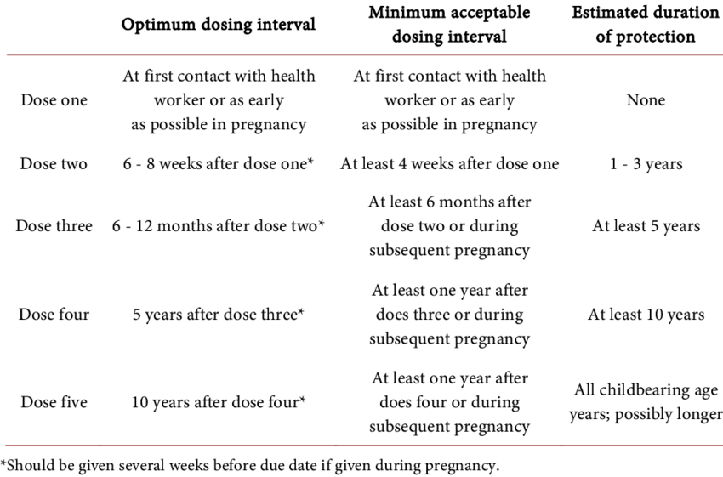

Q5: Most cost-effective intervention to prevent maternal deaths in rural Egypt
- Skilled birth attendance & timely referral

Q6: Aim of Iron & folate supplementation during pregnancy
- Prevents Neural tube defects & maternal anemia

Q7: Public health worker priority in this village?
- Education about early ANC & safe delivery
Q8: What is Most common population indicator for maternal health status?
- Maternal Mortality Ratio (MMR)

