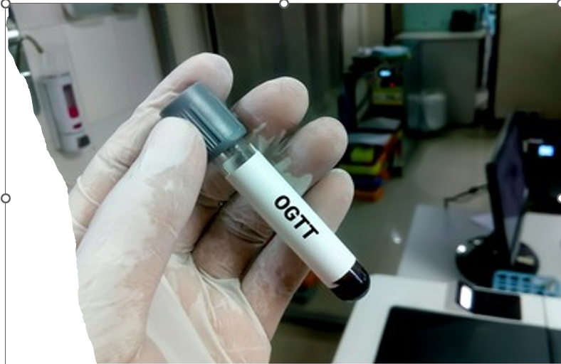

Normal curve:

|  |  |
| --- | --- |
| Timing | Reading |
| Fasting | Blood:70-105 mg /dl |
| Urine:Nil |
| 30 minutes samples | Blood:110-170 mg /dl |
| Urine: Nil |
| 60 minutes samples | Blood:120-170 mg /dl |
| Urine: Nil |
| 90 minutes samples | Blood:100-140 mg /dl |
| Urine: Nil |
| 120 minutes samples | Blood:70-120 mg /dl |
| Urine: Nil |

Nil: (No glucose detected)

2-Diabetic curve:

3-Renal Glucosurea::

1-Blood glucose levels are within the normal limits but urine glucose is positive.

2-There is lowering of renal threshold due to renal tubular defect in glucose absorption. GTT is also useful in the diagnosis of this renal tubular defect.

**4-Lag curve:**

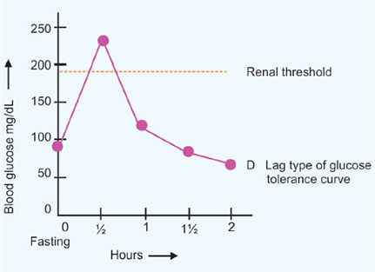

|  |  |
| --- | --- |
| Fasting blood sugar | Normal |
| Peak at | Sharp 1-1.5 hour |
| Renal threshold | Reached |
| After 2.5 hours | Rapid return to normal |
| Urine | Glucose is present but no ketones |
| causes | Hyperthyrodism-  After gastroenterosectomy-  During pregnancy |

**Flat curve:**

* **Causes:** Pituitary, thyroid or adrenal insufficiency.
* Digestive malabsorption

