***Tutor guide***

**M1 2024-2025**

**Second term**

* **Contents:** 
  1. Characters of O.6.U. graduates**:**
  2. Teaching strategy in O.6.U.
  3. -Guide lines (why P.B.L. “Problem Based Learning”) (what the student & tutor will do this term) , (modules in this term & their general objectives)
  4. Schedule for lectures , practicals , Early clinical exposure (ECE) , cases ( small group teaching) , (small group discussion ) , skill lab , & exams
  5. Rubrics for grading assignments and presentations
  6. Portfolio items
  7. Cases with objectives
  8. 8- Tutor guide for the cases
  9. 9- N.A.R.S.
  10. Blue prints
* **Characters of O.6.U. graduates:** 
  1. Work to maintain normal health, provide primary health care and deal with common health problems in the society
  2. Be aware of the importance of a good doctor patient relationship and work to establish and maintain it.
  3. Follow rules of medical ethics.
  4. Show appropriate attitudes and professionalism.
  5. Demonstrate appropriate communication, clinical and practical skills.
  6. Be prepared for lifelong learning.
  7. Be able to engage in post- graduate and research studies.
  8. Acquire basic administrative capabilities

**\*\*** **ملخص إستارتيجية التعليم والتعلم بالكلية\*\***

1.استراتيجية التعلم الذاتي:

أسلوب من أساليب التعلم المتطورة التى تمكن الطالب من تحصيل المعارف والمها ارت معتمداً على

قدارته الذاتية من مصادر التعلم المختلفة ، فيعلم نفسه بنفسه وفقاً لقدارته ولسرعته فى التعلم.

2ـ استراتيجيه التعلم التفاعلي:

تعتمد استراتيجية التعليم التفاعلي على إسلوب التفاعل بين الطالب والمحاضر والمادة العلمية ويمكن تطبيق هذا المفهوم من خلال عدة وسائل منها التعليم التعاوني والتعليم الإلكتروني.

أ- التعلم التعاوني:

من خلال عمل الطلاب معا فى مجموعات صغيرة العدد للعمل على حل المشكلات أو د ارسة حالة والمشاركة فى حملات التوعية في تفاعل إيجابي متبادل يشعر فيه كل فرد أنه مسئول عن تعلمه وتعلم الاخر .

ب-التعليم الالكتروني:

وسيمة تدعم العملية التعليمية وتحولها من طور التلقين إلى طور الإبداع والتفاعل وتنمية المها ارت، حيث تعتمد عمى تطبيقات الحاسبات الإلكترونية وشبكات الإتصال والوسائط المتعددة في نقل

المهاارت والمعارف وتضم تطبيقات عبر الموقع الالكترونى وغرف التدريس الإفتراضية.

3ـ التدريب

* التدريب الإكلينيكى
* التدريب الميدانى
* القوافل الطبية
* التدريب الصيفى بالمستشفى
* التدريب بمركز التدريب الطبى المستمر ووحدة الابحاث الطبية المتقدمة
* التدريب بالمستشفيات بالخارج

**\*\*اساليب وطرق التعليم والتعلم**

|  |  |  |
| --- | --- | --- |
| **أساليب أخرى لمتدريس التفاعمى** | **لاساليب الغير تقميدية** | **الاساليب التقميدية** |
| البحوث وتقديم العروض العملية  ) انشطة اخرى: المشاركة فى القوافل الطبية وحملات التوعية( | حل المشكلات | المحاضرات باستخدام الداتا شو |
| & Tutorial السيمينا ارت |
| الرسومات التوضيحية وعمل بوسترات للابحاث | نماذج ومحاكاة | الدروس المعملية والإكمينيكية  ) مستشفى الكلية ـ مستشفى طب القصر العينى  الكس  ترابيزة سكترا  التعليم باستخدام الحالات  التعليم التكاملي التفاعلي |
| Skill lab مشاهدة |
| التعلم الالكتروني | لعب الادوار |
| الزيا ارت الميدانية )الوحدات الصحية – المصل واللقاح – المحرقة بالمستشفى – وحدة التعقيم( | د راسة الحالة |
| التدريب الصيفى بمستشفى الجامعة وبالخارج | المناقشة فى مجموعات صغيرة |

**وللتأكد من تحقيق مخرجات التعلم المستهدفة:ـ**

يتم تقييم مستوى الطلاب بطرق متعددة تشمل:

* الامتحانات الدورية
* الامتحانات التحريرية
* حل المشكلات ودراسة الحالة
* الامتحانات العممية والاكلينيكية وتطبيق نظام) OSPE - OSCE

# عميد الكلية أ.د/عمرو نديم

* **PBL Philosophy:**

In a world where available information is growing exponentially, we believe that the most important thing a student needs to know is how to learn. So the main learning goals of the PBL are a framework for looking at concepts, skills, and abilities and help guide the creation of personalized student curriculum. PBL offers unique environments where students can flourish as individuals within a community of learners.

* **PBL Process:**

The core of the PBL process is the tutorials that will be held once weekly beside the practical sessions and the interactive lectures. In each tutorial there will be a case scenario that is delivered to the students, where they collaborate together through the seven jumps process to point out the possible problems present in the case and to find out the intended learning objectives need to be known through this case. In the second tutorial, they will discuss the objectives of the case after self study, and a new case will be delivered. In PBL process the role for lectures aim at clarification of complicated areas of information or to integrate different areas of information. Practical sessions and clinical skill lab are included as educational activities in BPL. They act as tools for the students to gain the needed psychomotor skills and to attain the professional attitude and behavior.

* **Student role:**

-The student is the center of the learning process in PBL. Students will depend on themselves in finding out the learning objectives by brain storming in the case study session. Then they will go home and study and search in the **texts or hand outs** for the information of the objectives they got. Then the following session they should try to present the information they gazered and summarized to their students in an easy palatable way. In BPL the students have to work hard, prepare themselves well for every tutorial group meeting, collaborate with their colleagues and practice team work. They also will have their reflection about the process, their colleagues and the tutor.

* **Tutors role:**
* The tutor will work as a facilitator more than traditional teacher who delivers all the information to the students. Tutors role is to stimulate and motivate the students to learn and to search for the information and knowledge. During the case they will guide the students and redirect them towards the intended learning objectives. The tutors share in the assessment process. Moreover, he share with the students the responsibility of setting the roles of the tutorial session.
* Tutor will divide the students into groups to work with each other.
* The tutor will receive guide information for the objectives in each case from the departments at least one week before the case is to be discussed, he should read them and then in the discussion of the case he should see if the students had fulfilled all the needed items so as to approve their work or they need to search more for certain items and get them so as to complete their work completely or they got more or un needed items they should discard them. By the end of the cases of the module students will have their hand out covering all items needed in the objectives they searched for
* All staff members should have their official mails done by the beginning of the academic year so as good communication may be applicable and to facilitate uploading of their lectures every Wednesday of each week
* In each session one of the students will be the reader (the one who reads the case) and another one will be the writer (the one who writes the objectives on the board after brain storming of the students with the tutor and collect them after that)
* In session ( 1 )
* One case will be red by the students
* They make brain storming with each other and with the tutor to reach the objectives the case is talking about. They will go home to search for them and make presentation about them the coming session according to rubrics given in this guide.
* Weeks for reading of the cases and discussion of the objectives are written above each case.
* The presentation have certain rubrics the tutor try that the students should stick more and more to them each time they make the presentation
* **STUDENTS SHOULD ATTEND THE CLINICAL DISCUSSION OF THE CASE**
* At the end of each module portfolio marks will be given according to :
* Performing the needed tasks and have them done and signed
* The attendance in the case sessions and the clinical case discussion
* **The presentation they showed along the module and their share in the discussions and preparation of the work needed (see professional behavior sheet included)**
* **The assignment they will be given which includes presentation and they should comply completely to the presentation and assignment rubrics (included in the guide)**
* **(the mark is given by the tutor and program heads after revising the assignments and discussing the students in them in the date of one of the case sessions scheduled with the students. This is to complete the mark of the portfolio for this module as shown in the assesment schedule included)**
* After the students finish the presentation in each session they will read the following case and brain storm to get the objectives that they will go home to prepare them as presentation in the coming case session and so on all the sessions
* If the case is long its presentation by the students may take two weeks not one week to ensure that the students presented the objectives in the case in a good way
* All students are to make their Emails in the first week and try to enter the learning management system on the moodle ([https://med@o6u.edu.eg/moodle)](https://med@o6u.edu.eg/moodle) so as to be able to have the on line information uploaded weekly and lectures , videos and on line formative exams as well as the grades

* **Scoring Rubric for Presentations:**

|  |  |  |  |
| --- | --- | --- | --- |
| **Category** | **Scoring Criteria** | **Total Points** | **Score** |
| **Organization (15 %)** | Were the main ideas presented in a clear manner? | 5 |  |
| Information is presented in a logical sequence. | 5 |  |
| Presentation appropriately cites requisite number of references. | 5 |  |
| **Content (45 %)** | * The Introduction is attention-getting, * It lays out the problem well, * It establishes a framework for the rest of the presentation. | 5 |  |
| Technical terms are well-defined in language that is appropriate for the target audience. | 5 |  |
| The Presentation contains accurate information. | 10 |  |
| The material included is relevant to the overall message/purpose. | 10 |  |
| Appropriate amount of material is prepared, and the points made reflect well their relative importance. | 10 |  |
| There is an obvious conclusion summarizing the presentation. | 5 |  |
| **Presentation (40 %)** | Speaker maintains good eye contact with the audience and is appropriately animated (e.g., gestures, moving around, etc.). | 5 |  |
| Speaker uses a clear, audible voice. | 5 |  |
| Delivery is poised, controlled, and smooth. | 5 |  |
| Good language skills and pronunciation are used. | 5 |  |
| Visual aids are well prepared, informative, effective, and not distracting. | 5 |  |
| Length of presentation is within the assigned time limits. | 5 |  |
| Information was well communicated. | 10 |  |
| **Score %** | **Total Points** | **100%** |  |

# **Professional Behavior of student in the case checklist**

**Students Name: ....................................**

**Date: ...................................................... End of module (Summative): ........................... Module title: .....................................................................** **Student’s Signature :............................ Tutor’s Name:.....................................................**

|  |  |  |  |  |  |  |  |
| --- | --- | --- | --- | --- | --- | --- | --- |
| **Criteria** | | |  | **Scale:** | |  | **Comments** |
| 1 and 2 is unsatisfactory,  3, 4 and 5 is satisfactory performance | |  |
| **Preparation:**  Is well prepared with relevant information, uses a variety of references and summarizes key points | | | | **1 2 3 4 5** | |  |  |
| **Critical thinking:** | | Identifies problem, analyzes problem, |  |  | |  |  |
| suggests possible reasons for the problem, helps group to formulate  learning objectives | |
| **1 2 3 4 5** | |  |
| **Participation:** | ks on turn and | |  |  | |  |  |
| Participates actively, tal listens attentively to others | **1 2 3 4 5** | |  |
| **Communication Skill & Group Skills:** | | |  |  | |  |  |
| Respects tutor and colleagues, communicates well uses appropriate language, accepts feedback and responds appropriately.    Contributes to group learning, shares information with others, demonstrates sensitivity to views and feeling of others, takes on assigned tasks willingly | | |
| **1 2 3 4 5** | |  |
| **Presentation skills:**  Presents the information relevant to the learning objectivse of the case, explains clearly the reasoning process with regard to solving the problem | | | |  | |  |  |
| **1 2 3 4 5** | |  |
|  | | |  |  | **SATISFACTORY** |  | **UNSATISFACTORY** |

**Steps to register on the Moodle**

**e-learning website for Faculty of Medicine**

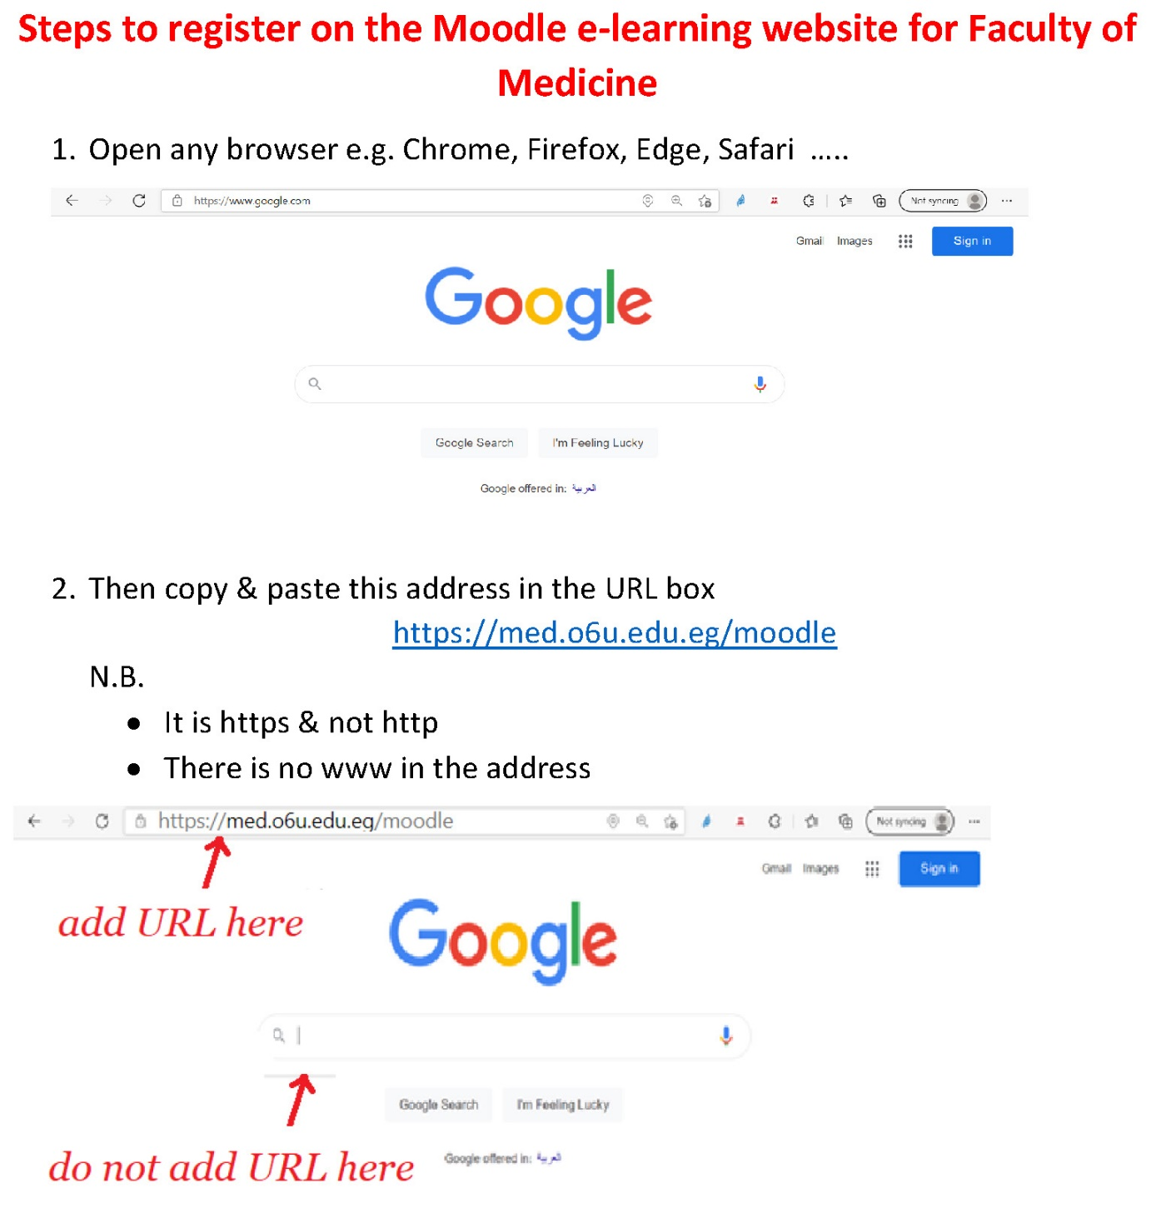



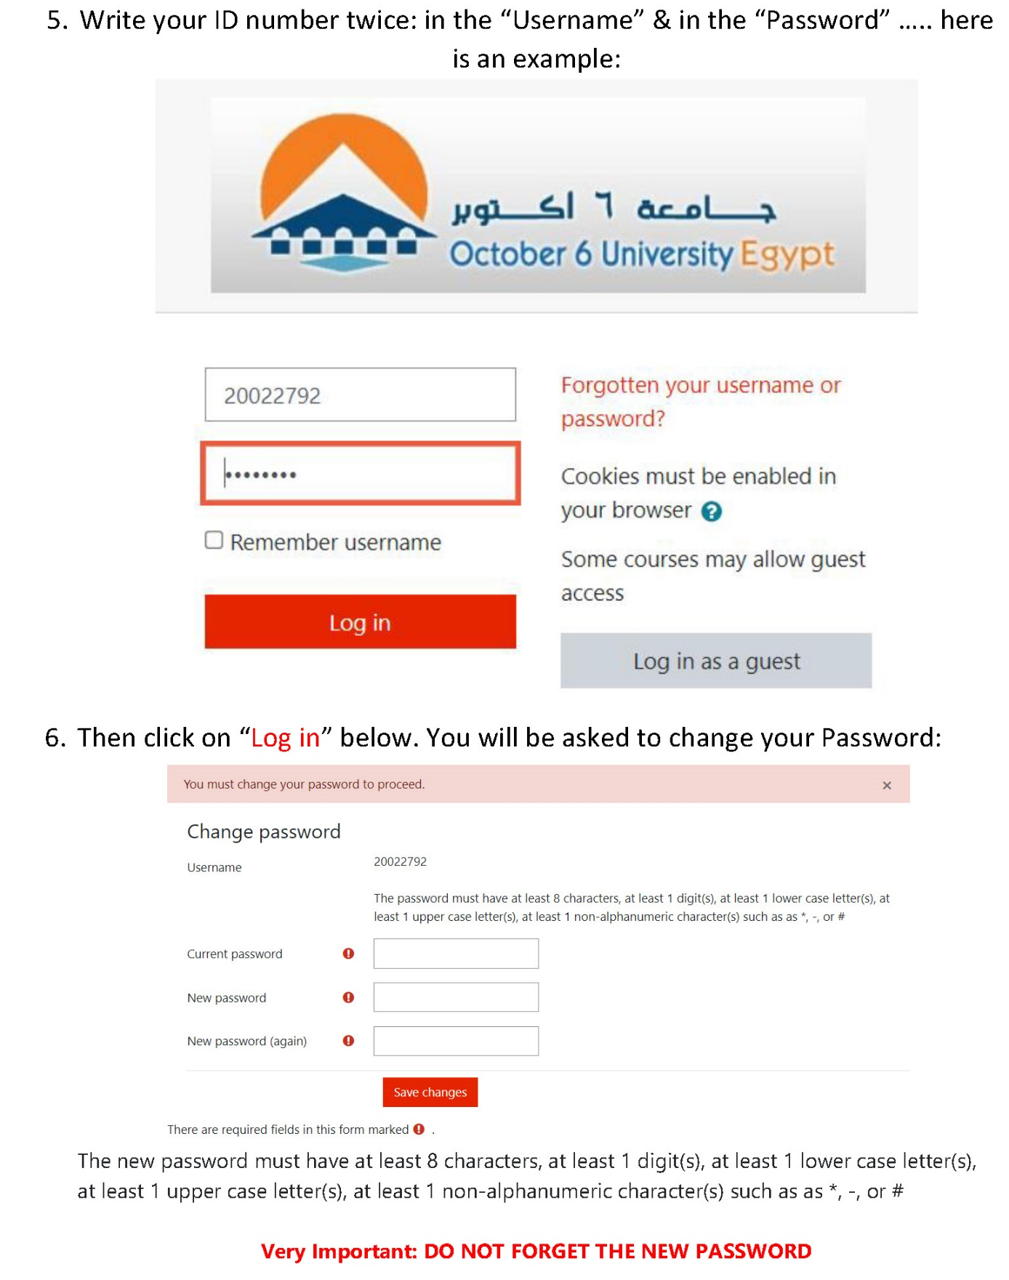

**How to enroll yourself in a Module?**

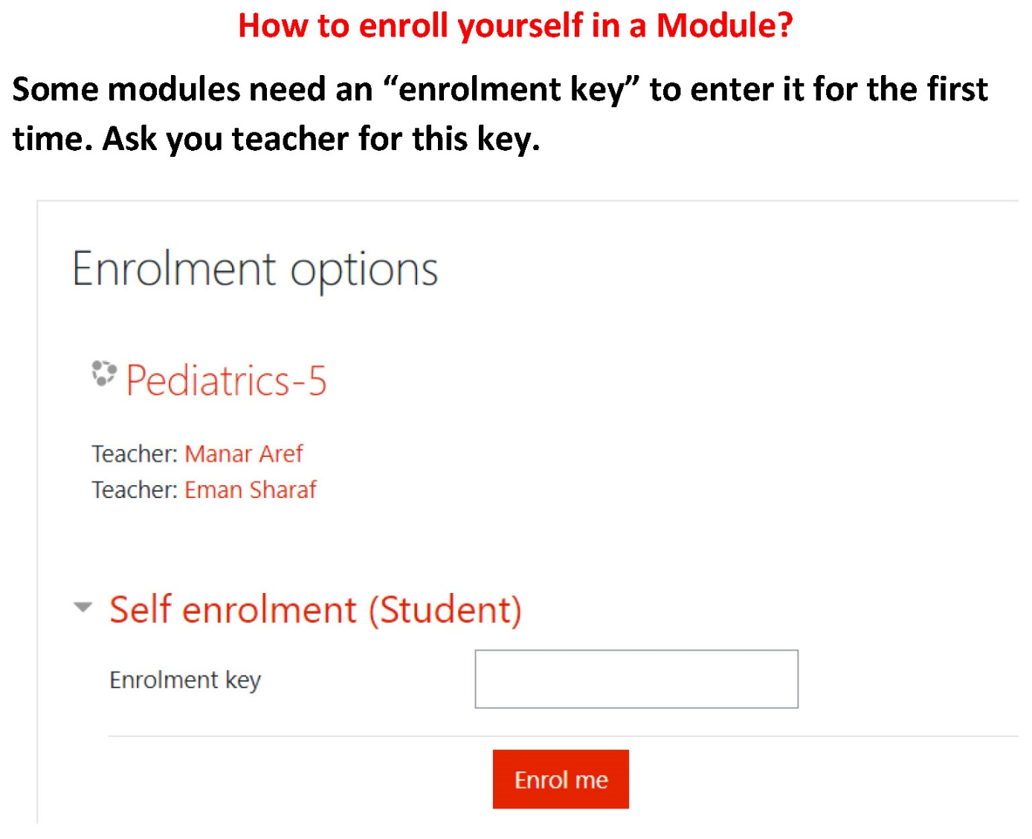

**-****The students portfolio (October 6 university - faculty of medicine - 2024 - 2025):**

* Portfolio will be formed and submitted electronically
* **The student binder for the portfolio should contain the followings:**
* **Binder should contain the names of the group of the students, and contact information ( telephone , - emails ) , their leader and names and emails of their tutor (s),**
* Students should form the tasks needed and collect the presentations the group will do along the sessions of the cases and put them in the binder of the portfolio, with the cases , CV and the needed assignments , prochures , or links for the channels as will be announced

-Students should attend the clinical discussion case that will be held with the members of the departments sharing in the module

* Any community medical work the student completed under supervision of a staff presenting the followings:
* Name of staff & position
* Date
* Site
* Results
* ObstacleS
* Conferences attended by him if present
* Visits done to clinical departments to see relevant experiments if present.
* **PORTFOLIO SHOULD BE SUBMITTED IN FULL BY FIRST WEEK OF MAY.**
* **Portfolio scoring (Rubrics for evaluating portfolios):**
* **Each student should be rated as one of the followings :**
* Out standing & he will be given 95% to 100% of the portfolio mark
* Acceptable & he will be given 70% to 75% of the portfolio mark
* Marginal & he will be given 60% to 65% of the portfolio mark
* Unacceptable & he will be given less than 60% of the portfolio mark

**Schedule available separately**

|  |  |  |  |  |
| --- | --- | --- | --- | --- |
| **OSPE** | **END MODULE** | **CONTNUOUS ASSESSMENT (portfolio )** | **MID MODULE** | **FIRST YEAR** |
| **30 marks total**  **-slides electronic and practical** | **40 marks total**  **30 MCQ**  **10 SAQs electronic** | **10 marks total** | **20 marks electronic** | **IMN 100** |
| **38 marks total**  **-slides electronic and practical** | **50 marks total**  **40 MCQ**  **10 SAQs electronic** | **12 marks total** | **25 marks electronic** | **IPA 125** |
| **30 marks total**  **-slides electronic and practical** | **40 marks total**  **30 MCQ**  **10 SAQs electronic** | **10 marks total** | **20 marks electronic** | **IPH 100** |
| **30 marks total**  **18 mcro**  **12 para**  **-slides electronic and practical** | **40 marks total**  **24 micro**  **16 para**  **30 MCQ**  **10 SAQs electronic** | **10 marks total** | **20 marks electronic**  **12 micro**  **8 para** | **IMP 100** |

**Portfolio tasks and blue prints:**

**Module IMN**

**Portofolio task:**

**Biohemistry: New laboratory tests for diagnosis and follow up of Diabetes mellitus.**

**IMN Midterm Blueprint 2025**

| **Topic** | **Mid-term MCQS (20 marks)**  **One MARK / (Q)** |
| --- | --- |
| **I-Biochemistry Department** |
| **Bioenergetics** | **4** |
| **Carbohydrates metabolism** | **8** |
| **Lipid metabolism** | **8** |

**IMN final exam Blueprint**

| **Topic** | **Final Exam 40marks**  **30MCQ(1MARK/Q)** | **SAQ (10 Marks)** |
| --- | --- | --- |
| **I-Biochemistry Department** |
| **Bioenergetics** | **2** |  |
| **Carbohydrates metabolism** | **3** |  |
| **Lipid metabolism** | **3** |  |
| **Protein metabolism** | **4** | **4 marks /1 Question** |
| **Nucleic acid metabolism** | **3** | **3 marks / 1 Question** |
| **Vitamins Metabolism** | **2** |  |
| **II-Community Department** |  |  |
| **Basic nutrition** | **2** |  |
| **Vitamins &minerals Antioxidants** | **2** |  |
| **Malnutrition** | **2** |  |
| **Nutrition throughout the life cycle** | **4** |  |
| **Balanced diet & obesity** | **3** | **3 marks/1Question** |

**Module IPA**

BLUEPRENT FOR LEVEL one SEMESTER two Module IPA 107 (2024/2025) Mod work Mid work End mod practical total 12 25

|  |  |  |  |  |  |  |
| --- | --- | --- | --- | --- | --- | --- |
| Topic | Lectures | Hours | % | Total  Marks | Mid exam | final |
| Introduction and Cell injury | 2 | 3 | 9% | 10 | 8 | 2 |
| Intracellular accumulatio extra cellular depositi | 2 | 3 | 9% | 8 | 7 | 1 |
| Inflammation | 3 | 4.5 | 13.5 % | 12 | 10 | 2 |
| Repair | 2 | 3 | 9% | 4 | - | 4 |
| Disorders of blood flo | 4 | 6 | 18.2% | 10 | - | 10 |
| Infections | 5 | 7.5 | 22.8% | 16 | - | 16 |
| Neoplasia | 4 | 6 | 18.2% | 15 | - | 15 |
| Total | 22 | 33 | 100% | 75 | 25 | 50 |
| Module work | Mid work | End module | practical | total |  |  |
| 12 | 25 | 50 | 38 | 125 |  |  |

Module IMP

Module IPH

### Cases

### Cases module pathology ( IPA)

Case ( 1 ) (brain abscess ) A 5 years old female patient was admitted to the emergency unit suffering from severe headache, after investigation she was diagnosed to have brain abscess. As aspiration of pus from the abscess was done and transported to the laboratory in a special transport media. Gram stain was done and revealed gram negative bacilli. By doing culture on blood agar under aerobic condition, no growth was obtained.

Objectives ( for brain storming ) :

- Define abscess (pathology) Describe gross and microscopic features, of brain abscess (pathology) Describe Composition of pus (pathology)

Enumerate complication of abscess (pathology) - Methods of treatment of brain abscess (surgery)

– Identify the sources of infection, mode of transmission of gram negative bacilli infectious diseases (micro)

Case ( 2 ) : ( Haemothorax ) A 17-year-old woman presented to the clinic with a history of dry cough, sore throat and mild fever. She was diagnosed to be having upper airway infection. She confirmed that she had had similar attacks in the previous 3 years. Chest X-ray revealed nearly complete replacement of the right hemithorax with a dense homogenous opacity. The patient was then referred to the surgical clinic. Additional clinical imaging showed an impaired percussion note and diminished air entry over the right hemithorax. The chest Xray was repeated and showed a very large, dense homogenous opacity occupying nearly 90% of the right lung. The preliminary initial diagnosis was Echinococcus of the lung. After a week of preparatory albendazole treatment, the patient underwent parenchyma preserving surgery.

- Objectives ( for brain storming ) :

- Definition of hemothorax ( pathology )

- Mention most common causes of hemothorax ( pathology )

-X ray picture and surgical approach in cases of hemothorax (surgery)

- Identify the sources of infection, mode of transmission of Echinococcus of the lungs (parasitology)

Case ( 3) : ( pulmonary T.B. ) A 50 years old man was brought to the emergency department with productive cough and bloody sputum. The patient complained from shortness of breath, and reported having lost 20 Kgs of his weight in a short period of time without being on any regimen to decrease weight. He also complained from night sweats two or three nights a week for the past month. The patient was heavy smoker. On examination the patient appeared thin, and tall, his vital signs were normal. His lung examination was notable for decreased breath sounds diffusely. Chest X ray revealed a cavity in the left upper lobe. The patient was diagnosed as having pulmonary T.B. – Objectives ( for brain storming ) :

- Definition of secondary TB ( pathology )

- mention fate of secondary TB ( pathology )

- X ray findings and treatment for pulmonary T.B. (internal medicine) -Identify the sources of infection, mode of transmission of pulmonary T.B. (parasitology)

- Mention the proper immunization for the T.B. (micro)

- Prevalance of T.B. in community (community)

- Medical treatment of T.B. (pharmacology)

Case ( 4 ) : (stomach upset ) A patient was admitted to the internal medicine clinic complaining from stomach upset, diarrhea, swollen abdomen cough, weakness and fatigue. Investigations revealed anemia and unexplained weight loss. The patient was diagnosed to be having hydatid cyst.

- Objectives ( for brain storming ) :

-Describe Gross and microscopic picture of hydatid cyst ( pathology )

- Diagnosis and treatment of hydatid cyst (surgery & internal medicine) - Causative agent for hydatid

Guide information for the module GMD :

Sources of infection , mode of transmission of gram negative bacilli infectious diseases

Gram-negative bacilli are responsible for numerous diseases. Some are commensal organisms present among normal intestinal flora. These commensal organisms plus others from animal or environmental reservoirs may cause disease.

* The most frequent infections caused by GNB are UTIs.
* Urinary tract infections usually happen when a GNB colonising the GI tract ascends through the urinary tract (endogenous infection). Nevertheless, GNB can also access the urinary tract through healthcare hands and/or devices (exogenous infections).
* The presence of bacteria in the urinary tract is called **bacteriuria**. Bacteriuria does not equal a UTI, since many people may have asymptomatic bacteriuria. Most patients with **asymptomatic bacteriuria** do not benefit from antibiotic therapy.
* (Symptomatic) UTI are classified into low UTI (cystitis, prostatitis) and high UTI (pyelonephritis, renal abscess). Some might have systemic signs and symptoms, such as fever, chills, sepsis and some might have only local signs and symptoms (e.g. cystitis).

**Intra-abdominal infections**

Many GNB, mainly Enterobacteriaceae, can colonise the GI tract without causing disease. Indeed, the GI tract is their normal habitat.

* Whenever the GI tract is disrupted due to inflammation, ischemia or perforation of any cause, the bacteria usually found in the GI tract can cause harm (infection). Although these infections are usually polymicrobial, Enterobacteriaceae are among the most relevant pathogens involved.
* These infections can be limited to the GI tract wall (**diverticulitis, cholecystitis, appendicitis…**) but they can spread to the peritoneum (**peritonitis**) and form **abscesses** (pus collections) within the abdominal cavity.
* Overall, intra-abdominal infections, especially in the case of abscesses, have high bacterial inoculum (high amounts of bacteria) and antibiotics frequently do not suffice for their management, requiring surgical or percutaneous source control (i.e. abscess drainage).

**Respiratory infections**

* Both Enterobacteriaceae and non-fermenters (**Pseudomonas aeruginosa, Acinetobacter baumannii, Stenotrophomonas maltophilia…**) can colonise the respiratory tract and they can cause respiratory infections. This usually happens in hospitalised patients or individuals who have been exposed to antibiotics.
* Respiratory tract infections caused by GNB such as Enterobacteriaceae or non-fermenters can range from tracheobronchitis to pneumonia, either ventilator or non-ventilator associated. Pneumonia caused by GNB is associated with significant morbidity and mortality.
* Not infrequently, pneumonia is difficult to diagnose since its presentation (clinical and radiological) is nonspecific and GNB can colonise the respiratory tract without causing disease.
* Treatment of Gram-negative infection is usually guided empirically by an antibiogram specific for the unit or hospital, until culture and sensitivity reports become available.
* The [aminoglycosides](https://www.sciencedirect.com/topics/medicine-and-dentistry/aminoglycoside), particularly [gentamicin](https://www.sciencedirect.com/topics/medicine-and-dentistry/gentamicin), were historically the antibiotics of choice in the treatment of Gram-negative infections; however, some [Gram-negative bacteria](https://www.sciencedirect.com/topics/medicine-and-dentistry/gram-negative-bacteria) encountered in the burn unit are now resistant to all the aforementioned antibiotic classes and often the treatment option is relegated older drug classes, namely the [polymyxins](https://www.sciencedirect.com/topics/medicine-and-dentistry/polymyxin).

**- Treatment of brain abscess:(pharmacology)**

**1-Combination of high dose parental antibiotics and neurosurgical drainage.**

**2-Third\fourth generation.**

**3-Patients with neurodurgery \head trauma**

**#Vancomycin+ Cefiazidine**

**# Meropenem +Vancomycin**

**#Modify antibiotics as per culture results.**

**# Duration: in 6-8 weeks.**

**Cases module pharmacology ( IPH )**

**Alzheimer’s Dementia**

* Chief Complaint:

“Mom has become uninterested and apathetic in the past month. She is not always cooperative with daily functions. I am moving out of state to help take care of my own grandchildren; so, my brother, Sam, is thinking about moving Mom to his house or to a nursing home. He will become her main caregiver.”

* History of Present Illness:

Norma Dale is a 74-year-old woman who presents to the geriatric care clinic for a routine visit accompanied by her daughter Ann. Norma was diagnosed with Alzheimer’s disease. 6 years ago. Her initial symptoms included forgetting times and dates easily, misplacing & losing items, repeating questions & current events, inability to answer questions, & increasing difficulty with managing finances. She was initially treated with tacrine, which was eventually discontinued due to complexity of QID dosing and elevated liver enzymes. Treatment with Aricept 10 mg at bedtime has been well tolerated for the past 4 years, & Norma has been participating more actively in family and social functions. Behavioral problems have been infrequent. Since her last clinic visit, Norma began using undergarments as extra protection for urinary incontinence. Norma lives with her daughter, Ann, who reports that this living arrangement has been tolerable. As the principal caregiver, Ann has been able to maintain a regular routine with her mother’s daily activities, nutrition, & financial responsibilities. However, Ann is moving in 1 month to live closer to her own daughter to help with grandchildren & has asked her youngest unmarried brother, Sam, to help take care of their mother.

Sam has agreed to be his mother’s caregiver. He lives and works across town & is not sure if he wants to move his mother into his home. There has been discussion about placing Norma in a long-term care facility. Norma displays lack of interest and apathy lately, especially when Ann & Sam are talking about her care. Ann asks about Norma’s current Alzheimer’s medication & her recent attitude and lack of cooperation.

* Neurological Examination:

1. Normal Motor, sensory, CNs, cerebellar, & gait. MMSE: score 16/30 *(compared to 17/30 last year & 19/30 initially)*.
2. Disoriented *(to country, season, month, date, day of week).*
3. Good registration but impaired attention & very poor short-term memory *(unable to remember any of 3 items after 3 min).*
4. Able to follow commands.
5. Displayed apathy during MMSE.

* CT scan: Mild to moderate generalized cerebral atrophy
* Assessment:

1. Alzheimer’s disease, stage 5 on the Global Deterioration Scale (moderate AD – early dementia).
2. Behavioral problems reported by caregiver as lack of interest, apathy, & uncooperative behavior.
3. Occasional urinary incontinence.
4. Occasional knee pain secondary to osteoarthritis; generally, well controlled with acetaminophen PRN.

**Questions:**

1. What drugs, dosage form, dose, schedule, & duration of therapy are best for the cognitive and noncognitive symptoms of this patient?
2. What alternatives would be appropriate if the initial therapy fails or cannot be used?
3. What clinical & laboratory parameters are necessary to evaluate the therapy for achievement of the desired therapeutic outcome & to detect or prevent adverse effects?

**Migraine**

Case 1:

In an outpatient clinic, a 31-year-old woman who is suffering from frequent migraine headaches of moderate severity; was prescribed a nasal spray that causes a selective vasoconstriction of the carotid vascular bed by stimulating 5-HT1D receptors.

**Questions:**

1. What is this drug?
2. What is its mechanism of action?
3. How the various members in its group are given in acute migraine?
4. What is the dose of this drug in acute migraine?
5. What are the expected adverse effects of this drug?
6. If it fails, can you give an ergot after it?
7. What are the serious drug interactions with this drug?
8. Is this lady needs prophylactic therapy?
9. What are the drugs that can used for prophylaxis of migraine?

Case 2:

In Emergency department, a 45-year-old woman was prescribed dihydroergotamine (DHE) + metoclopramide for severe migraine attack.

**Questions:**

1. The therapeutic effect of DHE is due primarily to
2. What are the advantages of DHE over ergotamine?
3. Why ergots are not first choice in migraine?
4. When is ergotamine used in treatment of migraine from the start?
5. How is ergotamine given in acute migraine?
6. Are simple analgesics a good choice in acute migraine?

**Cases module microbiology and parasitology ( IMP)**

**Short cases for students 2024 IMP 106**

**Cases in General bacteriology**

**Gram stain**

A 10-year-old child suffering from severe headache and neck pain is brought to the emergency department .On physical examination , the patient was found to be lethargic and had stiff neck and was diagnosed as meningitis .A lumbar puncture reveals numerous neutrophils The cerebrospinal fluid (CSF) protein level was found high and the glucose level was found low:

1. What is the significance of the presence of neutophils in the CSF?
2. Why the CSF protein level is high ?
3. Why the level of glucose level is low ?
4. What is the direct and rapid laboratory test that should be done to make an initial diagnosis ?

**Ziehl – Nelsen stain**

A 50 year old man is brought to the emergency room with a cough productive of bloody sputum.The patient complains of shortness of breath.He reports having lost approximately 20 kilograms from his weight. He also complains from night sweats two to three nights a week for the past month. The patient is heavy smoker.On examination, the patient is a thin tall male.All vital signs are normal.His lung examination is notable for decreased breath sounds diffusely.Chest X ray reveals a cavity in the left upper lobe.The patient was diagnosed as having pulmonary tuberculosis.

1. What type of sample you will take from the patient for laboratory diagnosis?
2. What type of stain is used for direct detection of the causative organism (s) in this sample ?
3. What is the color of the organism (s) on using this stain ?

**Gene transfer , antibiotic resistance and nosocomial infection (hospital acquired )**

An increase in **antibiotic resistance** has been observed in **gram negative bacilli** isolated from **urine** of patients in a critical care center . The same strains were isolated from hands of health care workers indicating contact transmission of the organisms . All strains **have the same plasmid profile** .

* + - 1. What is the source of urinary tract infections?
      2. What is the best method used to collect urine from ICU patients ?
      3. How you can identify the causative organisms ?
      4. What is the most important method of nosocomial infection ?
      5. What is meant by antibiotic resistance ?
      6. What is the significance that all strains have the same plasmid profile ?
      7. What are the measures used in order to decrease antibiotic resistance among organisms .

**Pasteurization**

A family routinely consumed unpasteurized milk ,several members experienced sudden onset of fever of crampy abdominal pain,fever and profuse diarrhea .*Campylobacter jejuni* ,**a Gram negative bacilli** ,were isolated and identified in all patients .

1. What is meant by enterocolitis?
2. Why milk is the main cause of diarrhea ?
3. How you can identify gram negative bacilli ?
4. What is the first measure you take in case of any diarrhea ?
5. Which is the treatment of choice for this type of enterocolitis?

**Parasitology Case Study:**

A 40-year-old male patient complaining of abdominal pain and swelling. Clinical examination revealed a palpable mass with a thrill in the right upper quadrant of the abdomen. Ultrasonography confirmed a fluid-filled cyst in the right lobe of the liver. Elevated liver function tests were observed. Blood picture revealed eosinophilia. The patient gave a history of contact with stray dogs.

1. What is the diagnosis?

**Parasitology Case Study: Hydatid cyst**

A 40-year-old male patient complaining of abdominal pain and swelling. Clinical examination revealed a palpable mass with a thrill in the right upper quadrant of the abdomen. Ultrasonography confirmed a fluid-filled cyst in the right lobe of the liver. Elevated liver function tests were observed. Blood picture revealed eosinophilia. The patient gave a history of contact with stray dogs.

----------------------------------------------------------------------------------------------------

**Parasitology Case Study:**

A 40-year-old male patient complaining of abdominal pain and swelling. Clinical examination revealed a palpable mass with a thrill in the right upper quadrant of the abdomen. Ultrasonography confirmed a fluid-filled cyst in the right lobe of the liver. Elevated liver function tests were observed. Blood picture revealed eosinophilia. The patient gave a history of contact with stray dogs.

Objectives :

**Tutor guide :**

Objective : Haemothorax is most frequently related to open or closed chest trauma or to invasive procedures of the chest.

Spontaneous haemothorax is less common and can have various causes, such as the use of anticoagulants, neoplasia, and rupture of pleural adhesions.

treatment of the underlying trauma should start immediately.

After insertion of a large chest tube, antibiotic prophylaxis in trauma patients should be administered for 24 h.

Further treatment depends on the haemodynamic stability of the patient, the volume of evacuated blood and the occurrence of persistent blood loss.

Surgical exploration by thoracotomy is necessary if >1.500 ml of blood has accumulated and/or an ongoing production of >200 ml of blood per hour is observed.

If the haemorrhage is less severe, careful investigation into the underlying cause must be performed and blood should be evacuated by tube thoracostomy..

-Objective : Identify the sources of infection, mode of transmission of Echinococcus of the lungs (parasitology)

**Answer:**

**a-** the sources of infection :

* The adult worm lives in small intestine of dogs
* Mature eggs pass in stool
* Eggs are ingested by intermediate host (herbivorous and occasionally man)
* In small intestine , onchosphere penetrates intestinal wall then to blood then to different tissues to develops into hydatid cyst .

b- mode of transmission of Echinococcus of the lungs:

**1)** ingestion of raw vegetables or drinking water contaminated with eggs of *E.granulosus* (infective stage).**2)** handling infected dogs where the hairs are usually contaminated with eggs.

**Tutor guide:**

**-Objective : Medical treatment of T.B. (pharmacology).**

**Anti-Tuberculous :First line Drugs (drugs with high efficacy)**

1. Isoniazid (INH): 5 mg/kg orally (300 mg/d)
2. Rifampicin: 10 mg/kg orally (600 mg/d)
3. Streptomycin: 15 mg/kg IM. (1g/day)
4. Ethambutol: 25 mg/kg orally
5. Pyrazinamide: 30 mg/kg orally

**Second line Drugs (less effective and more toxic)**

1. Ethionamide: 1g/d orally
2. Paraaminosalicylic acid (PAS): 10 mg/kg orally.
3. Cycloserine 10-20 mg/kg/d
4. Capreomycin, Kanmycin and Amikacin

**Isoniazid (INH)**

It is the ***most effective*** drug used in T.B. treatment

**Side effects:**

1. Peripheral neuritis: give vit B6 (more with slow acetylator)
2. Hepatotoxic (more with rapid acetylator)
3. Hemolysis in G-6-PD deficiency
4. Hypersensitivity
5. Tinnitus, GIT discomfort.

**Rifampicin (Rimactan) : Antibacterial activity**

***- Bactericidal antibiotic:*** Inhibit DNA dependent RNA polymerase and decrease RNA synthesis.

- ***Spectrum:*** T.B., leprosy, Gm –ve and Gm +ve bacteria, Chlamydia, pox viruses.

**Uses:**

1. T.B.: First line drug in combination with Isoniazid.
2. Meningitis: chemoprophylaxis in meningococcal meningitis 600 mg/day for 4 days (drug of choice).
3. Leprosy: 4-Resistant bacterial infection: e.g., staph.

**Side effects:**

1. Hepatotoxicity: impaired liver fucntoin, jaundice.
2. GIT disturbance: nausea, vomiting.
3. Hypersensitivity: *Flu like syndrome*
4. Orange red discoloration of all secretion
5. CNS: Headache, Ataxia, confusion
6. Hepatic microsomal enzyme inducer: increase metabolism and decrease actions of: oral anticoagulants, oral hypoglycemics, contraceptive pills and digoxin.

**Dosage schedules:**

1. Start with Rifampicin + Isoniazid +Pyrazinamide for 2 months, then, Isoniazide + Rifampicin for the next 4 months.
2. Isoniazide + Rifampicin + pyrazinamide + Ethambutol or Streptomycin for 2 months. Then, give Rifampicin and Isonizid for 4 months.

Tutor guide:

-Objective : Causative agent for hydatid cyst and mode of transmission (parasitology)

**Answer:** hydatid disease: is caused by infection of human tissues by unilocular cyst, the larval stage of *Echinococcus granulosus.*

**1)** ingestion of raw vegetables or drinking water contaminated with eggs of *E.granulosus* (infective stage).**2)** handling infected dogs where the hairs are usually contaminated with eggs.

**Cases module metabolism and nutrition ( IMN)**

|  |  |
| --- | --- |
| Cases for the Module (IMN ) | |
|  |  |

**Case 1 - Gout**

A 52-year-old male presented with severe pain in his wrists and right big toe, which was accompanied by inflammation and erythema of the joints. The patient had previously been diagnosed with acute gouty arthritis approximately 7 years ago, but had not experienced another acute attack since his original diagnosis. He had been taking simvastatin 40 mg nightly for hyperlipidemia for 7 years, 20 mg lisinopril daily for hypertension for 10 years, and hydrochlorothiazide 25 mg, also for hypertension, which was recently added two months ago. The patient had been steadily gaining weight over the last few years and was now about 50 lbs overweight. He stated that he drinks about a six pack of beer every day. The PCP suggested that he discontinue taking his hydrochlorothiazide and start taking amlodipine 5 mg daily, and to take naproxen 750 mg initially, followed by 250 mg every 8 hours until the symptoms of his gouty attack subsided. The PCP also suggested that along with exercise, the patient stop drinking or, at the very least, cut down on his alcohol intake

and consider beginning a low-purine diet.

**- Objectives :**

-Describe the purine and pyrimidine metabolism and hyper and hypouricemia (GOUT) (biochemistry, internal medicine)

**Case 2 – vitamin defeciency**

A 12-year-old boy with a 2-month history of reduced visual acuity was referred to a corneal specialist by an ophthalmologist. He had a history of high functioning autism and iron deficiency. At age 9, he had developed right optic nerve neuropathy, which had reduced his right eye visual acuity to 6/60 and was attributed to an Epstein-Barr virus infection. There was no significant family history. Dietary history revealed a restricted

diet, consisting only of hot chips and nuggets.

On presentation, the patient was short, extremely underweight and pale, with mild proximal muscle weakness. Visual examination showed only light perception in the right eye and 1/60 in the left eye. A relative afferent pupillary defect (RAPD) was noted in the right eye. Supratemporal field loss was noted in the left eye. Slit lamp examination revealed bilateral corneal and conjunctival keratinisation normal anterior and posterior chambers, and clear lenses. He had marked pallor of the right optic nerve disc and

temporal pallor of the left disc.

**Investigations:**

Systemic investigation revealed hypovitaminosis A (< 0.4 µmol/L (reference range 0.9–

2.5 µmol/L)); anaemia (haemoglobin=109 g/L); low iron levels despite iron supplementation; and low folate levels. Results for screening for haemolytic anaemia

were unremarkable.

CT and MRI of the brain showed narrowing of the left optic canal and internal auditory canal secondary to bony medullary expansion . Electrophysiology confirmed bilateral optic nerve dysfunction. There was mild to moderate bilateral sensorineural hearing loss above 4000 Hz. His bones and skull were found to be generally osteopenic on skeletal survey, with mild thinning of cortices in the long bones. He had normal electrophoresis, rendering thalassaemia unlikely; vitamin C, vitamin D and calcium levels were within

normal limits.

**- Objectives :**

-Discuss the chemistry, structure, and properties of fat soluble and water soluble vitamins and requirements and diseases resulting from vitamin deficiencies. (biochemistry and internal medicine)

### ---------------------------------------------------------------

Competency Area I: The graduate as a health care provider

1.2. Adopt an empathic and holistic approach to the patients and their problems.

1.3. Assess the mental state of the patient.

1.4. Perform appropriately timed full physical examination of patients appropriate to the age, gender, and clinical presentation of the patient while being culturally sensitive.

1.5. Prioritize issues to be addressed in a patient encounter.

1.6. Select the appropriate investigations and interpret their results taking into consideration cost/ effectiveness factors.

1.7. Recognize and respond to the complexity, uncertainty, and ambiguity inherent in medical practice.

1.8. Apply knowledge of the clinical and biomedical sciences relevant to the clinical problem at hand.

1.9. Retrieve, analyze, and evaluate relevant and current data from literature, using information technologies and library resources, in order to help solve a clinical problem based on evidence (EBM).

1.10. Integrate the results of history, physical and laboratory test findings into a meaningful diagnostic formulation.

1.11. Perform diagnostic and intervention procedures in a skillful and safe manner, adapting to unanticipated findings or changing clinical circumstances.

1.12. Adopt strategies and apply measures that promote patient safety.

1.13. Establish patient-centered management plans in partnership with the patient, his/her family and other health professionals as appropriate, using Evidence Based Medicine in management decisions.

1.14. Respect patients’ rights and involve them and /or their families/careers in management decisions. 1.15. Provide the appropriate care in cases of emergency, including cardio-pulmonary resuscitation, immediate life support measures and basic first aid procedures.

1.16. Apply the appropriate pharmacological and non-pharmacological approaches to alleviate pain and provide palliative care for seriously ill people, aiming to relieve their suffering and improve their quality of life.

1.17. Contribute to the care of patients and their families at the end of life, including management of symptoms, practical issues of law and certification.

Competency Area II: The graduate as a health promoter

2.1 Identify the basic determinants of health and principles of health improvement.

2.2 Recognize the economic, psychological, social, and cultural factors that interfere with wellbeing.

2.3 Discuss the role of nutrition and physical activity in health.

2.4 Identify the major health risks in his/her community, including demographic, occupational and environmental risks; endemic diseases, and prevalent chronic diseases.

2.5 Describe the principles of disease prevention, and empower communities, specific groups or individuals by raising their awareness and building their capacity.

2.6 Recognize the epidemiology of common diseases within his/her community, and apply the systematic approaches useful in reducing the incidence and prevalence of those diseases.

2.7 Provide care for specific groups including pregnant women, newborns and infants, adolescents and the elderly.

2.8 Identify vulnerable individuals that may be suffering from abuse or neglect and take the proper actions to safeguard their welfare.

2.9 Adopt suitable measures for infection control. Competency Area III: The graduate as a professional

3.1. Exhibit appropriate professional behaviors and relationships in all aspects of practice, demonstrating honesty, integrity, commitment, compassion, and respect.

3.2. Adhere to the professional standards and laws governing the practice, and abide by the national code of ethics issued by the Egyptian Medical Syndicate.

3.3. Respect the different cultural beliefs and values in the community they serve.

3.4. Treat all patients equally, and avoid stigmatizing any category regardless of their social, cultural, ethnic backgrounds, or their disabilities.

3.5. Ensure confidentiality and privacy of patients’ information.

3.6. Recognize basics of medico-legal aspects of practice, malpractice and avoid common medical errors. 3.7. Recognize and manage conflicts of interest.

3.8. Refer patients to appropriate health facility at the appropriate stage.

3.9. Identify and report any unprofessional and unethical behaviors or physical or mental conditions related to himself, colleagues or any other person that might jeopardize patients’ safety.

Competency Area IV: The graduate as a scholar and scientist

4.1 Describe the normal structure of the body and its major organ systems and explain their functions.

4.2 Explain the molecular, biochemical, and cellular mechanisms that are important in maintaining the body’s homeostasis.

4.3 Recognize and describe main developmental changes in humans and the effect of growth, development and aging on the individual and his family.

4.4 Explain normal human behavior and apply theoretical frameworks of psychology to interpret the varied responses of individuals, groups and societies to disease.

4.5 Identify various causes (genetic, developmental, metabolic, toxic, microbiologic, autoimmune, neoplastic, degenerative, and traumatic) of illness/disease and explain the ways in which they operate on the body (pathogenesis).

4.6 Describe altered structure and function of the body and its major organ systems that are seen in various diseases and conditions.

4.7 Describe drug actions: therapeutics and pharmacokinetics; side effects and interactions, including multiple treatments, long term conditions and nonprescribed medication; and effects on the population.

4.8 Demonstrate basic sciences specific practical skills and procedures relevant to future practice, recognizing their scientific basis, and interpret common diagnostic modalities, including: imaging, electrocardiograms, laboratory assays, pathologic studies, and functional assessment tests.

Competency Area V: The graduate as a member of the health team and the health care system

5.1 Recognize the important role played by other health care professions in patients’ management.

5.2 Respect colleagues and other health care professionals and work cooperatively with them, negotiating overlapping and shared responsibilities and engaging in shared decision-making for effective patient management.

5.3 Implement strategies to promote understanding, manage differences, and resolve conflicts in a manner that supports collaborative work.

5.4 Apply leadership skills to enhance team functioning, the learning environment, and/or the health care delivery system.

5.5 Communicate effectively using a written health record, electronic medical record, or other digital technology.

5.6 Evaluate his/her work and that of others using constructive feedback.

5.7 Recognize own personal and professional limits and seek help from colleagues and supervisors when necessary.

5.8 Apply fundamental knowledge of health economics to ensure the efficiency and effectiveness of the health care system.

5.9 Use health informatics to improve the quality of patient care.

5.10 Document clinical encounters in an accurate, complete, timely, and accessible manner, in compliance with regulatory and legal requirements.

5.11 Improve the health service provision by applying a process of continuous quality improvement.

5.12 Demonstrate accountability to patients, society, and the profession.

Competency Area VI: The graduate as a lifelong learner and researcher

6.1 Regularly reflect on and assess his/her performance using various performance indicators and information sources.

6.2 Develop, implement, monitor, and revise a personal learning plan to enhance professional practice

6.3 Identify opportunities and use various resources for learning.

6.4 Engage in inter-professional activities and collaborative learning to continuously improve personal practice and contribute to collective improvements in practice.

6.5 Recognize practice uncertainty and knowledge gaps in clinical and other professional encounters and generate focused questions that address them.

6.6 Effectively manage learning time and resources and set priorities.

6.7 Demonstrate an understanding of the scientific principles of research including its ethical aspects and scholarly inquiry and Contribute to the work of a research study.

6.8 Critically appraise research studies and scientific papers in terms of integrity, reliability, and applicability.

6.9 Analyze and use numerical data including the use of basic statistical methods. 6.10 Summarize and present to professional and lay audiences